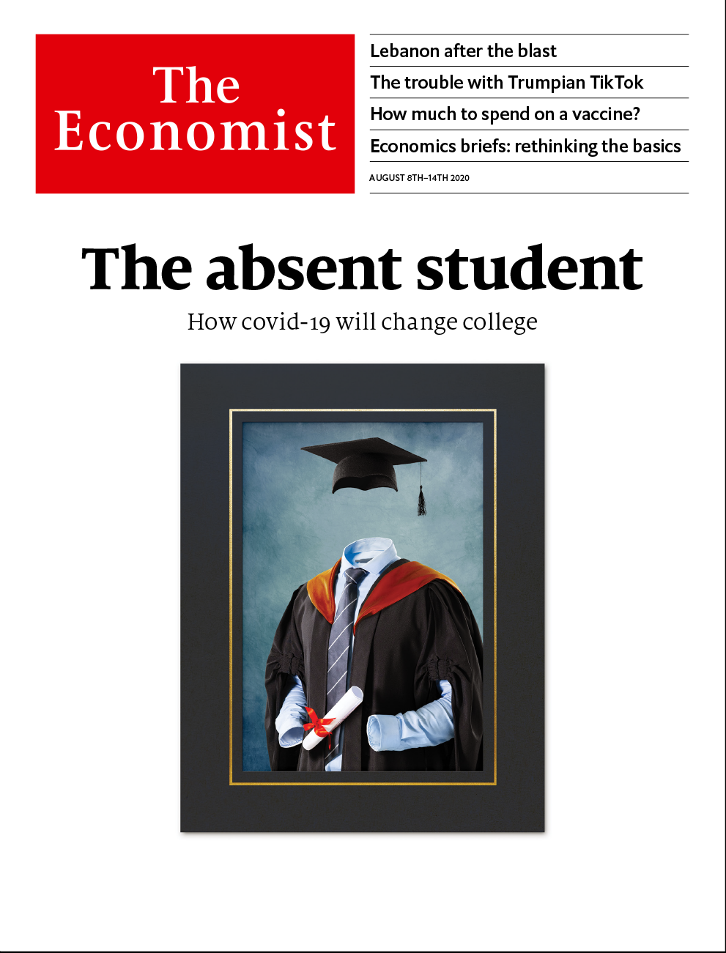

# Table of Contents

The world this week

Politics this week

Business this week

KAL’s cartoon

Leaders

Universities: The absent student

Lebanon: No way to run a country

Tech wars: Trumpian TikTok

Vaccine economics: A bigger dose

Gay rights: The world comes out

The dismal yet flexible science: When the facts change

Letters

Letters to the editor: On reopening schools, oil, French accents, Amazon, sports teams

Briefing

Covid-19 and college: Uncanny University

United States

Electing a president: Jarring

The postal service: Law of the letter

Hyperloops: Pipes of fancy

DC history: Without representation

Baseball returns: Strike two

Taxing and spending: From unthinkable to universal

Lexington: Channel-hopping

The Americas

Argentina: Fighting on fewer fronts

Guyana and Suriname: Oil futures

Bello: Beyond the troika of tyranny

Asia

Hindu nationalism: India shrining

Australia and covid-19: Borderline cases

Corruption in Uzbekistan: Weirs and recriminations

Personal freedom in Thailand: Cold cuts

Banyan: Trojan democrat

China

Entertainment: Heady Hunan

The civil code: Thirty more days of hell

Middle East & Africa

Lebanon: City in ruins

Mali: Fear and loathing in the Sahel

Prohibition in a pandemic: Tea-total

The pandemic in Africa: One million and not counting

Europe

Racism in Europe: See no evil

Open again: Genoa bridge reopens

Turkey: Sultan of censorship

Covid-19 in the Balkans: Not as stated

Charlemagne: Strandkörbe in place of sangria

Spain: The signal turns to red

Britain

Scottish independence: Is Caledonia Catalonia?

Covid-19 in Scotland: Independence fever

Food and trade: A pig of a problem

Planning reform: Weak foundations

Masks and culture: Made in the USA

John Hume, 1937-2020: A dove over Derry

Bagehot: The smell of rot

International

Coming out: Queer, there and everywhere

Business

Corporate America: The trouble with TINA

Stockmarket indices: Inclusive growth

Semiconductors: Worth an arm and a leg

Microsoft and TikTok: Unproductivity puzzle

European business: Sverige AB v Deutschland AG

Bartleby: Called to account

Schumpeter: Dangerous curves ahead

Finance & economics

Vaccine economics: More hard questions

Chinese finance: A dynamic duopoly

Banks’ earnings: Dud light

Pre-doctoral programmes: Selection effects

The IMF and the World Bank: Abandoning hope

Free exchange: Change for the dollar

Schools brief

A healthy dose of competition: From hospitality to hipsterism

Science & technology

Artificial intelligence: Bit-lit

Covid-19 testing: Dive in

Entomology: Parasites under pressure

Cookery: A good grilling

Books & arts

Museums and restitution: Legacies of violence

Johnson: The Greatest Phrases!

Climate change: A glacier’s pace

New American fiction: The girl next door

Home Entertainment: In the woodshed

Economic & financial indicators

Economic data, commodities and markets

Graphic detail

Life in the time of corona: 90% economy, 120% gastronomy

Obituary

Olivia de Havilland: The ingénue who roared



### Friday, August 7, 2020

|  |  |
| --- | --- |
| The world this week | 3 |
| Leaders | 6 |
| Letters | 1 |
| Briefing | 1 |
| United States | 7 |
| The Americas | 3 |
| Asia | 5 |
| China | 2 |
| Middle East & Africa | 4 |
| Europe | 6 |
| Britain | 7 |
| International | 1 |
| Business | 7 |
| Finance & economics | 6 |
| Schools brief | 1 |
| Science & technology | 4 |
| Books & arts | 5 |
| Economic & financial indicators | 1 |
| Graphic detail | 1 |
| Obituary | 1 |

|  |  |  |
| --- | --- | --- |
|  | Sections | Leaders |

The world this week

Politics this week

.

Business this week

.

KAL’s cartoon

.

|  |  |  |
| --- | --- | --- |
|  | Sections | Leaders |

|  |  |  |  |
| --- | --- | --- | --- |
|  | Articles | Sections | Next |

# Politics this week

Aug 8th 2020 |

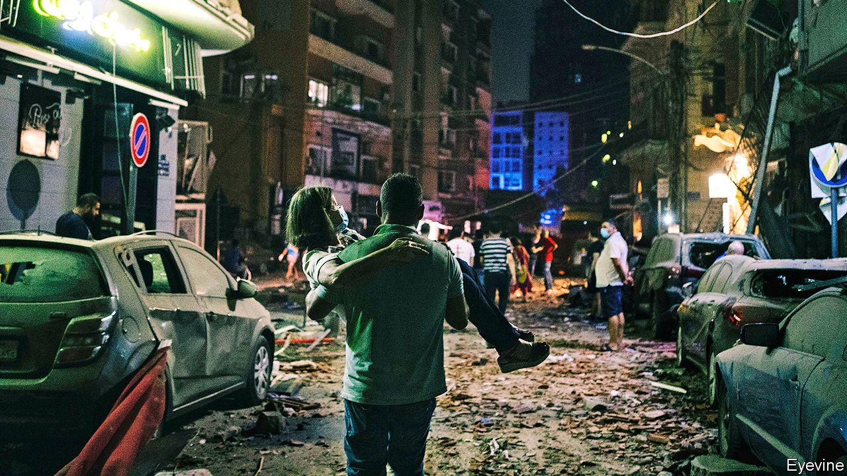

A state of emergency was declared in Lebanon, after a huge explosion at Beirut’s port. The blast was felt in Cyprus, 240km away. It killed at least 135 people, injured 5,000 and left 300,000 homeless. The cause was a fire in a warehouse holding 2,750 tonnes of ammonium nitrate, a chemical used in fertiliser and bombs. This highly explosive stockpile had lain neglected for six years. Lebanon’s prime minister, Hassan Diab, vowed that those responsible would “pay the price”. Lebanon was in an economic and political crisis even before the blast. See article.

Israeli aircraft struck military targets in southern Syria, in retaliation for an alleged attempt by militants to plant explosives near the Israeli-occupied Golan Heights area, which is also claimed by Syria.

The United Arab Emirates began operating the Arab world’s first nuclear power plant. The oil-rich UAE hopes it will meet a quarter of its electricity needs once it is fully operational. Qatar, a rival, has described the plant as a “flagrant threat to regional peace and environment”.

A report by the BBC Persian service accused Iran of covering up deaths from covid-19. Leaked official data showed the number of Iranians who have died with covid-19 symptoms to be nearly three times higher than the government admits. Known infections were almost double the public figures.

Armed men thought to belong to Boko Haram, a Nigerian jihadist group, attacked a refugee camp in Cameroon, killing 17 people.

Colombia’s Supreme Court ordered that Álvaro Uribe, a conservative former president, be placed under house arrest. It is examining whether Mr Uribe had tried to tamper with witnesses in an investigation that he instigated against a left-wing senator. Mr Uribe, the mentor of Colombia’s current president, Iván Duque, is the first sitting or former president since the 1950s to be detained.

Five months after the vote, a final result was declared in Guyana’s presidential election, allowing Irfaan Ali, of the mainly Indo-Guyanese People’s Progressive Party, to be sworn into office. The new president will be able to decide how to spend the country’s new-found oil income, which began flowing in February. See article.

Sri Lankans voted in parliamentary elections. Early returns suggest the Sri Lanka People’s Front of President Gotabaya Rajapaksa will win a clear majority.

Jihadists loyal to Islamic State attacked a prison in the city of Jalalabad in eastern Afghanistan. Some 29 people were killed during a day-long gun battle, including guards, assailants and inmates. Several hundred prisoners escaped, including fighters from IS and the Taliban.

Narendra Modi, India’s prime minister, laid the foundation stone of a temple to the Hindu god Ram in the city of Ayodhya. The temple is being built on the site of a mosque that was torn down by an organised Hindu mob in 1992, sparking riots in which 2,000 people died. Its construction has been a goal of Mr Modi’s Bharatiya Janata Party since the 1980s. See article.

The children’s commissioner for England said that schools should be opened ahead of pubs, restaurants and shops, and only shut when essential: “first to open, last to close”. She listed various ways in which missing out on education harms children, especially the poorest ones.

By contrast, Chicago joined a growing list of American cities that will keep schools closed in September and continue with remote learning.

Black Lives Matter activists scored their biggest upset in the Democratic primaries so far when Cori Bush defeated William Lacy Clay, the incumbent congressman in St Louis. Mr Clay, who is black, has served the district since 2001; his father held the seat before that for 32 years.

The former king of Spain, Juan Carlos, went into voluntary exile, two months after Spain’s supreme court opened an investigation into his alleged involvement in a high-speed rail contract in Saudi Arabia. He said he would assist prosecutors as required.

Hong Kong’s leader, Carrie Lam, postponed elections to the legislature that had been due in September. They will be held a year later, she said, because of covid-19. Pro-democracy candidates had been expected to do well.

America imposed sanctions on the Xinjiang Production and Construction Corps, and two Communist Party officials linked to it, for their alleged role in human-rights abuses. Xinjiang is a vast Chinese region where many ethnic-Uighurs have been locked up for their devotion to Islam and their Turkic culture.

China’s leader, Xi Jinping, declared the official completion of the country’s BeiDou satellite-navigation system, intended as a rival to America’s Global Positioning System, or GPS. A Chinese general said it marked an “important milestone” on China’s path towards becoming a “space power”.

The SpaceX capsule that transported two astronauts to the International Space Station came safely back to Earth, touching down in the sea near Florida’s Gulf coast. This was NASA’s first spacecraft splashdown since 1975.

## Coronavirus briefs

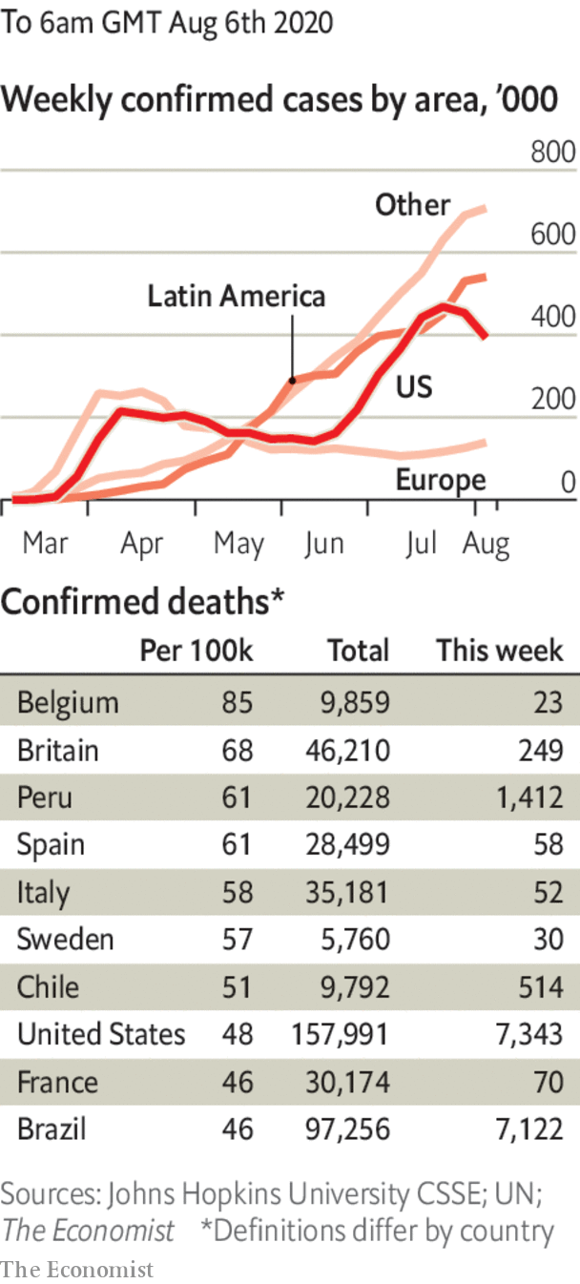

Manila was put back into lockdown. The 13m people in the Philippine capital will endure fewer restrictions than under an earlier lockdown, but mass transit is shut.

The Australian state of Victoria declared an emergency and imposed a night-time curfew in Melbourne, its capital. The city’s residents can only shop and exercise within 5km of their home. See article.

The Democratic convention in Milwaukee will now be entirely virtual. Some party officials will still go to the city, but Joe Biden is to broadcast his big speech from Delaware.

Deborah Birx, who heads the White House’s task force on covid-19, warned that the disease is more widespread in America now than in April. That earned her a rebuke from Donald Trump, who tweeted that she was “Pathetic!” for repeating what he said was a Democratic argument.

This article was downloaded by calibre from <https://www.economist.com/the-world-this-week/2020/08/08/politics-this-week>

|  |  |  |  |
| --- | --- | --- | --- |
|  | Articles | Sections | Next |

|  |  |  |  |
| --- | --- | --- | --- |
| Previous | Articles | Sections | Next |

# Business this week

Aug 8th 2020 |

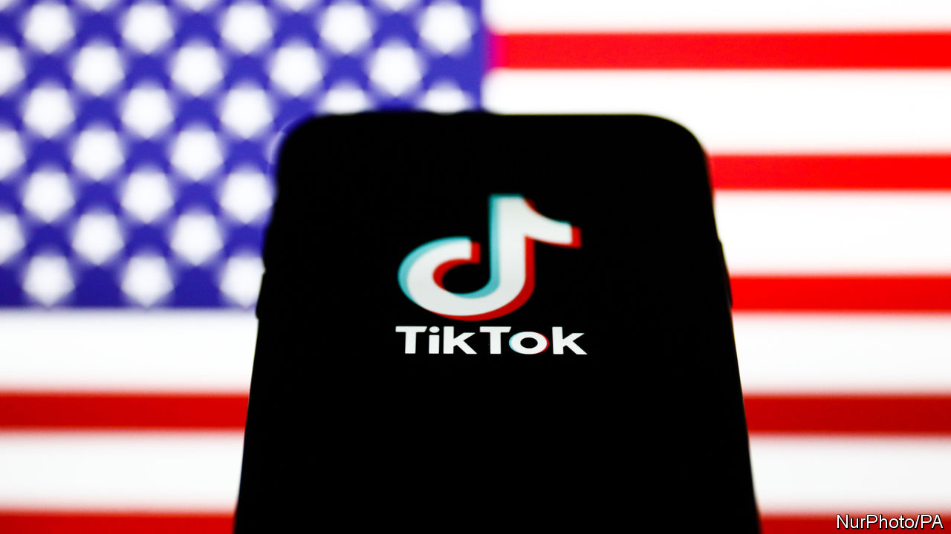

In an extraordinary turn of events, Donald Trump said he would now give his blessing to Microsoft’s recent proposal to acquire the American operations of TikTok, after the software giant said it had addressed the president’s concerns. Mr Trump had threatened to shut down the video app in the United States because of worries that its Chinese owner might collect user data for the Chinese government. Warning that he might intervene further, Mr Trump suggested that the US Treasury should get a cut from any deal. See article.

## Environmental crusader

BP said it aimed to reduce production in oil and gas by 40% before 2030 and hugely increase investment in renewable energy as part of its project to achieve net zero carbon-dioxide emissions by 2050. It is the most ambitious plan put forward by an oil company yet in the switch to green energy. BP reported a headline loss of $6.7bn for the second quarter, mostly because it wrote down assets in light of lower oil prices. It also reduced the size of its shareholder dividend for the first time in a decade.

BP was not alone among the oil giants in revealing a painful quarter. Chevron reported a loss of $8.3bn and ExxonMobil $1.1bn. Shell recently wrote down its assets by $16.8bn.

Bolstering its balance-sheet, Marathon Petroleum, an oil-refining company, agreed to sell its Speedway petrol stations to Seven & i Holdings, the Japanese owner of 7-Eleven convenience stores, for $21bn.

Anthony Levandowski, who helped found Google’s driverless-car project, was sentenced to 18 months in prison for stealing the company’s technology before going to work on a rival scheme for Uber. Mr Levandowski, once one of Silicon Valley’s brightest stars, will not go to jail yet because of covid-19. He was also ordered to pay $756,000 in restitution.

Elizabeth Warren, an American senator, wrote to the Securities and Exchange Commission asking it to investigate “potential incidents of insider trading” before the announcement that Kodak was to receive a government loan to make generic drugs. Kodak’s share price soared by over 2,000% following the announcement, but has fallen by more than half since then.

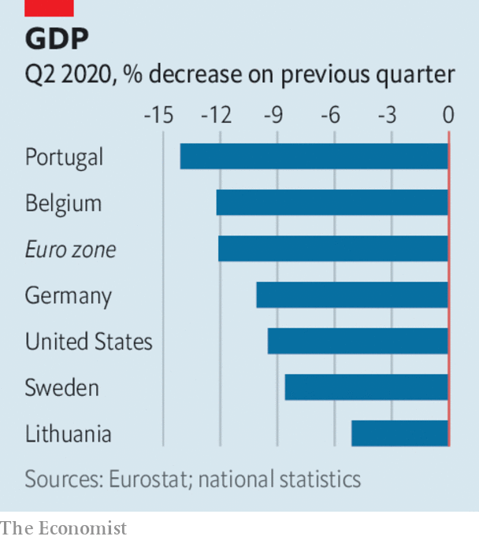

A raft of data for the second quarter revealed the extent of the damage that the pandemic is doing to economies. The euro zone’s economy was 12.1% smaller than in the previous three months. Spain’s GDP contracted by 18.5%, France’s by 13.8% and Italy’s by 12.4%. Earlier figures showed America’s economy shrinking by 9.5% in the quarter. Sweden, which controversially avoided a lockdown to keep its economy running, saw GDP shrink by 8.6%.

Two big takeovers involving health-tech companies were announced. Siemens Healthineers, a group listed separately to Siemens, its parent company, said it would buy Varian Medical Systems, best known for its use of artificial intelligence and machine learning in cancer treatments, for $16.4bn. And Teladoc Health, which operates a telemedicine platform, struck a deal to acquire Livongo, a rival, for $18.5bn.

Ford announced that Jim Hackett is to step down as chief executive. Jim Farley, the chief operating officer, will take over in October. Mr Hackett has held the position for three years, a time of lacklustre profits that drove many investors to despair. Ford did report a second-quarter net profit of $1.1bn, but that was mostly down to gains from an investment; without the gains it slipped to a loss. General Motors and Fiat Chrysler reported losses, but they were smaller than expected.

EasyJet operated just 709 flights for the three months ending June, in contrast with 165,656 in the same quarter last year. However, the European airline says demand is now “healthy” and it has increased its planned passenger capacity this quarter to 40%. Faced with a cash crunch, IAG, the owner of British Airways, said it would issue new shares to raise up to €2.75bn ($3.3bn).

James Murdoch resigned from the board of News Corporation, because of “certain editorial content”. He is Rupert Murdoch’s youngest son and was once seen as an heir to his father’s media empire, but he has drifted away from the business to take up liberal causes. That empire is much smaller now anyway, after the sale of film and television assets to Disney in 2019.

## Live from your living room

With cinemas under restrictions on social distancing and facing the prospect of more lockdowns, Disney decided to release “Mulan”, the live version of its animated hit, on Disney+ in September. Its streaming service has attracted over 60m subscribers since launching late last year, though it has yet to cover its costs. Overall, Disney reported a net loss of $4.7bn from April to June, its first since 2001, mostly because it had to close its theme parks at the start of the pandemic.

This article was downloaded by calibre from <https://www.economist.com/the-world-this-week/2020/08/08/business-this-week>

|  |  |  |  |
| --- | --- | --- | --- |
| Previous | Articles | Sections | Next |

|  |  |  |  |
| --- | --- | --- | --- |
| Previous | Articles | Sections | Next |

# KAL’s cartoon

Aug 8th 2020 |

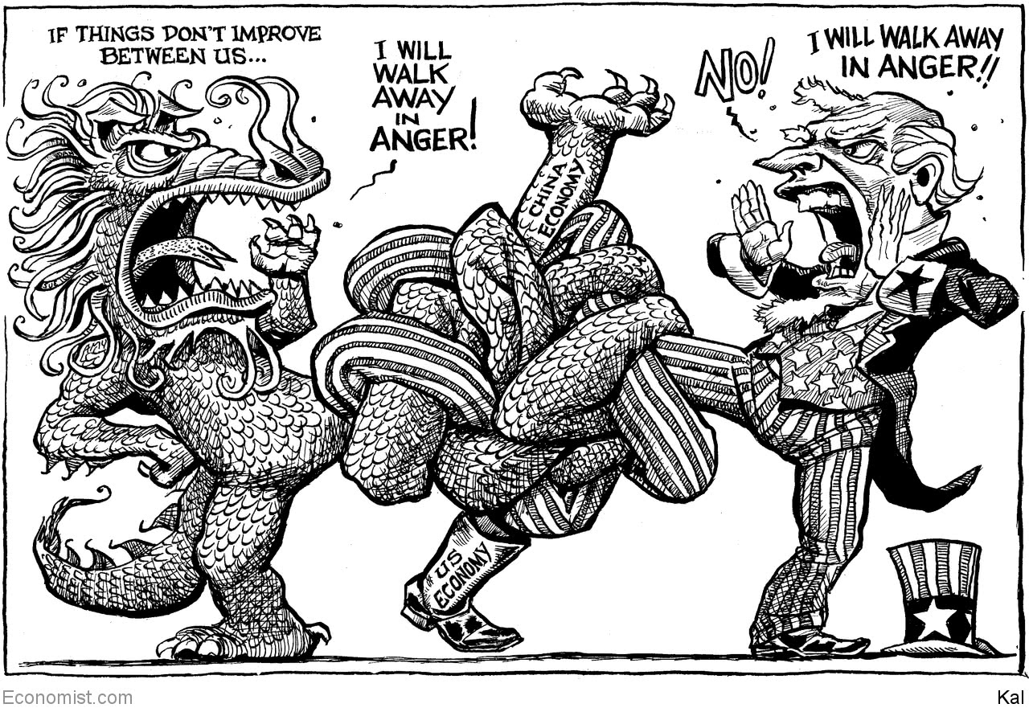

This article was downloaded by calibre from <https://www.economist.com/the-world-this-week/2020/08/08/kals-cartoon>

|  |  |  |  |
| --- | --- | --- | --- |
| Previous | Articles | Sections | Next |

|  |  |  |
| --- | --- | --- |
| The world this week | Sections | Letters |

Leaders

Universities: The absent student

.

Lebanon: No way to run a country

.

Tech wars: Trumpian TikTok

.

Vaccine economics: A bigger dose

.

Gay rights: The world comes out

.

The dismal yet flexible science: When the facts change

.

|  |  |  |
| --- | --- | --- |
| The world this week | Sections | Letters |

|  |  |  |  |
| --- | --- | --- | --- |
|  | Articles | Sections | Next |

#### The absent student

# Covid-19 will be painful for universities, but also bring change

They need to rethink how and what they teach

Aug 8th 2020 |

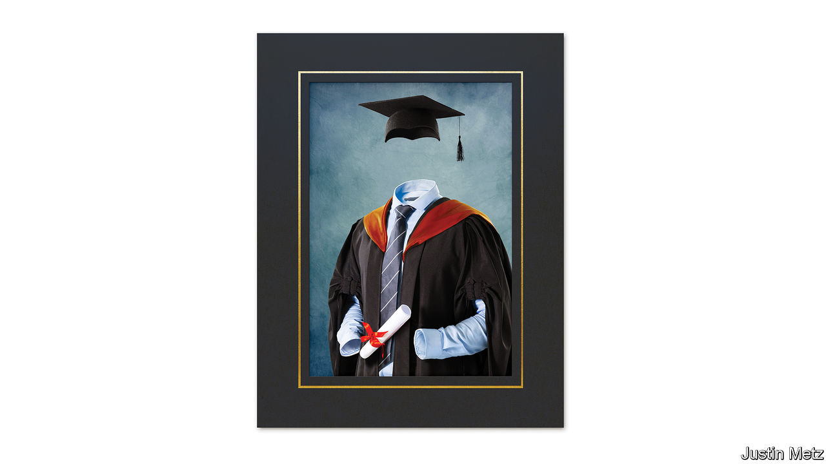

Editor’s note: Some of our covid-19 coverage is free for readers of The Economist Today, our daily [newsletter](https://my.economist.com/user#newsletter). For more stories and our pandemic tracker, see our [hub](https://www.economist.com/news/2020/03/11/the-economists-coverage-of-the-coronavirus)

IN THE NORMAL run of things, late summer sees airports in the emerging world fill with nervous 18-year-olds, jetting off to begin a new life in the rich world’s universities. The annual trek of more than 5m students is a triumph of globalisation. Students see the world; universities get a fresh batch of high-paying customers. Yet with flights grounded and borders closed, this migration is about to become the pandemic’s latest victim.

For students, covid-19 is making life difficult. Many must choose between inconveniently timed seminars streamed into their parents’ living rooms and inconveniently deferring their studies until life is more normal. For universities, it is disastrous. They will not only lose huge chunks of revenue from foreign students but, because campus life spreads infection, they will have to transform the way they operate (see Briefing).

Yet the disaster may have an upside. For many years government subsidies and booming demand have allowed universities to resist changes that could benefit both students and society. They may not be able to do so for much longer.

Higher education has been thriving. Since 1995, as the notion spread from the rich world to the emerging one that a degree from a good institution was essential, the number of young people enrolling in higher education rose from 16% of the relevant age group to 38%. The results have been visible on swanky campuses throughout the Anglosphere, whose better universities have been the principal beneficiaries of the emerging world’s aspirations.

Yet troubles are piling up. China has been a source of high-paying foreign students for Western universities, but relations between the West and China are souring. Students with ties to the army are to be banned from America.

Governments have been turning against universities, too. In an age when politics divides along educational lines, universities struggle to persuade some politicians of their merit. President Donald Trump attacks them for “Radical Left Indoctrination, not Education”. Some 59% of Republican voters have a negative view of colleges; just 18% of Democrats do. In Britain universities’ noisy opposition to Brexit has not helped. Given that the state pays for between a quarter and a half of tertiary education in America, Australia and Britain, through student loans and grants, the government’s enthusiasm matters.

Scepticism among politicians is not born only of spite. Governments invest in higher education to boost productivity by increasing human capital. But even as universities have boomed, productivity growth in the rich-country economies has fallen. Many politicians suspect that universities are not teaching the right subjects, and are producing more graduates than labour markets need. Small wonder that the state is beginning to pull back. In America government spending on universities has been flat in recent years; in Australia, even as the price of humanities degrees doubles, so it will fall for subjects the government deems good for growth.

There are questions about the benefits to students, too. The graduate premium is healthy enough, on average, for a degree to be financially worthwhile, but not for everybody. In Britain the Institute for Fiscal Studies (IFS) has calculated that a fifth of graduates would be better off if they had never gone to university. In America four in ten students still do not graduate six years after starting their degree—and, for those who do, the wage premium is shrinking. Across the world as a whole, student enrolment continues to grow, but in America it declined by 8% in 2010-18.

Then came covid-19. Although recessions tend to boost demand for higher education, as poor job prospects spur people to seek qualifications, revenues may nevertheless fall. Government rules will combine with student nerves to keep numbers down. Last month the Trump administration said new foreign students would not be allowed to enter the country if their classes had moved online. Sydney, Melbourne, UNSW and Monash, four of Australia’s leading universities, rely on foreign students for a third of their income. The IFS expects losses at English universities to amount to over a quarter of one year’s revenues.

The damage from covid-19 means that, in the short term at least, universities will be more dependent on governments than ever. The IFS reckons that 13 universities in Britain risk going bust. Governments ought to help colleges, but should favour institutions that provide good teaching and research or benefit their community. Those that satisfy none of those criteria should be allowed to go to the wall.

Those that survive must learn from the pandemic. Until now most of them, especially the ones at the top of the market, have resisted putting undergraduate courses online. That is not because remote teaching is necessarily bad—a third of graduate students were studying fully online last year—but because a three- or four-year degree on campus was universities’ and students’ idea of what an undergraduate education should look like. Demand for the services of universities was so intense that they had no need to change.

Now change is being forced upon them. The College Crisis Initiative at Davidson College says that less than a quarter of American universities are likely to teach mostly or wholly in person next term. If that persists, it will reduce the demand. Many students buy the university experience not just to boost their earning capacity, but also to get away from their parents, make friends and find partners. But it should also cut costs, by giving students the option of living at home while studying.

## Back to the mortarboard

Covid-19 is catalysing innovation, too. The Big Ten Academic Alliance, a group of midwestern universities, is offering many of its 600,000 students the opportunity to take online courses at other universities in the group. There is huge scope for using digital technology to improve education. Poor in-person lectures could be replaced by online ones from the best in the world, freeing up time for the small-group teaching which students value most.

Universities are rightly proud of their centuries-old traditions, but their ancient pedigrees have too often been used as an excuse for resisting change. If covid-19 shakes them out of their complacency, some good may yet come from this disaster. ■

This article was downloaded by calibre from <https://www.economist.com/leaders/2020/08/08/covid-19-will-be-painful-for-universities-but-also-bring-change>

|  |  |  |  |
| --- | --- | --- | --- |
|  | Articles | Sections | Next |

|  |  |  |  |
| --- | --- | --- | --- |
| Previous | Articles | Sections | Next |

#### No way to run a country

# A big blast should lead to big change in Lebanon

It is past time to reform the broken state

Aug 8th 2020 |

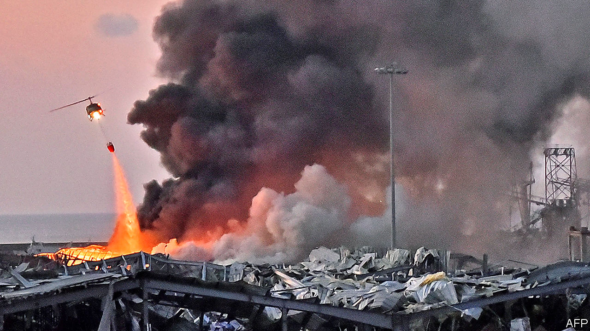

SO POWERFUL WAS the explosion that rocked Beirut on August 4th that people in Cyprus, 240km (150 miles) away, thought they had suffered an earthquake. Scores of people died and thousands were injured in the blast, which left the port in ruins. The Lebanese government says it was caused by 2,750 tonnes of ammonium nitrate, which can be used as fertiliser or as an explosive (see article). This appears to have been confiscated years ago from an abandoned Russian-owned cargo ship heading to Mozambique. Customs officials proposed exporting the stuff, giving it to the army or selling it to an explosives company—but they needed the judiciary’s approval. Their repeated requests were met with silence. So the material sat in a warehouse at the port.

What kind of government leaves a mountain of explosive chemicals lying around unsafely for the better part of a decade? The same kind that cannot agree on a budget for 11 years and that let its central bank run a Ponzi scheme to defend its unrealistic currency peg. The kind which is so deluded that it relies on aid, loans and remittances, spending far more than it collects in taxes. The kind that is controlled by an out-of-touch elite who fiddle and extort while the economy burns. In short, it is the government of Lebanon—and it is in desperate need of reform.

That much was clear even before the explosion showered Beirut with broken glass and pieces of rubble. For months Lebanon has been mired in a debilitating economic crisis, because of a rotten banking sector and a collapsing currency. The Lebanese pound has lost about 80% of its value on the black market against the dollar. Because Lebanon imports so much, inflation has spiked. The government defaulted on its debts months ago. The economy was weak before covid-19 forced politicians to lock down the country for two months earlier this year. Now it is in a coma. The poverty rate is expected to rise from 45% in 2019 to more than 75% by the end of this year. Many businesses have gone bust. Those that reopened had to close again recently because of a new surge of infections.

Without answers, the government asked the IMF for help. The fund wants a modest show of good faith, such as a new law on capital controls or a reform of the loss-making electricity industry. But Lebanese officials cannot even agree on the severity of the crisis. They have spent weeks bickering over how to estimate the losses racked up by the central bank. IMF officials have looked on with dismay. Even some in the government have had enough. On August 3rd the foreign minister quit, saying that Lebanon risks becoming a failed state. “I participated in this government on the basis that I have one employer named Lebanon,” Nassif Hitti wrote in his resignation letter, “and I found in my country many employers and conflicting interests.”

It is a new way of describing an old problem. For decades Lebanon has carved up political power among its religions and sects as a device for keeping the peace between them. Though designed to ensure that all Lebanese have a say in government, the system has been captured by an entrenched elite. This elite hands out government jobs based on sect. With power guaranteed, it can plunder ministries. The waste associated with its patronage schemes costs Lebanon 9% of GDP each year, says the World Bank. Corruption is rife. Residents of Beirut note that the explosion occurred in the city’s port, known locally as the “cave of Ali Baba and the 40 thieves”, owing to allegations of theft, bribery and embezzlement at the government-owned facility.

Most Lebanese want to ditch the power-sharing system. Ever fewer feel defined by their religion. (A growing number are not devout at all.) Big protests in October forced out the previous government, which was also incompetent. The current one entered office promising change, but has accomplished little.

That is, in part, because interests stand in the way. The warlords who wrecked Lebanon in the civil war are now the politicians who steal from it. Groups such as Hizbullah, a Shia militia-cum-political party, face few constraints. Foreign powers, such as Iran, which backs Hizbullah, and Saudi Arabia, which backs the Sunni elite, would surely try to scuttle reforms that diminished their clients or benefited their rivals.

They all play on fears of a sectarian power-struggle that might leave some groups worse off—or sink the country back into violence. The magnitude of the explosion at the port called to mind the massive car-bomb that killed the prime minister, Rafik Hariri, a Sunni, in 2005. A UN-backed court is due to deliver a verdict later this month in the case of four Hizbullah members accused of his assassination.

There was a time when such fears seemed like a good reason to move slowly in unpicking the power-sharing system. But those in power are using the crisis to hook more of their followers on the handouts they provide. And the cost of moving slowly is increasingly clear. It was not fighting or foreign occupation that led to the destruction of a large part of Beirut. It was incompetence by a corrupt and broken state. Only bold action will fix it. The government should do away with the power-sharing system sooner rather than later, and replace it with something more democratic and meritocratic. ■

This article was downloaded by calibre from <https://www.economist.com/leaders/2020/08/08/a-big-blast-should-lead-to-big-change-in-lebanon>

|  |  |  |  |
| --- | --- | --- | --- |
| Previous | Articles | Sections | Next |

|  |  |  |  |
| --- | --- | --- | --- |
| Previous | Articles | Sections | Next |

#### Trumpian TikTok

# Forced sales are the wrong way to deal with Chinese tech

America needs to sort out its own data-privacy regime

Aug 5th 2020 |

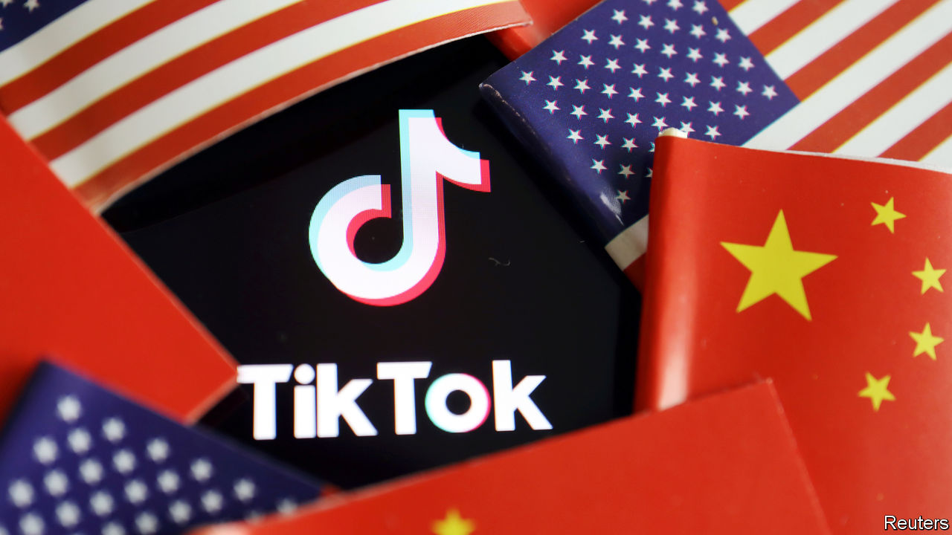

IN DECEMBER 2017 a Chinese technology firm called ByteDance bought Musical.ly, an app which let its young users dance and lip-sync to music videos. This did not, at the time, look like a recipe for geopolitical strife. ByteDance merged Musical.ly with a similar app called TikTok, which started growing at a blistering pace. Today TikTok has 100m users in America, and competes with Facebook and Snap. With growing popularity has come growing scrutiny, as Sino-American tensions spread from trade to tech, and a barrage of invective from President Donald Trump. This looks set to culminate in a forced sale of TikTok’s American business to a domestic buyer. Touted as vital to protect Americans’ data, the crackdown is in fact a depressing example of jingoistic opportunism, more likely to chill investment in America and stoke Chinese nationalism.

The legal basis for TikTok’s divestment comes from the Committee on Foreign Investment in the United States (CFIUS), which this week ruled that the Musical.ly deal was against America’s national-security interests. Having flirted with banning TikTok altogether, Mr Trump now seems willing to accept a fire-sale. Microsoft, an American software giant, is in talks to buy TikTok’s American operations, as well as those in New Zealand, Australia and Canada (see article).

ByteDance is the latest in a series of Chinese firms, among them Huawei, a telecoms-equipment provider, to be targeted by the Trump administration amid fears of cyber-spying and propaganda-peddling. It claims—without providing evidence—that the firms are, or could be, used to pass Americans’ personal data to the Chinese government. ByteDance will not be the last in the crosshairs. Lenovo, a partly state-owned Chinese firm, sells lots of computers in America. Tencent, a social-media giant, owns large stakes in video-game studios with millions of American users. On August 2nd Mike Pompeo, the secretary of state, suggested that America may take action against not only TikTok but also Tencent’s WeChat app and “countless more” Chinese firms “feeding data directly to...their national security apparatus”.

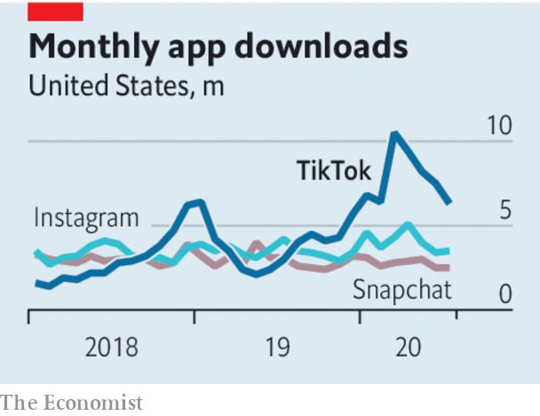

The data threat from China is real. But nationalist whack-a-mole, backed up with knee-jerk threats of expropriation, is no way to respond. The apparent detachment from any rules or procedure undermines investor confidence in America and heaps political pressure on technocratic bodies like CFIUS, which ought to consider cases based on their merits.

America would do better to strengthen the process of vetting foreign tech investments, and to get its own data privacy in order. CFIUS probes need to conclude more promptly; taking two years to start investigating the Musical.ly deal practically guaranteed a chaotic unwinding. And the committee’s political independence also needs bolstering. Mr Trump is watching over TikTok’s talks with Microsoft as if he were a feudal lord. He has even suggested that the Treasury should get a cut for making the deal possible, a demand with no precedent.

The Trump administration should tighten privacy law. America has until recently been relaxed about protecting its citizens’ data, and hostile to cyber-security concepts like encryption. A new federal data-privacy and cyber-security law would create transparent standards for handling Americans’ data and stymie foreign hackers. The government must also find a way to assure the quality of digital products containing opaque algorithms, which should apply to all firms, wherever they are based. Bills that do so have long been languishing in Congress. The Trump White House has made little effort to revive them.

The tension between maintaining global trade and rightful mistrust of the Chinese government is inevitable. Digital technologies, whose connected nature opens up all kinds of hypothetical meddling, are particularly tricky. But rushed asset sales at the barrel of a gun are not the answer. America needs a response that is less arbitrary and counter-productive.■

This article was downloaded by calibre from <https://www.economist.com/leaders/2020/08/05/forced-sales-are-the-wrong-way-to-deal-with-chinese-tech>

|  |  |  |  |
| --- | --- | --- | --- |
| Previous | Articles | Sections | Next |

|  |  |  |  |
| --- | --- | --- | --- |
| Previous | Articles | Sections | Next |

#### A bigger dose

# The world is spending nowhere near enough on a coronavirus vaccine

Far better to spend far too much

Aug 8th 2020 |

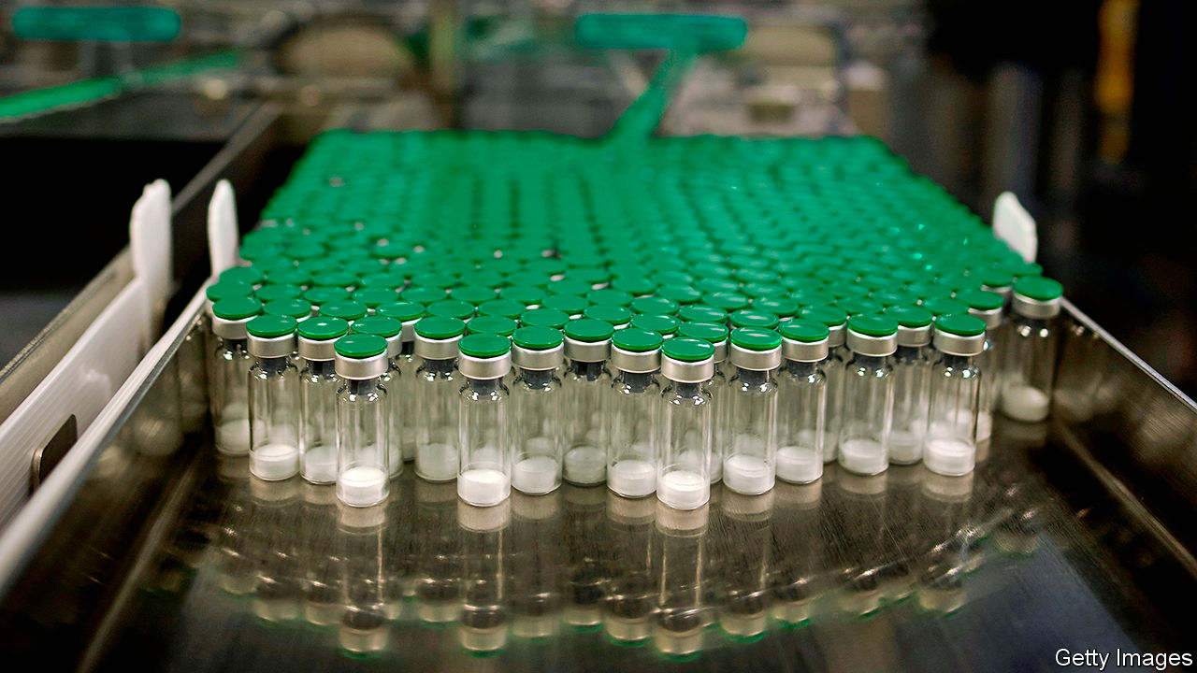

Editor’s note: Some of our covid-19 coverage is free for readers of The Economist Today, our daily [newsletter](https://my.economist.com/user#newsletter). For more stories and our pandemic tracker, see our [hub](https://www.economist.com/news/2020/03/11/the-economists-coverage-of-the-coronavirus)

CONSIDER THE following thought experiment. If you fail to eat a pizza within an hour, you will die from hunger. What do you do? Most people would immediately order a pizza—and not just one Margherita, but lots of them, from several different parlours. In order to maximise the chances that at least one pizzeria got you what you needed in time, you would not care that some of the pizza would be sure to go to waste.

The world is hungry for a vaccine against covid-19. So far about 700,000 deaths have been recorded from the disease, and the total is increasing at a rate of roughly 40,000 a week. If you also include unrecorded deaths, the actual numbers are much higher. Meanwhile, the global economy is experiencing its sharpest contraction since the Great Depression, of perhaps 8% of GDP in the first half of 2020.

In the face of this catastrophe, scientists look likely to produce a vaccine much faster than almost anyone could have predicted at the start of the pandemic. Yet global efforts to manufacture and distribute vaccines do not measure up. A mere $10bn or so has been devoted to the cause—the equivalent of ordering one pizza, rather than the several that are needed.

The figures are murky, but on a rough estimate the world has bought about 4bn doses of covid-19 vaccines for delivery by the end of next year, which is in theory enough to give half the planet one dose. In practice, however, far fewer people will secure protection from the disease. Some of the vaccines in production will fail to get regulatory approval, and a potential candidate that reaches a large-scale clinical trial—as several have—still has a 20% chance of failure. Others will be approved but may not provide full protection. They may not be suited to the elderly, for instance, or they may stop people dying from covid-19 but not from passing it to others. Other vaccines will require more than one dose in order to be effective. Because of these contingencies, even those countries, such as Britain and America, that have bought more than two doses for each of their citizens have still not bought enough.

Instead of seeing unproven vaccines as an extravagance, the world needs to think of them as an insurance policy. Research suggests that if ten or more vaccines are in development, there is a 90% chance of finding one which works. Once one of these candidates proves to be effective, billions of doses will need to be distributed quickly. But it is impossible to know in advance which candidate will succeed. Governments should therefore help pharmaceutical firms produce vast quantities of a range of different vaccines—ideally, numbering tens of billions of doses in all—long before regulatory approval is or is not granted. The winning vaccine could thus start to get to people quickly, even as doses of failed vaccines might be thrown away unused.

That may seem deliberately and needlessly lavish. Yet even boosting vaccine funding tenfold to $100bn or more, in line with the most ambitious proposals, pales in comparison with the $7trn which governments across the world have spent or pledged since the pandemic began in order to preserve incomes and jobs. The real extravagance would be to wait until a successful vaccine candidate emerges before rushing to boost production. In terms of the economic output that is saved, to say nothing of lives, it would make sense for the world to spend as much as $200bn on bringing forward an effective covid-19 vaccine by just one week.

For some, the prospect of such a heavy investment raises fears of “vaccine nationalism”, in which rich countries outspend poor ones in an attempt to corner the market for their citizens. The world as a whole can wring the most benefit out of limited supplies of vaccine by pooling resources and allocating doses on the basis of need—health-care workers first, vulnerable people next, and so forth. Around 80 countries are interested in such a deal. Unfortunately, however, politicians in some countries with manufacturing capacity are likely to put their own people first. One way to minimise the international scramble over who gets vaccines and when is to maximise supplies up front and to spread manufacturing capacity. Vaccines for the poorest countries would need to be subsidised, perhaps through GAVI, the alliance that already pays for other vaccines there.

The idea of deliberately overproducing something does not sit easily with politicians, especially in a world where there are so many claims on public funds. Faced with a large manufacturing capacity that turns out to be useless, politicians risk being accused of having wasted money—as the British government was when the emergency hospitals it had built early in the pandemic were not needed. Yet politicians must be rational. You buy insurance before you know what will happen, not after. ■

This article was downloaded by calibre from <https://www.economist.com/leaders/2020/08/08/the-world-is-spending-nowhere-near-enough-on-a-coronavirus-vaccine>

|  |  |  |  |
| --- | --- | --- | --- |
| Previous | Articles | Sections | Next |

|  |  |  |  |
| --- | --- | --- | --- |
| Previous | Articles | Sections | Next |

#### The globalisation of gay rights

# As more gay people come out, tolerance will spread

Though in some countries to be open is still to risk death

Aug 8th 2020 |

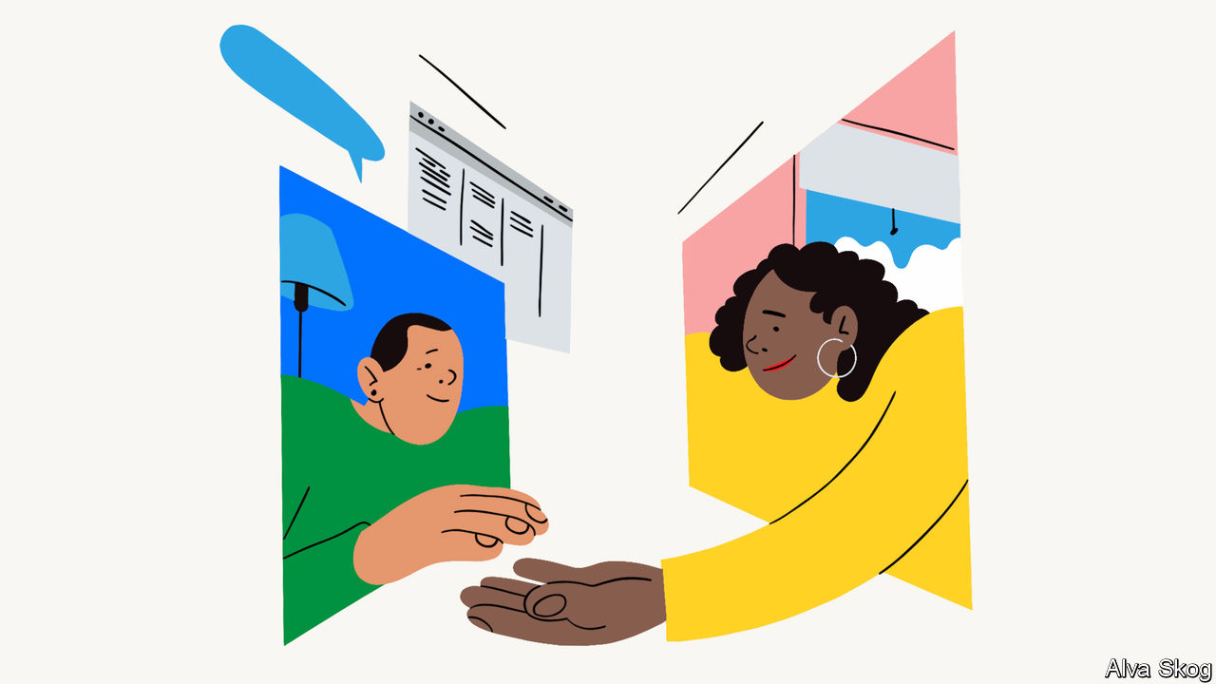

PHILIP LARKIN was only half-wrong. Sex didn’t begin in 1963, as the poet joked; for a hefty minority of Britons it was four years later—legally, at least—when Parliament nixed the law prohibiting gay sex. In this age of rainbow flags and pride parades, it is easy to forget how few lesbians and gays could be open about their sexuality until relatively recently. One who was, the journalist Peter Wildeblood, was “no more proud of my condition than I would be of having a glass eye or a hare lip”. Two years after decriminalisation in England and Wales, the Stonewall riots in New York popularised a term for this: coming out.

Since then, the closet has burst open. Actors and the characters they play are openly gay. Leo Varadkar, prime minister of Ireland until June, has a male partner; Serbia’s prime minister is a lesbian, as are the mayors of Chicago and Bogotá, the Colombian capital. Yet coming out remains a pivotal moment of self-recognition for gay teenagers. Thanks to the internet, they are finding the means and the confidence to do so in more places than ever before, and at a younger age than in previous generations (see article).

Yet there are plenty of places where being gay remains taboo. Even in liberal countries, gay members of some religious and ethnic minorities have a tough time. Gay sex is still illegal in 68 countries, and punishable by death in a dozen. Lesbian, gay, bisexual and transgender (LGBT) folk are subject to extra-judicial violence in many places, from beatings in bars to the gang-rape of lesbians by men who imagine that this might, as they see it, “cure” their sinful orientation. It would be reckless to encourage people to come out where to do so is to court injury or death. In all but the most repressive places, though, people are opening up. The International Lesbian, Gay, Bisexual, Trans and Intersex Association, a lobby group, has members in 164 countries. Pride parades march in China, Paraguay and the Faroe Islands.

Urbanisation helps. In big cities, every tribe has its place. You can play bingo with drag queens in Moscow, dance in gay bars in Nairobi (where gay sex is still illegal) and use gay hook-up apps in Beijing (where until 1997 gay people were jailed for “hooliganism”). Even in remote places, smartphones help teenagers discover that they are not alone. And that knowledge gives more of them the courage to come out. In 1985 barely a fifth of Americans had an openly gay relative, friend or colleague. Now 87% say they know someone gay or lesbian.

LGBT people coming out brings the extra advantage of spreading tolerance. Not always, of course. But sceptics and bigots are likeliest to change their minds when they realise that someone they know is gay. Familiarity reveals that homosexuals are just as human—and humdrum—as heterosexuals. It is easy to demonise the imaginary gay people depicted in a brimstone sermon; but much harder to fear the lesbian actuaries next door, or the gay dads cheering their daughter’s softball team. Pride parades, with their loud floats and copious flesh, are lots of fun. But learning that a sober-suited colleague happens to be gay is more likely to win over a conservative. One of the founders of Stonewall, a British gay-rights charity, said the name initially helped secure meetings with government ministers. To gays, it meant a riot; to the uninformed, it sounded like a firm of architects.

In 2002 about half of Americans said they tolerated homosexuality; now nearly three-quarters do. One study found that support for same-sex marriage increased rapidly in 2006-10 among Americans with a gay or lesbian friend, but fell among those with none. Even in countries where a majority remains hostile, change is coming. The proportion of Indians who said that gay people should be accepted rose from 15% in 2013 to 37% last year. Though an attempt to overturn Kenya’s gay-sex ban failed last year, the publicity it generated persuaded more locals to come out. That helps explain why over the same period the share of Kenyans who tolerate homosexuality nearly doubled, to 14%. In most places the young are more gay-friendly than the old, so discrimination will surely dwindle as the prejudiced pass away.

From Iran to Uganda, autocrats often caricature homosexuality as a foreign vice. Some even claim that there are no gay people in their country. In such places the most effective campaigners are, therefore, local gay people. The best thing liberals elsewhere can do is to provide financial and legal support to gay-rights groups and grant asylum to those who flee persecution.

## Got to let it show

Mr Wildeblood’s motivation for writing a book in 1955 in which he baldly stated “I am a homosexual” was, he said, “to turn on more lights, revealing, in place of the blurred and shadowy figure of the newspaper photographs, a man differing from other men only in one respect.” The rest of those lights are coming on, one by one. ■

This article was downloaded by calibre from <https://www.economist.com/leaders/2020/08/08/as-more-gay-people-come-out-tolerance-will-spread>

|  |  |  |  |
| --- | --- | --- | --- |
| Previous | Articles | Sections | Next |

|  |  |  |  |
| --- | --- | --- | --- |
| Previous | Articles | Sections | Next |

#### When the facts change

# Economics sometimes changes its mind

The science may be dismal but it is flexible, too

Aug 8th 2020 |

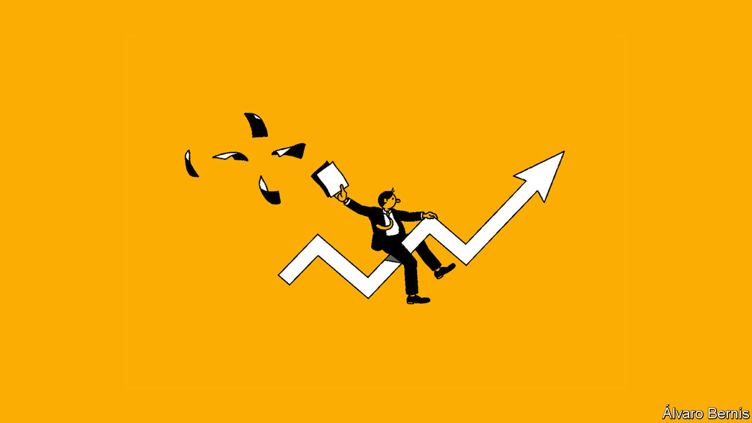

ECONOMICS IS A “disgrace”, according to Claudia Sahm, a former Federal Reserve researcher, who has chosen to “no longer identify” as an economist. Among several flaws, the profession fails to nurture the young, she argues, or listen to outsiders. A survey by the American Economic Association (AEA) found that only 31% of economists under the age of 44 felt valued within the discipline.

All this must be off-putting to youngsters beginning the long (and lengthening) journey into the profession (see [article](https://www.economist.com/node/21790460)). They may wonder if there is room for their ideas in a discipline that can seem hidebound, hierarchical and homogenous. Will they invigorate economics or will it indoctrinate them?

Budding economists can draw comfort from our series of six economics briefs that begins this week. Each looks at an issue (competition policy, minimum wages, inflation, the dollar, culture and public debt) that has prompted economists to revisit their field’s presumptions. Over the past decade or two, the profession has become more relaxed about minimum wages, inflation and public debt; less relaxed about monopoly power; less enamoured of flexible exchange rates; and more open to deep, institutional explanations of wealth and poverty.

What does it take to change economists’ minds? New ideas are not enough. The theory of monopsony, which explains why a minimum wage may help employment, not hurt it, had been around for at least 60 years before mainstream economics accepted its use in many low-wage labour markets. Recent nonchalance about high levels of public debt may seem new and mould-breaking. But the fresh thinking rests on theories set out in the 1950s and 1960s.

New facts are more compelling. The persistence of low interest rates despite high public debt has left an impression, as has the pre-pandemic combination of low inflation and low unemployment. The dollar’s rally in the global financial crisis showcased its peculiar role in the international financial system, as have various emerging-market tantrums since. Fresh evidence also matters in microeconomics. New Jersey’s decision to raise its wage floor in 1992 by more than neighbouring states (despite tipping into a recession) provided the natural experiment required to change economists’ minds about minimum wages.

New facts, then, are more persuasive than new ideas. But although an alternative theory is not a sufficient condition for a change of heart, it is often necessary. It takes a model to beat a model, as economists like to say. They sometimes cling to propositions in defiance of the facts simply because they have nothing better to replace them with.

That raises a third condition for persuasiveness. To convert economists to your cause, it is not enough to give them something new to believe. You must also offer them something fruitful to do. Appeal to their hands as well as their heads. Economists will jump on a revolution that gives them new toys or techniques to play with. This may explain why they have become more enthusiastic about institutional explanations of the wealth and poverty of nations. They cannot rerun history or sprinkle institutions randomly across countries to test their long-term effects. But they have found ingenious proxies for this kind of random variation. Economists, like many others, relish the chance to display their cleverness.

New facts and clever techniques help shift economic opinion. Does this also require new economists? Not necessarily. Some big names have changed their minds, or at least their tone. Olivier Blanchard is less fiscally cautious today than he was ten years ago as IMF chief economist, and Narayana Kocherlakota is much more doveish about monetary policy than when he was first appointed to head a Federal Reserve bank. The heretical tribes on the fringes of economics yearn to sack Rome. But it is more efficient to convert the emperor.

It is nonetheless striking that, in several of the areas covered by our series, vital work was done by economists who were in their 30s at the time (although all of them were already at elite institutions). According to the AEA’s survey, only 5% of economists aged under 44 feel they have a great deal of power within the discipline. But the young may have one power denied to their elders: the freedom to imagine a future economics, unencumbered by too heavy an intellectual stake in its past. ■

This article was downloaded by calibre from <https://www.economist.com/leaders/2020/08/08/economics-sometimes-changes-its-mind>

|  |  |  |  |
| --- | --- | --- | --- |
| Previous | Articles | Sections | Next |

|  |  |  |
| --- | --- | --- |
| Leaders | Sections | Briefing |

Letters

Letters to the editor: On reopening schools, oil, French accents, Amazon, sports teams

.

|  |  |  |
| --- | --- | --- |
| Leaders | Sections | Briefing |

|  |  |  |  |
| --- | --- | --- | --- |
|  | Articles | Sections | Next |

#### On reopening schools, oil, French accents, Amazon, sports teams

# Letters to the editor

A selection of correspondence

Aug 8th 2020 |

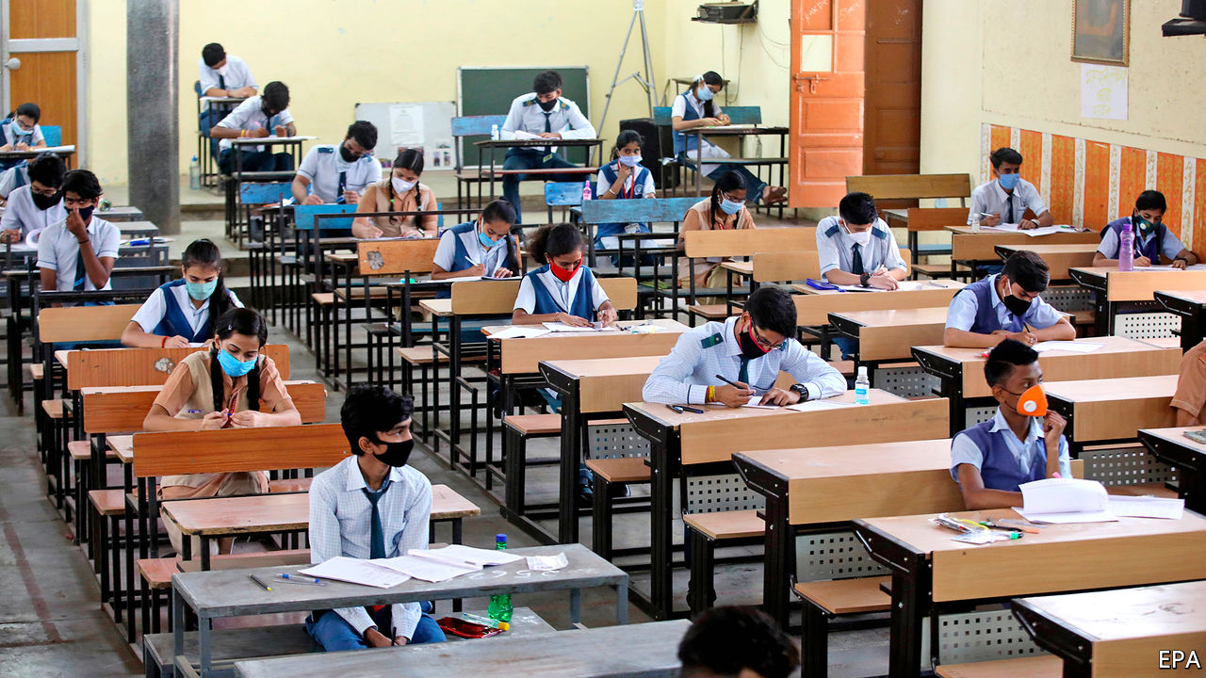

## School’s out for autumn?

Your leader calling for schools to reopen presented a straw-man argument when it described teachers as “obstructive” (“Let them learn”, [July 18th](https://www.economist.com/leaders/2020/07/18/the-risks-of-keeping-schools-closed-far-outweigh-the-benefits)). I am a high-school teacher just north of New York City. All my colleagues desperately want to be in school full-time come September. But the federal government has offered not one scintilla of advice or assistance on how to go about opening schools safely.

You also made an insulting insinuation about teachers being paid whether they work or not. That is silly. There is nothing I would want more professionally than to be in school. Teaching online is difficult, time-consuming and largely unrewarding, compared with teaching children in person. I don’t know anyone who prefers the former.

However, we simply do not want to rush back at the risk of our own health as well as the public’s. The evidence about young people and covid-19 is by no means clear. It seems that young adults have a much lower chance of getting seriously ill if they catch the virus. It is not at all certain that they cannot spread the disease, particularly high-school-aged students. Younger people contracted the virus at higher levels during the recent spike in America than earlier in the outbreak. Put hundreds of these young adults in closed classrooms with older teachers who then go home to their families and you may have a recipe for disaster.

LARRY FATA  
New York

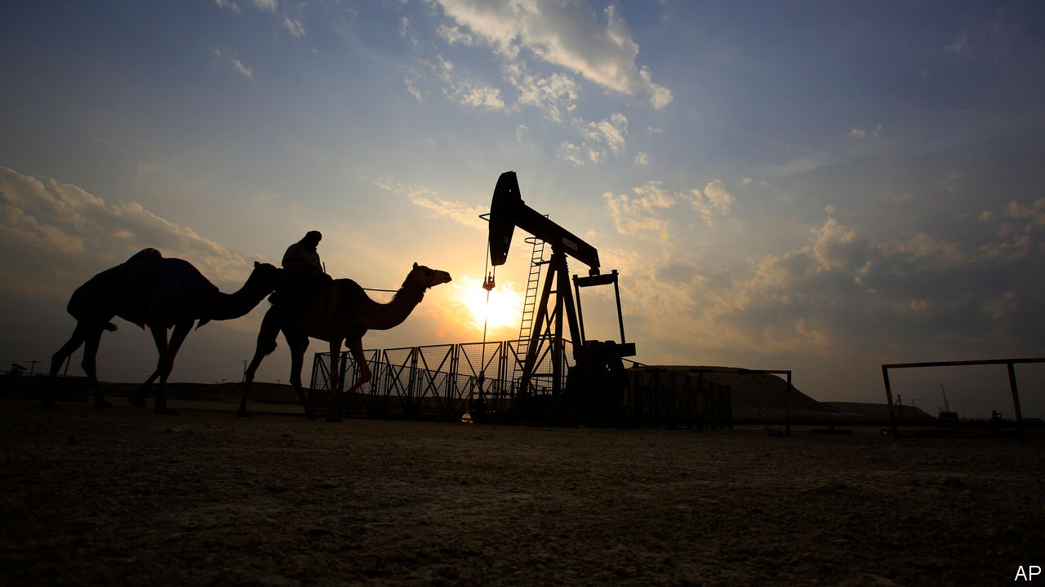

## Oil futures

I was intrigued by your leader about the future of Arab petrostates, and how they will soon no longer be able to “afford to buy loyalty with do-nothing public-sector jobs and free services” as the price of oil presumably falls and demand fails to recover (“There will be pain”, [July 18th](https://www.economist.com/leaders/2020/07/18/with-oil-cheap-arab-states-cannot-balance-their-books)).

Might I remind you of a similar prediction you made two decades ago, which anticipated that new advances in technology such as hydrogen fuel cells and bioethanol would help wean the world off oil (“The end of the Oil Age”, [October 25th 2003](https://www.economist.com/leaders/2003/10/23/the-end-of-the-oil-age)). Seventeen years later, bioethanol is long forgotten and hydrogen fuel cells can only be found in some cities’ buses.

If I were an Arab leader sitting in my $300m yacht looking at my da Vinci painting, you would forgive me if I took your conjectures with a grain of salt and did not put my precious painting up for sale just yet. I would however not stop reading The Economist. Your prognosis regarding the decreasing clout of OPEC has certainly come true.

YASIN MAND  
London

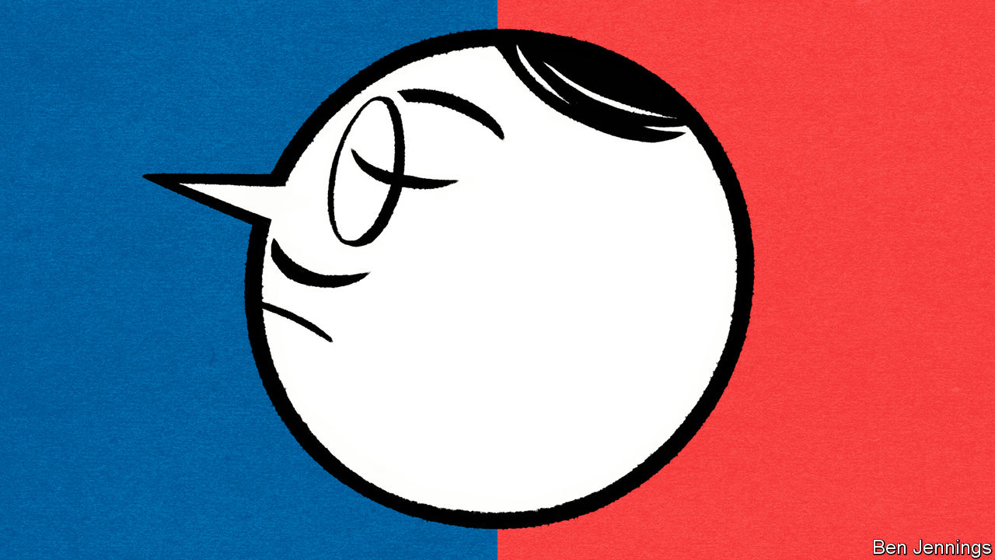

## Elocution lessons

Parisians might overcome their snobbery against regional accents following the appointment of Jean Castex as prime minister, you say (“Accent grave”, [July 18th](https://www.economist.com/europe/2020/07/18/parisian-snobbery-towards-regional-french-accents-persists)). That is overly optimistic. Paris has form when it comes to the marginalisation of speakers whose French is far removed from an idealised standard norm.

In 1635 the founding members of the Académie Française, France’s central language authority, declared that its principle function was to impose the language of the royal court on the rest of France. Today, examples abound of public figures still validating this bias. Look no further than footage of Jean-Luc Mélenchon mocking a southern French-speaking journalist rather than answer her awkward questions, or television presenters deriding Marie-Arlette Carlotti, a former minister, for shifting between southerly accented speech for her local audience, and a more standard accented speech for a national one.

In each case, there is adherence to the reproduction of a standard-language ideology. Pierre Bourdieu, who, like Mr Castex, was also from an Occitan-speaking family in the Gascon region, argued that the French elite is raised with the social capital necessary to exert power, and that language is central to this endeavour. French speakers who do not have such linguistic capital are reminded of their position in the social hierarchy whenever they turn on the television.

You suggested that a popular backlash against globalising elites might mean a bright future for non-Parisian types. Regrettably this isn’t supported by the evidence.

JONATHAN KASSTAN  
Lecturer in French and linguistics  
University of Westminster  
London

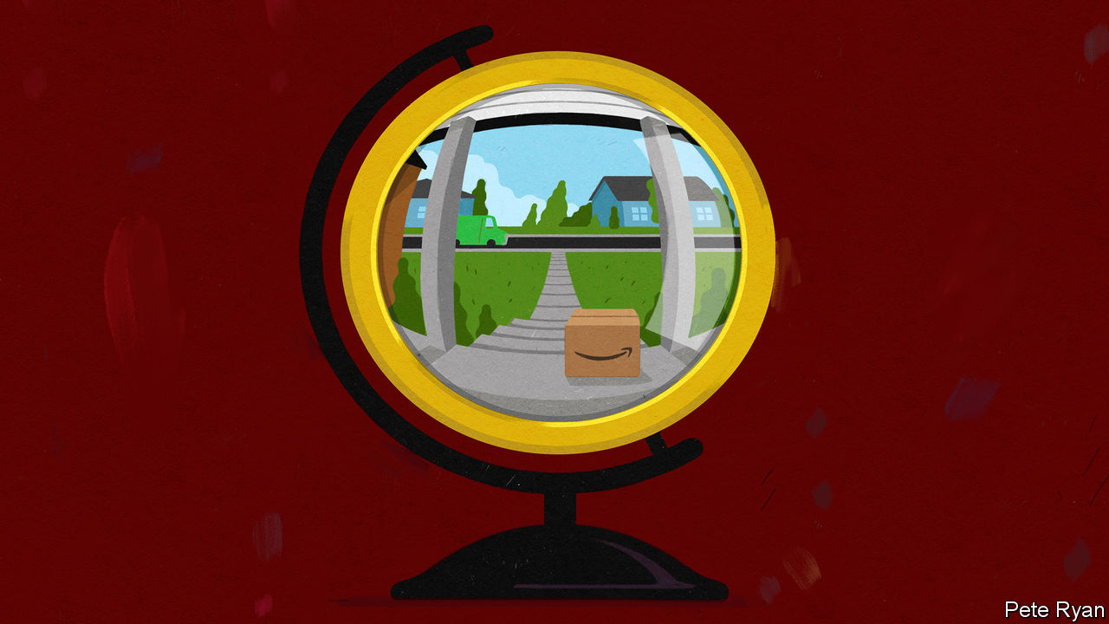

## Amazon in Europe

An important underlying assumption in your briefing on Amazon is that it is doing well in Europe (“And on the second day ...”, [June 20th](https://www.economist.com/briefing/2020/06/18/can-amazon-keep-growing-like-a-youthful-startup)). Where is the evidence? Amazon, as far as I am aware, has never included any profit or sales figures for its European retail operations in its statutory filings in America. It merely aggregates all revenue, including Amazon Web Services, from Europe.

Audited profit data is openly filed in London for Amazon EU SARL, based in Luxembourg, which appears to be more or less retail only, and is published only about eight months after Amazon’s annual accounts in the United States are filed. The latest numbers are for 2018 and show a loss of €259m ($300m), admittedly a significant improvement on the €876m it lost in 2017.

This is crucial. The claim that “No firm bestrides the physical and digital worlds in the way Amazon does” is difficult to make if it turns out, as I believe is the case, that after 25 years, Amazon has never managed to make money from retailing outside its home country. And possibly Canada.

MIKE FLANAGAN  
Charlbury, Oxfordshire

Where the Industrial Revolution saw people leaving the manual looms in their cottages to operate power looms in factories, the Distributional Revolution is causing workers who would have been employed in local stores to move to warehouses to pick orders. In both cases, the economic advantages are not without their social ramifications.

STEVE CULLEN  
Medfield, Massachusetts

I would not describe the logo on Amazon’s brown packages left at our homes as “smiling”. I would suggest “smirking”.

MARGARET CATING  
Londonderry, Vermont



## Leagues apart on team names

Johnson’s musings about the media’s reluctance to mention unmentionable words ([July 11th](https://www.economist.com/books-and-arts/2020/07/09/papers-should-print-offensive-language-if-it-is-crucial-to-a-story)) reminded me of a recent radio news item from CBC, Canada’s national broadcaster, on the pressure put on football teams in Washington and Edmonton to change their names. The report never mentioned the offensive names in question, the Redskins and Eskimos, leaving listeners wondering what the names were, and marvelling at a news piece that managed not to broach the core of its subject.

BOB MARTIN  
Halifax, Canada



Regarding the name of Cleveland’s baseball team (“Skin in the name”, [July 18th](https://www.economist.com/united-states/2020/07/18/renaming-the-washington-redskins)), the term “Indians” was proposed in 1915 to honour Louis Sockalexis, a Native American of the Penobscot nation, who was a star player for the Cleveland Spiders in the late 19th century. The interim team name “Naps” honoured Napoleon Lajoie, a star player a few years later. It had nothing to do with sleep, though the team’s performance during the ensuing century has unfortunately often been a cause of somnolence.

JOHN JAY  
Venice, Florida

This article was downloaded by calibre from <https://www.economist.com/letters/2020/08/08/letters-to-the-editor>

|  |  |  |  |
| --- | --- | --- | --- |
|  | Articles | Sections | Next |

|  |  |  |
| --- | --- | --- |
| Letters | Sections | United States |

Briefing

Covid-19 and college: Uncanny University

.

|  |  |  |
| --- | --- | --- |
| Letters | Sections | United States |

|  |  |  |  |
| --- | --- | --- | --- |
|  | Articles | Sections | Next |

#### Uncanny University

# Covid-19 could push some universities over the brink

Higher education was in trouble even before the pandemic

Aug 8th 2020 |

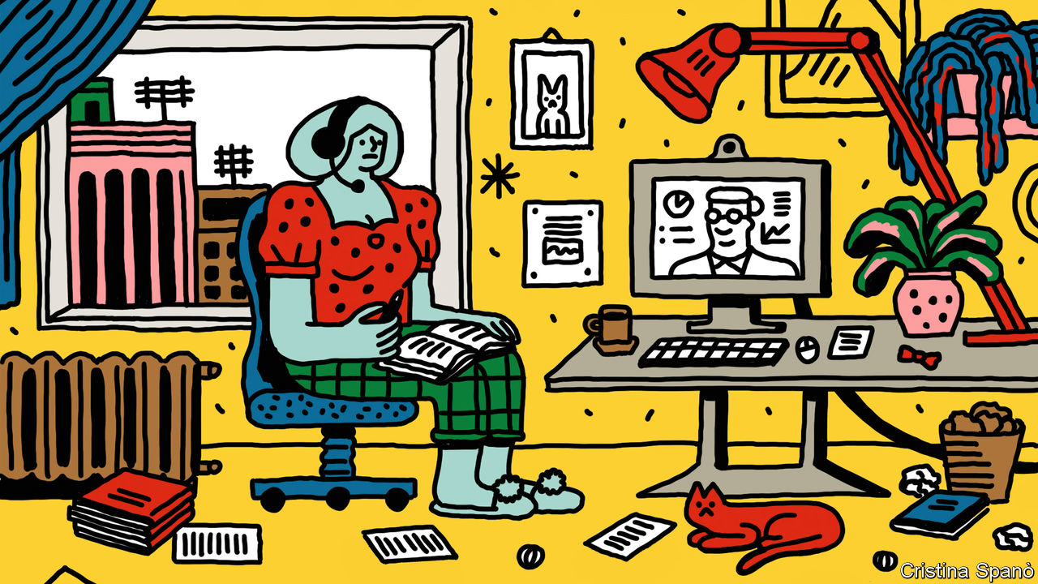

Editor’s note: Some of our covid-19 coverage is free for readers of The Economist Today, our daily [newsletter](https://my.economist.com/user#newsletter). For more stories and our pandemic tracker, see our [hub](https://www.economist.com/news/2020/03/11/the-economists-coverage-of-the-coronavirus)

DUE TO BE completed in 2022, Boston University’s $141m data-sciences centre will tower over the city like an uneven Jenga tower, providing 350,000 square feet of space. The University of Reading in Britain has nearly finished a £50m ($65m) life-sciences building, designed to make more space for subjects that are attracting lots of students. The University of New South Wales (UNSW) in Australia has pumped more than A$500m ($360m) into new facilities, as part of a project intended to push it into the top 50 of global rankings.

If these plans made sense in a world where students were crossing borders in droves, today they seem barmy. All three institutions are now considering cuts. Boston has said that it is likely some staff will have to be laid off or furloughed. Reading has announced that 15% of full-time jobs at the university are on the line. UNSW has already cut 8% of its staff and closed two of its eight faculties. At all three universities plans for new facilities are on hold.

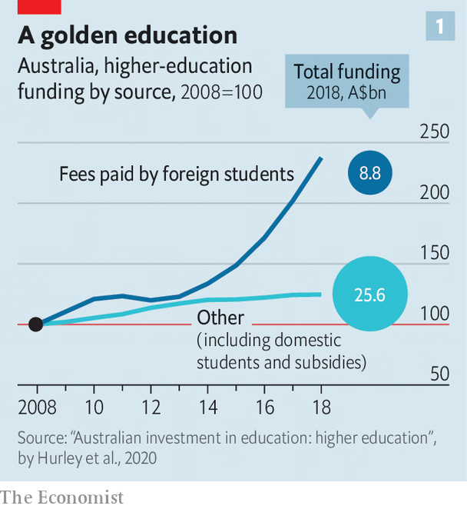

Covid-19 has put immense pressure on all universities. But the problems are about to get particularly severe for those in America, Australia, Canada and Britain that have come to rely on international students to fill their coffers. There are now more than 5m such students, up from 2m in 2000. In Australia foreign students provide a quarter of universities’ income (see chart 1). In Canada the tuition fees for a science degree at McGill, one of the country’s top universities, cost C$45,656 ($34,000) a year for an overseas student, compared with C$2,623 for a local.

Even before the pandemic, many such universities worried about worsening relations with China, the biggest source of international students. And higher education in America, Australia and Britain has also faced increasing scepticism from conservative-leaning governments about the value of a university degree. Academics, used to tricky questions, now face an existential one: how will universities survive with many fewer students in them?

The problem is that campuses make an excellent breeding ground for the virus, and students travelling across the world are a good way to spread it. A study by researchers at Cornell found that, although the average student at the university shares classes with just 4% of their peers, they share a class with someone who shares a class with 87%. The potential for the rapid spread of the disease was shown by the arrival of recruits at Fort Benning, an American army base. When 640 arrived in spring, just four tested positive. A few weeks later, more than a hundred did. According to the New York Times, some 6,600 covid-19 cases can be linked to American colleges.

## Welcome to the virtual freshers’ week

Many lecturers are understandably reluctant to get close to students. In July a letter from the provost of the University of Colorado Boulder, seen by The Economist, put pressure on staff to teach in person, warning that not doing so “simply deflects the burden of this vital mode of instruction onto fellow faculty members”. Indeed, at the end of the 2019-20 academic year most American colleges planned to open for in-person teaching. Now they are not so sure. According to data collected by the College Crisis Initiative at Davidson College, less than a quarter of universities will teach fully or mostly in person next term (another quarter have yet to decide what to do).

Even if professors turn up in person, many students will not. Harshita Bhatia, a 24-year-old from Mumbai, was supposed to start a masters in economics at the Australian National University in July. She has deferred it until February, not wanting to miss out on the full experience of university life in another country. Polling by QS, a consultancy, suggests that four in ten students may cancel or defer their plans to study overseas. More will do so if tuition goes online. In Australia visa applications from students are down by a third this year.

Strict regimes are emerging at the places which are welcoming students. At Harvard, where 13% of last year’s intake came from overseas, only 40% of undergraduates will return for the first term of the new year, with the rest continuing to learn from afar. Those on campus will be tested for the virus every three days and sign contracts promising not to have guests in their dorms. The University of Bolton, in northern England, is aiming to create a “covid-secure” campus, so that it can open in September. To get to classes students will have to pass through a body-temperature scanner, where they will be provided with masks and hand sanitiser. The university has bought 1,000 bikes to lend to students, so they do not have to take public transport.

## Viruses like company

The risk is that, beyond the lecture hall, youngsters will ignore many restrictions. In July the University of California, Berkeley reported an outbreak involving 47 covid-19 cases, with most traced to parties in the fraternities and sororities. At the time, administrators urged students to keep gatherings to below 12 people, to hold them outside, to stay at least six feet apart and to cover their faces; they have since announced that all classes will be online and only 3,200 of the university’s 40,000 students will be allowed to live on campus.

Even for students who do move into their dorms, a lot of teaching will be online. A video from Johns Hopkins University touts its new “on-campus studios” for lectures, the idea being that students can take part in lectures from the safety of their rooms. Such Zoom lectures may accelerate a long-running trend. Online-education providers, such as Coursera, have not revolutionised higher-education, as was routinely forecast at the start of the 2010s. But they have carved out a niche in the market, mostly offering business-focused classes to older students. Over the past five years or so a growing number of universities have begun to offer degrees online, sometimes in partnership with “online-programme managers”. In America an estimated one postgraduate in three was studying fully online last year, up from one in five in 2012.

This number now looks set to rise. In May Dan Tehan, the Australian education minister, offered funding for short online courses in topics that are judged to be “national priorities” like teaching and engineering that would run for six months, with fees ranging from A$1,250 to A$2,500. “We want to enable people, rather than bingeing on Netflix, to binge on studying,” he said. UNSW has announced plans to offer more remote courses. Tyler Cowen, an economist at George Mason University who runs his own education website, predicts a big increase in online learning.

Many students, however, prefer in-person teaching. Last year just one in seven American undergraduates pursued a degree online, estimates Richard Garrett of Eduventures, a consultancy. International students also tend to want “the cultural immersion” of another country, he says. Lots gravitate to big cities: in America, New York University is home to the most international students with 19,605; in Britain, University College London is, with 19,635. The experience of either city—with all the possibilities of exploration and romance which urban life brings, even under semi-lockdown—cannot be replicated through video calls in a parental living room.

The prospect now for international students is a far less appealing university experience—either wholly virtual or wholly surreal. Despite this, they will face little prospect of lower fees. The University of Adelaide is one of the few universities to have cut prices, offering students a 20% “Covid-19 Offshore Study Fee Rebate” so long as they confirm their place. Privately, administrators at British universities expect to make more use of discounts (sorry, “scholarships”) to entice foreign students, but they will try not to publicise that. Many universities argue that the education students receive will be just as good as it was before the pandemic. It remains to be seen how many students (and parents) will buy this. As a college counsellor working at a school in Xi’an in China asks: “Without the whole experience, why pay $50-60k for online courses you can get on Coursera?”

For those students not put off by these changes, other problems loom. The collapse of air travel means there may not be enough flights. Bolton is one of a number of British universities which is contemplating bringing students directly over from China and India. “We can charter a plane that will seat 300 people for around £300,000,” explains George Holmes, the vice-chancellor. Representatives would meet students in Delhi; on arrival, they would be whisked off to a hotel or halls to quarantine. The university would heavily subsidise the costs.

Indeed, entry restrictions currently prevent students from getting to lots of countries. Since February all Chinese visitors have been banned from entering Australia. Pilot programmes to fly in groups of a few hundred students were abandoned when the local case count rose. Currently Canada will not let in students who did not get a visa before March. Some Indian students are allowed into America, but Chinese ones are not. Both would be welcome in Britain, so long as they quarantined for a fortnight.

In July the Trump administration gave up on plans to rescind the visas of international students at universities that had moved to solely online teaching, after legal challenges from a number of universities, including Harvard and MIT. But later that month it announced first-year students will not be able to enter the country if they do not have in-person courses. Embassies and consulates have begun opening, but it is unclear whether they will be able to get through the visa backlog.

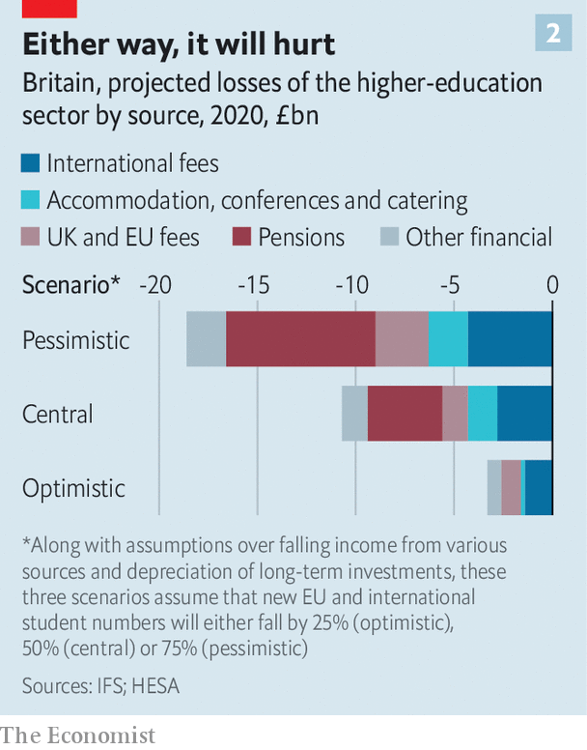

All this spells trouble. A report by the Institute for Fiscal Studies (IFS), a British think-tank, predicts that universities in that country will lose the equivalent of a quarter of their annual income, with high-ranking institutions suffering the greatest losses (see chart 2). Four leading Australian universities—UNSW, Sydney, Melbourne and Monash—receive more than a third of their income from foreign students. Across the world, it is prestigious universities that recruit the most globetrotters.

Some of these institutions are indeed in a risky situation. And yet, for the most part, elite universities are well placed to make it through the crisis thanks to hefty cash reserves and the ability to borrow on more generous terms. The very top tier are unlikely to struggle for students for long. “If you’re a prestigious institution, people are not going to turn down a hard-won opportunity to earn a diploma that has a lot of brand value, even if earning it turns out to be less fun and more inconvenient than they thought it would be,” thinks Kevin Carey of New America, a think-tank.

## Socially distant study buddies

Instead it is likely to be mid- and low-ranking universities that are most at risk, particularly those institutions with less prestigious brands that have nevertheless managed to attract lots of international students (or, in America, out-of-state ones, who also pay higher fees). The IFS reckons that the British universities most at risk of insolvency—of which it says there are 13, responsible for teaching 5% of British students—are those that entered the pandemic with weak finances. Of Australia’s top-ranking universities, only Monash is among the seven at “high risk” according to the Centre for the Study of Higher Education at the University of Melbourne.

The unequal effects of covid on university finances can be seen in the behaviour of American colleges. Over the past few months middling state universities and liberal-arts colleges have been far slower to announce reduced access to campuses so as not to put off potential students. Even before the crisis, a demographic dip in the number of 18-year-olds had caused around 50 colleges to close or merge. That is a small portion of America’s 4,000-odd higher-education institutions, but the trend is now likely to accelerate, as colleges lose out on money from accommodation and funding from state capitals.

Lobby groups everywhere have sought bail-outs. Universities Australia estimated that its members’ revenue would drop by A$3bn to A$4.6bn. British universities asked for a package of measures that would have come to £3.2bn; American colleges for around $50bn. Yet in all countries money has been limited. Congress gave American colleges around $14bn in March. In Britain some funding has been brought forward and loans will be on offer to cover 80% of lost income from international students, but only at research-focused universities. In Australia the government will stump up for income lost from domestic students, but not those from abroad.

Part of the reason for such reluctant bail-outs is that governments are waiting to see just how bad things get. But in an era when politics is increasingly divided along educational lines—between the have-degrees and the have-nots—universities appear to have little sway over politicians who see themselves as tribunes of the latter group. American universities are unlikely to receive much support from Donald Trump’s administration. President Trump has complained that colleges are focused on “Radical Left Indoctrination, not Education”, and has asked the Treasury to re-examine their tax-exempt status.

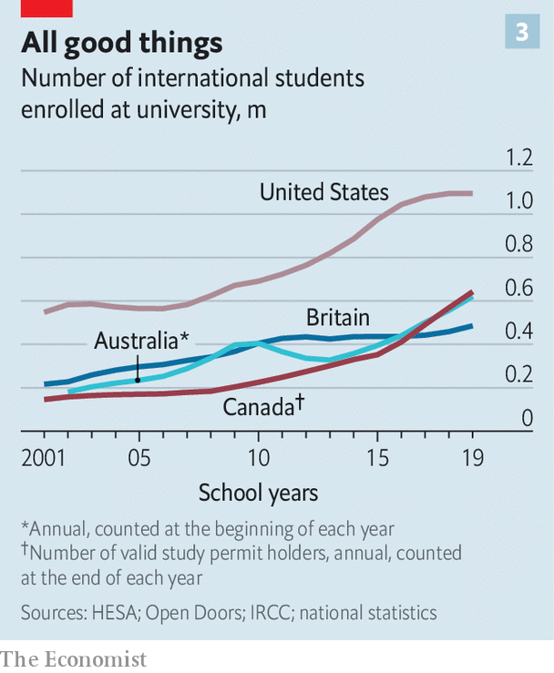

In other parts of the Anglosphere, governments want to make universities more focused on employment. As universities have grown, so too have doubts about the “return on investment”, says Peter Hurley of the Mitchell Institute at Victoria University. In Britain ministers are worried by research from the IFS which finds that a fifth of graduates would be better off had they not gone to university.

In both Australia and Britain governments have funded the expansion of higher education by passing more of the cost to students, via higher fees. But, since they also offer income-contingent loans, the state ends up footing a large part of the bill. In Britain the government has said that universities that get covid loans will need to focus more on subjects that either deliver high wages (such as engineering) or are judged to be particularly important to the country (such as teaching). Boris Johnson, the British prime minister, has also floated the possibility of introducing differential fees—at the moment the cost of all subjects is capped at £9,250—and has promised reforms to boost vocational education.

Mr Johnson has said he may follow Australia, where the government plans to more than double the cost of humanities courses while lowering fees for subjects it reckons are in areas of future employment growth or are otherwise important, including clinical psychology and agriculture. Yet some Australian higher-education experts doubt that the reforms will achieve their aims. Because students don’t pay up front for their degrees, instead receiving generous government loans, many suspect that altering the amount they pay for subjects won’t have much effect. The same would be true in England.



On top of this, all three governments have taken more hawkish stances towards China. Deteriorating relations between America and China over the past four years have contributed to a slowdown in the number of international students crossing the Pacific. Australian and British universities now worry they face the same fate. In June China’s Ministry of Education urged students to “exercise caution” before studying in Australia due to discrimination against those of Asian descent during the pandemic; something widely seen as a response to the Australian government’s decision to call for an inquiry into the origin of covid-19. Britain’s opposition to a new national-security law in Hong Kong has infuriated Beijing.

## Virtual versus vocational

Universities have a few reasons for hope. One is that prospective students do not have much else to do. “The gap year doesn’t look terribly attractive, the job market doesn’t look terribly enticing,” notes Matt Durnin of the British Council, which promotes the country’s education abroad. The other is that in a recession there is normally an uptick in the number of students.

Even so the next few months are likely to transform the fortunes of many institutions. Some will shut entirely. If the pandemic drags on, if a vaccine is not forthcoming or if the economic climate becomes particularly bad, then things will get bleaker still. Politicians will have bigger things to think about than protecting universities. The first two decades of the 21st century were ones of extraordinary growth for universities in many countries. That golden age is over. ■

This article was downloaded by calibre from <https://www.economist.com/briefing/2020/08/08/covid-19-could-push-some-universities-over-the-brink>

|  |  |  |  |
| --- | --- | --- | --- |
|  | Articles | Sections | Next |

|  |  |  |
| --- | --- | --- |
| Briefing | Sections | The Americas |

United States

Electing a president: Jarring

.

The postal service: Law of the letter

.

Hyperloops: Pipes of fancy

.

DC history: Without representation

.

Baseball returns: Strike two

.

Taxing and spending: From unthinkable to universal

.

Lexington: Channel-hopping

.

|  |  |  |
| --- | --- | --- |
| Briefing | Sections | The Americas |

|  |  |  |  |
| --- | --- | --- | --- |
|  | Articles | Sections | Next |

#### Electing a president

# Americans should worry less about foreigners and voter fraud

And worry more about long lines at polling booths and problems with vote counting

Aug 8th 2020 |

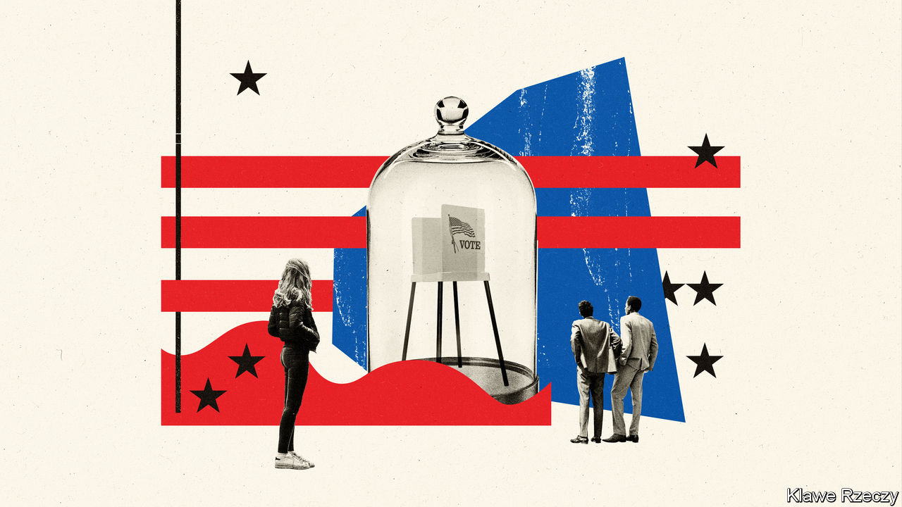

WITH LESS than three months to go until polling day, a president talking up the threat of fraud and a virus keeping people at home, Americans are understandably worried about this year’s presidential election. Even in more normal times, America’s system of casting and counting ballots is more complicated and inconvenient than it should be. In Georgia’s primary elections in mid-July some voters queued for five hours to make their voices heard. In New York, tens of thousands of mail-in ballots have been disqualified or are being disputed six weeks after the primary election there.

To simplify a bit, at election time Americans now worry about three groups of bad actors. The first is foreigners, who might meddle with the results. “Russian election interference” conjures-up images of hackers ensconced in St Petersburg breaking into vote-counting machines, or corrupting lists of eligible voters. But this is not what happened in 2016. The Russian interference that became such a big post-election story was an influence campaign rather than a technologically sophisticated plot to mess with voting returns.

The second group is fraudulent voters. These have long preoccupied Republican politicians. Donald Trump’s insistence that “2020 will be the most INACCURATE and FRAUDULENT Election in history” is different in style and motivation, but not in substance, from past claims. There is almost no evidence for this either. Mr Trump’s own commission on election integrity, which was seemingly set up to explain how the greatest candidate in history could possibly have lost the popular vote in 2016 (and which was run by Kris Kobach, an enthusiastic peddler of the myth), disbanded without finding evidence of voting fraud. Still, polls last time around suggested that about half of voters believe that electoral fraud is a real problem.

The third group of “bad actors” are Republicans. Democrats maintain that, by manipulating laws on what identification is acceptable at a polling station and where those stations are sited, and by purging inactive voters from the state lists of eligible voters, Republicans engage in a systematic kind of cheating, or voter suppression. There is evidence that this goes on. Republican operatives will sometimes admit to it in unguarded moments. But there is little evidence that voter suppression is decisive, perhaps because the main effect may be to disenfranchise people who would not have voted anyway (even in presidential elections, about 45% of eligible voters do not bother to cast a ballot).

After the 2016 election, activists aligned with the Democrats claimed that laws requiring voters to present photo ID before they could vote cost Hillary Clinton the state of Wisconsin and maybe the entire election. But academics have poured a lot of cold water on these theories; there is no compelling evidence that voter-ID laws changed the result of the 2016 election. Likewise, in 2018 the Democratic candidate for governor of Georgia alleged that her opponent, now-governor Brian Kemp, used his power as the secretary of state (a position that is responsible for administering elections) to disenfranchise voters and deny her the election. One investigation into the contest found that a programme designed to verify the information voters submit with their applications for registration could have disenfranchised up to 50,000 Georgians. Yet Mr Kemp’s margin was 55,000 votes—even if every single voter who was disenfranchised voted for his opponent, he would still have won.

## The right to queue

If worries about these three groups of bad actors can be overblown, Americans are far too relaxed about less exotic kinds of trouble on election day—the kind caused by incompetent administration, weird laws, lack of funding and too few volunteers at polling places.

America’s constitution, unlike those of other Western democracies, does not guarantee all its eligible citizens the right to vote. Instead, it leaves election administration up to the states. Polling-place closures and long queues caused by a lack of volunteers, as well as failures of new electronic machines (which happened in Georgia this year) are routine. The whole system is a bit creaky: an analysis by researchers at the Brennan Centre for Justice, a law and voting-rights group, found that the vast majority of states are using voting machines that are no longer manufactured.

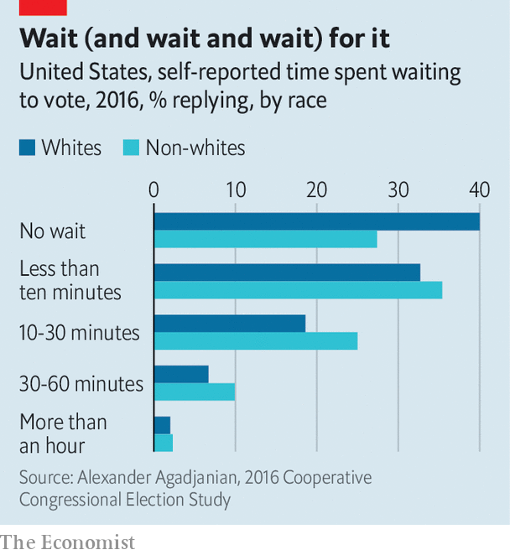

Though a visit to a polling place lasts minutes in many other Western democracies, it can take hours from start to finish in America. Big cities often have too few polling places with too few workers and cumbersome voting machines. All this waiting can dissuade people from voting, an effect seen disproportionately among non-white Americans. One poll taken after the 2016 election revealed that 73% of non-whites said they had to wait in line to cast their votes, compared with 60% of whites. The longer someone has to wait, the more the disparity grows; non-whites were 40% likelier than whites to report waiting longer than half an hour to vote (see chart).

The failure of the New York Board of Elections to prepare for an influx of mail-in ballots this year has raised renewed concerns about the capacity of postal voting systems (see article). Covid-19 means more voters than ever will attempt to cast their votes by post in November. The US Election Assistance Commission, an agency charged with helping election administrators, reckons that in 2016 41% of ballots were cast before election day. If that share increased it would lessen waiting times at polling stations. But the postal service and ballot-counters would be inundated with envelopes sent by voters who are new to the process and may have their ballot discarded because of some minor technical glitch. More postal voting could also make counting much slower on election night, creating doubt about who has really won that could last for days or even, in the case of a tighter election, months.■

Dig deeper:  
Sign up and listen to Checks and Balance, our [weekly newsletter](https://www.economist.com/checksandbalance/) and [podcast](https://www.economist.com/podcasts/2020/07/31/checks-and-balance-our-weekly-podcast-on-american-politics) on American politics, and explore our [presidential election forecast](https://projects.economist.com/us-2020-forecast/president)

This article was downloaded by calibre from <https://www.economist.com/united-states/2020/08/08/americans-should-worry-less-about-foreigners-and-voter-fraud>

|  |  |  |  |
| --- | --- | --- | --- |
|  | Articles | Sections | Next |

|  |  |  |  |
| --- | --- | --- | --- |
| Previous | Articles | Sections | Next |

#### Law of the letter

# The postal service has become a key part of America’s election infrastructure

Unfortunately it is also in a mess

Aug 8th 2020 |

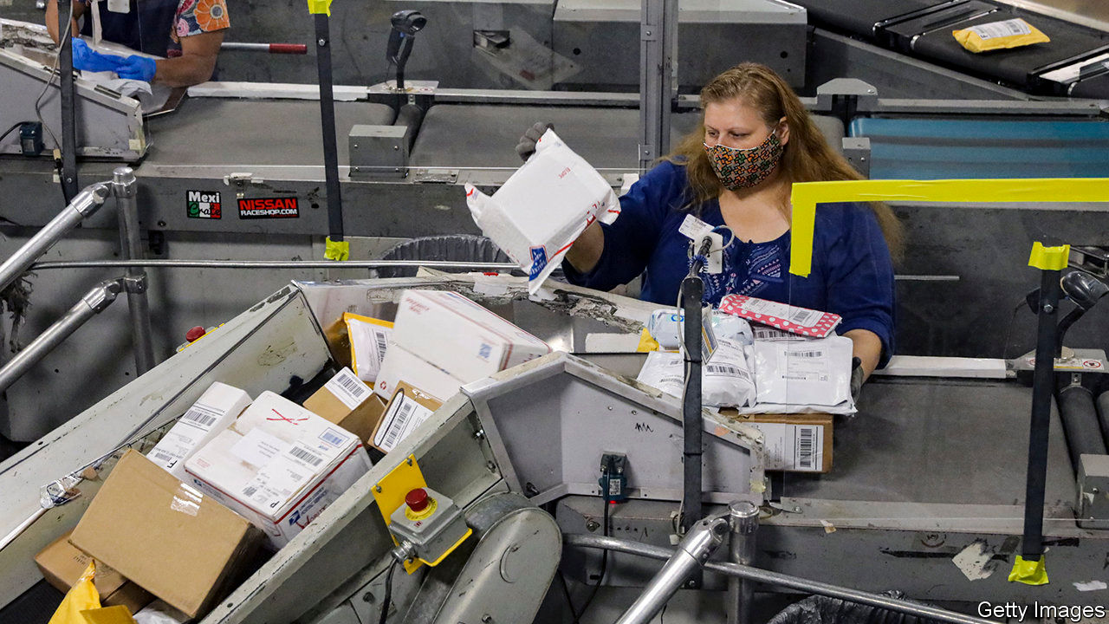

“THE POSTAL service”, said Donald Trump, as he signed covid-19 relief legislation in the spring, “is a joke.” He contended that the United States Postal Service (USPS) is losing money by “handing out packages for Amazon and other internet companies”, and needed to quadruple its package rates. Far from being a joke, the USPS is the nation’s favourite government agency, viewed favourably by 91% of Americans. But it is losing money: $4.5bn from January to March, more than double its losses for the same period last year. Neither the reasons nor the solution are quite so simple—and many see ulterior motives behind Mr Trump’s contempt.

The USPS’s financial woes have three main causes, one acute and two chronic. The acute one is covid-19. At least 2,400 postal workers have caught the virus and 60 have died. More than 17,000 of its 630,000 employees have been quarantined. Although package volume and revenue has grown along with online shopping, the volume of first-class and marketing mail have both declined.

Chronic problem number one is the decline in first-class mail, the postal service’s most profitable offering. In a digital age people send fewer letters and postcards. Chronic problem two is the Postal Accountability and Enhancement Act (PAEA), a law passed with bipartisan support in 2006 that requires USPS to prepay a large share of future retirees’ health benefits—a burden imposed on no other federal agency.

On current trends, the postal service estimates that it could run out of money sometime between April and October 2021, unless there is relief or reform. House Democrats included money for the postal service in their version of the CARES Act enacted in March, but after Steven Mnuchin, the Treasury secretary, said Mr Trump would veto any legislation that included funding for the postal service, it was cut. The only relief the USPS has so far been offered is a $10bn line of credit from the Treasury that lets Mr Mnuchin see the terms of its ten biggest contracts, which includes the one with Amazon (the USPS does a lot of “last mile” delivery for Amazon).

To put the service on firmer financial footing—or, some believe, to undermine it—Louis DeJoy, who became Postmaster General in May, implemented operational changes last month. Instead of setting as a paramount goal delivering to customers all mail received by a post office on a given morning, the new rules forbid carriers from leaving late or making extra trips back to the station, as often happens if more mail arrives than a single truck can hold.

Many question why Mr DeJoy opted to implement those changes just before a presidential election that will be unusually reliant on mailed ballots. Mr DeJoy, unlike the previous four postmasters general, has never worked for USPS; he ran a logistics company and has been a generous donor to Republicans. Gerry Connolly, a Democratic congressman who chairs the subcommittee that oversees USPS, calls Mr DeJoy’s rationale “a smokescreen...Under the guise of ‘We can’t afford it and we’re making efficiencies’, it’s directly affecting the delivery of mail on the eve of an election.”

Others posit different motives. Two years ago the Office of Management and Budget released a report mulling the sale and privatisation of the USPS, a position long advocated by some market-friendly wonks. Mr Trump has a long-standing grudge against Jeff Bezos, who owns both Amazon and the Washington Post. Some believe the president sees raising package rates as a way to exact revenge. The latest stimulus bill passed by the House contains $25bn for USPS, and removes any conditionality—such as letting Treasury see contractual terms—from its $10bn line of credit. This may not survive negotiations, or the threat of Mr Trump’s veto.

Mr Connolly is defiant. “We have a pandemic spreading; it’s more virulent than ever, the unemployment numbers are going up, GDP shrank by the largest number ever recorded, and you want to veto a bill over the fact you have your nose in a snit about Jeff Bezos and Amazon? Good luck on selling that.” The postal service too will be on the ballot in November—if the ballot papers can be delivered by USPS.■

Dig deeper:  
Sign up and listen to Checks and Balance, our [weekly newsletter](https://www.economist.com/checksandbalance/) and [podcast](https://www.economist.com/podcasts/2020/07/31/checks-and-balance-our-weekly-podcast-on-american-politics) on American politics, and explore our [presidential election forecast](https://projects.economist.com/us-2020-forecast/president)

This article was downloaded by calibre from <https://www.economist.com/united-states/2020/08/08/the-postal-service-has-become-a-key-part-of-americas-election-infrastructure>

|  |  |  |  |
| --- | --- | --- | --- |
| Previous | Articles | Sections | Next |

|  |  |  |  |
| --- | --- | --- | --- |
| Previous | Articles | Sections | Next |

#### Pipes of fancy

# Could dawdling America lead the world in a new form of transport?

Some urban planners in the Midwest think so

Aug 8th 2020 | CHICAGO

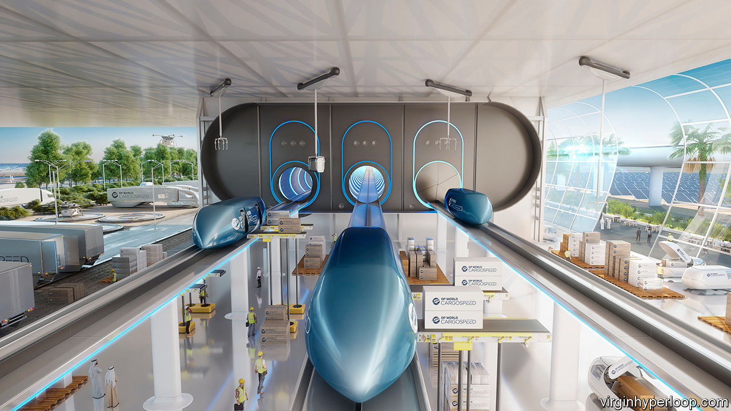

FOR DECADES not much has changed in how Americans shift themselves and their goods about. They mostly still rely on cars, lorries, trains and planes that would look familiar to someone visiting from the mid-20th century. Now, various companies are pushing for the regulation of (and public support for) schemes to create public intercity transport within depressurised pipes. A mention of the method, in a House infrastructure bill passed last month, has spurred excitement that these pipe-dreams could become reality.

A hyperloop system involves passengers or freight transported by pods elevated by magnets, which travel within raised pipes. The pods can be propelled at 620mph (1,000kph), says Jay Walder, boss of Virgin Hyperloop One, one of the firms pushing the idea. At that pace “you could move between Columbus and Chicago in 40 minutes”, he says, so covering the 460 miles many hours quicker than by driving and at a cost (and overall carbon impact) that he says would be lower than flying.

His firm runs an experimental centre near Las Vegas, where engineers—including some who worked on the Mars Rover programme—have run over 400 tests using a 500-metre-long pipe. So far they have sent pods flying at 240mph, though slowing down can be tricky. “We’ve shown it can work,” he says. He hopes next to build a 15km pipe to test the higher speeds, possibly near Columbus, Ohio, though Missouri and parts of some western states are also interested. Requirements include flat topography, empty space and no corners.

These schemes are sufficiently advanced for some state and local-government officials to take them seriously. Thea Ewing, of Ohio’s transport commission, says a recent feasibility study showed it could be done. The population is booming in Columbus, which lost all its rail services in 1979, so there is plenty of demand for new transport—for example, to Chicago and Pittsburgh. She says the pipes could come up on state-owned land beside motorways or (where they exist) railways. Another route being considered would link Kansas City and St Louis, both in Missouri.

Why do it? “We see it as something to help convert the region,” she says. Looking ahead to projects that would not be completed until mid-century is common practice for transport planners. A hyperloop could allow spouses to work in different cities while still living together, or Ohioans to pop to Chicago’s fancy restaurants or concert venues for an evening.

In reality, though, such schemes would only be viable if they were useful for transporting goods, too. “Mostly this would be for freight,” says Mark Patton, who oversees transport plans for the Columbus region. Paul Judge, who runs a thriving plastics manufacturer, Axium, in the city, says he would welcome it if it meant he could run a big factory, cheaply, in one spot and ship his billions of units of shampoo bottles, hand-sanitisers and the like to markets in the region.

Who would pay for it? Both private and public funds would be needed. Some public help would come from providing the land, but investors hope for more. Mr Walder says he expects America will eventually see a $2trn national infrastructure plan to help restart the economy. Part of that might throw the Midwest a loop. ■

This article was downloaded by calibre from <https://www.economist.com/united-states/2020/08/08/could-dawdling-america-lead-the-world-in-a-new-form-of-transport>

|  |  |  |  |
| --- | --- | --- | --- |
| Previous | Articles | Sections | Next |

|  |  |  |  |
| --- | --- | --- | --- |
| Previous | Articles | Sections | Next |

#### Without representation

# Residents of Washington, DC could once vote for Congress

Might they soon be able to again?

Aug 8th 2020 |

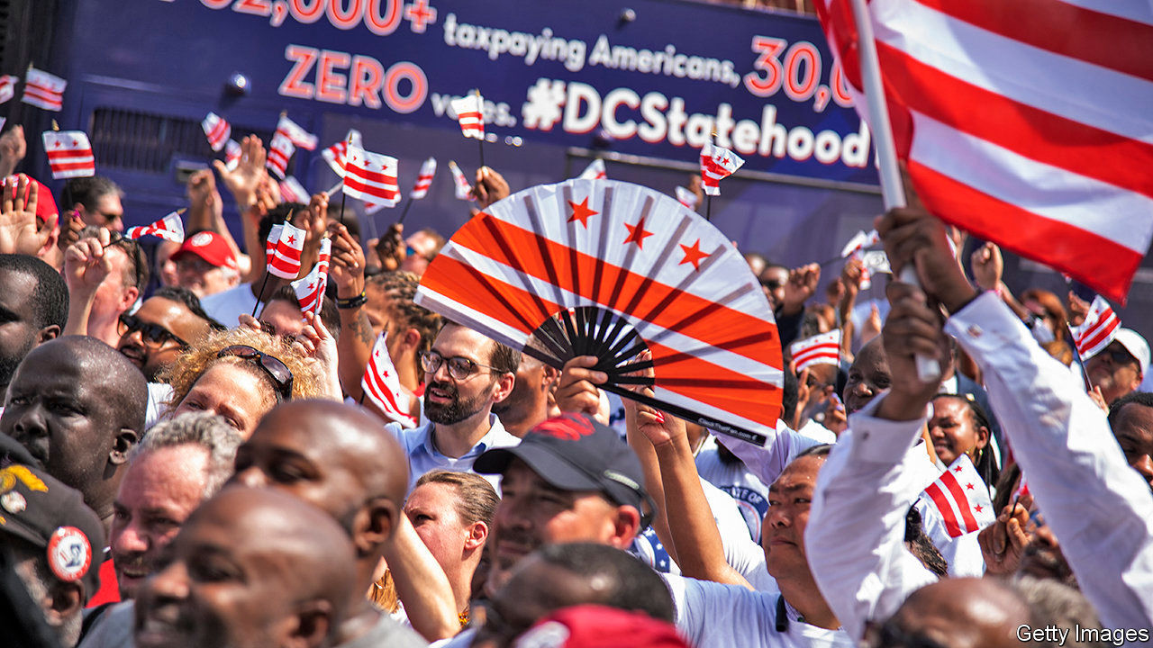

WASHINGTON, DC was not always a funky trapezoid shape. It took on that form in 1847, when residents of Alexandria City (now in Virginia) spearheaded an effort to leave the capital and be reincorporated into Old Dominion state. Years of neglect from Congress and Washington’s various governing committees had left its infrastructure crumbling. Many slaveholding residents also believed that the capital would soon outlaw slavery, and cast an eye to friendlier territory next door. Following votes in favour from Alexandria residents and Congress in 1846, the Virginia state legislature met the next year to approve the retrocession of all District lands south of the Potomac river. That history is becoming newly relevant as the campaign for DC statehood has gained momentum.

Before the retrocession, the District was ten square miles of land that included both present-day Alexandria City and Arlington County, Virginia, in addition to its current territory north of the Potomac. This was its original design as set out in 1790, when northern political leaders met their southern opponents to establish a capital on the Potomac in exchange for a powerful national bank and an expanded role for the federal Treasury. The story of this “dinner-table bargain” has now been popularised by a song in the musical “Hamilton”.

The original capital district was not just geographically different from the one that exists today. Its residents also enjoyed different rights. Between 1790 and 1801, people living in the newly converted district could vote for both the House of Representatives and the state legislatures of Virginia and Maryland, depending on which side of the Potomac they lived. That is because the District of Columbia was not officially incorporated until the turn of the century; until then, de facto residents still enjoyed all the de jure rights of a citizen living in the surrounding state. In 1801 Congress passed the Organic Act, a law officially establishing Washington as a district separate from its adjacent states. Residents were to be governed by Congress, and were no longer counted as residents of Maryland or Virginia. Their right to vote was stripped away.

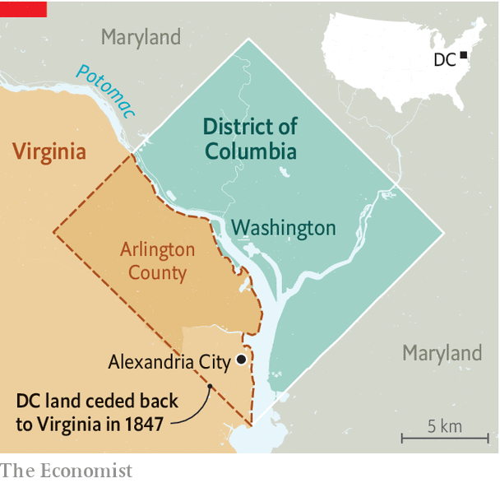

This history is little-known outside the capital city. Although its lack of voting rights is a live issue among the 700,000 people who live there, most other Americans pay it little attention. Polling suggests that those who have are split; statehood for Puerto Rico has greater support than statehood for the Swamp.

Democratic activists are an exception. They have embraced the issue not only for the sake of residents’ voting rights, but also for the two additional Democratic senators the District, which is almost half black, would undoubtedly send to Capitol Hill if it became a state. In “It’s Time to Fight Dirty: How Democrats Can Build a Lasting Majority in American Politics”, David Faris, a political scientist, cites statehood for DC as one of several “dirty” tricks Democrats could pull to tilt the electoral system—which confers advantages to Republicans who represent sparsely populated, rural states—back towards equality. In June a majority of members of the Democrat-controlled House of Representatives voted to admit DC into the union as the 51st state. Of the 25 candidates who ran for the Democratic presidential nomination this year, 18 supported statehood.

The political implications of granting statehood to DC have caused an uproar on the right. Just before the House vote, Tom Cotton, a Republican senator from Arkansas, told the Senate that granting statehood to the district and conferring voting rights on its citizens constituted a “power-grab” by Democratic politicians to “rig the rules of our democracy and try to give [them] permanent power”. That, of course, is part of the appeal for some of the idea’s supporters. How could it happen?

Stasha Rhodes, campaign manager of an advocacy group called “51 for 51,” says that “bypassing the filibuster and getting 51 votes is the most straightforward path to statehood.” If Democrats did manage to win control of the Senate and White House in November, admitting DC as a state could be on their agenda. Though some legal experts argue that Congress has the power to restore the voting rights they rescinded from District residents in 1801, others believe that the Constitution grants congressional representation only to residents of states. If that is so, advocates would need to turn to a constitutional amendment to get proper representation in Congress.

51 for 51 maintains that the fight for statehood is about rights. America’s founders believed that proper representation in government was key to a modern social contract. Accordingly, many adopted “no taxation without representation” as a rallying cry during the war of independence. The same demand for voting rights is now the District’s unofficial slogan. Proponents point out that, thanks to laws about voting overseas, there is nowhere—apart from prison—an American citizen can move to and be deprived of their right to vote for congressional representation. Nowhere, except the District of Columbia.■

Dig deeper:  
Sign up and listen to Checks and Balance, our [weekly newsletter](https://www.economist.com/checksandbalance/) and [podcast](https://www.economist.com/podcasts/2020/07/31/checks-and-balance-our-weekly-podcast-on-american-politics) on American politics, and explore our [presidential election forecast](https://projects.economist.com/us-2020-forecast/president)

This article was downloaded by calibre from <https://www.economist.com/united-states/2020/08/08/residents-of-washington-dc-could-once-vote-for-congress>

|  |  |  |  |
| --- | --- | --- | --- |
| Previous | Articles | Sections | Next |

|  |  |  |  |
| --- | --- | --- | --- |
| Previous | Articles | Sections | Next |

#### Strike two

# Baseball’s faltering restart

America’s favourite pastime is struggling with covid-19

Aug 8th 2020 | NEW YORK



THE CRACK of the bat made an abnormal baseball season feel fleetingly familiar. On August 2nd Aaron Judge, the Yankee right-fielder, hit his second home-run of the game, his sixth in five straight games. The eight-inning moon shot broke a 7-7 tie against the Boston Red Sox, the Yankees’ bitter rival. As the ball soared 468 feet into the stand, the commentators went wild. Your correspondent leapt from her sofa. It was exciting, but weird. No scrum of fans chased the ball in the bleachers, which were devoid of Bleacher Creatures. There were no fans. The crowd cheering was a recording.

Baseball’s season began on July 23rd, four months late because of the pandemic. After just three games, the Miami Marlins’ games were temporarily suspended after 18 players—more than half the roster—and some backroom staff tested positive for covid-19. Five games into its season the St Louis Cardinals were hit by an unrelated outbreak. Seven players and six team staffers tested positive. Rob Manfred, Major League Baseball’s (MLB) commissioner, threatened to shut down the season unless the sport improved its handling of the virus, but he later backtracked. It is hard to imagine the season continuing if a third team has an outbreak. “It’s a little bit of three strikes and you’re out,” says Zachary Binney, an epidemiologist who focuses on sports at Oxford College at Emory University in Atlanta.

MLB has a 113-page protocol manual designed to keep teams virus-free, yet players and staff are still spitting and giving high-fives and fist-bumps. Bob Geren, a Los Angeles Dodgers’ coach, was caught on camera pulling down his mask to cough. Protocols are being tightened and each team must have a compliance officer. Many players and around a dozen umpires are opting out of the season. David Price, a pitcher with the Dodgers, recently tweeted, “Part of the reason I’m at home right now is because players’ health wasn’t being put first. I can see that hasn’t changed.”

Perhaps MLB should have followed the professional basketball and hockey leagues’ bubble model. The National Basketball Association’s teams are living and playing their games, without fans, in Disney World in Florida, while the National Hockey League’s teams are playing in two bubble sites in Canada, which has managed to flatten its curve, unlike its neighbour. Neither league has had a coronavirus case since the bubbles were put in place.

The National Football League, which begins its season in September, is keeping an eye on the MLB’s performance. The nature of football, with its large rosters, contact on every play and huddles, puts its players at risk of covid-19. The time of year it is played, in the autumn and winter, when there might be a second wave, may also prove challenging. The NFL gets a disproportionate amount of its income from television, so it is especially keen for the season to last to the end of the playoffs and the Super Bowl.

Editor’s note: Some of our covid-19 coverage is free for readers of The Economist Today, our daily [newsletter](https://my.economist.com/user#newsletter). For more stories and our pandemic tracker, see our [hub](https://www.economist.com/news/2020/03/11/the-economists-coverage-of-the-coronavirus)

This article was downloaded by calibre from <https://www.economist.com/united-states/2020/08/08/baseballs-faltering-restart>

|  |  |  |  |
| --- | --- | --- | --- |
| Previous | Articles | Sections | Next |

|  |  |  |  |
| --- | --- | --- | --- |
| Previous | Articles | Sections | Next |

#### From unthinkable to universal

# Universal basic income gains momentum in America

Paying for it remains another matter

Aug 8th 2020 | NEW YORK

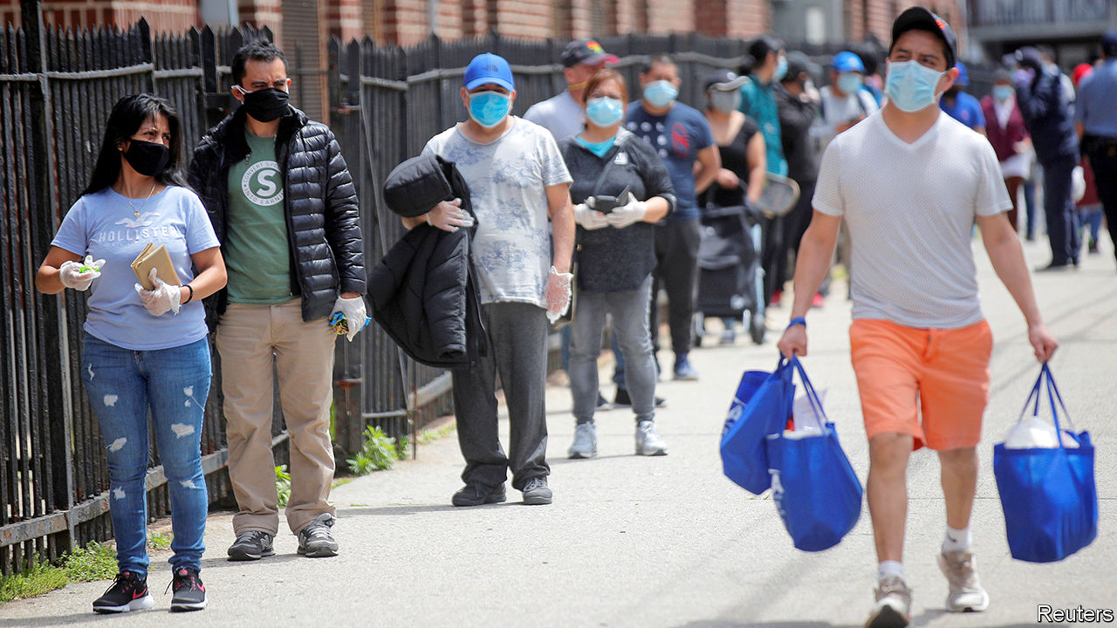

COLETTE SMITH and her husband are both out of work. They had exhausted their savings, when she received a one-time $1,000 cash infusion as part of a scheme run by Neighbourhood Trust, a financial coaching non-profit, and Humanity Forward, an organisation devoted to building support for universal basic income (UBI) founded by Andrew Yang. UBI was the centrepiece of Mr Yang’s run for the Democratic presidential nomination, in which he advocated a guaranteed income of $1,000 a month, a “Freedom Dividend”, as he called it, for every American adult, regardless of their financial circumstances.

There are two big hurdles to introducing UBI in America. One is building support for something that sounds, to many, alarmingly socialist. The other is working out how to pay for it. Mr Yang’s campaign for the Democratic nomination may have failed. But on one of these points he has been wildly successful. A recent Stanford study showed that people are warming to the UBI idea. In April 88% of liberals backed it, while support among conservatives rose from 28% before covid-19 to 45%. Universal benefits can be easier for politicians to sell, because they are less vulnerable to the racial politics that have undermined support for welfare spending in the past.

Dreams of a UBI have a peculiar history in America. In 1967 a coalition of welfare recipients, led by African-American women, demanded “decent income as a right”. Martin Luther King wrote about it in his final book. At the other end of the political spectrum, Donald Rumsfeld and Dick Cheney drew up a guaranteed minimum-income proposal for President Richard Nixon. Milton Friedman and Friedrich Hayek, beloved of libertarians, were enthusiasts too.

More recently, UBI has been taken up by technologists who believe that software will leave a large number of Americans jobless, leading to social unrest. It has also been promoted by some of the organisations which make up the Black Lives Matter movement, who see it as a way to mend racial disparities in wealth.

Mr Yang points out that the approval rating for UBI was only about 25% when he began his presidential run, but by the time he ended it, in February, it was 66%. “The energy around universal basic income has skyrocketed, and it’s going to remain elevated until a bill passes,” says Mr Yang, who believes the job losses caused by covid-19 will not quickly be reversed. In June Jack Dorsey, Twitter’s boss, gave Mr Yang’s organisation $5m to build the case for UBI.

Funding a generous UBI has always seemed impossible. But many seemingly impossible economic policies have been enacted recently, opening the door to wackier ideas. Under America’s economic-stimulus plan to deal with the fallout from the pandemic, for example, Congress sent $1,200 to every adult. The scheme was so generous that, combined with extended unemployment benefits, aggregate household income is forecast to rise this year.

In May more than dozen cities, including Atlanta, Los Angeles, Newark and St Paul, along with the Economic Security Project, launched Mayors for a Guaranteed Income, a network of mayors experimenting with UBI-like schemes. Mr Dorsey has also given money to this group. In February 2019 Stockton, California, began an 18-month experiment to give $500 to 125 randomly selected people. This is being extended for another six months to help participants weather the slump.

In Jackson, Mississippi, the Magnolia Mothers’ Trust provides poor African-American mothers with $1,000 in cash monthly, no strings attached, for a year. It recently began a larger experiment with 75 more participants. Hudson, a small city in upstate New York, recently announced a five-year scheme to give a monthly $500 payment to 20 people. In Newark, New Jersey, Ras Baraka, the mayor, is hoping to get a pilot programme up and running. A third of Newark’s residents live in poverty and have to make tough decisions, Mr Baraka says, like “heat or eat.” Nearly 60% of Newark households carry delinquent debt. But to introduce a proper UBI in Newark, he says, would require federal funding.

For all the enthusiasm about UBI experiments, they remain problematic. It is hard to fully evaluate their effect because they are not universal (in the sense of received by everyone). Most take the form of occasional cash payments to poorer Americans. Nor are they generous enough to live on, which is what true UBI believers advocate. Finally, because they tend to be funded by philanthropy, the experiments do not factor in the substantial tax rises that would be needed to pay for them.

The proposal Mr Yang ran on would have cost $2.8trn annually, which is about what the federal government spends each year on Social Security (pensions), Medicare (health care for the elderly) and Medicaid (health care for the poor) combined. Even then it would provide adults with no more than $12,000 a year—not enough to lift a workless family with two adults and two children above the federal poverty line.

A more targeted effort that did not aim to be universal could do much more on that score. Ms Smith, along with 1,000 other residents of the Bronx, received a one-off $1,000 grant from Mr Yang’s outfit. This allowed her to buy food and to restore the internet, which her 14-year-old son needed for remote learning. This helped a great deal. But UBI advocates still have to explain why it would not be better to give families such as hers larger sums rather than a smaller payment that also goes to those who do not need it.■

Dig deeper:  
Sign up and listen to Checks and Balance, our [weekly newsletter](https://www.economist.com/checksandbalance/) and [podcast](https://www.economist.com/podcasts/2020/07/31/checks-and-balance-our-weekly-podcast-on-american-politics) on American politics, and explore our [presidential election forecast](https://projects.economist.com/us-2020-forecast/president)

This article was downloaded by calibre from <https://www.economist.com/united-states/2020/08/08/universal-basic-income-gains-momentum-in-america>

|  |  |  |  |
| --- | --- | --- | --- |
| Previous | Articles | Sections | Next |

|  |  |  |  |
| --- | --- | --- | --- |
| Previous | Articles | Sections | Next |

#### Lexington

# The meaning of One America News Network

The president’s new favourite network reveals more about America than it intends

Aug 8th 2020 |

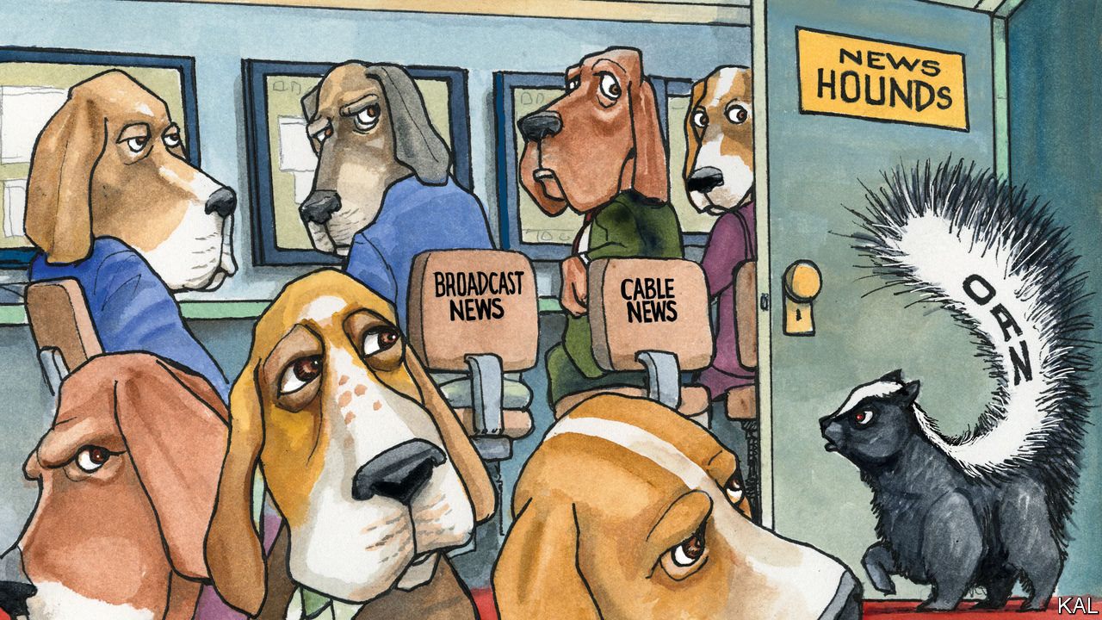

SHORTLY AFTER touching down in Texas on July 29th, Donald Trump gave a review of the in-flight entertainment on board Air Force One. “It is AMAZING watching @FoxNews how different they are from four years ago. Not even watchable. They totally forgot who got them where they are!” he tweeted. The president’s relationship with his once-favourite cable-news network has publicly soured. With its “phony polls, done by the same group of haters that got it even more wrong in 2016”, Fox is “doing nothing to help Republicans, and me, get re-elected on November 3rd”, Mr Trump has complained. “Watching @FoxNews on weekend afternoons is a total waste of time,” he tweeted in April. Fortunately, however, “We now have some great alternatives, like @OANN.”

Great or not, the One America News Network is certainly alternative. Launched on Independence Day in 2013 by Robert Herring, a circuit-board millionaire who decided to cash in his chips and spend them on running a television network, the cable channel serves up news from another dimension. Its reports suggest that the coronavirus, whose seriousness it considers exaggerated, may have been developed in a North Carolina laboratory. Hydroxychloroquine is a miracle drug—not that you are likely to hear about it, because of a massive disinformation campaign orchestrated by Big Tech and the Chinese-controlled World Health Organisation. Another thing you won’t know is that Martin Gugino, the 75-year-old who fractured his skull when he was pushed to the ground by two police officers in Buffalo in June, was using an antifa-inspired police-tracking device on his phone when he was tackled.

This is the regular-strength, daytime stuff. OANN’s evening talk-shows are still more eye-opening. Graham Ledger usually kicks off his hour-long slot by announcing: “The doors to the newsroom are locked, and the PC police are not getting in!” Mr Ledger, who considers wearing a face mask to be an act of submission, recently filmed himself going out for a clandestine haircut, in breach of California’s lockdown rules. “This is not unlike, of course, what they had to live through during Hitler’s time,” he observed, from behind dark glasses, on his way to the salon. Mr Ledger’s show is followed by “Tipping Point”, presented by Liz Wheeler, who denounces the “trained Marxists” of Black Lives Matter with a glare that could turn liberals to stone.

Thrillingly angry talk-shows are not new to the American airwaves. They became a fixture on radio after the abolition in 1987 of the Fairness Doctrine, which had required broadcasters to give equal treatment to competing points of view. As America was criss-crossed with cable and audiences got access to hundreds of channels, television networks found that they, too, could get higher ratings by zeroing in on one group—conservatives, say—than by trying to cater to everyone. As a bonus, it turned out that opining was cheaper than reporting. Advertisers preferred the more opinionated channels too, within reason, as they were able to tailor their ads to more specific audiences. Commercials on OANN fit the content perfectly: after watching an apocalyptic report about protests in Portland, viewers might be shown a commercial for a dynamo-powered emergency radio (“Your life may depend on it!”). After bulletins that question the validity of mainstream science, they see ads for alternative supplements, such as crystals that promise to unlock the power of beetroot.

This has helped cable news remain profitable—and influential—even as other forms of journalism have withered. While American newspapers have shed about half their newsroom staff in the past ten years, as readers and advertisers have fled online, the cable-news industry employs about as many people as it did a decade ago, according to the Pew Research Centre. Ratings have held steady, helped in recent years by a White House that generates extraordinary amounts of news.

OANN is only a small fish in a big swamp. It is not carried by some of the large cable and satellite companies (despite a campaign that has included a billboard ad encouraging people to call the mobile-phone number of an executive at Dish, a satellite firm). It claims to make money, though it declines to say how much. The network appears to be run on a shoestring, making free use of library footage, suffering from occasionally dodgy sound and misspelled captions, and employing just 50 journalists, who are mostly confined to studios or stationed outside the White House.

## Square-eyed, swivel-eyed

Still, it would be foolish to switch off to the dangers represented by OANN. It is the fourth-rated cable-news network, after Fox, CNN and MSNBC (and ahead of the likes of BBC America, CNBC, Fox Business and Bloomberg). Mr Trump, who well knows that a joke can turn into something serious, promotes its stories to his 85m Twitter followers with a relentlessness that makes some wonder if he is planning a career at the channel after his presidency. For those who swallow OANN’s stories, whether by tuning in directly or hearing them second-hand, it is an unhealthy addition to their news diet. The pandemic has shown how misinformation can kill.

The bigger reason to worry about OANN, however, is that TV is a lagging indicator of opinion. Talk-shows are less about persuasion than about affirmation: of views formed online, on social media and in forwarded emails and WhatsApp messages. Viewers don’t tune in to Ms Wheeler to learn about the world, but to experience an expression and celebration of the opinions and the identity they have already been introduced to on the fringes of the internet.

“There are tens of millions of Americans who have developed a taste for these sorts of conspiracy theories, and for whom Fox may be too tame,” believes Charlie Sykes, a former conservative talk-radio host who quit his show in 2016 after opposing Mr Trump. Even if Mr Trump loses in November, fake news will thrive. Like OANN, he amplifies harmful nonsense. But the act only works because so many cannot distinguish politics from entertainment. ■

Dig deeper:  
Sign up and listen to Checks and Balance, our [weekly newsletter](https://www.economist.com/checksandbalance/) and [podcast](https://www.economist.com/podcasts/2020/07/31/checks-and-balance-our-weekly-podcast-on-american-politics) on American politics, and explore our [presidential election forecast](https://projects.economist.com/us-2020-forecast/president)

This article was downloaded by calibre from <https://www.economist.com/united-states/2020/08/08/the-meaning-of-one-america-news-network>

|  |  |  |  |
| --- | --- | --- | --- |
| Previous | Articles | Sections | Next |

|  |  |  |
| --- | --- | --- |
| United States | Sections | Asia |

The Americas

Argentina: Fighting on fewer fronts

.

Guyana and Suriname: Oil futures

.

Bello: Beyond the troika of tyranny

.

|  |  |  |
| --- | --- | --- |
| United States | Sections | Asia |

|  |  |  |  |
| --- | --- | --- | --- |
|  | Articles | Sections | Next |

#### Fighting on fewer fronts

# Argentina reaches a deal with its foreign creditors

That is good news. It will take much more to overcome the economic and health crises

Aug 5th 2020 | BUENOS AIRES

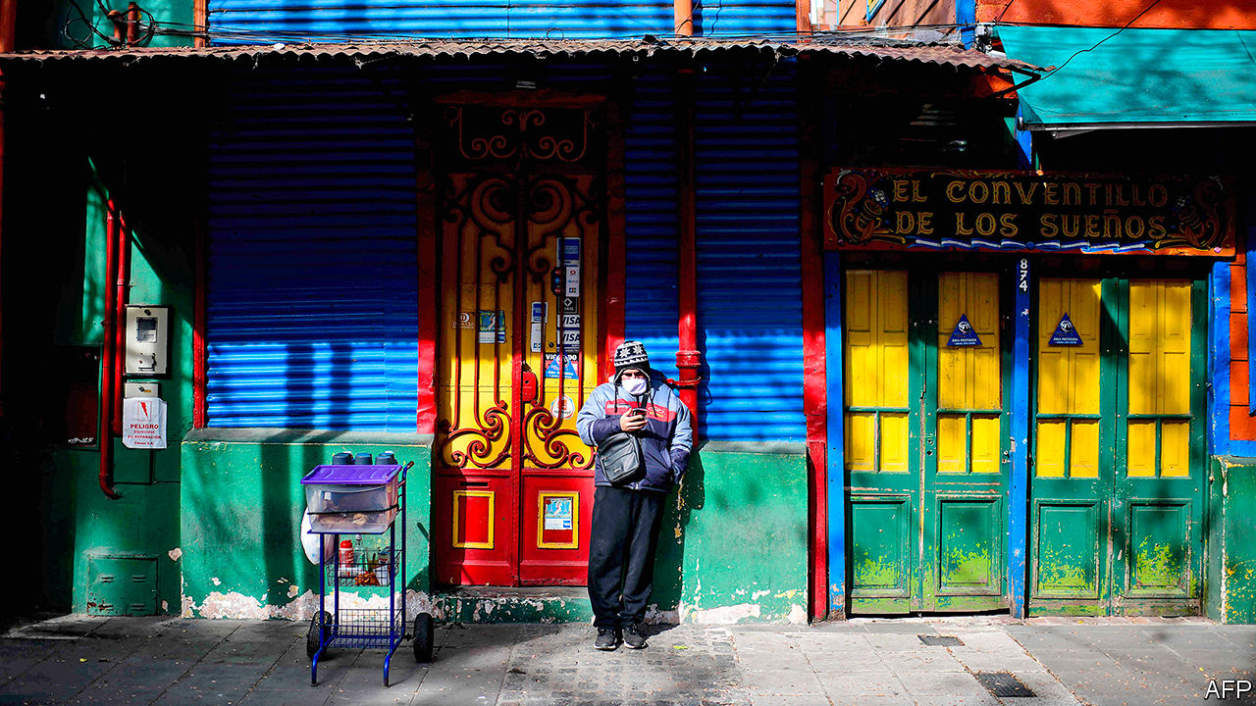

AT ALBERTO FERNÁNDEZ’S official residence in a suburb of Buenos Aires, the mood mixed relief and caution. “We’ve dodged a bullet,” said an adviser to Argentina’s president after the government had reached a deal with creditors on August 4th. The news came just as the country recorded 166 covid-19 deaths, a daily record. “The challenge is a path out of pandemic and deep recession,” said the adviser.

The summing-up is accurate. Mr Fernández, a Peronist who became president in December, had appeared to be on a collision course with holders of $65bn-worth of foreign-law bonds. That is about 40% of the government’s foreign debt and equivalent to 16% of this year’s GDP. The economy minister, Martín Guzmán, initially demanded big cuts in interest payments and a delay until 2023 in resuming them. Argentina, now on its ninth debt default, looked set for yet another legal battle with creditors, which would have weakened the peso, quickened inflation and prolonged its exile from international credit markets.

The government’s agreement with the main holders of the debt has probably averted that danger. It is offering new bonds worth almost 55% of the face value of the ones they own, up from an original proposal of 38%. It will start to pay a bit earlier than it had first proposed (interest due every March and September will instead be paid every January and July). It has also agreed to make collective-action clauses, which allow a supermajority of creditors to force others to agree to a debt restructuring, more favourable to investors by making it harder for Argentina to make a separate peace with a subset of creditors, then turn on the rest. Argentina will now have to renegotiate its $44bn debt to the IMF.

The agreement with creditors is “great news”, says Federico Sturzenegger, a former head of the Central Bank who has been a critic of Mr Fernández. Most Argentines are less enthusiastic. “I can’t pay my taxes, so how can I celebrate us paying debts?” asks Ricardo as he opens his small grocery store in downtown Buenos Aires. His first client, Marta, a cleaner, scoffs: “People are starving. We need the money, not the foreign banks.” Mr Fernández’s approval rating has recently dropped, from 61% to 51%.

What comes next “is the hard part”, says an IMF official: the intertwined tasks of suppressing the pandemic and restoring growth. That is what will improve the mood of people like Ricardo and Marta.

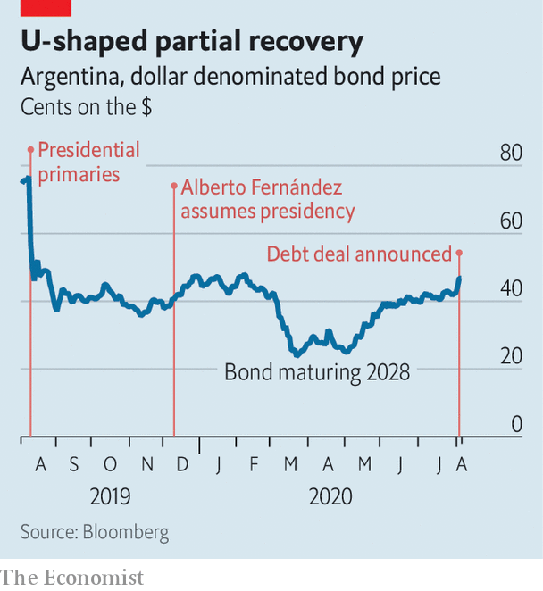

The Fernández government acted early in response to covid-19. It imposed a nationwide lockdown in mid-March and has maintained it in the most densely populated areas. That has kept Argentina out of the ranks of the worst affected countries. Despite the lockdown, though, the number of cases and deaths has jumped in the capital and the surrounding province of Buenos Aires, home to 45% of Argentines.

The cost has been high. The IMF expects the economy to contract by 10% this year, worsening a crisis that began under Mr Fernández’s predecessor, Mauricio Macri, in 2018. Annual inflation is nearly 43%. The official poverty rate, 35% at the end of last year, now probably exceeds 40%.

Although the government will now be spending less to service its debt than originally planned, it has little cash to fight recession and poverty. The budget deficit this year is projected to be 8% of GDP. It is being financed directly by the Central Bank, one reason inflation is so high. If the government is to restore growth, attract investment, curb inflation and pay creditors as promised it will need another plan.

One precondition is reducing the budget deficit. That will require a cut in public spending as soon as the pandemic allows. The government should de-index the pension system, use tax incentives to boost exports and liberalise labour laws to encourage investment, especially in agri-business and energy, argues Aldo Abram, director of Libertad y Progreso, a conservative think-tank. “Do we know what we have to do, economically, to get out of this hole?” Mr Abrams asks. “Yes. Do I see a president ready to confront these issues? No.”

One reason may be the influence of the vice-president, Cristina Fernández de Kirchner. A populist, she was president herself from 2007 to 2015 and chose Mr Fernández to be the Peronist movement’s presidential candidate.

Ms Fernández (no relation to the president) has used her clout most in non-economic areas. Her supporters lead the ministries of interior, security and defence. Under indictment for corruption (and with her two children being investigated), she is pushing for sweeping changes to the judiciary, including an expansion of the Supreme Court. Her critics say that is to make room for judges loyal to her.

She has a say on economic matters, too. She lobbied the president to issue a decree expropriating Vicentin, a big cereal producer. President Fernández eventually withdrew it, saying the courts would not co-operate. Though she fought foreign bankers during her presidency, she favoured this month’s settlement, and made sure she got some of the credit. During the frantic negotiations on August 3rd, Mr Guzmán visited her at home to explain his strategy. Her influence, though in favour of a sensible policy in this case, “is not a good narrative to sell investors”, says a longtime adviser to the president.

With the debt deal, Mr Fernández has made his impossible-seeming job a bit easier. Now he must overcome a recession, tame a disruptive vice-president and, above all, contain the pandemic, which is ravaging poor villas around Buenos Aires. He has handled Argentina’s creditors with finesse. Covid-19 is more implacable.■

This article was downloaded by calibre from <https://www.economist.com/the-americas/2020/08/05/argentina-reaches-a-deal-with-its-foreign-creditors>

|  |  |  |  |
| --- | --- | --- | --- |
|  | Articles | Sections | Next |

|  |  |  |  |
| --- | --- | --- | --- |
| Previous | Articles | Sections | Next |

#### Oil futures

# Democracy wins in Guyana and Suriname

The neighbours’ new presidents have contrasting challenges

Aug 8th 2020 |

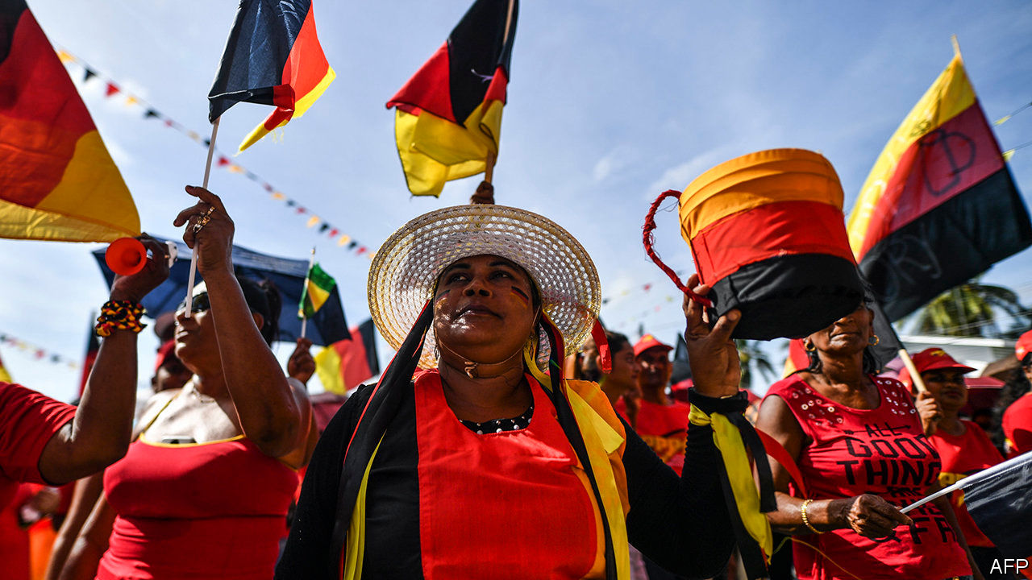

FOR FIVE months Guyana has waited to see if the stand-off between its president, David Granger, and the opposition would end in violence, a coup or a peaceful transfer of power. On August 2nd peace prevailed. The Elections Commission declared that Irfaan Ali, the opposition’s candidate, had won the election held on March 2nd. He took office the same day.

Mr Ali had a minuscule lead on election day, but a disputed tally by the chief elections officer gave victory to Mr Granger. A drawn-out recount and legal battles followed. It looked as if Mr Granger, a former army brigadier, was determined to remain in office. He relented under pressure from other countries such as the United States and Britain, the former colonial power, plus regional organisations such as the Caribbean Community. Independent media and Guyana’s private sector lobbied for Mr Granger to go. His supporters plan a court fight, but have little prospect of success.

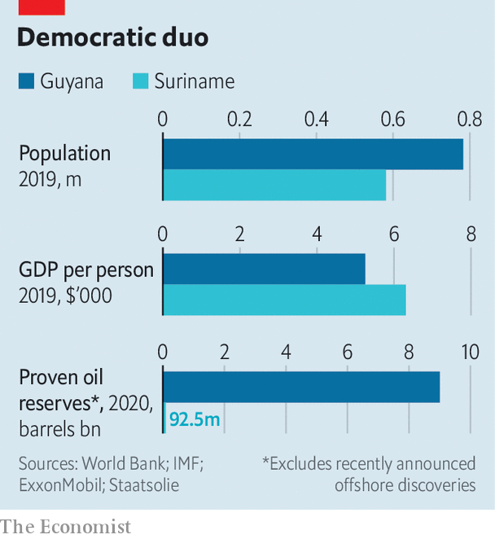

The transfer of power comes just as Guyana begins to cash in on massive offshore oil deposits (see chart). Thanks to them, the IMF expects the economy to grow by 53% this year. In a few years, South America’s third-poorest country, which has one of the world’s highest rates of emigration, will probably be one of its richest. The chance to control the bonanza raised the stakes in the bitter rivalry between Mr Granger’s mainly Afro-Guyanese coalition and Mr Ali’s mainly Indo-Guyanese People’s Progressive Party (PPP), which began before independence in 1966. The winner could hope to stay in power for decades.

It is hard to trust that the new government will spend the oil money wisely. The PPP’s 22 years in power before 2015 are remembered for corruption (as are the 28 years of rule before that by the People’s National Congress, now Mr Granger’s party). Bharrat Jagdeo, the president from 1999 to 2011, still calls the shots in the PPP and is the new vice-president. He chose Mr Ali, a former housing and water minister, as the party’s candidate because he could not run. Guyana’s Special Organised Crime Unit has charged Mr Ali with conspiracy and fraud. He denies the allegations, and promises honest management of the oil money.

The PPP has said it will dissolve the Natural Resource Fund, set up by Mr Granger’s government to receive oil revenue. It is supposed to release the money into the economy at a rate that does not drive the value of the currency to levels that would make other enterprises uncompetitive or overwhelm the capacity of Guyana’s weak institutions to spend it well. But it is not clear what the new government will replace it with, or when.

More than $90m, about 2% of last year’s GDP, is sitting in a bank account at the New York Federal Reserve. An early test of Mr Ali will be whether he bows to pressure to spend much of that money to bail out GuySuCo, the state-owned sugar producer, which is having trouble paying its wage bill. Mr Granger’s government had sought to reduce the firm’s losses by shutting down some money-losing estates, which contributed to his election loss. Mr Ali may be tempted to preserve unproductive jobs, mostly held by Indo-Guyanese workers. There are wiser ways to spend the money: on boosting infrastructure and education and on measures to protect the country from covid-19, which is spreading alarmingly, and from climate change. That might win over the half of Guyanese who did not vote for him.

Suriname’s new president, Chan Santokhi, also wondered whether he would take office after winning an election. His period of suspense was shorter. The vote took place on May 25th, and he was sworn in on July 16th. The doubt was whether President Desi Bouterse, who has dominated Suriname’s politics for more than 40 years and was convicted last year by a military court of murdering 15 political opponents in 1982, would yield power.

He did, but has left Mr Santokhi with a mess. Before leaving office Mr Bouterse gave public servants a 50% pay rise, which the government cannot afford. The budget deficit last year exceeded 10% of GDP. Mr Santokhi persuaded public-sector unions to wait for the pay rise. He has begged banks for cash, raised income-tax rates and deferred payment of a loan taken out last year to buy a hydroelectric dam.

Suriname, like Guyana, is an emerging petro-power. Apache, an American oil company, and its French partner, Total, announced this year three big oil finds offshore. Others are about to drill. Surinamese may share Guyanese worries over how well the windfall will be managed. Mr Santokhi is a former police commissioner and justice minister but the new vice-president, Ronnie Brunswijk, seems less strait-laced. He began his career as Mr Bouterse’s bodyguard, fought a guerrilla war against his former boss in the 1980s, and has been convicted by a Dutch court for cocaine smuggling. He owns a football club and a gold-mining business.

The oil will not flow for perhaps five years, which means that Mr Santokhi, whose term ends in 2025, may reap as little political benefit from it as the unlucky Mr Granger. The economy will shrink by 5% this year, reckons the IMF. Gold may help before the oil money arrives. It accounted for more than three-quarters of exports last year. Investors’ mistrust of the dollar has pushed its global price to a record high.

Dutch-speaking Suriname’s largest ethnic groups, like Guyana’s, are of African and Indian origin. But its political divide reflects attitudes to Mr Bouterse rather than ethnic identity. He has now left the scene. The fight over how to spend Suriname’s new riches, when they come, may be less bitter than Guyana’s. That, perhaps, is Suriname’s real gold.■

This article was downloaded by calibre from <https://www.economist.com/the-americas/2020/08/08/democracy-wins-in-guyana-and-suriname>

|  |  |  |  |
| --- | --- | --- | --- |
| Previous | Articles | Sections | Next |

|  |  |  |  |
| --- | --- | --- | --- |
| Previous | Articles | Sections | Next |

#### Bello

# How Joe Biden might change policy towards Latin America

Less confrontation, more co-operation

Aug 8th 2020 |

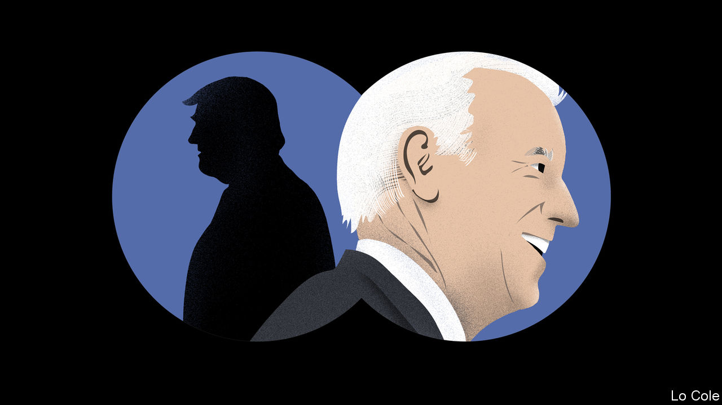

“FOR THE first time in history, you can truly envision a western hemisphere that is secure, democratic and middle-class, from northern Canada to southern Chile, and everywhere in between.” So said Joe Biden in a speech at Harvard University in 2014. Much has changed since then, not least the destruction of lives and livelihoods wrought by the pandemic. Even so, were Mr Biden to be elected president of the United States in November, for many Latin Americans he would offer a vision that is reassuring and familiar compared with the unpredictable sound and fury of Donald Trump.

Mr Trump won in 2016 in part because he promised to build a wall to keep out Latin American immigrants, declaring that Mexico was “not our friend”. Nevertheless, he has developed relatively good relations with the most important governments in the region. Jair Bolsonaro, Brazil’s president, used Mr Trump’s success as a template for his own campaign in 2018. He has closely aligned Brazil’s foreign policy, normally independent, with the Trump administration’s views. Andrés Manuel López Obrador, on his only foreign trip in 21 months as Mexico’s leader, last month went to Washington and praised Mr Trump’s “kindness and respect”. To keep the border open for trade, Mexico’s government has collaborated in shutting it to asylum-seekers.

Wary of Mr Trump’s threats of tariffs and sanctions, many governments have fallen into line “out of necessity and especially out of fear”, says a Latin American official. Ordinary Latin Americans are not impressed: the percentage who express a favourable view of the United States fell from the high 60s in 2015 to around 45 in 2017, according to the Pew Research Centre.

Mr Trump’s Latin American policy has centred on a (so far) failed bid to overthrow what John Bolton, his former national security adviser, called “the troika of tyranny”—the leftist dictatorships in Venezuela, Cuba and Nicaragua. In his recent memoir Mr Bolton blamed the failure to oust Nicolás Maduro in Venezuela, despite swingeing sanctions, on Mr Trump’s lack of constancy and foot-dragging inside the administration. As important, the administration underestimated the difficulty of prising the army away from Mr Maduro. Its critics say its Latin American policies are based on the president’s need to win Florida, home to large Cuban and Venezuelan diasporas, in November. “Domestic politics always figures in policy towards Latin America, but never before to this degree,” says Michael Shifter of Inter-American Dialogue, a think-tank in Washington.

Were Mr Biden to win, his priorities would be the American economy and dealing with China. But Latin America might not be at the bottom of his to-do list. He knows the region far better than recent presidents. In Barack Obama’s second term Vice-President Biden took on responsibility for the Americas. “He dedicated time to it, set out to learn about it and talked to a lot of people in the region,” says the Latin American official.

Juan Gonzalez, who advised Mr Biden on Latin America back then, stresses that the region and the world are not as they were in 2016. “The challenges are much greater,” he says. But he thinks there are opportunities for the United States in the region, not just threats to be managed. American firms that bring supply chains back from China could benefit Mexico and Central America. Mr Biden has long supported immigration reform. As president, he would be likely to resume his previous policy in Central America, with an aid programme aimed at fighting corruption and deterring migration through economic development.

On Venezuela, Mr Gonzalez says that sanctions should be part of a broader policy that would include seeking negotiations for free elections. A Biden presidency would revert to Mr Obama’s Cuba policy, which saw engagement as more likely to weaken the communist regime than Mr Trump’s intensification of sanctions. It would press Mr Bolsonaro on his failure to protect the Amazon.

An immediate issue concerns leadership of the Inter-American Development Bank. Breaking with a 60-year understanding that its president is a Latin American, the Trump administration wants the job for Mauricio Claver-Carone, an official at the National Security Council and an architect of its Venezuela policy. He may get it at a meeting of the bank’s governors next month. A Biden administration would probably force him out in favour of a less polarising figure. To do that, Mr Biden must win.

Dig deeper:  
Sign up and listen to Checks and Balance, our [weekly newsletter](https://www.economist.com/checksandbalance/) and [podcast](https://www.economist.com/podcasts/2020/07/31/checks-and-balance-our-weekly-podcast-on-american-politics) on American politics, and explore our [presidential election forecast](https://projects.economist.com/us-2020-forecast/president)

This article was downloaded by calibre from <https://www.economist.com/the-americas/2020/08/08/how-joe-biden-might-change-policy-towards-latin-america>

|  |  |  |  |
| --- | --- | --- | --- |
| Previous | Articles | Sections | Next |

|  |  |  |
| --- | --- | --- |
| The Americas | Sections | China |

Asia

Hindu nationalism: India shrining

.

Australia and covid-19: Borderline cases

.

Corruption in Uzbekistan: Weirs and recriminations

.

Personal freedom in Thailand: Cold cuts

.

Banyan: Trojan democrat

.

|  |  |  |
| --- | --- | --- |
| The Americas | Sections | China |

|  |  |  |  |
| --- | --- | --- | --- |
|  | Articles | Sections | Next |

#### India shrining

# India’s ruling party replaces a mosque with a Hindu temple

The construction of the shrine is the culmination of a 30-year campaign

Aug 4th 2020 | DELHI

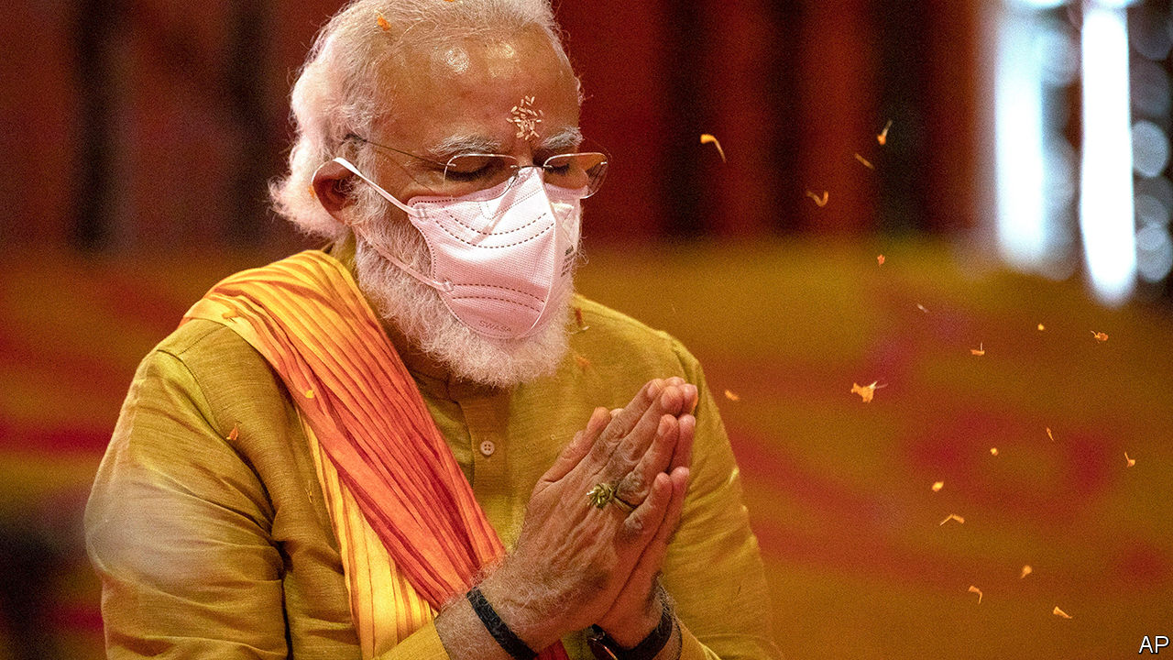

THIRTY YEARS ago a thrusting activist called Narendra Modi helped to organise a month-long political procession across northern India. The Ram Rath Yatra began at the city of Somnath, in his home state of Gujarat, and snaked up and down the country on its way to a mosque in the city of Ayodhya in the state of Uttar Pradesh, at the spot where many Hindus believe the god Ram was born. Mr Modi had recently joined the national campaign team of the Hindu-chauvinist Bharatiya Janata Party (BJP), which was agitating for the demolition of the mosque and the construction of a temple in its stead.

The cavalcade vaulted the BJP into the top ranks of Indian politics. At the next election its share of the vote nearly doubled, making it the biggest opposition party. And even though the mosque was destroyed in 1992 after a BJP rally at its gates descended into a riot, the courts dithered for decades about what should become of the ruins, leaving the party with a perennial campaign issue. The fact that the demolition sparked nationwide violence that claimed over 2,000 lives only helped the BJP, by heightening sectarian tensions.

The episode also accelerated the career of Mr Modi, whose efficiency and drive earned the admiration of the BJP’s top leaders. He received a further boost when a fire aboard a train in his home state of Gujarat killed 59 Hindu pilgrims returning from Ayodhya. Local Muslims were accused of arson, and in the ensuing pogrom at least 1,000 people, the vast majority of them Muslim, died. Although the courts have cleared Mr Modi, Gujarat’s chief minister at the time, of complicity in the violence, he has been lauded by Hindu extremists ever since for putting Muslims in their place.

On August 5th Mr Modi, now prime minister, returned to Ayodhya—for the first time since 1991, according to some reports. He was there to lay the foundation stone of the temple for which he and his party have campaigned for his entire career, and for which the Supreme Court had at last cleared a path in November. Mr Modi (pictured) prayed and chanted in religious garb and a medical facemask alongside Yogi Adityanath, a firebrand Hindu cleric whom he elevated to chief minister of Uttar Pradesh, and Mohan Bhagwat, the head of the Rashtriya Swayamsevak Sangh, a goose-stepping Hindu paramilitary group with perhaps 5m members. Then he helped manoeuvre a 40kg silver brick into place before declaring, “The wait of centuries is ending.” He did not mention, much less lament, the vandalism that had cleared the way for the temple’s construction.

Although India is officially a secular republic, the barrier between faith and state has never been absolute. The state has even abetted the construction of a Hindu temple on a site occupied by a mosque before—in the 1950s, at Somnath, the starting point of the Ram Rath Yatra. But previous governments concentrated on reforming Hinduism, weeding out practices deemed backward, such as discrimination on the basis of caste. In that vein, in 2018, the Supreme Court ruled that women must be allowed to enter the Sabarimala temple in the southern state of Kerala.

The BJP, in contrast, has propagated the notion that Hindus, who make up about 80% of the population, are hard done by in modern India, and that Muslims, who account for just 14%, get too good a deal. Since winning a thumping election victory last year, it has reversed, at least in part, the three supposed injustices on which it has campaigned longest and most insistently: the failure to honour Ram at his birthplace, the special constitutional status granted Jammu & Kashmir, India’s only state with a Muslim majority, and the distinct laws on marriage and inheritance that apply only to Muslims. On August 5th last year the government not only revoked Jammu & Kashmir’s modest autonomy, but downgraded it from a state to a territory and split it in two for good measure. A week before it had rescinded Muslim men’s right to divorce their wives instantly and at whim and had made it a crime to attempt to do so.

These moves in part reflect the BJP’s political dominance. For the first time, it enjoys a majority in both chambers of parliament and no longer has to rely on less sectarian allies to pass legislation. But the sudden rush to advance the Hindu nationalist items on its agenda also reflects the diminished chance of making good on its other main campaign promise: to accelerate economic growth and spread opportunity. The growth rate was already slowing before covid-19 arrived; the IMF now predicts that the economy will contract by 4.5% this year. Millions are being pitched into poverty.

What is more, the BJP has not yet hit on a fresh cause with the appeal of the Ram temple. When it amended the laws on citizenship to favour Hindus at the end of last year, it was met with surprisingly big and persistent protests in favour of secularism. The government itself, meanwhile, seems wary of stoking confrontation with China, despite recent Chinese border encroachments that have aroused public indignation. After Chinese troops beat 20 Indian soldiers to death high in the Himalayas in June, it took Mr Modi’s government two weeks to retaliate, and then only with a decree banning an assortment of Chinese-owned smartphone apps.

In the Ramayana, the epic poem that tells the story of Ram, the god is exiled from Ayodhya by his father, the king, and passed over as heir to the throne. Although it takes him many years and titanic struggles to do so, Ram eventually returns in triumph to Ayodhya, where he takes his rightful place as king and ushers in a golden era. Mr Modi is deliberately echoing the story with his own triumphant return to Ayodhya. He would doubtless like Indians to imagine that a golden era lies ahead. But the BJP’s current political ascendancy is made of baser stuff. ■

Editor’s note (August 5th 2020): This story has been updated since it was first published.

This article was downloaded by calibre from <https://www.economist.com/asia/2020/08/04/indias-ruling-party-replaces-a-mosque-with-a-hindu-temple>

|  |  |  |  |
| --- | --- | --- | --- |
|  | Articles | Sections | Next |

|  |  |  |  |
| --- | --- | --- | --- |
| Previous | Articles | Sections | Next |

#### Borderline cases

# Australia’s internal travel restrictions are tested in court

Clive Palmer, a mining magnate, thinks they are too severe

Aug 8th 2020 | SYDNEY

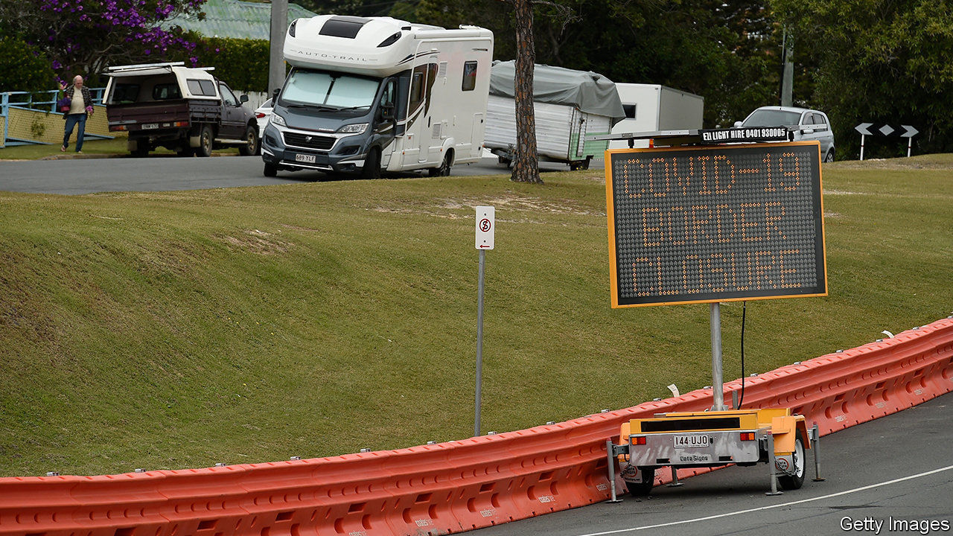

TOO MANY roads cross the southern border of the state of Queensland for police to patrol them all. Instead, the authorities have been setting up waist-high plastic barricades to block small streets that lead to neighbouring New South Wales near the sprawling city of Gold Coast. The intention is to prevent people entering Queensland from avoiding police checkpoints. The state, which has only a few active cases of covid-19, is closing itself off to the 15m residents of Victoria, New South Wales and the Australian Capital Territory, in an effort to prevent more from being imported.

Walls of a less visible variety have been erected all over Australia since the pandemic began. All bar one of its eight main states and territories have imposed border controls, either banning certain domestic travellers or forcing them to quarantine in hotels on arrival.

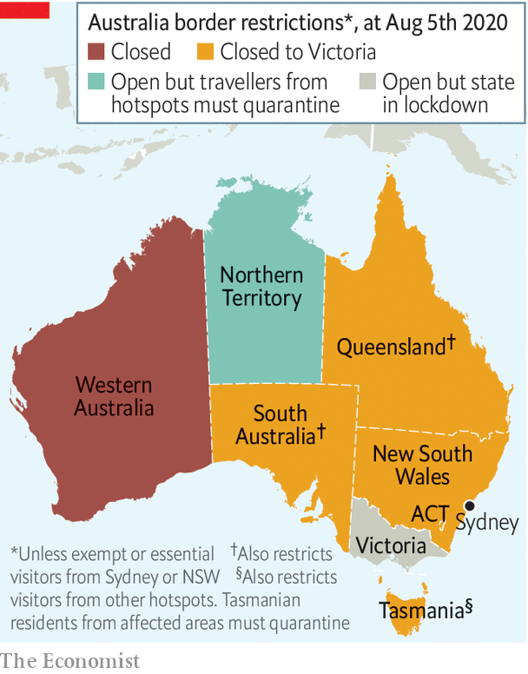

Victoria accounts for the vast majority of Australia’s 7,500-odd active cases. Sydney, the capital of New South Wales, has far fewer cases—just a dozen or so each day. But the twitchy governments of other states are nonetheless banning Sydneysiders as well as Victorians (see map).

This has helped to stop the coronavirus spreading to less populated parts of the country. Several states and territories have technically eliminated the disease, meaning that they have no local transmission at all. But imported cases continue to pop up, spurring constant tightening of restrictions on interstate travel.

Tasmania, an island, started making use of its natural fortifications in March, imposing two weeks’ quarantine on all arrivals from other parts of Australia. It had planned to launch a travel “bubble” with other covid-free states on August 7th, but delayed at the last minute. Its borders will be closed until at least the end of the month, and probably longer.

Western Australia, already separated from the rest of the country by a vast desert, shut out all other Australians in April, and has no plans to open back up. Its government makes exceptions only for miners and other “essential” workers.

Australians seem happy to tolerate these fetters to keep the virus at bay. Western Australia’s premier, Mark McGowan, who faces an election next year, hit an approval rating of 89% in a poll conducted shortly after he closed the border. His counterpart in Tasmania fares nearly as well. Annastacia Palaszczuk, Queensland’s leader, who is also approaching an election, boasts that locals stop her in the street “telling me they support our stance when it comes to the borders.”

But the controls have scuppered plans to revive domestic tourism and irritated some businesses. Clive Palmer, a mining magnate from Queensland, was incensed by Western Australia’s refusal to grant him special permission to fly in for business. Mr McGowan, complains Mr Palmer, “has great admiration for countries which have heads of state…with dictatorial powers, but that is not Australia.”

Mr Palmer has sued the government of Western Australia, arguing that the constitution declares that “trade, commerce and intercourse among the states… shall be absolutely free.” The courts have previously ruled that there can be limited exceptions. Mr McGowan believes that a pandemic qualifies. In times like these, he asserts, “constitutional niceties should…go out the window.” But Mr Palmer argues that the state’s sweeping border closure is not proportionate to the threat.

The federal government initially argued for looser restrictions, too. It sent officials to testify in support of Mr Palmer at a hearing late last month. Western Australia’s approach was “indiscriminate” and “uncompromising”, argued Scott Morrison, the prime minister. A more reasonable policy would be to open “in a staged, sensible, jurisdiction-by-jurisdiction way”, suggested the attorney-general, Christian Porter.

But the federal government has since withdrawn its support for Mr Palmer. The prime minister explained that the commonwealth had “taken into account the changed state of the pandemic” and the “high level of concern” about covid-19 in Western Australia. In other words, with infections rising and voters feeling scared, Mr Morrison’s Liberal Party is not planning to go to bat for liberal principles. ■

Editor’s note: Some of our covid-19 coverage is free for readers of The Economist Today, our daily [newsletter](https://my.economist.com/user#newsletter). For more stories and our pandemic tracker, see our [hub](https://www.economist.com/news/2020/03/11/the-economists-coverage-of-the-coronavirus)

This article was downloaded by calibre from <https://www.economist.com/asia/2020/08/08/australias-internal-travel-restrictions-are-tested-in-court>

|  |  |  |  |
| --- | --- | --- | --- |
| Previous | Articles | Sections | Next |

|  |  |  |  |
| --- | --- | --- | --- |
| Previous | Articles | Sections | Next |

#### Weirs and wherefores

# A dam failure raises concerns about corruption in Uzbekistan

An investigation into the causes is taking a long time to report

Aug 8th 2020 | TASHKENT

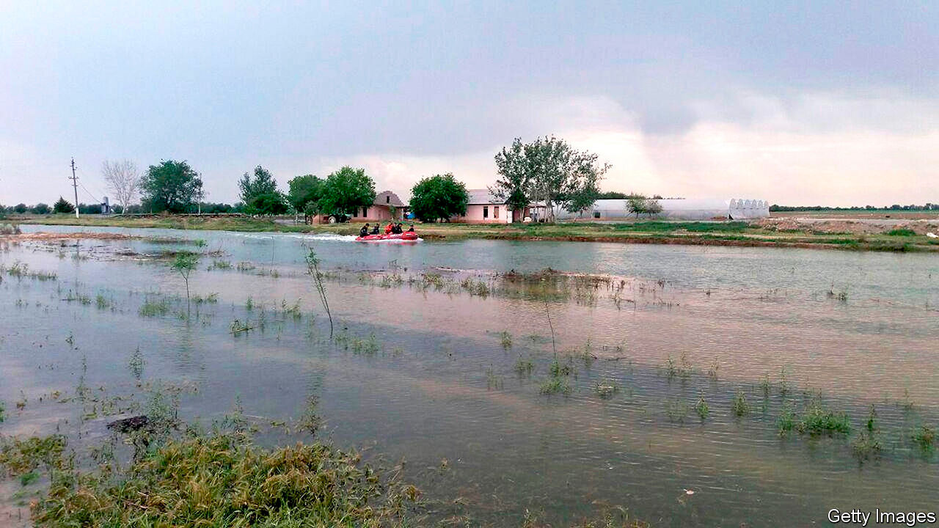

WHEN A DAM burst in Uzbekistan in May, Shavkat Mirziyoyev, the president, was quick to promise justice for the victims. Those responsible for the disaster, which killed six people and displaced over 100,000, would answer before the law “regardless of who they are”, he pledged. On social media, ordinary Uzbeks aired their suspicions that negligence or corruption must have contributed to the collapse, since the Sardoba dam had only been completed three years before. The structure should surely have been built to withstand the storms that officials initially blamed for the tragedy, they argued. Days after the devastating flood—which washed away crops as well as homes in both Uzbekistan and neighbouring Kazakhstan, causing over $1bn of damage—the president formed a task force to investigate. He gave it a month to report back.

Three months on, the report has still not arrived—and the task force now says it will take another five months to complete. But its preliminary findings do seem to bear out ordinary Uzbeks’ fears: nine people, including government officials and employees of firms that helped build the dam, have been arrested and face charges of embezzlement, fraud, negligence and violation of health-and-safety rules.

Just how far the rot goes is hard to say. The authorities have released the name of just one of the nine suspects, but no senior bureaucrats or businessmen appear to have been arrested. Journalists looking into the dam’s collapse, meanwhile, have been harassed and fired. And the composition of the task force has raised eyebrows: it includes Abdugani Sanginov, a senator who, as head of a government agency, awarded contracts for the construction of the dam. Media reports also claim that his family has ties to some of the firms that won the contracts. Mr Sanginov has brushed aside suggestions of any conflict of interest.

That an investigation is even being conducted is testament to the spirit of reform instituted by Mr Mirziyoyev after he came to power in 2016. His late predecessor, the dictatorial Islam Karimov, would have simply brushed the whole episode under the carpet. But the disaster is especially awkward for Mr Mirziyoyev, since he presided over the dam’s construction as prime minister and became president shortly before it started operating.

Moreover, Mr Sanginov is not the only member of Mr Mirziyoyev’s government to have had to fend off accusations of a conflict of interest. Jakhongir Artikkhodjaev, the mayor of the capital, Tashkent, has acknowledged ties to firms building Tashkent City, a flagship office, housing and leisure complex intended to signal that Uzbekistan is open for business again after decades as a largely closed dictatorship. Municipal officials say the contracts were awarded with appropriate oversight, and Mr Artikkhodjaev insists the firms won them fair and square. Indeed, he implies they are participating in the project largely out of a sense of civic duty.

Under Mr Karimov, Uzbekistan became a byword for crony capitalism. An American diplomat described Gulnara Karimova, the ex-president’s disgraced daughter, as a “robber baron” in a cable that was later leaked. Last year Ms Karimova was indicted in America for allegedly soliciting $865m in bribes from foreign firms hoping to do business in Uzbekistan. She is now in jail in Uzbekistan on corruption charges, although the judicial proceedings against her have been far from transparent.

The current authorities insist that Uzbekistan has changed beyond recognition since Ms Karimova held sway. But many close connections between business and government remain. Most notably, Oybek Tursunov, Mr Mirziyoyev’s son-in-law and a senior member of his staff, owns stakes in several financial firms, including a big bank and a payments network. Mr Mirziyoyev positions himself as a champion of transparency and has pushed through an impressive array of reforms to improve the investment climate and reduce corruption. But ordinary Uzbeks still need to be convinced that it is the public good, not private interests, that dictate how the government spends its money. ■

This article was downloaded by calibre from <https://www.economist.com/asia/2020/08/08/a-dam-failure-raises-concerns-about-corruption-in-uzbekistan>

|  |  |  |  |
| --- | --- | --- | --- |
| Previous | Articles | Sections | Next |

|  |  |  |  |
| --- | --- | --- | --- |
| Previous | Articles | Sections | Next |

#### Cold cuts

# Thai pupils fight for the right to be hirsute

Protests against strict dress codes in state schools are growing

Aug 8th 2020 |



AT A BUSY intersection in Bangkok 15-year-old Benjamaporn Nivas sits in her school uniform with her hands bound behind her and her mouth taped shut. A sign hanging from her neck reads “This pupil violates school rules by wearing her hair long, past her ears and with a fringe. Please punish her.” On Ms Benjamaporn’s lap lies a large pair of scissors to help passers-by fulfil the request by administering a more suitable hair-do.

When Ms Benjamaporn (pictured) appeared in this way in late June, she was not actually being punished by her school, but rather was trying to draw attention to the humiliating hair-related discipline teachers in Thailand often inflict on students. She was, predictably, punished for doing so, by the police, who forced her to abandon her protest within hours. A week later she and other members of a campaign group called “Bad Student” had submitted more than 300 complaints to the ministry of education on behalf of pupils who had been given haircuts by their teachers over the previous four months alone.

The enforcement of uniform hairstyles—crew-cuts for boys and fringeless bobs for girls—dates to a dress code introduced in 1972 by Thanom Kittikachorn, a military dictator who was later toppled in a student-led uprising. The dress code was subsequently relaxed, and as recently as May the education ministry reiterated that rules on hair and attire are up to schools, but many remain extremely strict.

Teachers often shear pupils ineptly on purpose. Photos and videos of haphazard or lopsided cuts administered by zealous educators abound on social media. A student in Yasothon province in north-east Thailand had a T shaved into his hair as punishment for refusing to cut it shorter. Another in Sisaket had half her locks trimmed in front of the whole school. “One side was long, while the other was short. I was embarrassed,” she told local reporters.

Pupils argue that the issue goes beyond fashion. “It is about having rights over our bodies and reforming an ossified education system. If you do not prostrate yourself or obey the ‘elders’ you are deemed bad,” explains Ms Benjamaporn. Netiwit Chotiphatphaisal, a university student who caused a stir in 2016 by refusing to prostrate himself before the statue of a former king, describes such practices as “oppression resulting from decades under the military disguised as traditions”. In 2018 an official at the education ministry told local papers: “It is to the benefit of the military government and conservative members of the ruling class that young Thais learn a rigid system from an early age.”

Yukti Mukdawijitra of Thammasat University believes that public punishments are a way to embed a culture of unquestioning obedience to authority. Social media, however, have given pupils a way to fight back. The generals who run Thailand have in recent years been clamping down on dissent, banning nettlesome political parties and tightening restrictions on online criticism. But young Thais do not seem to like being told what to do—and some, at least, are not afraid to say so.■

This article was downloaded by calibre from <https://www.economist.com/asia/2020/08/08/thai-pupils-fight-for-the-right-to-be-hirsute>

|  |  |  |  |
| --- | --- | --- | --- |
| Previous | Articles | Sections | Next |

|  |  |  |  |
| --- | --- | --- | --- |
| Previous | Articles | Sections | Next |

#### Banyan

# Even in death, Lee Teng-hui is helping shape Taiwan’s identity

He oversaw the island’s democratisation and in death is riling China again

Aug 5th 2020 |

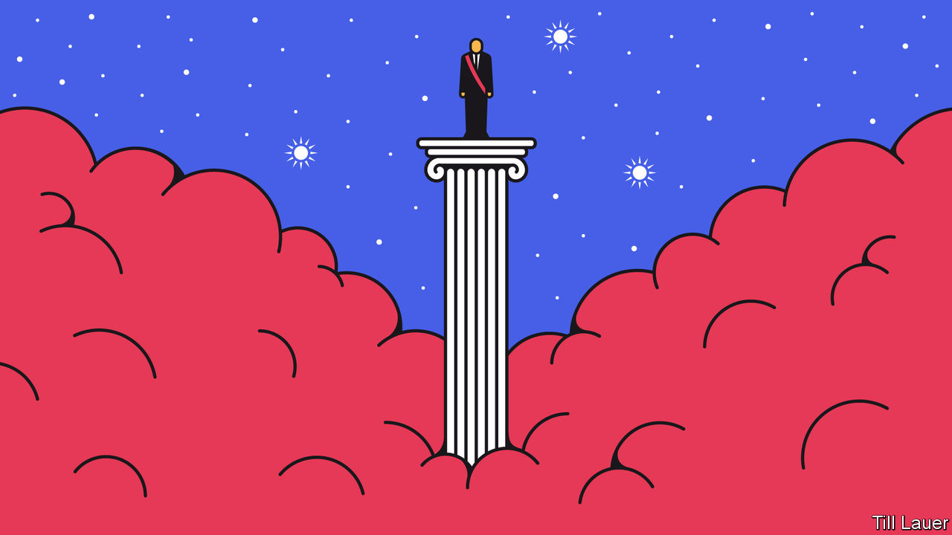

AS TAIWANESE CONTEMPLATED the momentous occasion, in March 1996, of being able to choose their president for the first time, China’s Communist Party launched a campaign of intimidation. Its leaders snarled on television. The armed forces simulated an invasion of Taiwan with beach-landing drills. And missiles landed in the seas around the island, in effect blockading it. The object of China’s fury: the incumbent president, Lee Teng-hui, whom they accused of wanting to split the motherland by formally declaring Taiwan’s independence.

China’s actions backfired. Taiwanese refused to be intimidated. Election rallies were huge. Children rode on parents’ shoulders, air horns lent a carnival air and taxis raced around the capital, Taipei, flying candidates’ flags out of their windows. Never has Banyan witnessed such a boisterous election. Mr Lee’s stump speeches drew crowds to flatter a rock star. Tall and with a near-permanent toothy grin, he was the first leader of the Kuomintang (KMT, or Nationalist) party to address people in their native Taiwanese rather than in Mandarin, the language that KMT carpetbaggers had brought with them when they fled the mainland, defeated by the Communists in 1949. Taiwanese, he said, should not fear China’s “state terrorism”. His victory was emphatic, with more votes than the three other candidates combined. Taxis were still beeping the following day.

Mr Lee died on July 30th, aged 97. The arc of his remarkable life traced Taiwan’s own modern history. He was born under Japanese colonial rule, to a farming family. He studied in Kyoto and joined the Japanese imperial army, though he never saw action.

To Mr Lee, Japanese rule seemed mild compared with that of the KMT under Chiang Kai-shek. The KMT existed to reclaim the mainland from the Communists (even today, Taiwan’s official name is the Republic of China). It brooked no dissent. Anti-government protests on February 28th 1947 led to more than 20,000 Taiwanese—students, artists, doctors, lawyers and intellectuals—being rounded up and shot. It was the start of a decades-long “White Terror”. It was only in 1987 that Chiang’s son, Chiang Ching-kuo, finally lifted martial law.

A young Mr Lee dabbled with communism. A more enduring inspiration was Zen Buddhism. It taught that there is no shame in bending like a reed, nor any wisdom in hurrying. In 1961 Mr Lee was baptised a Christian, and if his evangelism hinted at a messianic streak, it was also rooted in grassroots activism. As an agricultural economist, he was at the heart of Taiwan’s development. A leap in the output of the island’s farms kick-started an economic transformation which later led to calls for political freedom.

For years Mr Lee kept his head down. Still, state goons kept a dossier on him, even filling it with titbits from KMT informers at Cornell University, where he received a PhD. His appointment in 1972 to a ministerial portfolio under Chiang Ching-kuo was an extraordinary turn. Given mounting popular anger at rule by mainlanders, Chiang turned to Taiwan-born politicians to lend the regime legitimacy. Sometimes, Mr Lee later said, of his decision to join the KMT, the safest place “is the most dangerous”.

Mr Lee, in the words of Richard Kagan, his biographer, was the “ultimate Trojan horse”. By 1978 he was mayor of Taipei and by 1984 Chiang’s vice-president. When Chiang died four years later, Mr Lee assumed the presidency, despite efforts by KMT hardliners to thwart him. After students began calling for full-blown democracy in 1990, he promised to institute it, dispensing with the farcical notion that Taiwan ruled China in the process (China did not reciprocate). When he stepped down in 2000, his informal support helped propel the independence-minded Chen Shui-bian to victory. Soon after, the KMT kicked the Trojan horse out.

China’s communists loathed Mr Lee, a “deformed test-tube baby cultivated in the political laboratory of hostile anti-China forces”, especially for promoting a distinct Taiwanese identity, separate from that of China. But he, not they, won the battle for hearts and minds: two-thirds of the island’s citizens identify as Taiwanese first; only 3% as Chinese first. He also helped resist China’s efforts to isolate Taiwan diplomatically. America’s health secretary, Alex Azar, who will this month become the most senior American official to visit Taiwan in decades, may attend his funeral. Even on the way to his grave, Mr Lee has a knack for needling the bullies in Beijing.

This article was downloaded by calibre from <https://www.economist.com/asia/2020/08/05/even-in-death-lee-teng-hui-is-helping-shape-taiwans-identity>

|  |  |  |  |
| --- | --- | --- | --- |
| Previous | Articles | Sections | Next |

|  |  |  |
| --- | --- | --- |
| Asia | Sections | Middle East & Africa |

China

Entertainment: Heady Hunan

.

The civil code: Thirty more days of hell

.

|  |  |  |
| --- | --- | --- |
| Asia | Sections | Middle East & Africa |

|  |  |  |  |
| --- | --- | --- | --- |
|  | Articles | Sections | Next |

#### The magic of Malanshan

# Why TV shows made in China’s Hunan province are so popular

Mao’s birthplace now makes raucous quiz shows

Aug 8th 2020 | CHANGSHA



AMONG THIS summer’s television hits in China has been “Sisters Who Make Waves”. The show involves 30 female celebrities over the age of 30 competing for a spot in a five-member band. Viewers watch them train, perform and live together (some of the contestants are pictured). Five hundred women, picked at random, get to vote for their favourite. Within three days of its airing in June, over 300m had watched the first episode on Mango TV, a streaming app owned by the state television network of Hunan, a central province. Social-media sites brim with praise from young feminists for these somewhat older role models: at last, a break from the devoted mothers and dewy-faced ingénues beloved of official broadcasters.

Making waves is what Hunan Broadcasting System (HBS) does best. It is the most-watched television network after China Central Television (CCTV), the state broadcaster—and occasionally surpasses its ratings. That is striking for an outfit run by the government of a province that is better known as China’s largest producer of rice and the birthplace of Mao Zedong—“red tourism” centred on Mao’s formative haunts draws devotees of the chairman from around the country.

But Changsha, the provincial capital, has become a font of China’s popular culture. It is home to over 12,000 companies involved in creating it. They employ one in eight of the city’s workers. By one official calculation, no other sector contributes more to Changsha’s wealth. In 2017 (the most recent year for which figures are available) creative and cultural industries generated 9% of the city’s GDP—a proportion twice as high as their contribution to national output. At their heart in Hunan is a broadcaster with a knack for cranking out programmes that are watched throughout China. In 2018 HBS’s affiliates produced six of China’s best-liked costume dramas and eight of its most popular songs.

Changsha’s standing has turned its biennial “Golden Eagle” awards into one of China’s three most prestigious prize-giving ceremonies for TV stars. By GDP per person, Hunan ranks 16th among China’s 31 provincial-level regions. But its 67m people are the country’s fifth-biggest spenders on culture, education and entertainment.

Hunan’s journey to national pop-culture prominence began in the 1990s when the provincial broadcasting authorities created a satellite TV station with licence to try something new. It produced lively news reports, a celebrity-led variety show called “Happy Camp” and even a matchmaking programme. By 2000 hotels in Beijing were luring guests with placards boasting, “We have Hunan Satellite TV”, the New York Times observed at the time.

Much of that early success was the work of a Hunanese bureaucrat, Wei Wenbin. When he took over as director of the Hunan Radio and Television Department, Mr Wei read up about America’s entertainment industry. On land once used by a state-run rose farm, he built a vast park for television and film production and moved the new satellite TV station there. The area, Malanshan, has since grown into a cultural powerhouse, drawing media giants such as iQiyi and Tencent. In 2017 eight of the ten most-streamed variety shows on the Chinese internet were hatched there.

Hunan TV was the first network in China to try broadcasting for profit. That led it to focus on entertainment, a priority which helped it avoid political mistakes, as Wu Changchang of East China Normal University has noted. According to Mr Wu, Hunan TV struck a delicate balance between winning the love of viewers and approval from the Communist Party, which is a “prerequisite” of commercial success in China.

The government has occasionally winced. In 2011 it took “Happy Girls”, a fantastically popular singing contest, off air. The official explanation was that the show was too racy for its prime-time slot, but many wondered whether its huge excitable fan base worried the party. In 2004 a forerunner of the show, “Super Girls”, had let spectators vote for contestants by text message—a first in China. That smacked too much of democracy for the government. After a few years Hunan TV limited voting mainly to a studio audience. These days the network strives even harder to please the party. In 2017 it launched a series about ideology called “Socialism is Kind of Cool”. It included a quiz show on the life and works of Xi Jinping, China’s leader.

Yet Hunan’s stations still have “political space to explore new things”, in the view of a manager at Mango TV. The government wants to get “closer to its audience”, he says, in particular to the young who spend hours glued to their smartphones. Internet broadcasters such as Mango TV, with 18m subscribers, help it to do so.

Hunan TV’s ability to experiment matters for the development of Chinese broadcasting. Li Shuwan, a former presenter at the station, says the province is a training ground for much of the country’s television talent. Industry insiders call Changsha the “West Point” of China’s cultural-entertainment industry, a reference to the American army’s elite academy.

It is just as competitive. In 2013 Ms Li was one of only two students from Hunan University who were admitted to Hunan TV’s graduate programme. This year some 30,000 people applied for 100 spots on Mango TV’s trainee scheme. Mango TV encourages young recruits to speak up and suggest fresh ideas. They can receive funding to implement their proposals.

Yang Tianhao, a co-founder of Erka Media, which manages 600 social-media influencers from its offices in China (including Changsha) and Los Angeles, says that young people in Hunan’s capital are risk-takers, with parents who are more willing to let their children try their luck in a fickle industry than counterparts in richer Chinese cities. Well before Hunan’s “Sisters” filled smartphone screens, a Hunanese woman was making them: Zhou Qunfei, the founder of Lens Technology. Born to a poor, rural family, she was named the world’s richest self-made woman in 2018.

People in China like to point to character traits which they believe are shared by natives of a particular province. The executive at Mango TV detects “a cultural gene to break the rules” among Hunanese. For evidence, he points to Mao and Liu Shaoqi, who was born in Changsha and served as Mao’s prime minister. Hunan’s broadcasters certainly have an interest in cultivating the stereotype: an edgy feel is crucial to the success of their brand. ■

This article was downloaded by calibre from <https://www.economist.com/china/2020/08/08/why-tv-shows-made-in-chinas-hunan-province-are-so-popular>

|  |  |  |  |
| --- | --- | --- | --- |
|  | Articles | Sections | Next |

|  |  |  |  |
| --- | --- | --- | --- |
| Previous | Articles | Sections | Next |

#### Thirty more days of hell

# Why China’s divorce law is so controversial

Women are afraid of being trapped in violent marriages

Aug 8th 2020 |

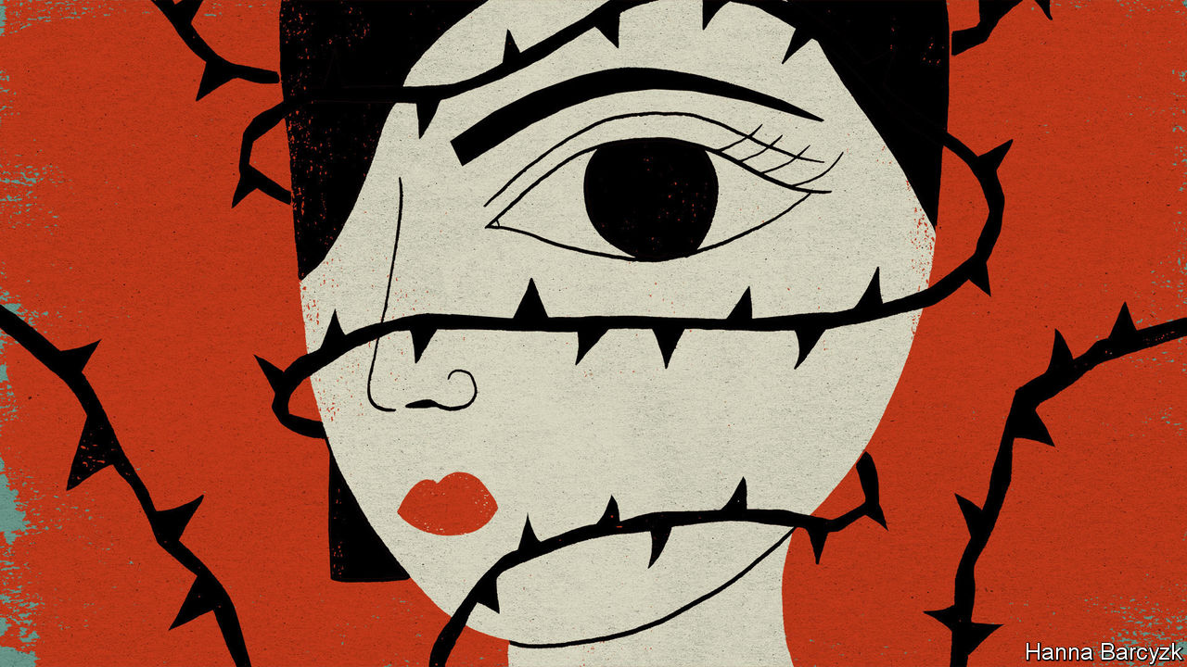

UNDER CHINA’S new civil code, adopted in May, couples will have to wait 30 days between registering their intent to split for good and actually doing so. Nothing wrong with that, some might argue—many other countries have similar “cooling-off” requirements. On matters related to marriage, Chinese law is still remarkably liberal. Yet weeks after the restriction was introduced (it will take effect in January), many netizens remain furious. It will, they say, imperil the lives of women.

The Communist Party sometimes allows, or even encourages, debate about laws before they are passed. But the passions this new requirement has aroused, and their persistence well beyond the law’s adoption by the country’s rubber-stamp parliament, have been unusual. The hashtag “oppose cooling-off” has been viewed over 40.6m times on Weibo, a Twitter-like service. “I am 22 years old this year. I am afraid of getting married after reading the new marriage law,” was one comment.

The government’s motive is clear. It sees happy families as the bedrock of social stability. The country’s soaring divorce rate must therefore be a threat, in its view. Around 5% of divorces are done “rashly”, Sun Xianzhong, a legislator, told state media. A cooling-off period would give spouses a chance to “calm down”, he said.

It was not until after the Communist Party seized control of China in 1949 that women across the country gained the right to divorce their husbands. But divorce did not become common until after 2003, when a month-long delay to allow “examination” of a divorcing couple’s motives by local officials was no longer required. Thereafter, straightforward uncouplings could be processed in a single day. Between 2003 and 2018, divorces per 1,000 people rose from just over one to 3.2, a similar rate to America’s.

Couples who genuinely want to divorce will not be dissuaded by a month of delay. Rather, the cooling-off period will endanger victims of violence, says Lu Pin, a feminist activist who moved to New York after the arrest of fellow campaigners in China in 2015. It is mainly women who will be affected by the new law—they initiate three-quarters of divorces in China.

The legislation says no cooling off will be needed if a spouse suffers abuse. But will officials accept allegations of it? A study in 2017 by academics at Queen Mary University of London and Sichuan University found that, while men in China were overall less likely than those in Britain to get into fights or beat up other people, they were twice as likely to assault their partners. However, in divorce cases that go to court, judges often ignore accusations of abuse, especially when raised by female plaintiffs.

Debate about the new law has been fuelled by news in July of a woman in Henan province who jumped from a building to escape her violent husband. She is now paraplegic. She had filed for divorce, but was required to attend mediation. State media said her plight was no reason to worry about the cooling-off period—she had simply failed to report the abuse quickly enough. If she had not “put up with it”, perhaps the “pain and hurt she endured” could have been reduced, said Southern Metropolis Daily. The cooling-off period may not be a radical change. But, says Ms Lu, “if we had other measures protecting women’s rights, people might not be so angry.” ■

This article was downloaded by calibre from <https://www.economist.com/china/2020/08/08/why-chinas-divorce-law-is-so-controversial>

|  |  |  |  |
| --- | --- | --- | --- |
| Previous | Articles | Sections | Next |

|  |  |  |
| --- | --- | --- |
| China | Sections | Europe |

Middle East & Africa

Lebanon: City in ruins

.

Mali: Fear and loathing in the Sahel

.

Prohibition in a pandemic: Tea-total

.

The pandemic in Africa: One million and not counting

.

|  |  |  |
| --- | --- | --- |
| China | Sections | Europe |

|  |  |  |  |
| --- | --- | --- | --- |
|  | Articles | Sections | Next |

#### Shattered

# Beirut after the blast: the crunch of glass, acrid smoke and stairs slick with blood

Lebanon was in a mess even before the explosion, thanks to a squabbling, inept government

Aug 5th 2020 | BEIRUT

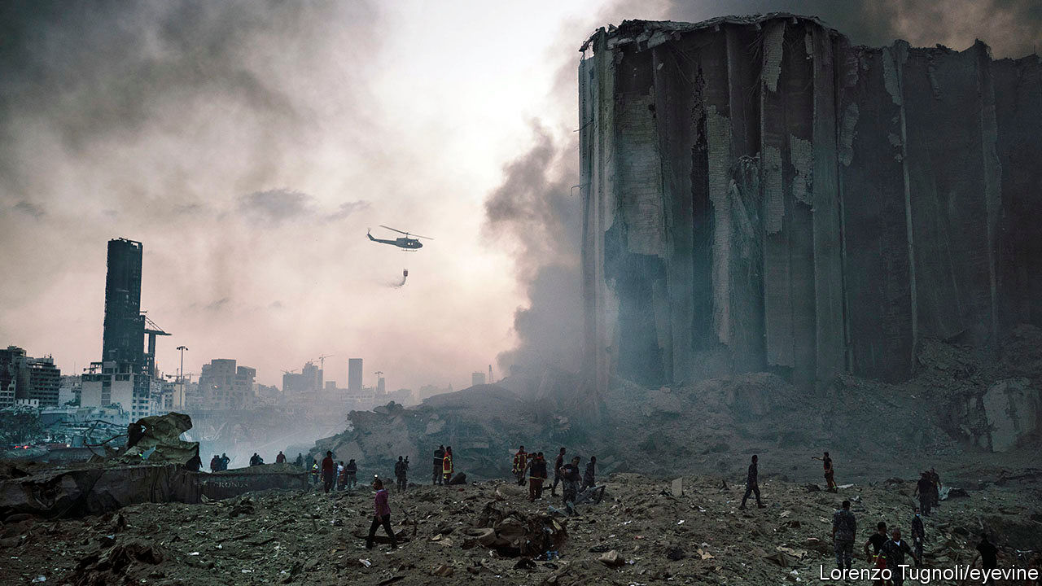

THE CLOCK had just struck 6pm when the world shook. From Sassine Square, one mile (1.6km) from the blast, it seemed like a car bomb or a gas explosion—a disaster, but a localised one. Only on the drive down towards the Mediterranean did the scale of the devastation become clear. Streets were blanketed with broken glass that rained down from battered buildings. At a busy intersection three women sat in the median holding scraps of fabric to bloodied heads. Beirut was an assault on the senses: the crunch of glass under tyres, the wail of sirens, the acrid smell of smoke.

The explosion at Beirut’s port on August 4th was gigantic. Residents of Cyprus felt it, 150 miles (240km) away. Seismological monitors in Jordan registered it as the equivalent of a minor earthquake. The shock wave left much of Beirut’s city centre in ruins. By the next evening the death toll was 135, a number that will surely rise as rescuers dig through the rubble. Another 5,000 people were injured. The financial cost will run into the billions, in a country that can ill afford to pay.

The cause seems to be negligence, a mind-boggling degree of it, even by the debased standards of Lebanon’s government. In 2013 Lebanon seized a cargo of ammonium nitrate, used in fertiliser and in explosives for mining and quarrying, from the MV Rhosus, a Russian-owned vessel plying the seas from Georgia to Mozambique. The chemicals, all 2,750 tonnes of them, were stored in a warehouse at the port. (The Oklahoma City bombers in 1995 used just two tonnes of the stuff to kill 168 people.) Some officials warned of the danger of keeping a giant bomb next to a population centre. Their pleas were ignored.

It is still unclear what ignited the stockpile. Local media suggest that workers were welding nearby. Whatever the cause, it sent forth a towering fireball and a shock wave that slammed across half of Beirut. A sickly plume of reddish smoke lingered over the city long into the night. Scientists interviewed on television warned residents to shut their windows and wear masks because of toxic fumes laced with nitric acid.

The country’s intensive-care wards were already near capacity because of a recent spike in covid-19 cases. None was prepared for the influx of thousands of urgent cases in a single night. At Saint George hospital, a kilometre from the port, the damage was so severe that doctors had to halt surgeries and evacuate the building. Four nurses were killed by the blast and 15 patients on respirators died when their machines shut down. Other patients, clad in their hospital gowns, some with IV lines still attached to their arms, sat bleeding and stunned in a car park across the street. “It’s apocalyptic. There’s no other word for it,” said a neurosurgeon at the hospital.

In a nearby apartment building the stairs were slick with blood left by residents fleeing their ruined flats. Inside, doors were blown off their hinges; furniture took flight. An estimated 300,000 people, nearly 5% of the country’s population, were left homeless by the blast. Some found shelter with family or friends. Others had nowhere to go. They swept broken glass off their furniture and bedded down for the night in flats without windows or doors or electricity. The city looked no better the next morning. Workers with brooms swept up glass until it overflowed dumpsters and piled in heaps on the kerb. Pedestrians looked up nervously as they walked, lest falling debris land on their heads.

Repairing the damage would be a tall order in good times. These are not good times in Lebanon. The economy has all but collapsed since October. Its currency, the pound, had been pegged for decades at 1,500 to the dollar. But the country has run short of dollars to maintain the peg and finance its yawning trade deficit. It can no longer sustain a years-long Ponzi scheme that saw the central bank (Banque du Liban, or BdL) borrow dollars from commercial banks in exchange for above-market interest payments. The pound now trades at more than 8,000 on the black market, an 80% devaluation from the official rate. The government defaulted on its debts in March for the first time in history.

For most Lebanese life has become a seemingly endless succession of crises. Consumer prices are rising by 90% a year and by 246% for food. A 500-gram jar of Nescafé can cost 10% of the monthly minimum wage; a kilo of beef goes for 15%. The army stopped serving meat to soldiers to cut costs. On June 30th the government raised bread prices by a third, the first increase in a decade. Half the country now lives below the poverty line, and three-quarters may need aid by year’s end.

Fuel shortages have led to interminable midsummer blackouts: power cuts in Beirut, normally three hours a day, stretched up to 20 hours in July. Back-up generators ran out of diesel or broke down from overuse, leaving many Lebanese in hot, dark apartments. Ogero, the state telecoms monopoly, has warned of internet outages if it cannot power its infrastructure. The main public hospital treating covid-19 patients had to shut wards and turn off air-conditioners because of the black-outs. Petty crime was already on the rise, even before the explosion that left thousands of apartments open to intruders. One man held up a pharmacy at gunpoint—for nappies. Another robbed a pedestrian, then came back to apologise, saying he needed the cash to feed his family.

The government, installed in January, was meant to be a technocratic one that would tackle the economic crisis. It has accomplished almost nothing. After the default it asked the IMF for a financial agreement worth up to $10bn. Several months and 20 meetings later there is no progress towards a deal—because Lebanon is still negotiating with itself.

The cabinet and the parliament are bickering about the size of the financial sector’s losses. In an economic plan released in April, the government estimated a net loss of 154trn pounds between the BdL and commercial banks. (The plan optimistically envisions an exchange rate of 3,500 pounds to the dollar.) That was the starting point for talks with the IMF. But the country’s bankers are furious about the government plan, which would clean up balance-sheets by wiping out shareholders and the largest depositors. They released their own accounting that estimates losses at less than half the official figure, largely thanks to an even more unrealistic estimate of Lebanon’s future exchange rate. “It’s the same kind of financial wizardry that got us into this mess,” says Henri Chaoul, a former financial adviser to the government.

Mr Chaoul resigned in June in protest over the impasse. The IMF is still talking with the cabinet: they held a meeting on July 10th focused on the electricity sector. But the fund has warned that negotiations can progress only if Lebanon agrees on one set of numbers, or if the cabinet pushes through a few meaningful reforms as a show of good faith. Neither has happened. “It’s criminal,” says Alain Bifani, a former director-general of the finance ministry, who also quit his job in protest.

Add to this, now, the devastation of the Lebanese capital. Damage at the port alone will cost hundreds of millions of dollars to fix. Among the buildings destroyed was Lebanon’s main grain silo, leaving the country with less than a month’s supply of wheat. Homeowners wonder how they will find the cash to pay for new glass or for aluminium window frames. Business owners, barely eking out a profit before the disaster, say they will call it quits rather than rebuild. The government pledged to investigate, and to find the culprits within five days—enough time to name a scapegoat, but not to conduct a serious inquiry.

There is rage in the streets, but also resignation. Lebanon has endured much in its modern history: a civil war from 1975 to 1990, occupations by Israel and Syria, a ruinous war with Israel in 2006, and myriad other conflicts and attacks. The Lebanese prided themselves on their ability to pick themselves up and rebuild their society. This moment feels different. The economic model has failed; so too the power-sharing system that kept the peace between the country’s religions after the civil war. As the country sinks, its venal political class seems oblivious. Gone is the optimism of October, when hundreds of thousands of Lebanese took to the streets to demand the overthrow of an entrenched regime. Now their thoughts are turning increasingly to emigration. ■

This article was downloaded by calibre from <https://www.economist.com/middle-east-and-africa/2020/08/05/beirut-after-the-blast-the-crunch-of-glass-acrid-smoke-and-stairs-slick-with-blood>

|  |  |  |  |
| --- | --- | --- | --- |
|  | Articles | Sections | Next |

|  |  |  |  |
| --- | --- | --- | --- |
| Previous | Articles | Sections | Next |

#### Fear and loathing in the Sahel

# The challenge of mediation in Mali

A short-term political deal may store up more trouble

Aug 8th 2020 | BAMAKO

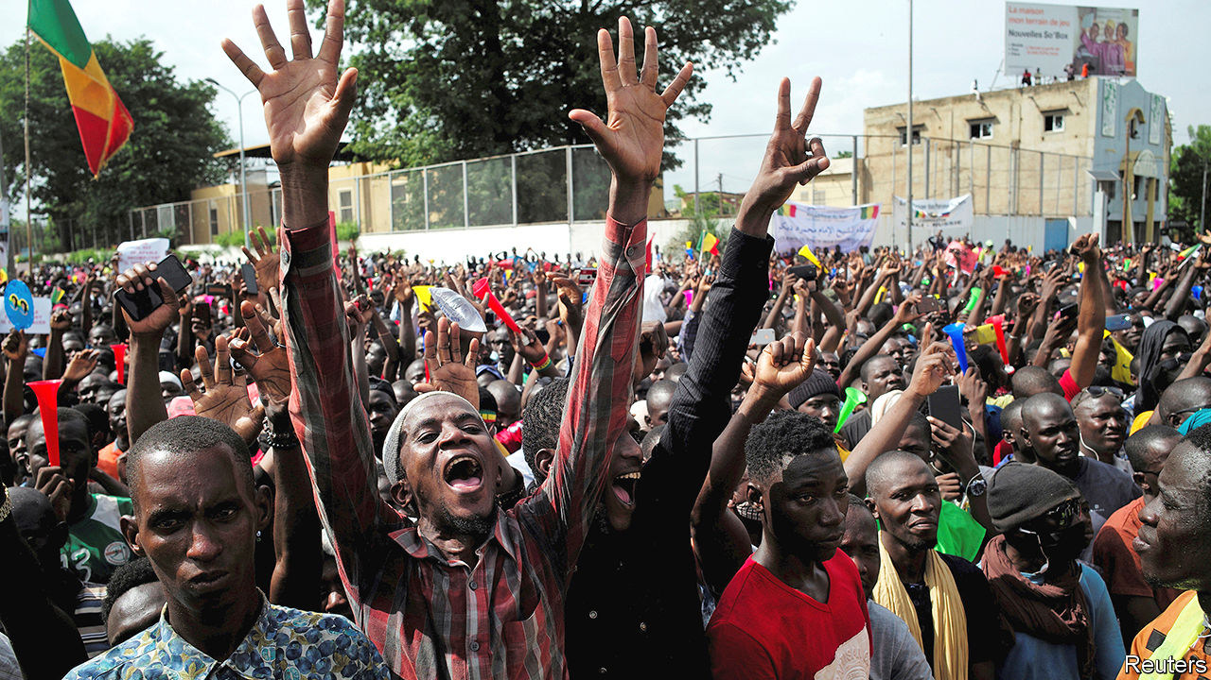

“WE ARE PROTESTING for Mali,” says Cheick Oumar Kanté on the streets of Bamako, the capital, “because Mali is on the road to extinction.” Since June 5th tens of thousands have taken part in demonstrations organised by a group of opposition leaders called the M5-RFP and bolstered by the moral authority of a charismatic imam, Mahmoud Dicko. The protesters have been complaining angrily about the growing jihadist insurgency, Mali’s dire economy and recent dodgy elections. “Nothing works in this country any more,” says Ousmane Dembele, a demonstrator. Their main demand is for President Ibrahim Boubacar Keïta to resign.

The government’s response has lurched between concessions and violence. The protests had been largely peaceful until the weekend of July 10th, when security forces fired on the crowds, killing at least 11 people and wounding 85. Protesters lit fires in the National Assembly building and occupied the state television premises. After a truce for the Muslim holiday of Eid al-Adha, protests have been starting up again.

Western governments are nervous too, since Mali is at the core of Europe’s fight against jihadists in the Sahel. France has 5,100 troops in this fragile region; in 2012 it intervened when jihadists almost toppled Mali’s government. France’s allies, including America, Britain and Germany, have also sent forces, some in a contingent of 15,000 UN peacekeepers. EU troops are also training local soldiers. Yet if Mali’s government is shown to lack legitimacy, Western efforts are more likely to fail.

Dodgy legislative elections in March and April triggered the protests. The poll, which had been delayed for 17 months, was rushed through as the covid-19 pandemic began to spread. Turnout was only 35%. When the results were first announced, the ruling party got 41 of 147 seats, and lost almost all its seats in Bamako. A week later the constitutional court awarded it another ten seats, smoothing the path to a ruling coalition and reinstating close allies of Mr Keïta, one of whom has now been elected president of the national assembly. Though the questionable election provided the spark, it was “neither the principal cause nor the motor of the protests”, says Ibrahim Maïga, who is based in Bamako for the Institute for Security Studies.

Much of the anger stems from the government’s inability to stop the violence. In the first six months of this year more than 1,800 people were killed in fights involving jihadist groups and ethnic militias, about as many as were killed in the whole of last year. On March 25th the main leader of the opposition, Soumaïla Cissé, was seized by gunmen, probably jihadists. He has not been seen since. To make matters worse, the French intervention itself is unpopular. One survey found that almost 60% of Malians think that the French forces are in cahoots with the insurgents.

Malians are fed up with corruption, while the economy goes from bad to worse. Karim Keïta, the president’s son, who heads parliament’s defence committee, is a particular target of derision. He resigned from his post after videos circulated on social media showing him cavorting in Spain with scantily clad women.

Yet President Keïta does not fit the mould of those ousted by protests in other parts of the region. He did not come to power through the barrel of a gun. He has been president since 2013 and is not expected to run for a third term in 2023. The main charge against him is that he is out of touch and incompetent. In normal circumstances he would be voted out.

Some now worry that Mr Dicko will use his growing power to push Mali in a more Islamist direction. In 2009 he campaigned successfully against amending a law that compels married women to obey their husbands. He has inveighed against racy Mexican telenovelas broadcast during Ramadan and against sex education in schools.

Other leaders in the Sahel may be more worried that the crisis could spill over into their countries. In late July five presidents from the region flew to Bamako to mediate. They proposed a reform of the constitutional court, a government of national unity, an inquiry into the deaths of protesters, and new elections for 31 seats in parliament that are still disputed. But the MPs who would have to run again rejected the idea. So has the M5-RFP.

The gap between the parties is still wide. Mr Dicko has suggested there may be a way out without the president having to step down. But the M5-RFP still demands he leaves. There are few good options. Most Malian institutions are in trouble. The constitutional court was dissolved in July. The prime minister’s cabinet has only six ministers. The composition of the national assembly is disputed. If the president were to resign, it would mark “a big jump into the void”, says Ibrahim Yahaya Ibrahim, who is based in Dakar for the International Crisis Group, a conflict-prevention NGO. Yet if Mr Keïta were to stay on, violence in the streets might worsen, he adds.

The truce is over. Some protests resumed on August 3rd. Mr Keïta could still seek to forge a compromise with the protest leaders by sacking his prime minister, Boubou Cissé. After all, he is already on his sixth prime minister in seven years. Yet if he merely plays musical chairs among the elite and ignores deeper problems, says Mr Maïga, “it will only delay the next bomb, the next explosion.” And next time the protests could be led by firebrands far more radical than Mr Dicko. ■

This article was downloaded by calibre from <https://www.economist.com/middle-east-and-africa/2020/08/08/the-challenge-of-mediation-in-mali>

|  |  |  |  |
| --- | --- | --- | --- |
| Previous | Articles | Sections | Next |

|  |  |  |  |
| --- | --- | --- | --- |
| Previous | Articles | Sections | Next |

#### Prohibition in a pandemic

# Why Johannesburg restaurants are full of teapots

Clue: it’s not about the rooibos

Aug 8th 2020 | JOHANNESBURG



UPON ARRIVAL at an expensive restaurant near Sandton, Johannesburg’s financial district, nothing feels unusual, at least in this age of covid-19. The maître-d’ zaps a temperature gun at patrons’ masked faces and spritzes their hands with sanitiser. Only when ushered into the dining room does something seem odd: every table has a pot of tea.

South Africans like their rooibos, but the liquid in many tea-cups is a darker red—claret, even. On other tables there are cans of tonic next to teapots. Reality dawns when two young women are given shot glasses of Jägermeister inside their tea-cups.

South Africa banned alcohol sales for the second time this year on July 12th, so as to prevent drunks from taking up precious space in hospitals. But restaurants, which are struggling to stay afloat, are open and customers are thirsty. “Are you serving special teas?” your correspondent hesitantly asks a waiter. “Yes”, he replies, the ripple of a smile just visible from the edges of his mask.

An unscientific sample of local establishments suggests the patchiness of prohibition. A steak house in an affluent suburb also uses teapots for red wine, and puts cans of fizzy apple juice next to glasses of beer. Other joints are more brazen. At a café popular with families, parents keep one eye on their children ricocheting inside a bouncy castle and the other on their ice bucket.

The willingness of South Africans to flout the booze rules is a sign that bans rarely work. It shows that the police are unwilling or unable to enforce them—at least in rich areas. But it also reflects how many South Africans are reluctant to obey laws set by a ruling party that itself shows little respect for propriety.

In recent weeks local journalists have revealed how members of the African National Congress and their families have won juicy contracts for supplying personal protective equipment, despite having little experience in medical kit. Cronyism has been rife for years, but the sight of “tenderpreneurs” coining it is especially galling when thousands are dying. On August 3rd President Cyril Ramaphosa compared such people to hyenas circling wounded prey.

Yet he has done too little to stop the scavengers. More than two years after he took office, South Africans are waiting for prosecutions to be brought against those accused of wrongdoing during the reign of his predecessor, Jacob Zuma. Meanwhile the former president continues to stall his own trial over an arms deal cut more than 20 years ago. It is enough to make one order a cup of tea.

This article was downloaded by calibre from <https://www.economist.com/middle-east-and-africa/2020/08/08/why-johannesburg-restaurants-are-full-of-teapots>

|  |  |  |  |
| --- | --- | --- | --- |
| Previous | Articles | Sections | Next |

|  |  |  |  |
| --- | --- | --- | --- |
| Previous | Articles | Sections | Next |

#### A million and not counting

# Africa closes in on 1m reported cases of covid-19

The true number will be much higher

Aug 8th 2020 | JOHANNESBURG

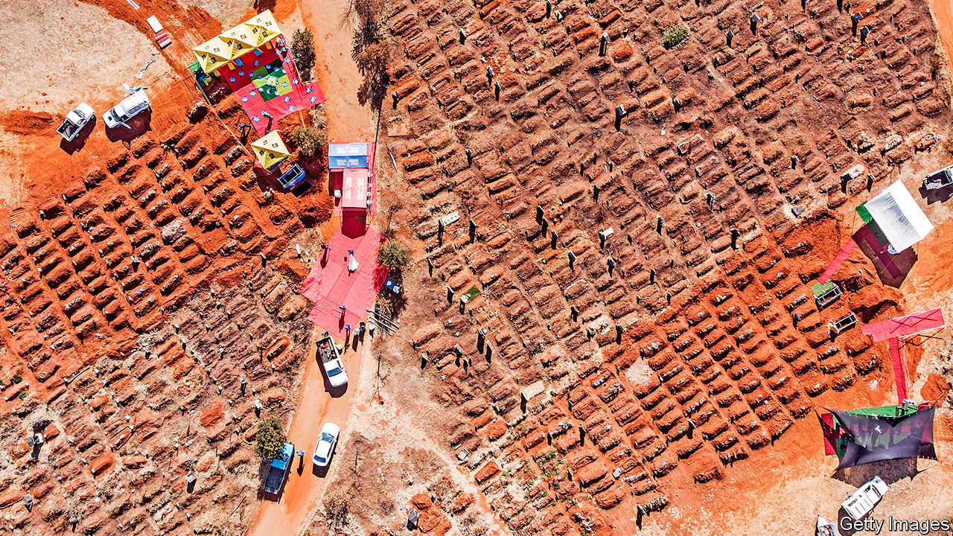

“IT’S BEEN hectic,” says Thabo Nko, an undertaker in Soweto, a township on the outskirts of Johannesburg. Before the pandemic he would do two or three burials in a week. These days he is doing about 20. The nearest public cemeteries are full, so he has to bury some corpses 50km away.

Surprisingly, all the death is not good for business. Overwhelmed authorities are behind on issuing the death certificates families need to claim on their funeral insurance policies. For the first time since opening in 2007, Mr Nko is laying people to rest before he is paid. “I had to drop that rule,” he says. “There is too much to do.”

South Africa has the world’s fifth-highest number of reported cases. It accounts for 53% of the confirmed cases and 43% of deaths from covid-19 in Africa. But that does not mean the rest of the continent is being spared. Instead it reflects a lack of data in most other countries—and how their peaks may be yet to come.

As of August 5th the Africa Centres for Disease Control and Prevention, a public-health body, had recorded 992,710 cases in Africa. It took about five months for the continent to reach 500,000 cases and another month to reach close to 1m. The compound daily growth rate of new cases over the past two weeks was higher in sub-Saharan Africa than in other regions. In reality the millionth African contracted covid-19 many weeks ago.

The full extent of the undercount is unknown. The share of tests that come up positive is below 5% in only a few countries, suggesting widespread underreporting elsewhere. Low test-positivity-rates are found in states with relatively efficient governments, such as Botswana; countries with feared security forces, like Uganda; and those that have both, such as Rwanda.

Elsewhere the shares are much higher. In most of the countries where the International Rescue Committee works the rates are in double digits—for instance Somalia (17%, as of July 30th), Congo (20%), South Sudan (19%), Ivory Coast (16%) and the Central African Republic (16%). Relative to its population, Britain has done 600 times more tests than have the African countries where the IRC works.

Another hint of underreporting is found in the number of cases among Africa’s elites, who are more likely to get tests. At least three of South Sudan’s five vice-presidents have had covid-19. Burundi’s former president, Pierre Nkurunziza, probably died of it. So too did Perrance Shiri, Zimbabwe’s agriculture minister (who was better known for organising mass killings in Matabeleland in the 1980s). Unlike most of the country’s doctors, his pallbearers had protective gear.

Patchy data make it hard to assess many African countries’ responses. Mauritius, an island that quickly closed its borders, has largely suppressed the virus. Rwanda’s track-and-trace system, which includes random testing, has slowed transmission.

Cases seem to be growing quickly in most countries as they loosen lockdowns to try to revive their economies. States that appeared to have the virus under control, such as Ethiopia, Kenya and Zambia, are all experiencing daily growth rates above the regional average. Ghana’s widely praised testing strategy, involving a “pooled method” in which multiple samples are tested at once, is becoming less effective as cases rise. In Nigeria, home to nearly one-sixth of Africans, testing is held back by shortages of reagents and kits. It is using less than half of its testing capacity, according to a survey by the Tony Blair Institute.

Two supposed advantages for African countries are geography and demography. The relative isolation of rural areas was meant to slow transmission. It still might. But, notes Matshidiso Moeti, the head of the WHO Africa region, “the virus has spilled out of major cities and spread into distant hinterlands.”

The continent’s youthfulness is more of an obvious boon. Most Africans were born in the 21st century. Africa has a lower share of people over the age of 65 than any other continent. A recent paper published by the American Journal of Tropical Medicine and Hygiene argued that Uganda’s age structure will keep death rates lower than in other parts of the world. (Other pan-African models suggest that such advantages are outweighed by poor health systems.)

About 2% of Africans diagnosed with covid-19 have died. That is only half the global average. But such numbers should be treated with great caution. There is a delay between diagnosis and death, so the rate can be misleading when infections are rising rapidly. Also, only a few African countries keep good cause-of-death records. The WHO says it is trying to improve this, but the work is not happening fast enough. And politicians may not see it as in their interest to reveal how many people have died on their watch.

Even in South Africa, which has reliable records, the toll is probably far higher than the official tally of 9,298. On August 5th the country’s Medical Research Council noted that from May 6th to July 28th there were 28,329 more deaths from natural causes than forecast by historical trends. The vast bulk of these will probably have been related to covid-19.

Such data chime with Mr Nko’s experience. South Africa has an older population than other African states. But many covid-watchers fear that what is happening at the southern tip of the continent may be repeated elsewhere. Whether it will be recorded is another question. ■

Editor’s note: Some of our covid-19 coverage is free for readers of The Economist Today, our daily [newsletter](https://my.economist.com/user#newsletter). For more stories and our pandemic tracker, see our [hub](https://www.economist.com/news/2020/03/11/the-economists-coverage-of-the-coronavirus)

This article was downloaded by calibre from <https://www.economist.com/middle-east-and-africa/2020/08/08/africa-closes-in-on-1m-reported-cases-of-covid-19>

|  |  |  |  |
| --- | --- | --- | --- |
| Previous | Articles | Sections | Next |

|  |  |  |
| --- | --- | --- |
| Middle East & Africa | Sections | Britain |

Europe

Racism in Europe: See no evil

.

Open again: Genoa bridge reopens

.

Turkey: Sultan of censorship

.

Covid-19 in the Balkans: Not as stated

.

Charlemagne: Strandkörbe in place of sangria

.

Spain: The signal turns to red

.

|  |  |  |
| --- | --- | --- |
| Middle East & Africa | Sections | Britain |

|  |  |  |  |
| --- | --- | --- | --- |
|  | Articles | Sections | Next |

#### See no evil

# American ideas about racism are influencing Europe

But it is hard to measure bias in countries that don’t collect ethnic data

Aug 8th 2020 |

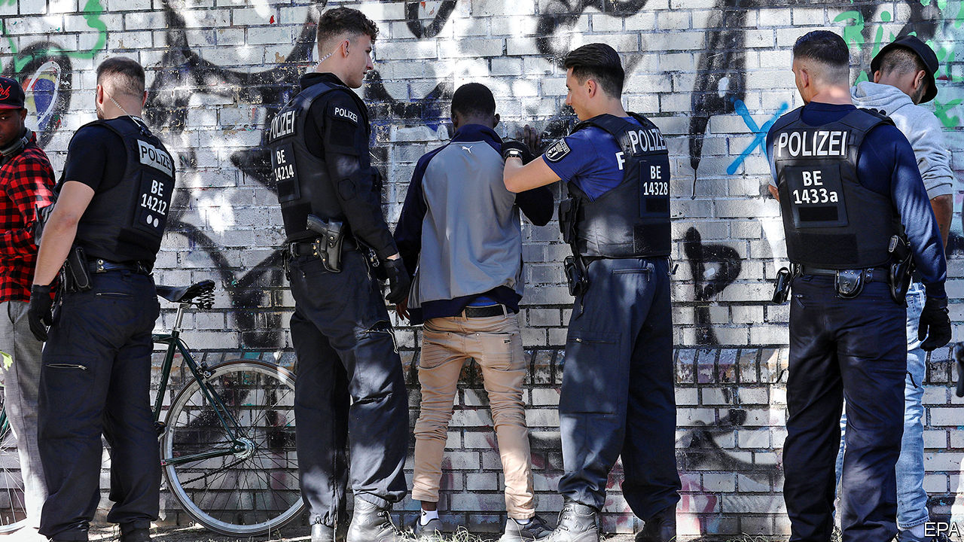

FROM THE 1940s-60s, philosophical ideas about racism tended to flow westward across the Atlantic. Writers of the Francophone négritude school such as Léopold Senghor and Aimé Césaire foreshadowed America’s “black is beautiful” movement, as did Jean-Paul Sartre’s essay “Black Orpheus”. Frantz Fanon’s polemics against French colonialism influenced American debates on violence in the civil-rights movement. African-American writers and musicians like Richard Wright, Miles Davis and Nina Simone went to Europe to escape America’s colour bar. Analyses of Nazi racism by the philosophers of Germany’s Frankfurt School crossed the Atlantic with Hannah Arendt and Herbert Marcuse. Marcuse’s student Angela Davis earned her doctorate in Berlin; after she joined the Black Panthers, ending up on the run from the FBI, James Baldwin wrote in support of her from his home in France. Segregationists made the most of all this, disparaging the civil-rights movement as a conspiracy of European socialist eggheads.

This summer, as the Black Lives Matter movement spread internationally, some Europeans felt that the tide had turned: the latest American ideas about racism were now flowing into Europe. Academics—especially those who have studied in America—have embraced concepts like institutional racism and white privilege, eagerly translated by local news media (“weisse Privilegien”, “le privilège blanc”). Activist journalists like Rokhaya Diallo in France, Alice Hasters in Germany and Clarice Gargard in the Netherlands are elated that anti-black racism is being taken so seriously. So are many Europeans, black and otherwise.

Yet others see it as part of what Régis Debray, a French centre-left thinker, calls the “Americanisation of Europe”. Some argue that the focus on anti-black racism diverts attention from bigotry against Muslim minorities, who are more numerous in Europe. Paul Scheffer, a Dutch immigration scholar, thinks applying an American conception of race gets it wrong: “African-Americans’ history is one of slavery and forced segregation, but the history of black communities in Europe is one of migration,” with more social mobility and fluid status. The question is whether the new American-influenced vocabulary fits.

One tug-of-war is over the term institutional racism, meant to convey that systems can produce racist outcomes even if no one in them is racist. French and German government bodies accept the term; but deny it describes them. However, they generally do not gather data on ethnicity, an ostensibly anti-racist measure that makes it almost impossible to detect institutional racism. Last month Germany’s interior minister cancelled an inquiry into institutional racism in the police. France’s interior minister resists calls to probe the police. Yet in 2015 a study found that 22 out of 26 recent victims of French police killings were “visible minorities”. Some Dutch cops cheerfully admit racial profiling, notably in the case of Typhoon, one of the country’s top rappers, whose car they stopped in 2016 because it was posh and he is black. In June Mark Rutte, the Dutch prime minister, said the Netherlands suffers from systemic but not institutional racism. No one knew what he meant.

There is more to institutional racism than policing. In most European countries some groups with immigrant backgrounds do worse in school than white natives. Exams relying heavily on language proficiency often split students into university- or vocational-track education by the age of 12. Residential segregation occurs partly because immigrants are steered into public housing and partly because of discrimination. In one study 95% of callers with native German accents got appointments to view houses in a wealthy neighbourhood of Bremen, whereas only 24% of callers with Turkish accents did.

Then there is employment discrimination. A Dutch study in 2018 that responded to job listings with imaginary résumés, varying only their ethnicity, found that fictitious applicants with non-Western immigrant backgrounds got 30% fewer invitations to interviews than native whites. Depressingly, a similar study in 1977 got about the same result. In the same vein, in 2019 the Dutch tax authority was found to have withheld child benefits wrongfully from some 11,000 parents, most with non-Western immigrant backgrounds, over baseless suspicions of fraud. Many were financially ruined and the government will pay them €500m ($590m), but the authority was exonerated of racism because it had selected them on the basis of dual nationality.

Those who think terms like institutional racism fit America but not Europe make some good points. Of the 1.5m convicts in American prisons in 2018, a third were black, nearly treble the black share of the population. It is uncertain how skewed French and German law enforcement are (since ethnic data are scarce), but overall they shoot and jail people at less than a fifth America’s rate, so the damage is less grave. Even in segregated European cities like Paris, no group approaches the degree of segregation of blacks in American cities. Europe’s generous welfare states also help to smooth out racial disparities. More subtly, “Black Lives Matter” takes on a different flavour in countries where African and Caribbean minorities (often former colonial subjects) are part of a fluid hierarchy of groups of colour. Whereas the income gap between black and white Americans has grown since 2000, all Dutch minority groups are catching up, if slowly.

None of that erases the reality of discrimination in Europe. Indeed, Ms Gargard says, to belittle the new vocabulary of racism as an ill-fitting American import is to dodge responsibility: “It’s been difficult to talk about racism in European countries because we like to pretend we are tolerant, and that racism is something that happens in the United States.” ■

This article was downloaded by calibre from <https://www.economist.com/europe/2020/08/08/american-ideas-about-racism-are-influencing-europe>

|  |  |  |  |
| --- | --- | --- | --- |
|  | Articles | Sections | Next |

|  |  |  |  |
| --- | --- | --- | --- |
| Previous | Articles | Sections | Next |

#### Open again

# Genoa bridge reopens

Aug 8th 2020 |

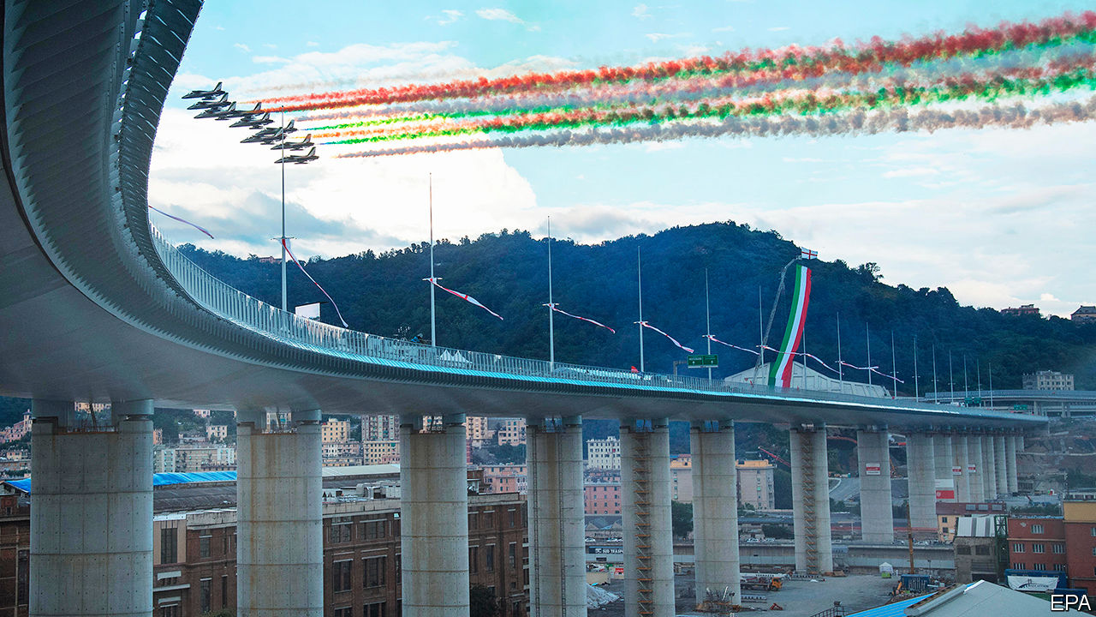

JUST TWO YEARS after its famous bridge suddenly collapsed, killing 43 people, the Italian city of Genoa inaugurated a sleek new replacement in the presence of the country’s president and prime minister, as well as an air-force flypast. The feat of engineering was impressive. But many of the victims’ relatives stayed away, objecting that the tragedy had been turned into a carnival.■

This article was downloaded by calibre from <https://www.economist.com/europe/2020/08/08/genoa-bridge-reopens>

|  |  |  |  |
| --- | --- | --- | --- |
| Previous | Articles | Sections | Next |

|  |  |  |  |
| --- | --- | --- | --- |
| Previous | Articles | Sections | Next |

#### Sultan of censorship

# Turkey’s president cracks down on social media

Uppity netizens insulted Recep Tayyip Erdogan and his son-in-law, the finance minister

Aug 8th 2020 | ISTANBUL

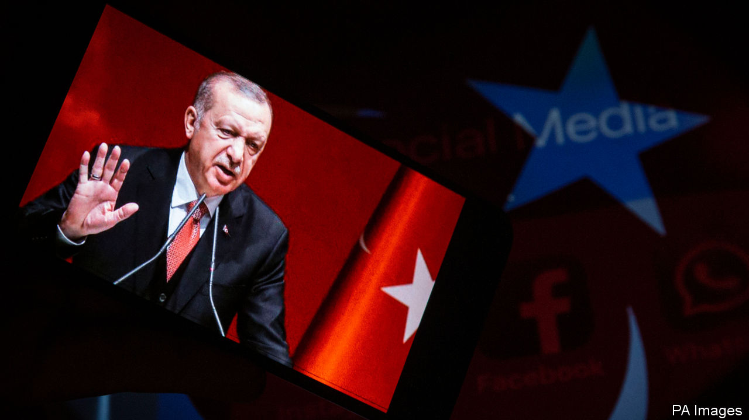

TURKEY’S PRESIDENT, Recep Tayyip Erdogan, has already neutered the traditional media, putting critical journalists out of work or behind bars and using friendly tycoons to take over the country’s top newspapers and news channels. Now he has taken aim at the internet.

His latest assault came on July 29th when parliament adopted a law designed to force social-media giants to comply with Turkish requests to remove content. Henceforth, companies such as Twitter and Facebook will have to appoint local representatives to process such requests within 48 hours. Those who do not comply will face bans on advertising, fines of up to $6m, and eventually bandwidth cuts of up to 90%, which would make them unusable.

The government says the law will protect social-media users from abuse and disinformation. Critics say it will become a powerful censorship tool. Turkey already blocks at least 400,000 websites, says a report by the Freedom of Expression Association, a rights group, and churns out more Twitter and Reddit content-removal requests than any other country. Armed with the new rules and a pliant court system, the government will lean even harder on such companies to take down politically inconvenient material, including old posts, says Yaman Akdeniz, a lawyer. “Articles will vanish from archives,” he warns. “They will try to delete the past.”

Others are worried about provisions requiring user data to be stored locally. “The law says the government can access these data only when they concern a crime or a national-security issue or similar reasons,” says Ahmet Sabanci, a tech writer, “but in Turkey these kinds of laws are bent easily.”

With most of the mainstream press in Turkey now in the hands of Mr Erdogan’s allies or businessmen who depend on his government for large contracts, social media have been a sanctuary for dissent. Police are now bursting into that sanctuary. Over the past three years, hundreds of people have been detained for criticising Turkish military offensives against Kurdish insurgents in Syria. Dozens have been investigated on charges of attempting to “destabilise the economy” with their tweets. Where targeted bans do not suffice, the government uses blanket ones. Wikipedia was banned between 2017 and this January. “I’m a lot more nervous,” says a popular Twitter commentator, preferring not to be named. “I feel like the frog in the pan when the water is starting to boil.”

For the thin-skinned Mr Erdogan, the motivation seems to be at least partly personal. Tens of thousands of cases have been opened against people accused of “insulting” Turkey’s leader, mostly on social media. (These include a user who compared Mr Erdogan to Gollum, a power-worshipping imp.) At least 11 were detained on July 1st for posting crude comments about the president’s daughter and his son-in-law, Turkey’s finance minister, after the birth of their new child. “This is why we should bring this to our parliament,” a furious Mr Erdogan said, “to remove these social-media networks completely, to control them.” He seems to mean it. ■

This article was downloaded by calibre from <https://www.economist.com/europe/2020/08/08/turkeys-president-cracks-down-on-social-media>

|  |  |  |  |
| --- | --- | --- | --- |
| Previous | Articles | Sections | Next |

|  |  |  |  |
| --- | --- | --- | --- |
| Previous | Articles | Sections | Next |

#### Not as stated

# Balkan governments said the coronavirus was under control

They spoke too soon

Aug 8th 2020 |

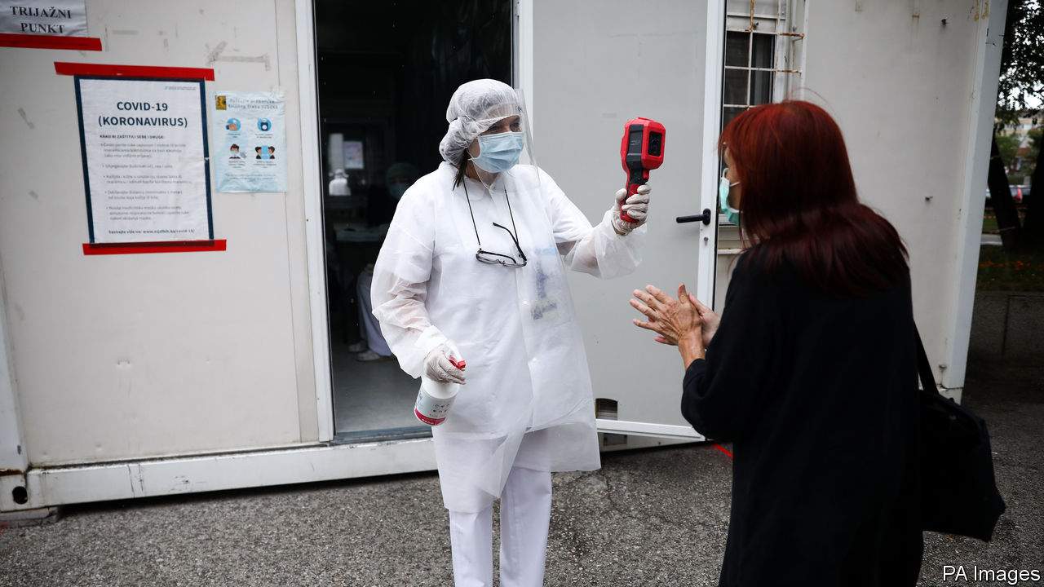

FOR A FEW months it seemed that the Balkans were having a good pandemic. Infection and death rates were low. In March, as covid-19 began to spread fast across Europe, most Balkan countries locked down quickly and strictly. In May the Montenegrin prime minister crowed that his was the first covid-free country on the continent. But by the end of July Montenegro had the second-highest infection rate in Europe. Now, eight of the ten European countries with the fastest-rising infection rates are in the Balkans. If it were ever true that early firm action had worked, that advantage was lost with rapid reopenings. Or perhaps the early numbers were wrong, thanks to poor measurement or a cover-up; maybe the picture was never as good as it had seemed to be.

Until the beginning of June, according to Serbian statistics, only 244 people had died from the disease. Then an investigative report claimed the true figure was 632. The president and government, at the time engaged in an election campaign, denied that it was trying to suppress the real numbers. But Gorica Djokic, a leader of Serbia’s doctors’ union, said the higher figures matched those the union received from colleagues across the country.

Today, says Dr Djokic, and under pressure from 2,870 angry doctors who have signed a letter of protest, the authorities seem to be publishing more accurate figures. She reckons that one reason for the low infection numbers in the early months was that there was hardly any testing. Today there is more. But even Serbian doctors who, like her, work in covid hospitals are still not being tested. She thinks the authorities fear the health system would be crippled if all the doctors carrying the virus took weeks off work.

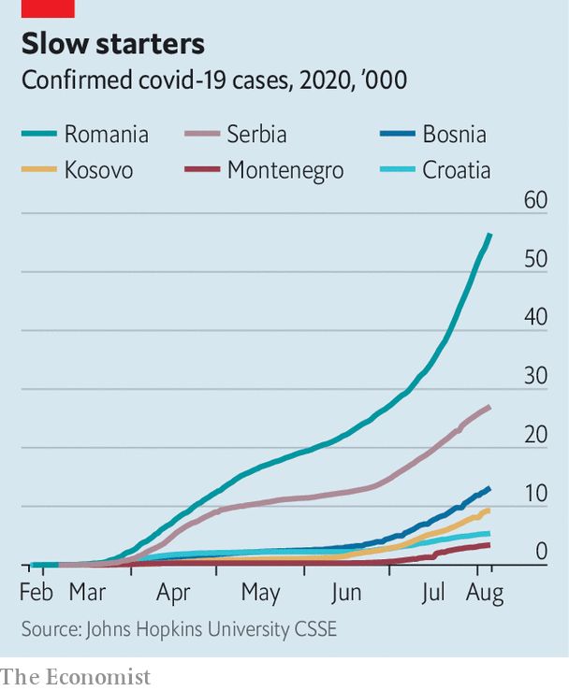

As in much of the rest of Europe, official messages have been confusing. In the Balkans this confusion has been compounded by low levels of trust in government. Many people believe the government is lying about there even being a virus, says Brikena Hoxha of the Kosovar Stability Initiative, a think-tank; and that it is paying families to claim relations died from covid-19 as part of a scam to procure foreign aid.

In March Kosovo’s president, then embroiled in a political dispute with the prime minister and his government, told citizens they could ignore its instructions to stay at home. On August 2nd the prime minister announced that he had tested positive for the virus. Unchecked, families wander in and out of hospital to buy food and medicine for their infected relatives. Thousands are now flocking to Albania, where they are packing the beaches in scenes similar to those on the Romanian Black Sea coast; the number of infections in Romania is also rising fast.

As for Bosnia, Adi Cerimagic, an analyst, says that although hospitals have been coping well, scandals in covid-related procurement have led many to believe that “while they locked us down, they were making money with it.” In May Silver Raspberry, a well-connected fruit-and-vegetable firm, bagged a $5.8m contract to supply ventilators. In June Novak Djokovic, Serbia’s tennis star, ignored advice and went ahead with a regional tournament he had organised. He hugged and partied with his Croatian and Bulgarian tennis buddies, several of whom were infected.

Large minorities believe covid conspiracy theories, which are often promoted by prominent people, including a former Serbian minister of health. Clerics have also played a role. In Montenegro infections have shot up as holidays begin, and also after huge anti-government demonstrations led by the Orthodox church. Across the region the pandemic has coincided with Orthodox, Catholic and Muslim festivals which have brought families and flocks together. Worse, says Mr Cerimagic, in this poor part of Europe the pressure to return to work is immense, and that pushes up infection rates further. ■

Editor’s note: Some of our covid-19 coverage is free for readers of The Economist Today, our daily [newsletter](https://my.economist.com/user#newsletter). For more stories and our pandemic tracker, see our [hub](https://www.economist.com/news/2020/03/11/the-economists-coverage-of-the-coronavirus)

This article was downloaded by calibre from <https://www.economist.com/europe/2020/08/08/balkan-governments-said-the-coronavirus-was-under-control>

|  |  |  |  |
| --- | --- | --- | --- |
| Previous | Articles | Sections | Next |

|  |  |  |  |
| --- | --- | --- | --- |
| Previous | Articles | Sections | Next |

#### Charlemagne

# Germans learn to love the staycation

Thanks to covid-19, the traditional German holiday looks very different this summer

Aug 8th 2020 |

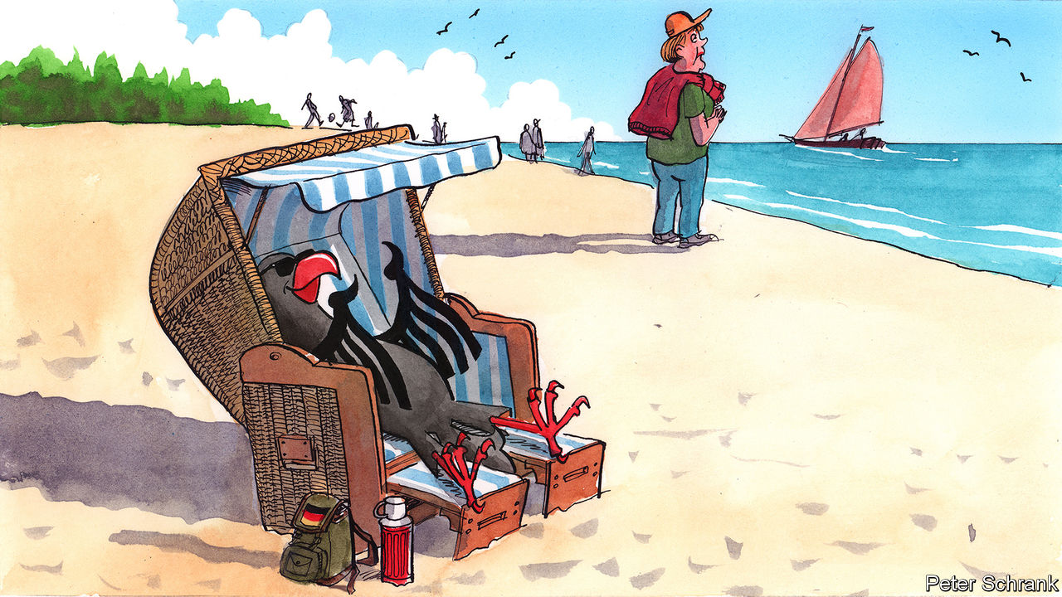

GERMANS HAVE long dreaded the prospect of a European “transfer union” that would hand their hard-earned money to poorer southerners. Yet every summer they are happy to do the job themselves, travelling in their millions, and spending in their billions, to Spain, Italy, Greece and Portugal. Germans account for roughly one in every four euros dished out by European tourists. More than anyone else, it is their absence that the deserted hotels, bars and restaurants of Europe’s south have felt most acutely this summer.

Such were the thoughts that came idly to Charlemagne as he bobbed gently in the Baltic Sea this week. (Not quite as cold as you might imagine, although he didn’t linger.) A brief stay in Rügen, a resort island off Germany’s north-east coast, was enough to witness the other side of the devastation that the coronavirus has visited upon the tourist industries of southern Europe. For Germany’s holiday hotspots—the coasts, Bavaria’s mountain hideaways, the Black Forest—are booming, happily lapping up much of the displaced German tourist spend. The influx has been “extreme”, says Mario Jacobs, who runs a fish restaurant in Stralsund, a handsome town near Rügen, and can’t quite seem to decide whether the extra business is worth the extra work. Hordes of day-trippers to the North Sea coast have forced officials to impose temporary mask-wearing orders and beach closures.

In fact a good summer and, with luck, a strong autumn will hardly make up for a spring in which, like almost every other part of the economy, Germany’s resorts shuttered and furloughed their workers. Even now second-tier sites, like the Eifel region or the Harz mountains in central Germany, are struggling to attract enough locals to replace the lost foreign trade. One-third of the country plans to take no holiday at all. This is no small disruption for a place that takes its pleasure as seriously as Germany.

For many Italians, Spaniards, French folk and Greeks, holidaying anywhere other than in their home country seems perverse. By contrast, young Germans who choose to do so “might come across as a little bit backward,” says Sina Fabian, a historian at Humboldt University. “We can also do GERMANY!” is the slightly desperate motto adopted by one travel agency. If Germans took to foreign travel a little later than the British, they eventually did so with the zeal of the convert, aided by the mighty Deutschmark and some of Europe’s most generous holiday allowances: by 1968 half the West German population went abroad at least once a year. The ritual of the sun-soaked southern-Europe sojourn, traceable to Goethe’s romantic journeying in Italy, was later immortalised in Schlager songs like Udo Jürgens’s “Urlaub im Süden” (“Holiday in the South”). In 1993, when a politician said that Germany might as well buy Majorca for 50m marks, not everyone was sure he was joking.

Yet in truth Germans were starting to warm to the wonders of their own land even before covid-19, notes Hasso Spode at Berlin’s Technical University. They may travel abroad more than other folk, but trips in Germany far outnumber those to anywhere else: a quarter of Germans’ holidays last year were spent at home. The secret of Rügen, at least among Germans (foreigners, bar the odd Scandinavian, are as rare as hens’ teeth), is long out. Mile-long traffic jams and overcrowded beaches are features of every high season. Despite patchy infrastructure, and its distance from most of Germany’s big population centres, Mecklenburg-West Pomerania, the state through which most of Germany’s Baltic littoral runs, has been the country’s most popular holiday destination for years.

And why not? The virtues of the domestic holiday are much underrated, in Germany and other northern European destinations. True, Germany may not carry the languid allure of the Mediterranean, and even the geniuses that staff its tourist agencies can do nothing about its climate (mild sunburn testifies to Charlemagne’s luck in Rügen). Stepping off the train in Stralsund, this columnist admits his heart sank to see the same döner stands and strawberry kiosks he had left behind three hours earlier in Berlin.

But such trifles are surely outweighed by the advantages. More often than not the hunt for authenticity abroad results in difference-splitting compromise or, worse, surrender to tourist traps. At home the scams are easier to spot. For people-watchers the daily human comedy is enriched when conducted in a language one understands. Sightseeing becomes an investigation of one’s own national story. Just north of the beach that hosted Charlemagne’s inquiries sits a vast strength-through-joy holiday complex left unfinished by the Nazis, a jarring contrast to the innocent pleasures of the seaside resorts. And even changeable weather conceals a thrill: how much more enticing the warmth of the sun when one knows it might disappear at any moment.

## From one transfer union to another

Creatures of habit at the best of times, Germans have struggled to adapt to the disruption. Tourist officials in Rügen describe first-time visitors used to all-in-one package trips unfamiliar with the idea of following a map or booking a restaurant. But the island is practised at diversifying its offerings, retaining a nostalgic appeal to older east Germans who recall the communist beach holidays of their youth while reaching out to richer greenhorns. Local officials, of course, welcome the custom. “Normally you spend a lot on marketing, and this year it came for free!” exclaims one.

Yet the shift is unlikely to be permanent, reckons Ms Fabian. Previous catastrophes have not bucked long-term trends in travel habits. A good thing for southern Europeans, for whom coronavirus has delivered a vicious one-two: domestic lockdown followed by evaporating tourism. Indeed, it was hair-raising forecasts of economic collapse in Italy and Spain that recently convinced Rügen’s MP, one Angela Merkel, to consent to large-scale common EU borrowing and redistribution for the first time. Precisely because Germany’s tourists are not spending in Europe’s south this summer, its taxpayers are preparing to do just that. ■

Editor’s note: Some of our covid-19 coverage is free for readers of The Economist Today, our daily [newsletter](https://my.economist.com/user#newsletter). For more stories and our pandemic tracker, see our [hub](https://www.economist.com/news/2020/03/11/the-economists-coverage-of-the-coronavirus)

This article was downloaded by calibre from <https://www.economist.com/europe/2020/08/08/germans-learn-to-love-the-staycation>

|  |  |  |  |
| --- | --- | --- | --- |
| Previous | Articles | Sections | Next |

|  |  |  |  |
| --- | --- | --- | --- |
| Previous | Articles | Sections | Next |

#### The signal turns to red

# Spain’s high-speed trains are poor value

Yet more are planned

Aug 8th 2020 | MADRID

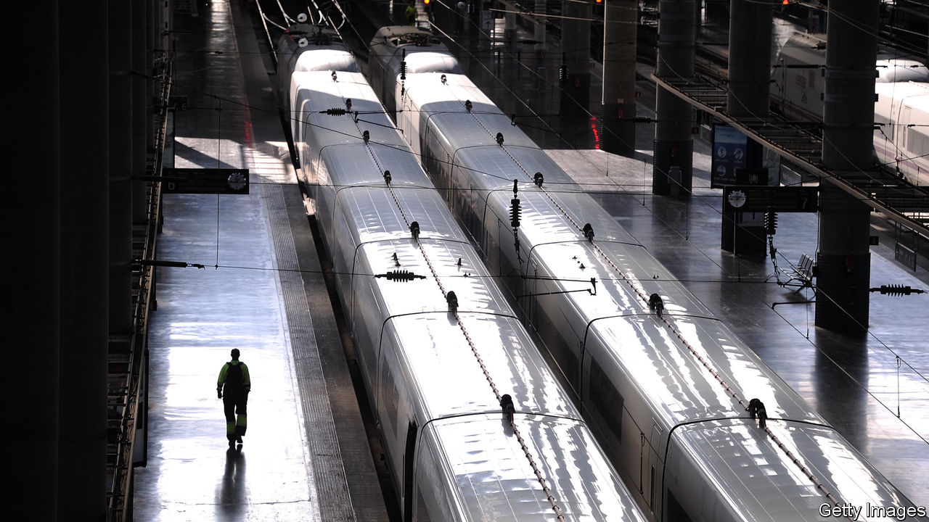

ATOCHA STATION in Madrid is a daily marvel. From its platforms a phalanx of sleek white high-speed trains, known as AVEs, streak across Spain. Punctual and comfortable, they have slashed journey times in a large and mountainous country long notorious for poor transport. For Spaniards, they are an icon of modernity. But many are not worth the money spent on them, says a new report by the independent fiscal authority (AIREF from its Spanish initials).

Over the past three decades Spain has poured money into transport infrastructure, including motorways and airports as well as AVEs. It now has 3,086km (1,929 miles) of high-speed rail lines (over 250km per hour), second only to China. Passenger numbers have almost doubled in the past decade, as the AVEs have grabbed business from domestic flights. Even so, per kilometre of track, there are less than a third as many as in France.

The network has cost €61bn ($72bn) so far. AIREF has now done the first thorough cost-benefit study of the trains. It finds that the benefits, including to the environment, are less than the total cost, though it thinks that could eventually change for the lines from Madrid to Seville and to Barcelona. But there are plans for a further 5,654km of high-speed lines, at a cost of at least €73bn. Far better, says AIREF, to invest in neglected commuter networks, which carry 89% of rail users. It urges the setting up of an independent agency to set transport priorities and evaluate projects.

The Socialist-led government broadly welcomed the report. It may find it hard to implement. One problem is that some of the pending lines are half-built, such as those to Galicia and in the Basque Country. It may make sense to finish them. “The important thing is to stop new lines starting,” says Ángel de la Fuente of Fedea, a think-tank. Since they would serve less-populated areas, they would have even fewer passengers.

Places that lack high-speed trains understandably feel left out. Take Extremadura, the poorest region of mainland Spain: ancient diesels take six hours to cover the 400km between Madrid and Badajoz. The covid-19 crisis means that money will be especially tight. But Spain’s Congress is more fragmented than ever. That means that the price of a vital vote is sometimes the promise of yet another high-speed track.

This article was downloaded by calibre from <https://www.economist.com/europe/2020/08/08/spains-high-speed-trains-are-poor-value>

|  |  |  |  |
| --- | --- | --- | --- |
| Previous | Articles | Sections | Next |

|  |  |  |
| --- | --- | --- |
| Europe | Sections | International |

Britain

Scottish independence: Is Caledonia Catalonia?

.

Covid-19 in Scotland: Independence fever

.

Food and trade: A pig of a problem

.

Planning reform: Weak foundations

.

Masks and culture: Made in the USA

.

John Hume, 1937-2020: A dove over Derry

.

Bagehot: The smell of rot

.

|  |  |  |
| --- | --- | --- |
| Europe | Sections | International |

|  |  |  |  |
| --- | --- | --- | --- |
|  | Articles | Sections | Next |

#### Scotland

# How the Scottish National Party risks turning Caledonia into Catalonia

The independence battle looks like turning into an ugly stalemate

Aug 8th 2020 |

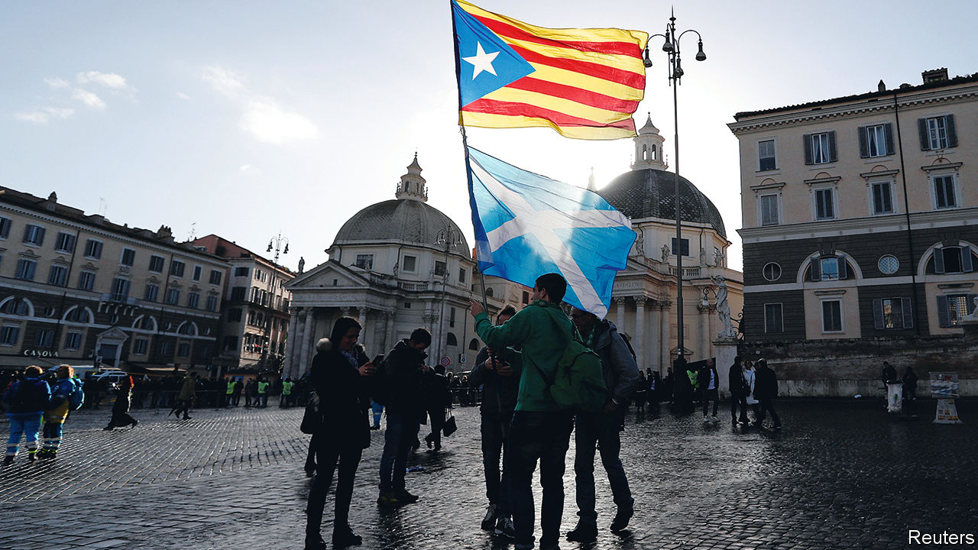

THE INDEPENDENCE marches which occasionally wind through grey Scottish cities are colourful affairs. The blue and white of the Saltire jostle with the red and yellow of the Estelada, the banner of Catalonia’s separatist movement.

The struggle for Catalan independence from Spain has been an inspiration not just for Scotland’s nationalists: it also influenced David Cameron, the Conservative prime minister who permitted and then won the referendum on independence in 2014. If he had not, he wrote in his memoirs, the question of Scotland’s future would have festered and the case for independence grown stronger. Catalonia held an illegal referendum in 2017, which was followed by arrests and riots. It was, wrote Mr Cameron, a lesson in the perils of mishandling separatists.

Those boasts do not look so clever today. Recent polls show Scots favouring independence—the first time that a sustained lead for independence has been seen, says Sir John Curtice, a political scientist at the University of Strathclyde. One factor, he says, is Brexit, which has pushed Remainers into the hands of Nationalists. While Brexit has degraded the British government’s reputation for competence and sound judgment, managing coronavirus has built up the Scottish government’s (see [article](https://www.economist.com/node/21790477)). Mr Johnson is unpopular. The Scottish National Party is projected to take 55% of the vote in the elections to the Scottish Parliament in May 2021, according to recent polls, which would give Nicola Sturgeon, Scotland’s first minister, an outright majority, and allow her to demand a second referendum on independence.

The Conservative Party is spooked. Boris Johnson made a flying visit to Orkney on July 23rd, where he said the “sheer might of our union” had seen Scotland through coronavirus. On July 30th Jackson Carlaw, leader of the Scottish Conservatives, was ousted after only six months in the job. He admitted that he was not up to the job of defending the union. His replacement, Douglas Ross, is the pugilistic MP for Moray and a part-time football referee.

Mr Cameron thought the best way to contain separatism was an “agenda of respect” towards the Edinburgh administration. Mr Johnson, in contrast, wants to reassert Whitehall’s role in governing Scotland, and splash some Treasury cash. “There will be a little less about pleasing the devolved administration and more about pleasing the people,” says an official.

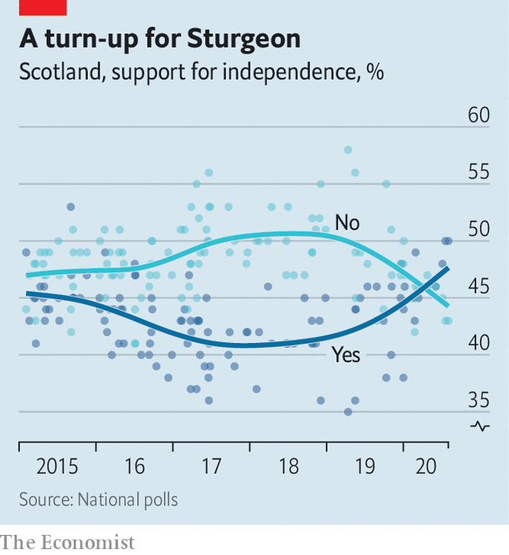

But even if Ms Sturgeon triumphs, Scotland will not be on a rapid trajectory to independence. Instead, there will be a long stalemate between London and Edinburgh. The Nationalists may have support, but, like the Catalan separatists, they lack a road map to an independence referendum that is recognised by the British government and triggers exit negotiations.

The government is not constitutionally obliged to permit the Scottish Parliament to organise a referendum. In the 2019 general election, Mr Johnson promised to “return to sender” any request for a referendum. He has happily ignored the Scottish Parliament on Brexit. And the Scottish Conservatives have done well out of the division of the country over independence. They displaced Labour as the second party by scooping up the votes of scunnered unionists with the mantra “No to Indyref2”. “Polarisation suits the poles,” says James Mitchell, a professor of public policy at Edinburgh University. “You can appeal to that substratum of the electorate, even if it’s a minority.”

Mr Johnson’s refusal would also threaten the unity of the ultra-disciplined SNP. Ms Sturgeon says the Westminster government’s consent and international recognition are essential if a referendum is to lead to independence. Catalonia’s illegal ballot now serves as a warning, not an inspiration. Spain dismissed the result and public support has slipped. “The Russians might be cool with it but that’s not what we’re aiming for,” says a Sturgeon supporter.

If Mr Johnson won’t give way, there will be pressure on her to produce a Plan B for independence. A group of activists is asking Scotland’s highest court to rule that the Westminster Parliament’s consent for a referendum is unnecessary. Pete Wishart, an SNP lawmaker, says the European Union should be asked to recognise a poll if Mr Johnson doesn’t. Some even say Ms Sturgeon could simply declare independence after an election. Tory strategists like it when hotheads sound off in this way because it frightens the middle classes.

Then there’s Labour. Ms Sturgeon’s best hope of breaking the stalemate is a deal with Labour in 2024, in which she supports a minority Labour administration in exchange for a referendum. But Sir Keir Starmer, the party’s new leader, says he opposes such an agreement. Mr Johnson told voters in 2019’s general election that a vote for Labour is a vote to break up Britain, and Mr Starmer will want to avoid that happening next time round.

Both sides think they can win a war of attrition. Mr Ross says voters are exhausted by constitutional wrangling and want their schools and hospitals fixed. The nationalists hope that obstinacy on Mr Johnson’s part will fuel their cause.

The price of stalemate is deteriorating governance. Scotland is caught in a rolling referendum campaign, which encourages freebies such as the abolition of prescription charges, and discourages unpopular but necessary reforms. “Any difficult issue which would be at least immediately unpopular but might be the right thing to do is pushed aside,” says Professor Mitchell. And the devolution settlement lacks friends. The SNP thinks it no substitute for statehood, whereas growing numbers of Tories think sending ever-more powers to Edinburgh has failed to stop separatism. “They fed the crocodile,” says one.

Devolution accommodates two fundamental ideas about the constitution: one which says that sovereignty lies with the Scottish people, and another which says it lies with the Westminster Parliament that legislated for devolution. They need not clash. But if the SNP triumphs in the Scottish election next May, the question of whether Scotland can vote a second time will force them into conflict. Mr Johnson and Ms Sturgeon will both claim mandates. Mr Cameron will not have saved Scotland from Catalonia’s limbo. ■

This article was downloaded by calibre from <https://www.economist.com/britain/2020/08/08/how-the-scottish-national-party-risks-turning-caledonia-into-catalonia>

|  |  |  |  |
| --- | --- | --- | --- |
|  | Articles | Sections | Next |

|  |  |  |  |
| --- | --- | --- | --- |
| Previous | Articles | Sections | Next |

#### Covid-19 in Scotland

# How coronavirus strengthened Scottish independence

The country has a powerful case of independence fever

Aug 8th 2020 |

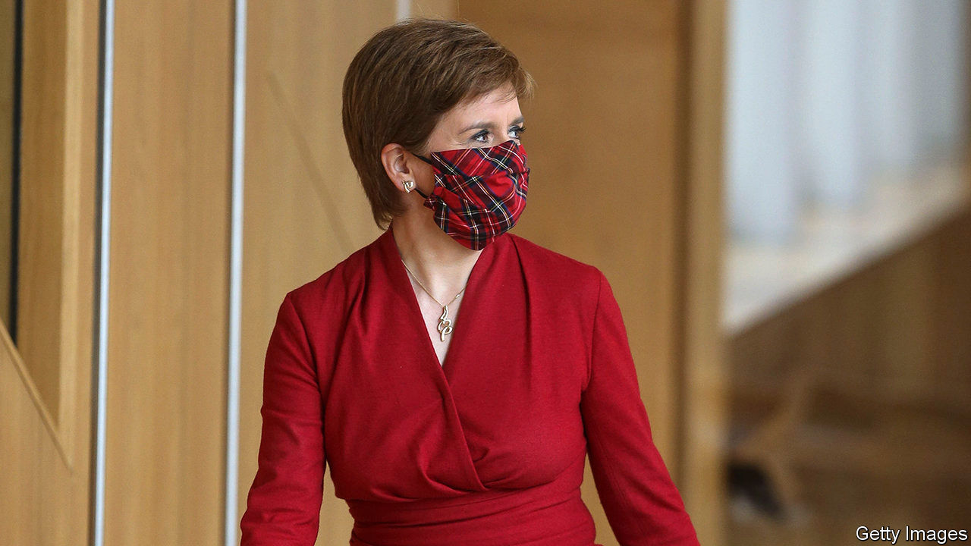

NICOLA STURGEON recoils from the suggestion that coronavirus could be politically advantageous. It has, after all, been linked to more than 4,200 Scottish deaths. Even so, the pandemic has left Scotland’s first minister in rude political health. Some 74% of Scots think her handling of the pandemic has been good or very good, according to Panelbase, a pollster. In contrast, Boris Johnson, who spent three nights in intensive care and scores just 21%, has been stricken by the virus personally and professionally.

In the 2014 referendum, the Nationalists struggled to get Scots to imagine what an independent government might look like. The pandemic was just what the doctor ordered. Health is devolved under Britain’s constitution, so Ms Sturgeon’s administration has the trappings of a state-in-waiting. Unlike the rumpled, details-light Mr Johnson, she has given poised daily televised press conferences packed with useful information.

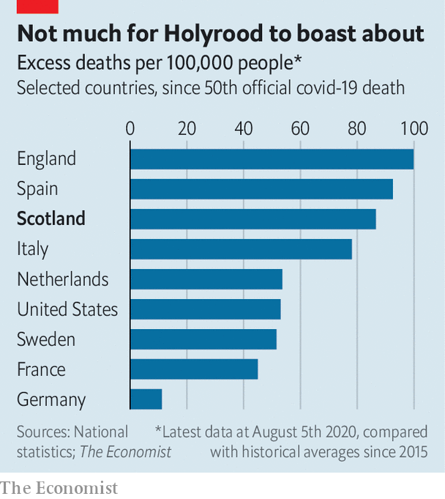

Pointing to rising support for independence, Sir John Curtice, of the University of Strathclyde, says that “some people may, in the wake of coronavirus, have bought into the argument that, ‘You know what, maybe an independent Scotland could govern itself a wee bit better’.” That perception is detached from reality. Scotland’s outbreak has followed a distinctly British course. In early March Scotland’s chief medical officer said the outbreak would mean “business as usual” for Scots, mirroring English scientific officials’ optimism. As in England, hundreds of elderly Scots were discharged into care homes to free up hospital beds, which may have hastened the spread of the virus. Ms Sturgeon’s administration is accused of covering up an outbreak at a conference in February. She was censured by Scotland’s chief statistician for claiming that the virus was a fifth as prevalent in Scotland as in England. Scotland’s excess mortality rate, a measure that accounts for different reporting methods in different states, is high (see chart).

Westminster has helped Scotland through the crisis. The Treasury has funded the furlough scheme which pays the wages of Scottish workers. The central government also runs a network of mobile-testing centres in Scotland and Scottish scientists sit on British expert committees.

The government has thus fulfilled the unionists’ promise in the 2014 referendum that Britain would be Scotland’s protector in hard times. Yet the appetite for separation has rarely been so high. The threat of a hard border between England and Scotland after divorce has been the unionists’ trump card. But 37% of Scots polled in early July said border controls to stop covid “should already be happening”, while a further 36% said they may be necessary in the future. Fewer than one in five opposed them.

Scottish Conservatives are worried. It was bad enough when nationalists had to build their case on solid foundations. Now they seem to be able to win the argument on soggy territory, too. Says one despairing Tory: “How are we losing ground when the Union is working as it never has before?”

Editor’s note: Some of our covid-19 coverage is free for readers of The Economist Today, our daily [newsletter](https://my.economist.com/user#newsletter). For more stories and our pandemic tracker, see our [hub](https://www.economist.com/news/2020/03/11/the-economists-coverage-of-the-coronavirus)

This article was downloaded by calibre from <https://www.economist.com/britain/2020/08/08/how-coronavirus-strengthened-scottish-independence>

|  |  |  |  |
| --- | --- | --- | --- |
| Previous | Articles | Sections | Next |

|  |  |  |  |
| --- | --- | --- | --- |
| Previous | Articles | Sections | Next |

#### Trade and farming

# Why food blocks a British-American trade deal

It’s a pig of a problem

Aug 8th 2020 |

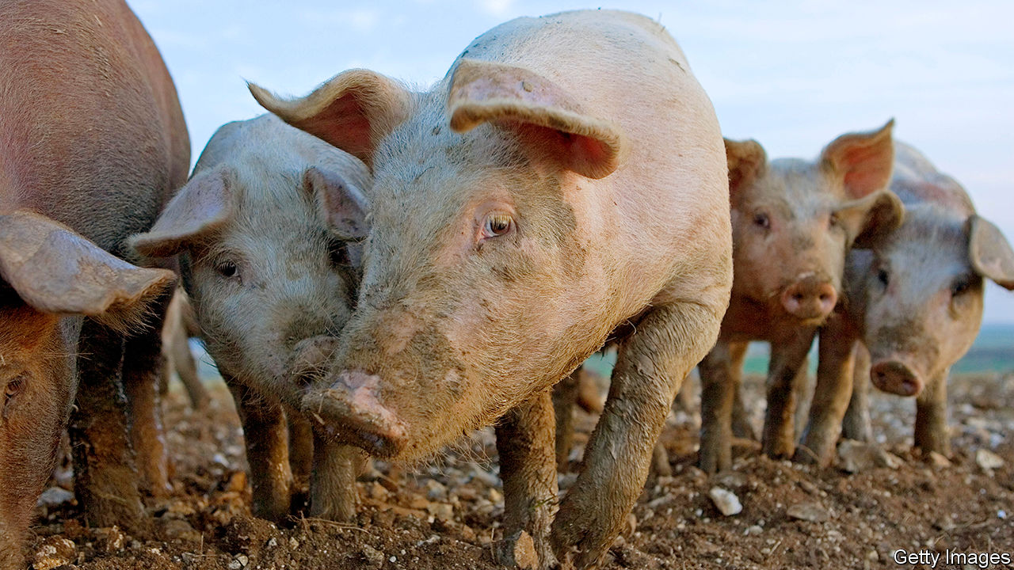

WHEN LIZ TRUSS, Britain’s international trade secretary, and her American counterpart, Robert Lighthizer, met in Washington on August 3rd-4th nobody expected a breakthrough. Both parties had previously said that a deal was unlikely to be struck in 2020. That’s partly because food, one of the main issues, is a particularly indigestible matter.

The problem is that farming is not just an industry. What people eat and how they produce their food is central to how societies see themselves.

America regards Brexit as an opportunity to export pork and chicken, among other foods, across the Atlantic. Many Britons do not like that idea. The words “chlorinated chicken” are morphing into an insult on Twitter, as in “this deal is an undercooked chlorinated chicken.”

The problem is not, ultimately, that Americans wash their chicken meat in chlorine. British consumers already drink water and eat lettuce treated with chlorine. The European Union’s own Food Safety Authority says that this process does not pose a health risk. Objections to the chlorination of chicken are a symptom of a deeper division, between regulatory systems embedded in different philosophies and different values.

The American system focuses on the end product, and whether what the consumer puts in her mouth will make her ill. Americans call it “science-based”. If studies have not shown that a practice, such as injecting cattle with hormones in order to beef them up, causes harm to the consumer then it is safe to put those products on supermarket shelves.

On that basis, there is no reason why Britons should not welcome American food, which is just as safe as European stuff. A comparison of annual infection rates by the three most frequently-reported food-borne parasites that are transmitted by meat shows they are roughly the same in America and Europe.

Europeans rely instead on the “precautionary principle”, which does not just look at known impacts on health, but also incorporates wider concerns about the food industry’s production methods—even when studies have not established that they pose a threat to human health. It led the EU to impose an early ban on genetically modified organisms. The ban has been relaxed but regulations remain tighter than in America. The EU has also taken a tougher stance on pesticides.

Where Britain lands on this divide is of great interest—and not just to farmers and trade negotiators. Environmentalists are arguing for sticking to the European approach; economic liberals for adopting one that is friendlier to innovation.

Europe’s enthusiasm for a farm-to-fork system, which regulates the steps that produce the food as well as the food itself, is an illustration of the difference between the two regulatory philosophies. In Europe, there is a push for farms and natural systems to coexist, not to be seen as competing with each other for land.

British cultural peculiarities emphasise a third element: animal welfare. That is the source of concerns about chlorinating chicken. Opposition to the chemical’s use comes from the belief that farmers chlorinate food that has been dirtied, morally as well as physically, by bad animal-welfare practices. Europe mandates nicer conditions for chickens than America does.

Sow stalls, similarly, make pigs more profitable by housing them more densely. Used in 75% of American farms, they have been banned in Britain since 1999 and Europe since 2013. And Britain holds its farmers to higher animal-welfare standards than Europe does. Charcuterie is best made with the fatty meat of castrated boars, but Britons do not like the idea of neutering boars to improve their salami, especially as it is commonly done without anaesthetic. So whereas European farmers routinely snip their pigs, British farmers who want to receive the industry’s Red Tractor quality-assurance label must leave their boars’ masculinity intact.

The government has to tread a tricky path between the demands of American trade negotiators, British farmers and lobbyists from animal-welfare and environmental groups. An agriculture bill to replace the EU’s Common Agricultural Policy is currently making its way through Parliament. It is supposed to navigate between these different interests. In May, the government annoyed the animal-welfare and environmental lobbyists by defeating an amendment that would have ensured food imports met the same standards that are required of British farmers.

But the bill has a lot in it for those who worry about nature. It proposes a principle of public money for public goods, whereby farmers will be recompensed for improving air, water and soil quality, and fostering biodiverse ecosystems. And on July 28th, Ms Truss launched a new Trade and Agriculture Commission to gather all interests in the food chain, from farmers to industry and animal-welfare groups. A few days later, the first volume of the National Food Strategy, an independent but government-commissioned review of Britain’s food system, advised that the government should seize the “once-in-a-lifetime opportunity” presented by Brexit to protect Britain’s “high environmental and animal-welfare standards”.

If a trade deal does bring cheap American meat to Britain, farmers will struggle to compete. They could wind up making most of their income as custodians of the land, while producing smaller quantities of pricier meat—as already happens with some beef. The practice could spread. ■

This article was downloaded by calibre from <https://www.economist.com/britain/2020/08/08/why-food-blocks-a-british-american-trade-deal>

|  |  |  |  |
| --- | --- | --- | --- |
| Previous | Articles | Sections | Next |

|  |  |  |  |
| --- | --- | --- | --- |
| Previous | Articles | Sections | Next |

#### Testing, testing

# Boris Johnson’s grand planning reform has weak foundations

It is not the big deal it is cracked up to be

Aug 8th 2020 |

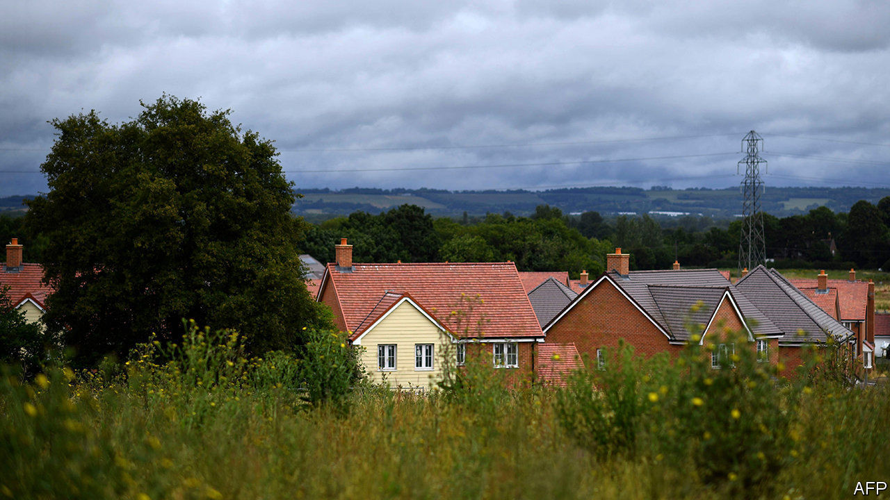

THE TEST of a British government’s radicalism is what it will do to build houses. Successive governments have ducked loosening Britain’s planning system because it means taking on middle-class homeowners who fear spoilt vistas, more traffic and lower house-price growth. David Cameron talked a good game, but watered down his bid to loosen the rules after the Daily Telegraph mounted a vociferous campaign titled “Hands Off Our Land.”

Boris Johnson says he wants to take a wrecking ball to the system. “The time has come to do what too many have for too long lacked the courage to do—tear it down and start again,” he wrote in the foreword to proposals published by the government on August 6th. He has few excuses not to be bold. He has a large majority, an economic crisis, a penchant for construction projects and an office stuffed with self-styled radicals who advocate deregulation as a route to unleashing growth.

The grand plan is to shift from a regime in which councils vet individual houses to an American-style zoning system, which will designate land by type. The government will issue local councils with binding house-building targets, adding up to 300,000 a year nationally and intended to force land onto the market.

“Growth” areas will be earmarked for major development; big projects will get outline approval automatically. “Renewal” areas will be designated for “gentle densification”. And building will be restricted in “protected” areas. Plans should be short and simple, the government says, and stripped of unnecessary assessments that make house-building slower. Section 106 rules, under which councils can haggle for affordable housing or cash from developers, will be replaced by a nationally set tax, which may speed up building.

But the scheme introduces new battle-lines in the system. The big fights will come over how the councils draw up their zones. “Protected” areas could include conservation areas, green spaces or individual gardens, the proposals say. Well-to-do neighbourhoods will lobby to ensure that building happens on the other side of town. “It makes it harder for nimbies to reject houses in the ‘growth areas’, but until the area is designated you haven’t passed Go,” says the boss of a big developer.

What’s more, the government says that the green belt—the tracts of open land that prevent cities such as Oxford, Cambridge and London from expanding—will remain protected. The scheme focuses on local authorities, and doesn’t consider how wide areas such as the arc of land between Oxford and Cambridge should develop.

The proposals would also require new buildings to meet a “beauty” test, with design codes inspired by dinky cottages and Georgian terraces. Roger Scruton, the late conservative philosopher and enemy of much modern architecture, produced a report for the government on these ideas. As now, the communities secretary will be able to intervene to overturn councils’ decisions, and locals will be able to lodge appeals. All this defeats the point of a true zoning system under which “a local authority of Bauhaus-loving modernists would be free to build that,” says Tony Travers of the London School of Economics. “This is an attempt to weld together completely inconsistent ideas…It could end up being more restrictive not less restrictive.” The nimbies aren’t beaten yet. ■

This article was downloaded by calibre from <https://www.economist.com/britain/2020/08/08/boris-johnsons-grand-planning-reform-has-weak-foundations>

|  |  |  |  |
| --- | --- | --- | --- |
| Previous | Articles | Sections | Next |

|  |  |  |  |
| --- | --- | --- | --- |
| Previous | Articles | Sections | Next |

#### Made in the USA

# With face-masks, Britain imported an American culture war

The coverings should be uncontroversial—they are not

Aug 8th 2020 |



BRITONS LIKE to think of themselves as a fair-minded bunch who play by the rules. The national character, in theory, involves standing in queues, getting in a round at the pub and “walking” before being given out in cricket. The wearing of face-masks, then, ought to be uncontroversial: it is a public-spirited act that benefits all. From August 8th, the mandatory use of masks will be extended to more indoor spaces in England, and police will be more vigorous in enforcing the rules.

Yet the use of masks in Britain, which rallies around its health service, is lower than it is in America, a country now synonymous with weirdly aggressive anti-mask sentiment. In part that is because the government has put out confusing public-health messages. Usage surged after it became compulsory on public transport and in shops.

But a new study by King’s College London and Ipsos MORI, a pollster, found that 13% of Britons believe that “the government only wants us to wear face masks as a way of controlling us”, and that 18% are “more focused on protecting civil liberties” than controlling the coronavirus. The Daily Telegraph, a conservative broadsheet, has run several pieces decrying their use, arguing that masks destroy public confidence, make their wearers feel “less human” and prove that Britain is “the scaredy-cat of Europe”. A letter-writer to the paper called mandatory mask-use “a massive infringement of my personal liberty”. Toby Young, founder of the Free Speech Union, calls the decision to require people to wear masks “very disappointing”.

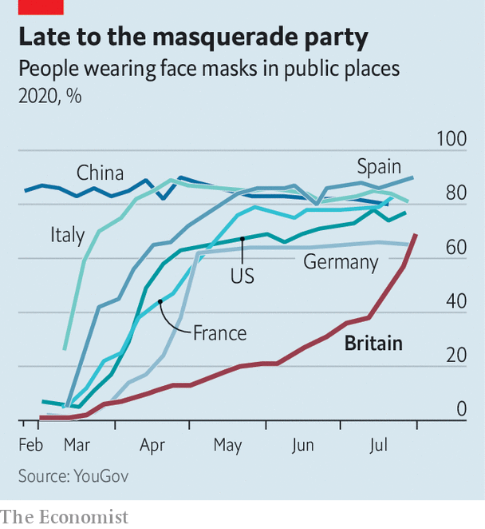

The British controversy mirrors a trend in America where, says Bobby Duffy of the Policy Institute at King’s College, “your views on a range of issues can be predicted knowing your party identity through a process called ‘conflict extension’, where you start with things like abortion and slowly more and more issues are rolled into this identity.” More than twice as many Democrats as Republicans say masks should always be worn in public places.

In Britain the gap between Labour voters and Conservatives who say they have recently worn a mask is just 9%. But identities related to Brexit have in some ways supplanted party affiliation. A review by the Royal Society of academic literature on the use of masks noted the difficulty “for co-ordinated action due to political polarisation—which is notable in countries such as the US, UK and Brazil, which in turn results in distrust of the opposing party and beliefs in false information that can undermine public-health messages.”

That suggests the importance of a second finding by Kings College: people who get most of their news from social media are much likelier than the general public to hold anti-mask views. Just 10% of Britons think wearing a mask is bad for health, but among those who get their news from WhatsApp, the proportion rises to 27%. More than a third of those who get their news from WhatsApp, and just under a third of those who get their news from YouTube, believe that mandatory masks are a form of government control. A new study by Pew, an American pollster, finds that “those who rely on social media for news are less likely to get the facts right about the coronavirus and politics and more likely to hear some unproven claims.”

Melinda Mills, an Oxford sociologist who co-wrote the Royal Society report, says she has received vicious abuse on Twitter for her research: for instance, calls for her to be jailed for “criminal deception and accomplice to murder”. (They were eventually deleted after she complained to Twitter.) “People are going into rabbit holes of information,” says Ms Mills.

As Brexit gets done, the issue’s political salience, and thus its power to polarise the population, is fading. But conspiracy theories and political sentiment originating in America and elsewhere easily make their way to Britain through social-media streams. “We do have a polluted information environment and it’s much easier to spread that type of disinformation than it was in the past, and it is much more difficult for people to sort the trustworthy information from the untrustworthy information,” says Mr Duffy. So far, Britain’s political leaders have not taken much advantage of it; Britons must hope it stays that way.■

Editor’s note: Some of our covid-19 coverage is free for readers of The Economist Today, our daily [newsletter](https://my.economist.com/user#newsletter). For more stories and our pandemic tracker, see our [hub](https://www.economist.com/news/2020/03/11/the-economists-coverage-of-the-coronavirus)

This article was downloaded by calibre from <https://www.economist.com/britain/2020/08/08/with-face-masks-britain-imported-an-american-culture-war>

|  |  |  |  |
| --- | --- | --- | --- |
| Previous | Articles | Sections | Next |

|  |  |  |  |
| --- | --- | --- | --- |
| Previous | Articles | Sections | Next |

#### A dove over Derry

# John Hume’s vision of peace in Northern Ireland is only half-fulfilled

He did more than anybody else to end the bloodshed, but mutual respect between Catholics and Protestants remains elusive

Aug 5th 2020 |

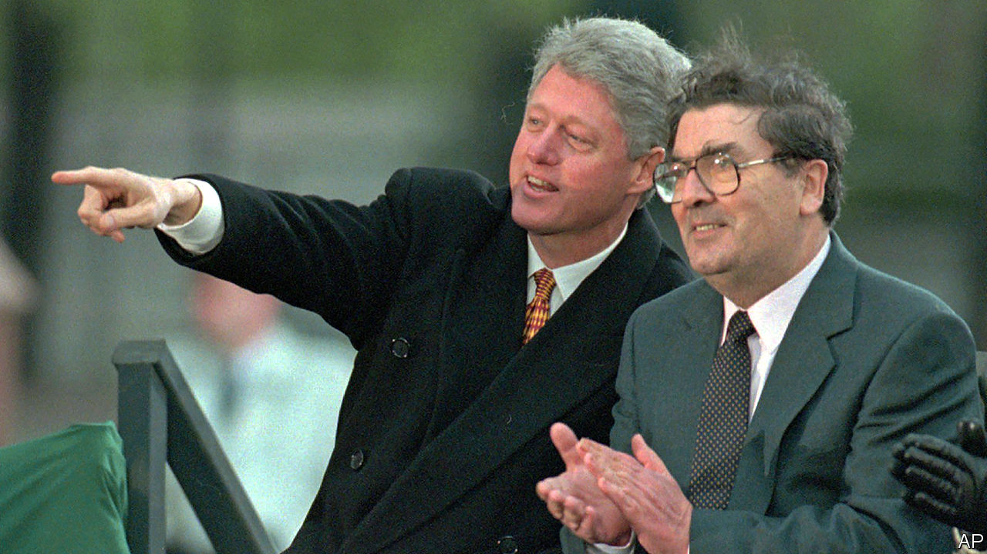

OF ALL NORTHERN IRELAND’S representatives, John Hume was both the most cosmopolitan and also the most parochial. When he died in his native Derry on August 3rd, infirmity had kept him away from the public arena for many years. Even so, memories of his central role in forging the peace agreement of 1998 that earned him a Nobel Prize remained vivid, among both veterans of global politics and his neighbours in a rainy, quirky corner of Ireland whose idiosyncrasies he reflected. Bill Clinton mourned his friend’s “unshakable commitment to non-violence, persistence, kindness and love”. Humbler local folk heeded the family’s request to light “candles for peace” in their homes, as did some heads of government, including Britain’s Boris Johnson. His funeral on August 5th in Derry’s Catholic cathedral was attended by Ireland’s leading politicians but remained a low-key affair because of the pandemic.

Mr Hume was prescient. Much sooner than any other elected figure in Northern Ireland, he realised that the murderous passions of his homeland could be stilled only by bringing them into a larger arena, European or transatlantic. After 1969, as rioting in his native streets escalated into full-blown urban war, his response was to look far and wide for antidotes. As a fluent speaker and former teacher of French, he believed in the peace-making power of the European Union. He was a respected figure in the European Parliament, where Franco-German amity fascinated him as a template for what might happen in Ireland.

As a visitor to Capitol Hill, he had a dogged message for Irish-American politicians: their best gift to the motherland lay not in stoking violence by supporting the Irish Republican Army (IRA) but in working to promote prosperity, reconciliation and peaceful change. His relations with some congressmen prepared the ground for the White House (under Jimmy Carter, then Mr Clinton) to take an interest in Ireland. Mr Hume and Mr Clinton worked in risky lockstep to coax the champions of armed Irish nationalism into respectable politics.

Mr Hume’s non-violent stance was not an easy one to maintain, especially after January 1972 when British troops shot dead 14 peaceful demonstrators in Derry. The killings triggered a surge of volunteers for the bombing and shooting campaign of the IRA. Mr Hume insisted there were other ways for aggrieved Catholics to advance their cause. Seeking fairer terms for co-existence with their Protestant, pro-British neighbours was always better than vengeful killing, Mr Hume insisted, and many in his town took heed.

Thanks in part to his charisma, the Social Democratic and Labour Party, which he had co-founded as a voice of moderate Irish nationalism, regularly drew more Derry voters than Sinn Fein, which was in effect the political wing of the IRA.

Uniquely, Mr Hume combined a commitment to peace with street credibility. Having grown up in hard times, with a father who lost his shipyard job in 1945, he knew the grind of life at the bottom. It was a scene in which poverty and anti-Catholic discrimination were mitigated only by a church-based tradition of self-help. He qualified as a teacher (after half-training for the priesthood), but retained the saltiness of the Derry streets, where Catholic invocations and colourful swear-words flow readily from the same tongue.

Derry’s other hallmark is its smallness: rated a city because of its cathedrals, it is really a modest town of 110,000 where all lives are interconnected, despite the segregation of the streets. When Dervla Murphy, a travel writer, visited during the conflict, she was bemused to find a house where, for lack of space, an off-duty British soldier bedded down with a family member in the IRA. To Mr Hume, who had emerged from that world and also looked beyond it, it was common sense that communities must find a way of living together in respect.

His vision is only half-fulfilled at best. The killing has mostly ended, and since January pro-British Unionists and Irish nationalists have once again been sharing power, and the spoils of patronage, after a three-year political deadlock. But they show little sign of mutual respect. The two camps have opposing visions both of the future and the past. Quarrels over how to commemorate, or legally adjudicate, the conflict still absorb much political energy.

But there is hope in the fact that many young Northern Irish people refuse to place themselves in either the Protestant Unionist or the Catholic nationalist camp. Already, a majority of those under 25 eschew both labels, notes Jon Tonge of Liverpool University, who studies Northern Irish opinion. Mr Hume relished the fact one of his forebears was a Scottish Presbyterian settler who married a local Catholic. A melting away of his homeland’s seemingly insuperable boundaries would honour his memory. ■

This article was downloaded by calibre from <https://www.economist.com/britain/2020/08/05/john-humes-vision-of-peace-in-northern-ireland-is-only-half-fulfilled>

|  |  |  |  |
| --- | --- | --- | --- |
| Previous | Articles | Sections | Next |

|  |  |  |  |
| --- | --- | --- | --- |
| Previous | Articles | Sections | Next |

#### Politics

# Boris Johnson’s horrible House of Lords list

It reveals a contempt for the institutions of government

Aug 8th 2020 |

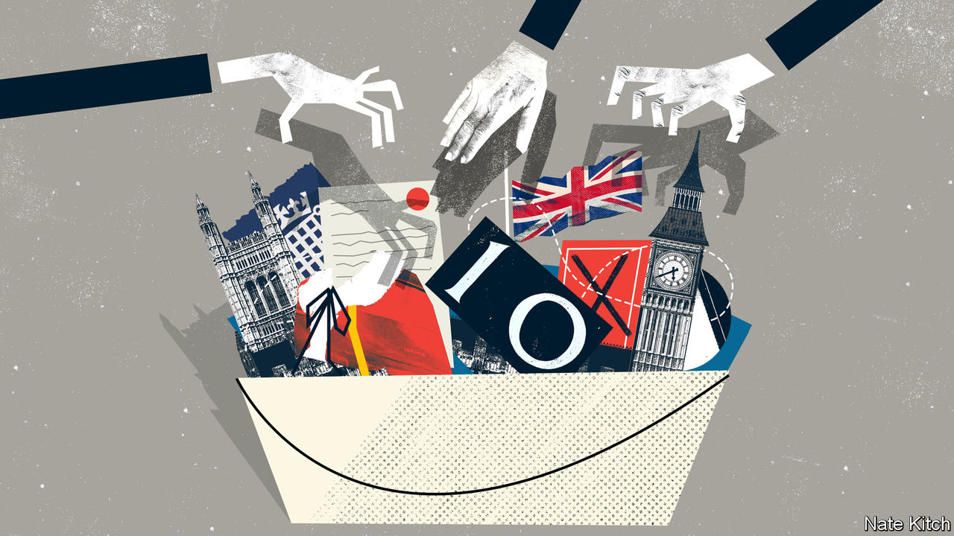

WALTER BAGEHOT, a Victorian editor of The Economist, celebrated the House of Lords as the more dignified of the two Parliamentary chambers. “Dignified” is hardly the word for the bumper bucket of new peers—36 in all—that Boris Johnson has just created. The list includes the son of a Russian KGB-agent-turned-oligarch who owns a couple of newspapers in Britain and a party castle in Italy; an ageing, irascible cricketer who supported Brexit; a former Revolutionary Communist Party activist and IRA apologist who also supported Brexit (the balm that washes away all sins); the prime minister’s brother; and sundry party donors, bag-carriers and hangers-on. This from a government that acknowledges the Lords is absurdly bloated, now with over 800 peers.

The few people who have defended Mr Johnson’s list have done so on the grounds that it was ever thus. Every prime minister comes into office promising to reform the Lords only to end up treating it as a patronage pissoir. In 2007, in what was dubbed the “cash for honours” scandal, the Parliamentary Standards Authority rejected seven of Tony Blair’s nominees. Harold Wilson’s resignation honours list in 1976, drawn up on lavender-coloured notepaper by Marcia Falkender, his private secretary and special friend, contained the names of several fraudsters.

Leave aside that this argument belongs in a banana republic. Leave aside, too, that the Lords has lighter financial disclosure rules than the Commons because peers are supposed paragons of probity. The argument ignores the context in which the list appears. Mr Johnson’s degradation of the Upper House is happening as the rules of public life are under unprecedented strain.

In the 18th and early 19th centuries the British political system was known as “Old Corruption”. The rich treated the state as their private property, appointing their cronies to “pocket boroughs”, securing jobs in the civil service for the fool of the family and buying great offices of state for themselves. The Victorians dismantled this system in the name of open competition and public duty, conscious that Britain couldn’t succeed as a great industrial power if it was hampered by an inefficient state.

Mr Johnson’s list suggests that the country is reverting to old habits. This is not about money changing hands in brown paper bags—British politics is still cleaner than in France or Italy—but treating government, if not quite with contempt, then as nothing more than a means to personal or ideological ends. The sense of high seriousness that the Victorians attached to government is being eroded before the public’s gaze, as insiders cash in on their knowledge and experience, ideologues bend the rules to push narrow agendas, and the likes of Evgeny (now Lord) Lebedev dole out jobs and party invitations to members of the political class.

The erosion of standards is encouraged by structural changes in political life. The collapse of party membership is forcing parties to take desperate measures to raise money. This is particularly true of the Conservatives who, with only 150,000 members, have resorted to auctioning places next to senior ministers at fund-raising dinners. One such dinner recently resulted in scandal: Richard Desmond, a property developer and former pornographer, took the opportunity to show his dining companion, Robert Jenrick, the housing secretary, a video of his £1bn property development in East London. He eventually persuaded Mr Jenrick to overrule his own department to grant permission for it.

The shortening of political careers means that young stars are always thinking of their next move. George Osborne, only 45 when he ceased to be chancellor, quickly built a new career by persuading Blackrock to pay him more than £650,000 to offer advice one day a week and Mr Lebedev to make him editor of the Evening Standard. At the same time, the internet has blown apart funding rules. A new book by Peter Geoghegan, “Democracy for Sale”, documents the ways in which politics is being transformed by invisible donors who try to influence it through “dark money”, internet wizards who delight in exploiting legal loopholes and spies who use bots and shell organisations to muddy the waters.

Still, Brexit acclerated the decline, eroding the legitimacy of the state and reducing its competence. Brexiteers launched a fusillade against any institution that got in their way, including the Supreme Court and the Lords. Political entrepreneurs could exploit the confusion to insert themselves into the heart of policy-making. Shanker Singham, the “brains of Brexit”, became the country’s most influential adviser on trade despite having no formal qualifications in economics and spending most of his career as a lawyer-lobbyist in America. Finally, Mr Johnson and his coterie of hardliners seized control of the Conservative Party.

Mr Johnson is a specialist in not taking anything too seriously. In her new book, “The Twilight of Democracy”, Anne Applebaum describes the atmosphere at the Spectator magazine in the mid-1990s, when she worked there alongside Mr Johnson (who later edited it): “the tone of every conversation, every editorial meeting, was arch, every professional conversation amusing; there was no moment when the joke ended or the irony ceased.” Mr Johnson is surrounded (some would say captured) by revolutionaries who believe in tearing down the current order. Dominic Cummings, Mr Johnson’s most important adviser, is a libertarian revolutionary who reveres technology and creative destruction. Michael Gove, the cabinet-office minister, has a neuralgic dislike of the “clerisy” that runs the establishment.

The combination of languid indifference to “boring institutions” and revolutionary fervour would be dangerous at any time. It is poisonous when public standards are being eroded by new technology and changing norms. The Victorians knew that Old Corruption would inevitably return unless you waged a relentless war on behalf of clean government and public probity. There is no sign that Britain’s current masters have either the firmness of purpose or philosophical conviction to wage such a war. ■

This article was downloaded by calibre from <https://www.economist.com/britain/2020/08/08/boris-johnsons-horrible-house-of-lords-list>

|  |  |  |  |
| --- | --- | --- | --- |
| Previous | Articles | Sections | Next |

|  |  |  |
| --- | --- | --- |
| Britain | Sections | Business |

International

Coming out: Queer, there and everywhere

.

|  |  |  |
| --- | --- | --- |
| Britain | Sections | Business |

|  |  |  |  |
| --- | --- | --- | --- |
|  | Articles | Sections | Next |

#### Queer, there and everywhere

# How the internet is changing the experience of coming out

Around the world, gay people are quicker to open up than before

Aug 8th 2020 | BOGOTÁ, NAIROBI AND NEW YORK

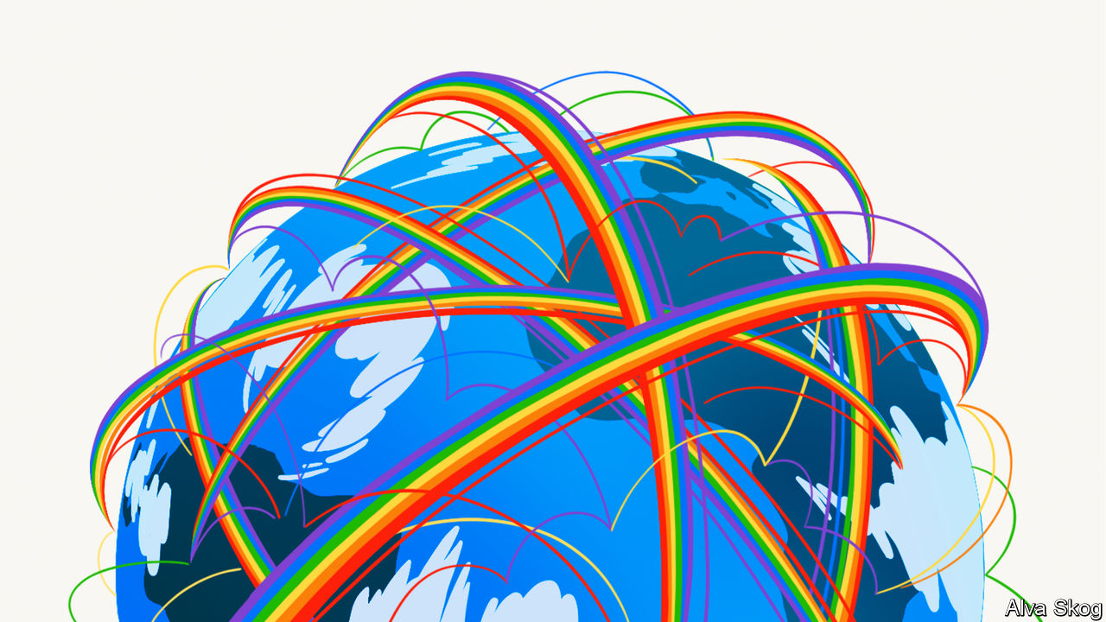

PROPPED UP BY his Union flag pillows, Tom Daley was at last ready to unburden himself. As the camera wobbled about, the then 19-year-old British diver—who the year before had won a bronze medal at the Olympics in London—told his fans he was ready to talk about his private life, though his darting eyes seemed to belie that assertion. After two minutes of build-up, he got to the point. “Come spring this year my life changed—massively—when I met someone and it made me feel so happy, so safe,” he confided. “And everything just feels great, and well that someone”—long pause, looking everywhere but at the camera—“is a guy.”

He told that camera in his bedroom, and YouTube told everyone else. There were some nasty comments, but thousands of strangers chipped in to offer congratulations, support and, sometimes, slightly odd queries. “Is it just me or are all of the gay guys really handsome and attractive?” one viewer wondered. Six years on, the video has been viewed more than 12m times. Mr Daley is now married to that “guy”, Dustin Lance Black, a screenwriter. They have a two-year-old son, Robbie.

Some lesbian, gay, bisexual or transgender (LGBT) people never tell their friends and families about this aspect of their identities. A few don’t feel the need. In 2013 interviewers from the Pew Research Centre, a think-tank, spoke to a 54-year-old American woman about her bisexuality. “This is not a subject to discuss or tell anyone about,” she said. “It is an activity—like bowling, or gardening.”

But most want to open up. The same Pew study found that more than three-quarters of American gay men had confided in all or most of the important people in their lives. So universal is that first moment of disclosure that several languages use variations on the same phrase. Koreans, Japanese, French and Spanish people all talk of “coming out”. The Chinese and Russians also borrow the English metaphor of “the closet”, the dark and constraining place from which LGBT people are said to emerge. “Boys Like Us”, a compendium of coming-out experiences published in 1996, argued that this was “the central event of a gay man’s life”. For many, it still is. A sixth of calls to Switchboard, a British LGBT helpline, concern coming out. It is the single biggest category.

Yet though the metaphor remains constant, the process is changing rapidly, thanks to the internet. Two big shifts are under way. People are coming out earlier than ever before. And the closet door is opening in an increasingly broad range of countries. Stark disparities remain: in liberal countries, such declarations are accepted or even—as in Mr Daley’s case—celebrated. But gay sex remains illegal in 68 countries, and openly LGBT people often face stigma or violence even where it is not. Transgender people often experience even greater prejudice, and so need extra courage to tell others how they feel.

Nonetheless, the International Lesbian, Gay, Bisexual, Trans and Intersex Association (ILGA), a lobby group, has members in 164 countries (up from eight in 1978). “That means there are people in those countries who are coming out,” says André du Plessis, its executive director. “We are everywhere. It’s been a joyful and sometimes painful unmasking of who we are.”

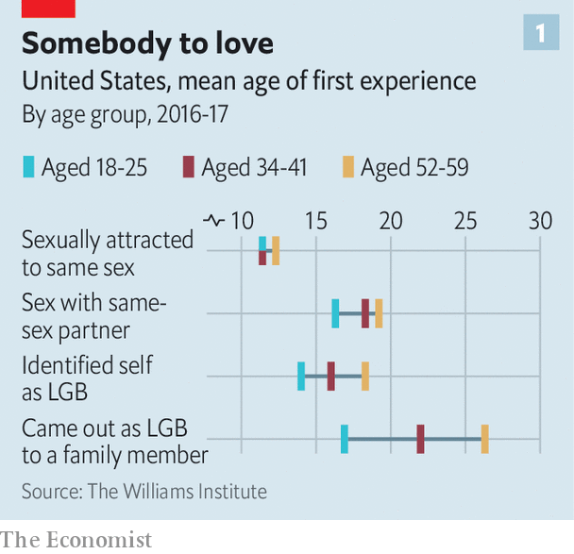

That unmasking happens at different times. About four in ten American gay men first begin to question their sexuality before they leave elementary school, reports Pew. Others only realise later in life. A handful come out in their 70s. But on average Americans are coming out earlier than in previous generations, mostly in their teenage years. In 2018 the Williams Institute at the University of California, Los Angeles (UCLA), found that whereas interviewees in their 50s had tended to reveal their sexuality at about the age of 26, those currently in their late teens and early 20s had already done so before their 17th birthday (see chart 1). Stonewall, a British charity, found an even starker divide. According to a poll it commissioned in 2010, LGBT youngsters typically came out at 17, 20 years earlier than the oldest cohort.

This shift can partly be attributed to a dramatic softening of public attitudes towards same-sex relationships. In 1987, more than half of Americans thought gay sex should be illegal, according to Gallup; nearly three-quarters now approve that it is legal. Gay characters frequently pop up in movies and on television; same-sex weddings are growing ever more common. All of this helps teenagers work up the confidence to come out to parents or friends, since those they confide in are more likely than ever to support them.

But before teenagers begin to tell others about their sexuality, they have to come out to themselves. That is where the spread of the internet makes a big difference. Children who begin to wonder about their sexuality or gender can quickly educate themselves—and each other—on their smartphones. They can access this information at any time and anonymously (unlike, say, checking out a library book). YouTube hosts a vast archive of self-help videos made by others farther along the same path; social networks can connect teenagers to peers with similar feelings. This helps to explain that whereas it took the oldest cohort in the UCLA study six years after first feeling attracted to someone of the same sex to identify as gay, lesbian or bisexual, the youngest sample made the jump in less than half that time.

## I want to break free

Consider the experience of a 14-year-old girl in Manhattan. When she began to wonder about her sexuality, she turned to the internet for answers. She spent a lot of time on Tumblr, a blogging platform, before figuring out that she is asexual (ie, she feels no sexual attraction to others). “Tumblr is where I found out about most of the stuff,” she says. “There’s a fricking ton of LGBT activism all over Tumblr.” Not long after having her suspicions confirmed, she decided to tell her mother. “I told her I’d looked it up and it all sounds like me.” A fellow student at her school, a 16-year-old transgender boy, saw his feelings echoed in videos posted by Jazz Jennings, a trans teenager who has 680,000 subscribers on YouTube. He told his parents a few years later, once he was sure.

Some teenagers use the internet to try out their newfound identities. A few, like Mr Daley, upload coming-out videos. Others share the news on social networks like Instagram. A study in 2014 by Stefanie Duguay, then of Queensland University of Technology, found that more than a third of a sample of 27 young LGBT Britons disclosed their interest in others of the same sex on their Facebook profiles. Three wrote posts that explicitly announced their sexual orientation.

The internet is particularly helpful in parts of the world that are less gay-friendly. A good example is Colombia. At first blush, it appears pretty tolerant. Gay sex was decriminalised in 1981, 22 years before America’s Supreme Court ordered states such as Texas to stop banning it. Gay Colombians can get married and adopt children. Claudia Lopez Hernandez, the mayor of its capital, Bogotá, is a lesbian.

But social attitudes have not kept pace with the law. Most Colombians are Catholic; many are socially conservative. Polls suggest they largely disapprove of gays adopting children, though they are coming around to same-sex marriage. A survey of about 5,000 LGBT Colombians, published earlier this year by UCLA, found that three-quarters were bullied as children. Several hundred report being attacked or sexually assaulted.

Unsurprisingly, then, Colombians are nervous about coming out. Roughly nine in ten lesbians and gay men have confided in at least some family members and friends. But most told nobody at high school despite typically realising they were attracted to someone of the same sex at about the age of 12, roughly the same time as their American counterparts. The internet gives such teenagers the chance to form digital support networks and online communities where they feel comfortable expressing their developing identities.

Take Emmanuel, a 19-year-old transgender man from Bogotá. After watching a documentary with his parents about transgender children, he told them he felt the same way. “I said ‘mum, dad—I’m trans’ and they got angry,” he says. “They told me ‘no, that’s wrong, you should not think that.’” He still lives with his parents. At college, he “tests the waters” with new friends by starting conversations about the 2018 winner of the Miss Universe Spain beauty pageant, a trans woman. “Depending on their reaction, it can be like ‘you get to know, you don’t get to know’.” He reckons he tells about one in five of them.

Online, it is a different story. He began confiding his feelings in strangers he met on Tumblr and Twitter, another social network, five years ago. He has messaged dozens of trans people and chats regularly to seven friends, who mainly live in America and Britain. “It is kind of a support group,” he says. Even though he largely shields his identity in public, he can be open online. “At least I know maybe I’ll come back home and turn on my computer and see my friends. They are the people who will call me by my name, who will give me tips on how to deal with situations. It helps a lot.”

Covid-19 makes the internet more crucial. It has been the only source of like-minded company for many LGBT people stuck in lockdown. Eleanor Tiernan, an Irish comedian, joked: “I came out just before lockdown. Suddenly I was free to be who I really was… but only as long as I stayed in my room.” Since the pandemic began to spread in Colombia, Emmanuel has been shut up in his parents’ small apartment most of the time. Because he has more time for domestic chores, his mother, who still treats him as a woman, tells him: “you’re getting like me, preparing to be a housewife.” His friends offer much-needed solace, chatting about the effects of the pandemic in their countries and playing online games.

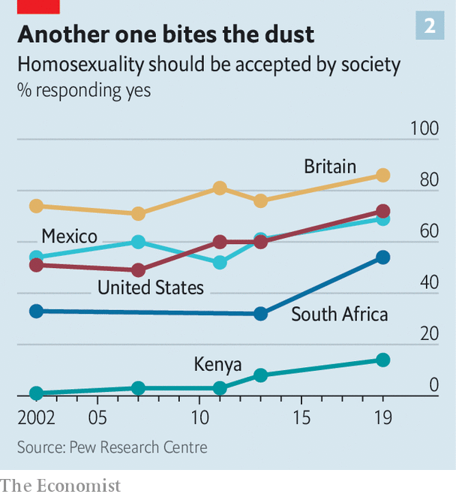

Such networks are even more important in countries where gay sex is illegal, like Kenya. Last year the country’s High Court upheld a colonial-era law that threatens a maximum penalty of 14 years in jail for “carnal knowledge against the order of nature”. Ministers claim it is an effective way to curb the country’s HIV epidemic. Although arrests under this law are rare, gay Kenyans are often intimidated or harassed by cops. Films depicting gay characters are censored; lesbians are raped by gangs of men, supposedly to “correct” their sexuality. Repression is popular. In 2019 only 14% of Kenyans believed homosexuality is acceptable, compared with 72% of Americans and 86% of Britons (see chart 2).

The closet is sometimes the safest option. Becky Odhiambo Mududa, who helps to run Nyarwek, a gay-rights NGO in rural Kenya, reckons only 50-100 of its 1,500 members have come out to everyone they know. Another 300 or 400 are comfortable telling only fellow LGBT people, she estimates. Those who are open benefit from up-to-date information about homophobic violence and police crackdowns, which members share with each other via an online messaging service.

Since Kenyan teenagers are unlikely to encounter peers or role models who are open about their homosexuality, the internet plays a greater role in education. Rose Ambasa, 21, grew up in a slum in the capital, Nairobi. She did not understand her feelings for other girls until she borrowed her brother’s smartphone one day and googled “Who is a lesbian? What do they do?” “I came to accept myself,” she says. “It helped me so much that I came out of depression.”

Some wait years to discover they are not alone. Purity, now 24, grew up in a village with no internet access. When she felt attracted to a female classmate at 14, she had no way of knowing whether others had such feelings. “I was scared,” she says. “I was trying to get it out of me, just praying to God to figure out what it is. I just wanted to be a normal girl.” As soon as she got a smartphone, on her first night at college five years later, she searched whether it was possible to fall in love with another girl. “I then discovered it’s normal.” The next day she confided in a classmate, who was sympathetic. Soon afterwards, she began dating another student.

The internet can also provide hope, even to those in the bleakest situations. Delphine, 21, was raped by local men when they found out she is a lesbian. When she fell pregnant, her mother forced her out of the family home. Three years on, she is in a long-term relationship with another woman. They are raising her son together. She finds inspiration for the future on YouTube, which she scours for videos of gay wedding ceremonies in other countries. “People applaud it,” she says, incredulously. She probably watches two weddings a day, and shares the couples’ joy. “We hope some day when our country allows it, we’ll get married,” she says. “We talk of growing old together.”

## Don’t stop me now

The internet’s increasingly pivotal role has its downsides. Natasha Jones, who runs a youth engagement programme at the Gay Centre in Manhattan, has seen good and bad. Plenty of teenagers only find out about her programme online, then come to ask questions and meet other teenagers before coming out to their parents. But, she says, the internet can be a source of misinformation during this formative time. The centre’s sexual-health classes often need to counter misconceptions young people have picked up online, such as that lesbians cannot get sexually transmitted infections or that losing your virginity is meant to be painful. “We have young people coming here with the wildest ideas,” she says. “YouTube has taught them and that’s fact.”

It also gives a space for homophobes and trolls to direct abuse at youngsters who raise their heads above the parapet. Worse, it provides a forum for involuntary “outings”. In Kenya, rumours about someone’s sexuality spread rapidly on social media. Several of the people supported by Nyarwek were “thrown out of the closet” in this way, by former partners or friends with grievances.

But bigots and dodgy information existed long before the internet. That it makes such things more visible does not negate the largely positive role it plays in gay people’s lives. Studies frequently find that gay people suffer higher rates of depression and anxiety than heterosexuals. “Trying to hold conflicting identities or lying to yourself causes incredible mental strain,” says Mr du Plessis. Enabling more people to be honest with themselves and others at an early age ought to reduce this strain. Greater openness will improve sexual health, too, enabling better targeting of preventive measures and treatment for HIV and other sexually transmitted infections.



The shift towards transparency will also raise awareness. In some countries, populist politicians caricature homosexuality as a western import. J.M. Kariuki, a Kenyan nationalist, was fond of calling it “that vice for which we Africans have no name”. Others deny its existence. Ramzan Kadyrov, the head of the Chechen Republic, has reportedly presided over the routine abduction, torture and killing of gay men. He denies that, instead claiming: “we don’t have any gays. If there are any, take them to Canada.” By shining a spotlight on domestic gay populations, the internet will make such claims even more risible. “In our advocacy work, one question that comes up is ‘where are these queer people, do these queer people exist?’” says Caroline Mwochi, also of Nyarwek. “Coming out actually puts a face on it.”

And being visible is the surest way to change social attitudes. The rapid rise in support for gay rights in America between 1980 and 2000 followed a steep increase in the number of Americans who said they knew a gay family member, friend or colleague. In 1985 only a little more than a fifth did; now 87% do. “We’ve seen over the decades that this is how change can take place in the hearts and minds of people,” says Mr du Plessis. “People often have a knee-jerk reaction. But when you take it down to a personal level, it becomes real: this is your daughter, your aunt, your minister, your colleague.” As coming out spreads around the world, tolerance probably will, too.

Purity, for one, isn’t going to wait. Now that she has come out, she regularly messages friends online to arrange to meet at a gay-friendly bar in central Nairobi. At an outing before the pandemic took hold, a flashing neon sign marked the entrance, on a bustling street packed with battered minibuses belching foul-smelling fumes. Inside, two young women moved closer together on the dance floor, just as one of the buses honked its horn. Another woman flicked a rainbow braid in her cornrows. Purity and her friends shared beer and gossip. She has no regrets about coming out. Though she has faced discrimination looking for a job, her mother surprised her by being “quite cool with it”. She is certain that one day she will meet another woman and they will marry. In the meantime, she says, “I feel good being who I am.” ■

This article was downloaded by calibre from <https://www.economist.com/international/2020/08/08/how-the-internet-is-changing-the-experience-of-coming-out>

|  |  |  |  |
| --- | --- | --- | --- |
|  | Articles | Sections | Next |

|  |  |  |
| --- | --- | --- |
| International | Sections | Finance & economics |

Business

Corporate America: The trouble with TINA

.

Stockmarket indices: Inclusive growth

.

Semiconductors: Worth an arm and a leg

.

Microsoft and TikTok: Unproductivity puzzle

.

European business: Sverige AB v Deutschland AG

.

Bartleby: Called to account

.

Schumpeter: Dangerous curves ahead

.

|  |  |  |
| --- | --- | --- |
| International | Sections | Finance & economics |

|  |  |  |  |
| --- | --- | --- | --- |
|  | Articles | Sections | Next |

#### The trouble with TINA

# America’s stockmarkets are flying high. Its companies still aren’t

The latest earnings season in America Inc is the weirdest in living memory

Aug 8th 2020 | NEW YORK

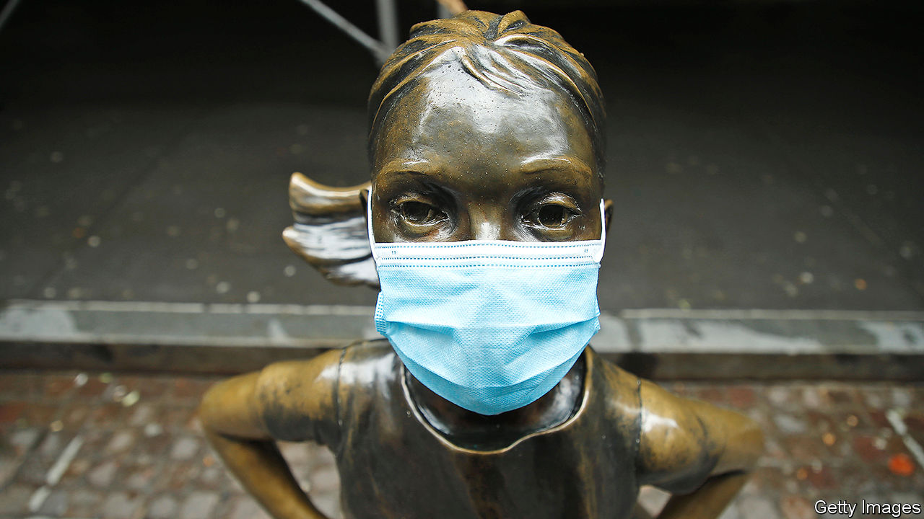

Editor’s note: Some of our covid-19 coverage is free for readers of The Economist Today, our daily [newsletter](https://my.economist.com/user#newsletter). For more stories and our pandemic tracker, see our [hub](https://www.economist.com/news/2020/03/11/the-economists-coverage-of-the-coronavirus)

BOB CHAPEK, Disney’s boss, sounded a cheerful note as he announced the entertainment giant’s quarterly results on August 4th. Its newish streaming service, Disney+, has acquired over 60m subscribers in less than a year, one-tenth the time it took Netflix to amass such an audience. “Mulan”, an upcoming blockbuster, will be released on Disney+ in September. “Despite the ongoing challenges of the pandemic, we have continued to build on the incredible success of Disney+ as we grow,” Mr Chapek intoned. The company’s share price jumped by 5%.

If you tuned out the first part of Mr Chapek’s statement—and six months’ worth of covid-19 news—you might conclude that Disney just had a bumper quarter. In fact, as its theme parks shut down, cinemas emptied and battered advertisers stinted on commercials on its television networks, the company lost $4.7bn. The reason for the market chirpiness is that things could have been far worse.

Disney’s experience sums up that of America Inc more broadly. Investors have been casting about for any signs of a rebound from the pandemic-induced recession. Real GDP shrank at an annualised rate of nearly 33% in the second quarter. And yet, with interest rates—and thus returns on safe assets like Treasury bonds—close to zero, money has poured into equities. American share prices have risen by more than 40% from their trough in March. The S&P 500 index of big firms is near an all-time high; the tech-heavy Nasdaq market reached it on August 4th. The feeling among investors that “there is no alternative” to stocks is so pervasive that they have dusted off an old acronym: TINA.

In one way, the latest quarterly results justify a degree of optimism. Three months ago the situation was so uncertain that many firms, not just in America, refused to offer their habitual guidance about future earnings—in some cases for the first time ever. Bereft of milestones, analysts slashed profit forecasts. Now it seems they may have erred on the side of gloom. Jonathan Golub of Credit Suisse, a bank, calculates that for those firms which have already reported their results for the most recent quarter—a group representing 84% of the S&P 500’s market capitalisation—earnings have beaten hyper-bearish estimates by a total of 24%.

Bulls see other hopeful signs. After a plunge earlier this year, capital spending grew at its fastest monthly pace since Morgan Stanley, an investment bank, began tracking it in 2004. New orders for factory goods rose by 6.2% in June. JPMorgan Chase, a bank, believes that a global “synchronised cyclical recovery from the covid-19 crash has started”, with manufacturing leading the way. “Recovery is happening,” echoes Michael Wilson of Morgan Stanley, pointing to promising advances in treatments and vaccines for covid-19.

Hang on a minute. The green shoots offer hope and earnings may have beaten expectations. But, as David Kostin of Goldman Sachs, another bank, notes, the bar was very low. By his reckoning, in a typical quarter about 5% of firms produce earnings per share above forecasts. That this quarter’s figure may be closer to 25% is merely “kabuki theatre” of expectation management, he says. If the bottom fell out of the economy in the second quarter, as official statistics imply, then the private sector must be dragging it down.

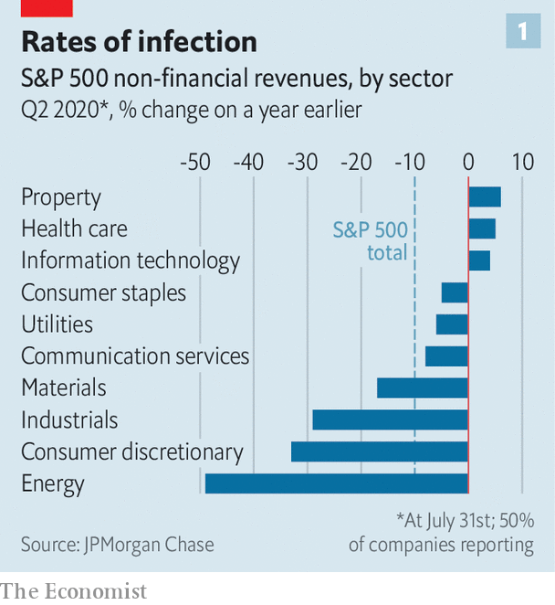

Quarterly sales fell by an average of 10%, year on year, at S&P 500 companies which reported by the end of July. Some industries suffered a bigger hit. Revenues plunged by half at energy firms, a third for producers of durable goods and other non-staples, and by nearly as much at industrial firms (see chart 1). Overall, earnings per share contracted faster at American firms, by a third year on year, than those at historically less profitable European ones, whose profits fell by less than a quarter.

The crunch is worse at smaller firms. Mr Kostin calculates that, as of August 3rd, quarterly earnings for S&P 500 companies were down by about 35% year on year. For those in the Russell 2000 index of smaller firms, they had nearly evaporated entirely.

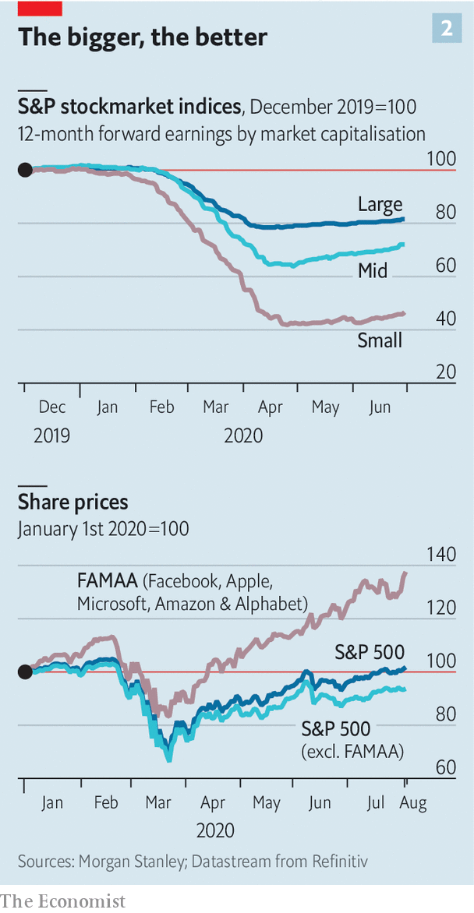

The collective headline numbers for big companies are also flattered by the success of America’s technology giants (see chart 2). Facebook, Apple, Microsoft, Amazon and Alphabet are thriving, by making life possible for remote workers, online shoppers and anyone who seeks solace online. The quintet, which together represent 22% of the S&P 500’s market value, up from 16% a year ago, has generated stockmarket returns of 35% so far this year, against -5% for the other 495 firms in the index.

This dominance has boosted the market—and investor confidence. But it poses a risk for the unwary. Mr Golub says that unlike the flaky internet firms that collapsed when the dotcom bubble burst two decades ago, the five tech titans have solid business models, little debt and strong revenue growth. But should a speedy recovery materialise, money could flow out of tech and into currently unloved sectors such as heavy industry.

Another underappreciated threat to share prices comes from government. Tobias Levkovich of Citigroup, a bank, points out that the “womb to tomb” safety net in Europe provides more generous and longer-lived relief in a downturn than America’s more threadbare benefits. Congress seems poised to reduce stimulus spending that has supported firms keeping furloughed workers on their payrolls and paid unusually plush unemployment benefits, which recipients could spend not just on rent and bills but also on other, less vital things. Mr Levkovich calculates that taxpayers financed between $50bn and $75bn of firms’ labour costs associated with furloughed workers. If such support is withdrawn in the second half of the year, he warns, “we must worry that the upside earnings surprises are not repeatable.”

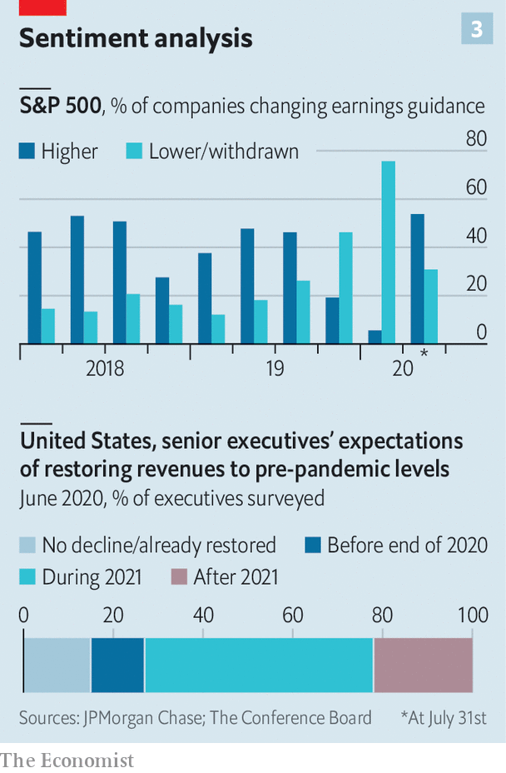

For the time being the market thinks they are. CEOs themselves are partly responsible for this, by tirelessly spinning investors a positive yarn. S&P 500 firms which forecast higher future earnings now outnumber those offering lower or no guidance by two to one (see chart 3). In the previous quarter the coy and pessimistic were 15 times as numerous as the sunny.

Yet when the Conference Board, a research group, recently surveyed hundreds of American bosses anonymously, it encountered much more pessimism about the timing and robustness of economic recovery than among CEOs in Europe and Asia. Whereas 40% of chief executives in China see sales returning to pre-pandemic levels by the end of 2020, only 12% of American bosses do. The Conference Board concludes that a return to pre-coronavirus revenues is “at least a year or more down the road” and that “risk and volatility will remain high for the foreseeable future.” Sooner or later investors seduced by CEOs’ public sweet talk—and by TINA—will come to their senses. Won’t they? ■

This article was downloaded by calibre from <https://www.economist.com/business/2020/08/08/americas-stockmarkets-are-flying-high-its-companies-still-arent>

|  |  |  |  |
| --- | --- | --- | --- |
|  | Articles | Sections | Next |

|  |  |  |  |
| --- | --- | --- | --- |
| Previous | Articles | Sections | Next |

#### Inclusive growth

# Joining the S&P 500 may not be as big a boon as often assumed

New research suggests that the share-price premium for entering Wall Street’s flagship index isn’t what it used to be

Aug 8th 2020 |

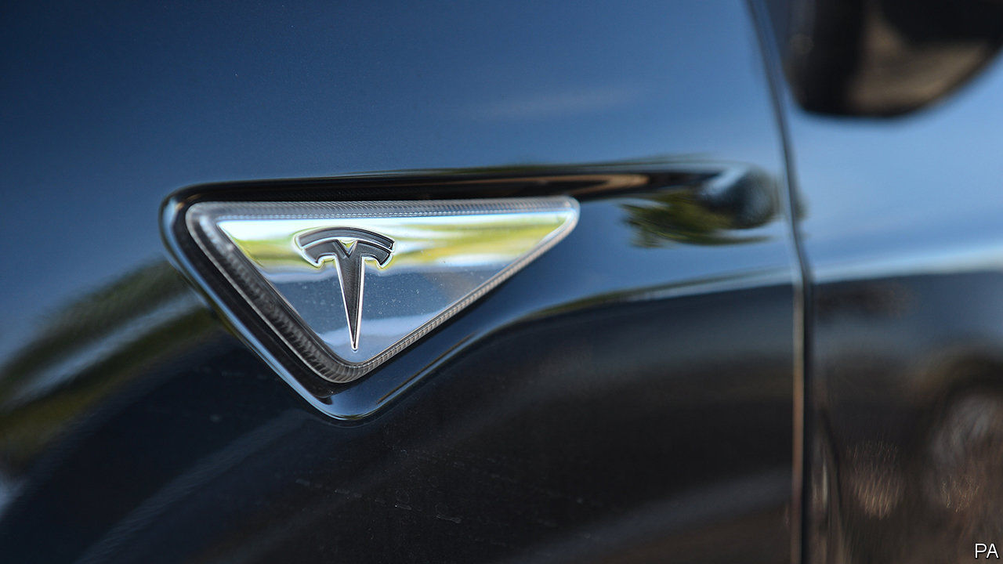

LAST MONTH Tesla reported second-quarter net income of $104m. This came as a surprise; the pandemic has pushed many carmakers into the red as cash-strapped consumers put off purchases. It also had Tesla’s investors aflutter, for it marked the firm’s fourth consecutive quarter of profits. At last, thanks to that milestone, the maker of snazzy electric vehicles—which in July overtook Toyota was the world’s most valuable car firm—met the formal criteria for inclusion in the S&P 500.

As covid-19 has boosted pandemic-resilient businesses such as technology firms while walloping industries such as travel, more companies than usual may drop out of or enter that coveted club this year. Membership of Wall Street’s flagship share index is seen as a boon, because “passive” investors, who do not actively pick winning stocks but merely track the broader stockmarket, must buy the shares of any new member (and sell those of the firm it displaces). This should drive up the entrant’s share price. Thereafter, one theory goes, increased common ownership of companies by large index funds, which hold stakes in listed rivals, reduces competitive pressure and leads to juicier shareholder returns all around.

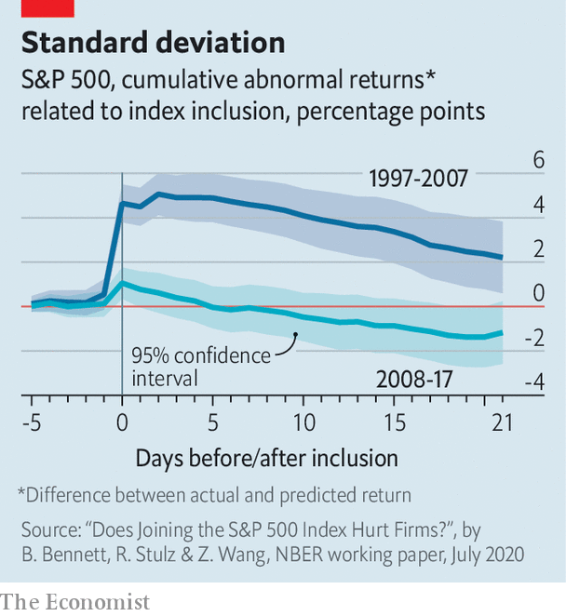

However, as passive ownership of assets in mutual and exchange-traded funds has swelled—from around 3% of their portfolios in 1995 to more than 40% at the start of 2020—the fillip from inclusion in the index appears to have weakened. It may even have become a burden.

That, at least, is the conclusion of a new paper by Benjamin Bennett of Tulane University, René Stulz of Ohio State University and Zexi Wang of Lancaster University. They looked at freshly minted S&P 500 firms between 1997 and 2017, five days before their ascension, then up to a year later. In the first decade of the sample, index inclusion increased “abnormal” stockmarket returns—ie, those relative to pre-inclusion expectations—by up to 4.9% in a firm’s first week in the index. This outperformance then gradually disappeared over 12 months. In the second decade, by contrast, the initial pop was negligible. Worse, abnormal returns turned negative within three weeks, and stayed there.

The researchers suggest two possible reasons. First, unlike active stockpickers, passive investors are indifferent to the price of a firm’s shares—if it is in an index, they must hold them. What they pay thus conveys less information about their view of a firm’s strengths and weaknesses than an active stockpicker would. Distorted market signals may make managers overconfident, warp investment decisions and lead to shabbier long-term earnings—which share prices in principle reflect. Second, an increase in passive holdings as a proportion of a firm’s shares dilutes the power of active (and activist) shareholders. Since they hold managers to account, corporate governance can slip after joining an index, also hurting long-term prospects. Tesla, and other S&P 500 wannabes, had better take note.■

This article was downloaded by calibre from <https://www.economist.com/business/2020/08/08/joining-the-s-and-p-500-may-not-be-as-big-a-boon-as-often-assumed>

|  |  |  |  |
| --- | --- | --- | --- |
| Previous | Articles | Sections | Next |

|  |  |  |  |
| --- | --- | --- | --- |
| Previous | Articles | Sections | Next |

#### Worth an arm and a leg

# Nvidia tries to get its hands on Arm

The deal would create a chipmaking potentate

Aug 8th 2020 |



FOR WEEKS rumours have swirled that Nvidia, an American company which designs and sells computer chips, wants to buy Arm, a firm which produces the fundamental blueprints on which most such chips are built. Arm, which is based in Britain, has since 2016 been owned by SoftBank, a Japanese technology conglomerate, which bought it for an extraordinary $32bn—the highest price ever paid for a European technology company. On August 3rd news reports said that Nvidia was close to a deal. It may splurge as much, or more.

That is because Arm is not a normal company. The firm’s core products are a set of fundamental designs for computer chips called instruction-set architectures (ISAs). Arm sells access to ISAs to the likes of Apple, Qualcomm and Huawei, giving those firms freedom to design and manufacture Arm chips however they want. The powerful chips in Apple’s iPhones are the product of this process, as are those in just about every smartphone in the world. Arm also creates its own chip designs, which it calls “cores”, and licenses them to companies that need a cookie-cutter starting-point for chips to put in their devices, as well as cars, connected fridges or anything else hooked up to the internet. As a result, Arm is everywhere.

Oddly for the sole supplier of technology that undergirds the global semiconductor industry, Arm makes relatively little money. In 2019 it pulled in less than $2bn in revenue. Nvidia, which faces plenty of competition, generated $2.8bn in net profit, mostly by selling powerful specialised chips used to play video games, or bolted onto existing machines in data-centres run by Google, Microsoft and other cloud-computing providers, where they are used to train artificial intelligence.

Chipmakers that currently rely on unfettered access to cutting-edge chip designs worry about losing it once Nvidia gets hold of Arm. Under SoftBank, which is not a chip company, none of this was an issue. But if Nvidia, which is one, owned Arm, it would exercise a degree of control over potential rivals. Chinese chipmakers in particular may fret that the American firm, whose operations are located almost entirely in its domestic market, will give the federal government power to block Arm’s designs from getting to China, as long as America’s tech standoff with its Asian rival continues. Nvidia declined to comment.

Nvidia remains tight-lipped about what exactly its intentions are. It has not confirmed it is in talks with SoftBank. One possibility is that it wants to combine its scale and Arm’s designs to create general-purpose chips that keep data-centres humming. At the moment this lucrative business is dominated by Intel, another American firm (Arm servers exist, but they are mostly designed by firms like Tesla and Amazon for their own purposes).

Nvidia could in principle compete with Intel by licensing Arm’s designs without buying the firm. Acquiring Arm would hand it control over the technology roadmaps of countless high-tech firms. Many companies would pay an arm and a leg for that sort of power. ■

This article was downloaded by calibre from <https://www.economist.com/business/2020/08/08/nvidia-tries-to-get-its-hands-on-arm>

|  |  |  |  |
| --- | --- | --- | --- |
| Previous | Articles | Sections | Next |

|  |  |  |  |
| --- | --- | --- | --- |
| Previous | Articles | Sections | Next |

#### Unproductivity puzzle

# Microsoft wants a slice of TikTok

What does a middle-aged tech giant want with a teenage sensation?

Aug 8th 2020 |

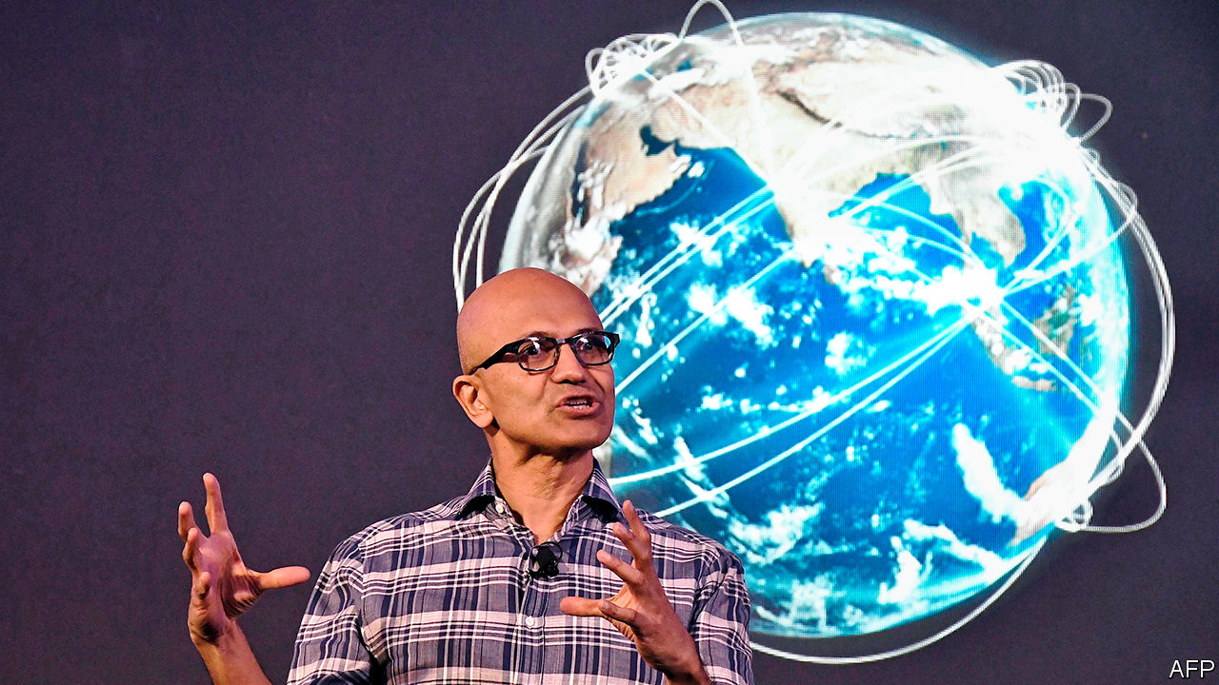

ON JULY 29TH the bosses of Alphabet, Amazon, Apple and Facebook endured a five-hour videoconference with a congressional subcommittee on antitrust. Satya Nadella, chief executive of Microsoft, America’s other technology titan, spent the day talking to investors, recruiting new hires and reviewing the latest quarterly numbers. His presence was not required—Microsoft no longer attracts the controversies that bring politicians running.

Or does it? On August 2nd the firm said it was in talks to buy the American, Canadian, Australian and New Zealand operations of TikTok, a wildly popular but problematic Chinese-owned video-sharing app. President Donald Trump had mused about banning it over fears that it could hand data on Americans to China’s Communist authorities, despite protestations by its parent company, ByteDance, that it would never do such a thing. After some unusual steps to mollify Mr Trump—including a statement in which it thanked him effusively for his “personal involvement”—Microsoft has until September 15th to hash out a deal.

Other suitors may cut in. ByteDance’s venture-capital backers, most of whom are American, will try to flush out rival bidders. They are disappointed that ByteDance failed to head off TikTok’s political travails. The Chinese group should have spun off the American unit this spring, keeping a big minority stake, says an investor close to the firm. But the ambition of its founder, Zhang Yiming, led ByteDance mistakenly to calculate that it could muscle through geopolitical tensions, the investor says.

TikTok’s price could rise if more bidders emerge, but it will still go for far less than ByteDance’s estimation of its value. ByteDance believes TikTok US would have been worth $200bn within a few years. Now it may have to sell the business for between $15bn and $40bn. That would be one of the year’s biggest deals. But once TikTok US, with its 100m or so users in America alone, turns profitable—which it is widely expected to soon—it may look like a bargain.

TikTok would propel Microsoft into the social-media big league. That may be Mr Nadella’s strategic aim. Google, the main division of Alphabet, is challenging Microsoft in cloud computing and office software. Nabbing TikTok would be a counter-strike against Google’s YouTube, notes Mark Moerdler of Bernstein, a research firm. The app would also give Microsoft a trove of data on young people, putting it on a par with the likes of Snapchat and Facebook’s Instagram.

At the same time, TikTok is a departure from Microsoft’s core competence of business-productivity tools. The app is unproductivity software par excellence. Microsoft’s gaming business, including the Xbox console, brought in only 8% of its $143bn in revenues in the 12 months to June. The firm has a mixed record with consumer technology. In July it shut Mixer, a live-streaming service for gamers that had failed to gain traction. And with TikTok Mr Nadella may expect an invitation to Big Tech’s next roasting on Capitol Hill. Controversies around TikTok’s content moderation and data protection will keep cropping up.

The next 40 days will be busy. Microsoft may try to buy more of TikTok than just the four English-speaking markets. But ByteDance will want to keep as much of its global presence as possible, especially with Mr Zhang under fire in China for selling out to the Yankees. The world may end up with two TikToks, one American-run, one controlled by ByteDance.

How an American TikTok would work is unclear. Microsoft would need to replace the app’s Chinese infrastructure, presumably by copying ByteDance’s code and auditing it. If it wants American teenagers to be able to view videos uploaded by Japanese or even British ones, it would have to license them from ByteDance, which may run afoul of Mr Trump. TikTok’s current appeal rests in part on its global assortment. Both versions of the app will be diminished by a split. Instagram’s Reels, a TikTok lookalike launched on August 5th, will try to woo disenchanted TikTokers. For the 45-year-old Microsoft, navigating the Sino-American tech tussle may be the easy part next to keeping teenagers’ attention. ■

This article was downloaded by calibre from <https://www.economist.com/business/2020/08/08/microsoft-wants-a-slice-of-tiktok>

|  |  |  |  |
| --- | --- | --- | --- |
| Previous | Articles | Sections | Next |

|  |  |  |  |
| --- | --- | --- | --- |
| Previous | Articles | Sections | Next |

#### Sverige AB v Deutschland AG

# Swedish firms have outshone German ones in the pandemic

How two northern European corporate realms have weathered covid-19

Aug 8th 2020 | BERLIN

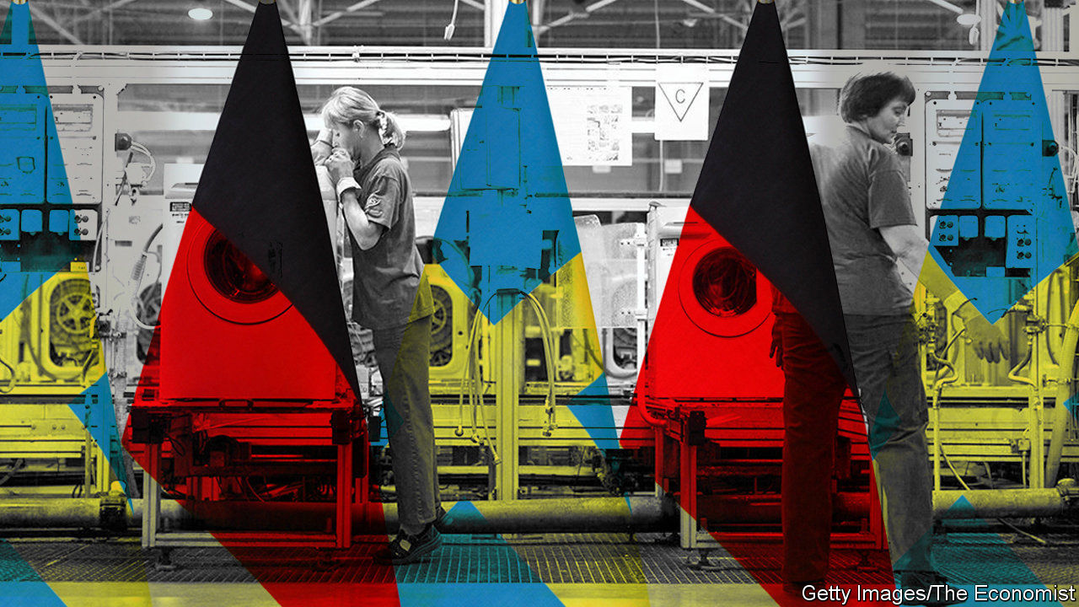

SINCE THE Middle Ages, when the Hanseatic League of merchant guilds dominated trade in northern Europe, the German and Swedish business worlds have been close. This remains the case. Both economies depend on exports, manufacturing and retail. Germany is the biggest market for many Swedish firms. Nearly a fifth of Sweden’s imports come from across the Baltic. The two countries’ stockmarkets also tend to move in lockstep (see chart).

You would, then, expect covid-19 to have affected Sverige AB and Deutschland AG in similar ways. Not quite. The 18 members of the DAX 30 index of Germany’s biggest firms that have already reported swung from a healthy profit in the second quarter of 2019 to a loss almost as big this year. For many companies, including Volkswagen, a giant carmaker, and BASF, the world’s biggest chemicals concern, results were even worse than analysts had expected. The income of the 27 Swedish firms in Stockholm’s OMX 30 that have reported so far fell by 49%, bad but much better than the DAX. If you include adjusted earnings of two opaque investment vehicles in the OMX, income actually rose.

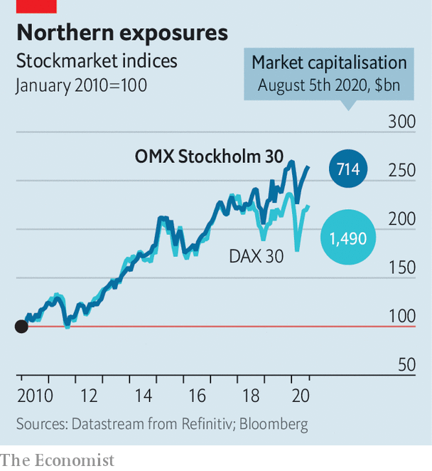

From makers of kitchen appliances (Electrolux) and telecoms equipment (Ericsson) to finance (Svenska Handelsbanken) and pharmaceuticals (AstraZeneca, which is listed in Stockholm, London and New York), big Swedish firms trounced expectations. “I have never seen so many companies come in with better than expected results,” marvels Esbjörn Lundevall of SEB, a Swedish bank.

Mr Lundevall points to three main reasons for the surprise. Sweden’s pandemic-relief effort, from cheap loans to furlough schemes, was more generous than predicted. Firms cut costs more radically than was thought possible. And, critically, demand recovered faster than forecast in June. As a result, Sweden’s GDP contracted by 8.2% in the second quarter, year on year, compared with a drop of 11.7% in Germany. Capital Economics, a consultancy, now expects Sweden’s economy to shrink by a relatively modest 2.5% in 2020. The country, it says, is the “best of a bad bunch in Europe”.

Many Swedish bosses put this down to their government’s controversial decision, which they vocally backed, to avoid the total lockdowns imposed across much of Europe. This allowed consumers to go about their lives and workers to send their children to schools, which remained open.

In public, CEOs of big German companies generally praised their government’s tougher policies. Privately, though, some shared the fears expressed openly by the BVMW, the association of Mittelstand firms that represents 3.5m businesses with up to 250 employees. In an open letter in May the BVMW called on the government to lift the lockdown “before it is too late” and criticised it for lacking an exit strategy.

Such calls may intensify if recent spikes in covid-19 cases turn into a new wave of infections. “A second lockdown would have cruel consequences,” says Hans-Jürgen Völz of the BVMW. Investors seem ambivalent about which country’s strategy is preferable for the long-term health of the economy. After falling more steeply than the OMX in March, the DAX has rebounded at a faster pace, too. In the past two months the fortunes of the Hanseatic peers have once again mirrored one another—trans-Baltic earnings disparities notwithstanding. ■

Editor’s note: Some of our covid-19 coverage is free for readers of The Economist Today, our daily [newsletter](https://my.economist.com/user#newsletter). For more stories and our pandemic tracker, see our [hub](https://www.economist.com/news/2020/03/11/the-economists-coverage-of-the-coronavirus)

This article was downloaded by calibre from <https://www.economist.com/business/2020/08/08/swedish-firms-have-outshone-german-ones-in-the-pandemic>

|  |  |  |  |
| --- | --- | --- | --- |
| Previous | Articles | Sections | Next |

|  |  |  |  |
| --- | --- | --- | --- |
| Previous | Articles | Sections | Next |

#### Bartleby

# Dealing with customer complaints

Companies called to account

Aug 8th 2020 |

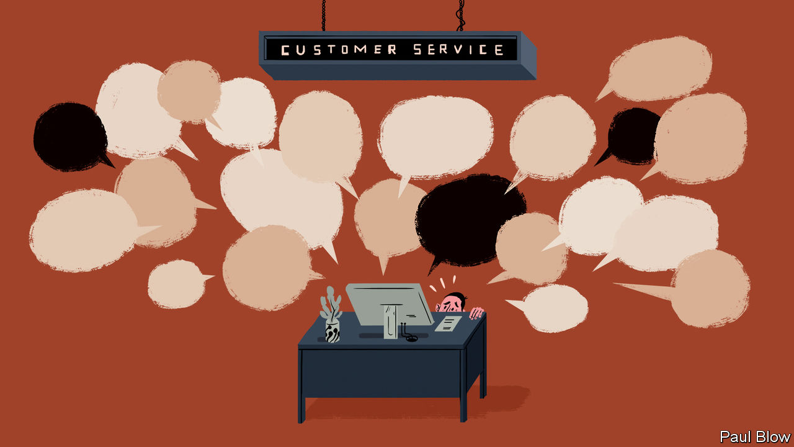

NOTHING IS MORE likely to sabotage a brand’s reputation than a customer complaint that goes viral. Social media often blow the problem out of proportion, leading television programmes and newspapers to pick up the story, which is invariably one that pits plucky members of the public against some heartless corporate Goliath. Consumer gripes—and stories about them—have multiplied during the pandemic as many services were cancelled because of lockdowns.

Rupert Younger of Saïd Business School at the University of Oxford says that views of companies are centred on the issues of capability and character. Firms’ capability is expressed in the quality of their products. The way that firms handle customer disputes, meanwhile, speaks to their character. If that quality is undermined, it can take time to rebuild public confidence. Research suggests that people and organisations alike tend to be judged by the worst thing they do.

One of the best-known pieces of brand damage occurred in 2008. Dave Carroll was travelling with United Airlines when he heard another passenger say that baggage handlers were carelessly tossing around guitars. When he arrived at his destination, Mr Carroll found his guitar had been damaged. After months of fruitless complaints, the musician made a video about his experience called “United Breaks Guitars”. Within a few weeks the video had received 5m views on YouTube and United contacted Mr Carroll to apologise and offer restitution.

The airline even pledged to use the video for internal training. But the corporate culture did not change sufficiently. In 2017 United suffered another public-relations disaster when a video emerged of security guards dragging a passenger off a plane to make way for a member of its own staff. The airline’s initial apology was viewed as ham-fisted, sympathising more with its own employees than with the unfortunate passenger, prompting Forbes magazine to dub United “the world’s most hated airline”.

Managers must thus be eternally vigilant when trying to protect their company’s good name. That can be expensive. Compensating customers costs money, as does having call centres that can respond quickly to queries and complaints.

There is a difference, however, between one-off complaints, which can usually be handled by common sense and a willingness to apologise, and a crisis that affects a wide range of customers, where solutions require extra costs on top of the complaint infrastructure. And costly crises can in turn be subdivided into those caused by a company’s own failings and those, like the pandemic, that are not its fault.

Airlines and travel companies have been the focus of a lot of customer complaints in 2020, thanks to all those cancelled holidays. “It took a hell of a lot of pressure to get companies to offer refunds, and even then it may take several months for them to pay out,” says Adam French of Which?, a British consumer magazine. Customers have also faced long delays on the phone, in part because the pandemic has reduced staffing levels at call centres.

Oddly enough, the poor reputation of some airlines may have cushioned the blow. “Ryanair has always marketed itself as cheap,” says Mr French, so customers don’t expect a high standard of service. The biggest reputational hit was to companies that had marketed themselves as treating customers better.

Airlines get away with more than other companies because they often have a monopoly on certain routes. But travel companies that want to behave well still have a problem. Repaying customers quickly puts a tremendous strain on cashflow at a time when they are generating a fraction of usual revenues.

Specialist Leisure, a British travel group, went into administration earlier this year; one of its main brands was Shearings, a coach-holiday operator. Mr French says the problem for Shearings was that, when it received customer deposits, it paid them to hotels where the tourists would stay. That created a cash squeeze when money had to be repaid. In short, it is all very well to have a good reputation as a prompt repayer. But that won’t help if the firm goes bust.

The pandemic has been an exercise in crisis management for thousands of firms. Dealing with angry customers is only one element. The rule of thumb for more normal times, Mr Younger says, is for companies to be clear about what they are offering and then to hold themselves to their promises. That means, at the very least, not breaking guitars.

This article was downloaded by calibre from <https://www.economist.com/business/2020/08/08/dealing-with-customer-complaints>

|  |  |  |  |
| --- | --- | --- | --- |
| Previous | Articles | Sections | Next |

|  |  |  |  |
| --- | --- | --- | --- |
| Previous | Articles | Sections | Next |

#### Schumpeter

# The trucking industry is in the midst of upheaval—and hype

E-commerce and self-driving cabs are among the potholes on the road ahead

Aug 8th 2020 |

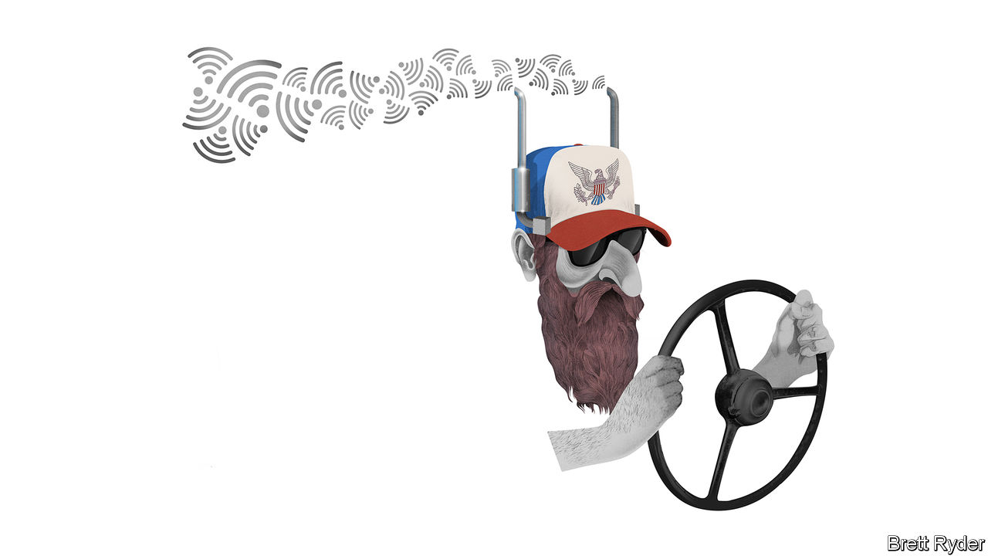

LIFE ON THE road has become a lot tougher since the 1980s, when Schumpeter spent a year driving a battered old lorry with several tonnes of four-hooved cargo around the western United States. The cab was too cramped to sleep in. The radio only played AM. And sweat would drench his shirt as he swerved down roads like the “Grapevine”, north of Los Angeles, with the smell of burning brake pads in his nose. Yet it was as close to the idyllic, free-wheelin’ life as a young Brit could hope for.

Not so for the genuine American trucker. Until that decade of deregulatory zeal, truckers were the best-paid members of America’s working class. Their union, the International Brotherhood of Teamsters, was revered and feared. And the romance of the road was celebrated in 1970s films like “Convoy”. Then came the Motor Carrier Act of 1980, which swept away restrictions on the number of haulage firms, as well as price controls. Union membership plunged and truckers’ livelihoods took a turn for the worse. Their sacrifice benefited the American consumer, though. As Steve Viscelli, a sociologist and author of “The Big Rig”, says, cheaper haulage on the back of lower wages for drivers supported a boom in big-box retailing that has transformed commerce ever since.

Today trucking is once again caught in an epochal upheaval that is also reshaping the retail industry. The main cause is online shopping, which is reducing long-haul delivery of containers from port to Main Street, and speeding up that of smaller packages from warehouses operated by retailers like Amazon and Walmart in America to consumers’ doorsteps. In addition, the experience of covid-19 is leading to a rethink of supply chains, which McKinsey, a consultancy, says may bring manufacturing closer to home and increase demand for road haulage. And as one of the world’s most fragmented industries, trucking is under pressure to become leaner, cleaner and more automated. The tech world is abuzz with efforts to disrupt it. Truckers, enjoying a rare moment of acclaim for their front-line work in the pandemic, are also on the front line of forces such as electrification and autonomous driving which, though overloaded with hype, could reshape their business.

This upheaval has only just begun to attract attention, despite the industry’s size and the fact almost every product travels by lorry. It often gets short shrift. Few would guess, for instance, that in America road-freight revenues are almost $800bn, about the same size as the world’s airline industry. In America and Europe there are 3.5m and about 3m lorry drivers, respectively, making trucking a jobs juggernaut. Yet it is so splintered that it is easy to overlook. China, for instance, has an estimated 8m trucking firms, most of which are one-man shops. America has almost 900,000, 96% of which own fewer than 20 lorries, according to the American Trucking Associations (ATA). In long-haul especially, this fragmentation comes at a high economic cost. The biggest 25 full-trailer (or “truckload”) freight firms in America, led by companies such as J.B. Hunt, account for less than a tenth of industry revenue. They are the most efficient, pay decent wages and are trundling through the pandemic with tolerable results. But the small fry producing the remaining 90% of revenues are in the slow lane. For about a third of the time they are on the road cargo-less—and drivers make no money. The pandemic is making their fortunes even worse.

Change is clearest in the short-haul segment, most recognisable in the fleets of delivery vehicles operated by logistics giants such as UPS, which have benefited from surging demand from locked-down shoppers, and increased profits despite the extra cost of door-to-door deliveries. Digitisation is helping improve efficiency, too. Uber Freight, the ride-hailing giant’s shipping arm, is developing a brokerage app to match carriers with shippers. In China, Full Truck Alliance, a startup backed by SoftBank, a Japanese technology group, is said to have a similar business model. E-trucks are on the horizon, albeit bedecked with bubblelike hoopla. The wild stockmarket debut of Nikola, a startup that plans to lease vehicles powered by hydrogen fuel cells, makes Tesla (which wants to start making a massive “semi” e-truck in Texas) look like a boring investment. At some times recently Nikola, which has yet to produce, let alone sell, a single vehicle, has been worth more than Fiat Chrysler. At least the histrionics have drawn attention to plans by more sober American truck- and engine-makers like PACCAR and Cummins to manufacture e-vehicles. Amazon has a $5bn order with Rivian, a startup, for 100,000 electric vans.

The biggest force of disruption is autonomous driving, which some fear could hit trucking like a neutron bomb, killing jobs that account for as much as 40% of freight costs. “Driver-assist” technology such as adaptive cruise control, which adjusts a lorry’s speed to keep a safe distance from vehicles in front, is already a reality. Bob Costello of the ATA says that the use of autopilot with a driver on board could be common within five years. TuSimple, a startup based in California and China, last month announced a partnership with Navistar, a truckmaker, to build semi-articulated robot trucks by 2024.

## Right lane exits

The spectre of platoons of driverless lorries barrelling down highways is probably some way off. Regulation for self-driving trucks is non-existent. The powerful rail industry will fight tooth and nail against a technology that imperils its future. Truckers, too, will raise a stink if they feel they have no prospects. Driverless cabs will not be here for decades, says Mr Costello.

One day they will come, though. The benefits of autonomous and electric trucking may be too powerful to resist, says John Murnane of McKinsey. In the meantime expect a further split in the trucking industry, with the best-capitalised firms in the fast lane and the also-rans headed for the off-ramp. For truckers, even less of the romance of the open road will remain. But as journeys shorten, at least they will sleep in the cab less often. ■

This article was downloaded by calibre from <https://www.economist.com/business/2020/08/08/the-trucking-industry-is-in-the-midst-of-upheaval-and-hype>

|  |  |  |  |
| --- | --- | --- | --- |
| Previous | Articles | Sections | Next |

|  |  |  |
| --- | --- | --- |
| Business | Sections | Schools brief |

Finance & economics

Vaccine economics: More hard questions

.

Chinese finance: A dynamic duopoly

.

Banks’ earnings: Dud light

.

Pre-doctoral programmes: Selection effects

.

The IMF and the World Bank: Abandoning hope

.

Free exchange: Change for the dollar

.

|  |  |  |
| --- | --- | --- |
| Business | Sections | Schools brief |

|  |  |  |  |
| --- | --- | --- | --- |
|  | Articles | Sections | Next |

#### Jab economics

# Hard questions as scientists and governments seek covid-19 vaccines

They must work out how much to invest, and how best to distribute the goods

Aug 8th 2020 |

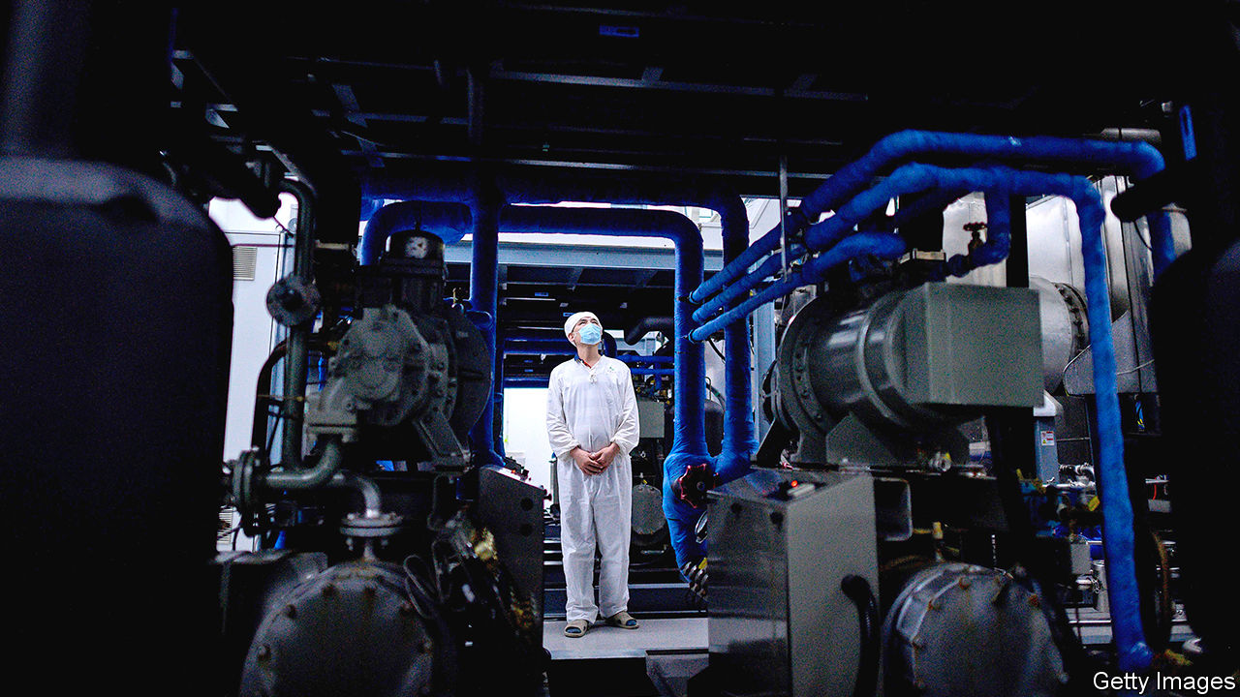

Editor’s note: Some of our covid-19 coverage is free for readers of The Economist Today, our daily [newsletter](https://my.economist.com/user#newsletter). For more stories and our pandemic tracker, see our [hub](https://www.economist.com/news/2020/03/11/the-economists-coverage-of-the-coronavirus)

SLOWLY BUT surely the economic costs of the covid-19 pandemic are becoming clear. On July 30th America’s statisticians revealed that the economy shrank by 9.5%, year on year, in the second quarter. Output in the euro zone fell even further. Even South Korea, which has managed the virus better than almost any other country, has not escaped a deep recession.

A vaccine would help end the economic chaos. Scientists and pharmaceutical companies have stepped up to the task. More than 150 vaccines are being developed worldwide, with six in final, large-scale clinical trials. It took the vaccination effort against hepatitis B—the disease for which the most candidate vaccines were developed—decades to make the progress that the attempts against covid-19 have made in months. The public-health and economic costs of the pandemic are such that, even as scientists beaver away, policymakers must grapple with two questions: how much to spend on vaccines, in order to ensure enough are made, and how to ensure they are distributed fairly.

Governments so far have invested more than $10bn in covid-19 vaccines, and made forward purchases of about 4bn doses (though data on deals are murky). As the vaccines may require a course of two doses, in theory this amount could inoculate the world’s most vulnerable people. In fact, effectiveness is far from assured, so a large share of purchases could turn out to be duds. A typical vaccine in final trials has a 20% chance of failure. Some of the candidate covid-19 vaccines involve novel technologies, so the risk of failure could be higher. That explains why rich countries are backing several efforts, with deals being signed every few days (see chart 1).

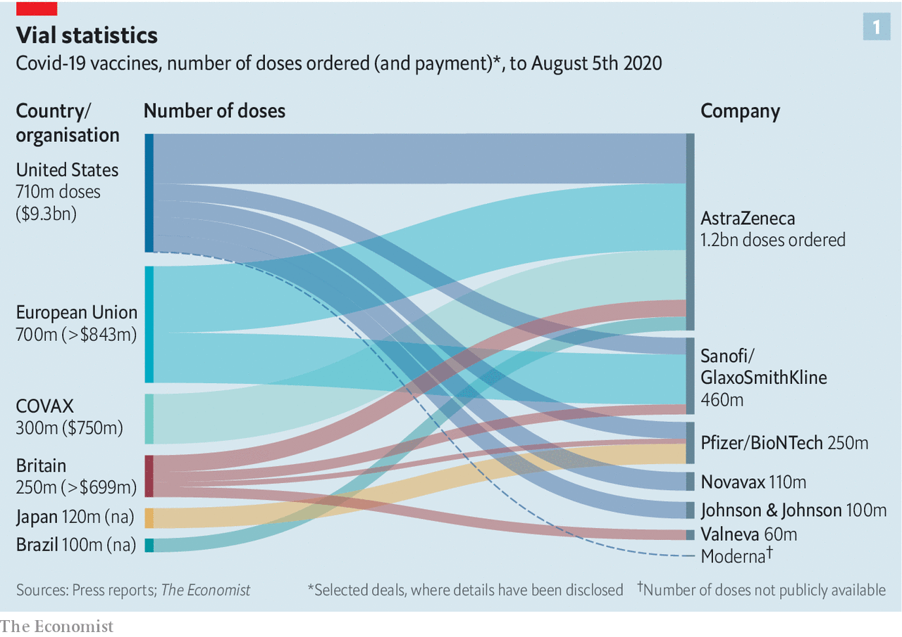

Despite the scramble in America and Europe to get to the front of the queue, countries elsewhere are likely to be under-supplied, and for some time. Japan has arranged to buy enough for just one dose per person, according to Goldman Sachs, a bank (see chart 2). On average, emerging markets have secured enough to cover less than a third of their citizens.

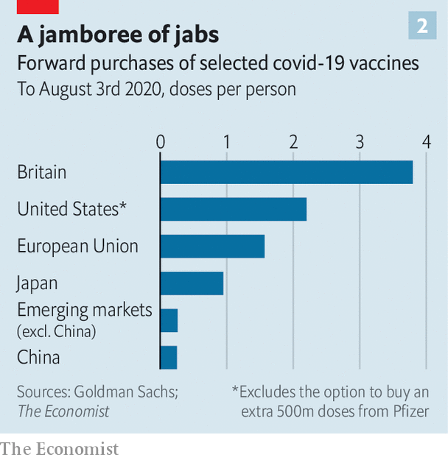

GAVI, an alliance that funds vaccines for poor countries, has set up COVAX, a purchasing pool for several late-stage vaccine candidates. It promises participants doses of an effective vaccine for up to 20% of their population by the end of 2021, with rich countries paying for their supplies and funding a kitty for poor ones. About 80 high- and middle-income countries have said they want to join. But it remains to be seen how many put money on the table: they must pay for the first 15% of their vaccines by the end of the month.

Even meeting the commitments they have already made will be a stretch for pharma companies, much less producing enough for the world. Existing manufacturing facilities can be repurposed for some types of jabs. For others, however, new ones must be built. These can cost about half a billion dollars apiece, and typically take three years to get up and running.

A company normally sets up production once a vaccine wins regulatory approval. But these are not normal times. To speed things up, some firms have started mass-producing vaccines that are still in clinical trials. Companies may have promised 4bn doses, but some of their vaccines may not pass trials and will have to be poured away. Many experts think supply will also be constrained by global shortages of things like vials and syringes. They put a more realistic estimate of global supply by the end of next year at nearer 2bn.

As that is nowhere near enough to cover the world, it is easy to imagine fights breaking out once effective vaccines become available. The experience of past pandemics is hardly encouraging on this front. During the H1N1 (swine flu) pandemic in 2009-10 rich countries cornered supplies of the vaccine to fight the disease. Only when they had more than they needed did they offer some of it to poor countries. By then, the disease had swept across the planet and the pandemic was over.

Early in the covid-19 pandemic, too, global co-operation quickly broke down. By late April, 80 jurisdictions had restricted exports, with governments especially keen to hoard supplies of disinfectants, personal protective equipment and thermometers. Some countries even seized shipments passing through their territory.

Fearful of a repeat of such marauding, the Coalition for Epidemic Preparedness Innovations, an alliance of charities and governments that has funded the early development of some of the most promising covid-19 vaccines, has organised manufacturing on several continents. So have some pharma companies.

The World Health Organisation (WHO) is also trying to avert vaccine politics. It has drawn up guidelines for how early supplies should be distributed in order to save the most lives, protect fragile health systems and hasten the end of the pandemic. The first doses would go to health and social-care workers, and the next batch to the 20% of people in each country who are most likely to die from covid-19 if infected. The rest would then go to places with the highest risk of outbreaks. COVAX has signed up to these principles, but there is no indication that countries would respect them in their bilateral deals with drug companies, rather than act in narrow self-interest.

There are slim hopes that America, China or Russia, among others, will allow exports of a vaccine made on their territory before enough is available for all of their citizens. But vaccine manufacturing and distribution involves a complicated global supply chain of raw ingredients, adjuvants (chemicals commonly used to boost potency), vials and so on. In the worst case, countries denied a share of the vaccines could ban exports of such inputs to the hoarding country. Everyone loses.

A global free-for-all, then, seems inevitable. One way to mitigate this would be to spend more. Some economists argue that governments could do more to hurry along vaccine manufacture and distribution. Separate groups of researchers reckon that the world needs to invest around $100bn in order to make several vaccines early and in sufficient quantities. That would be a ten-fold increase in what has been spent. But set against the output lost and the $7trn in stimulus injected into the global economy so far, it is peanuts. ■

This article was downloaded by calibre from <https://www.economist.com/finance-and-economics/2020/08/08/hard-questions-as-scientists-and-governments-seek-covid-19-vaccines>

|  |  |  |  |
| --- | --- | --- | --- |
|  | Articles | Sections | Next |

|  |  |  |  |
| --- | --- | --- | --- |
| Previous | Articles | Sections | Next |

#### A dynamic duopoly

# Do Alipay and Tenpay misuse their market power?

Both dominate payments in China

Aug 8th 2020 | SHANGHAI

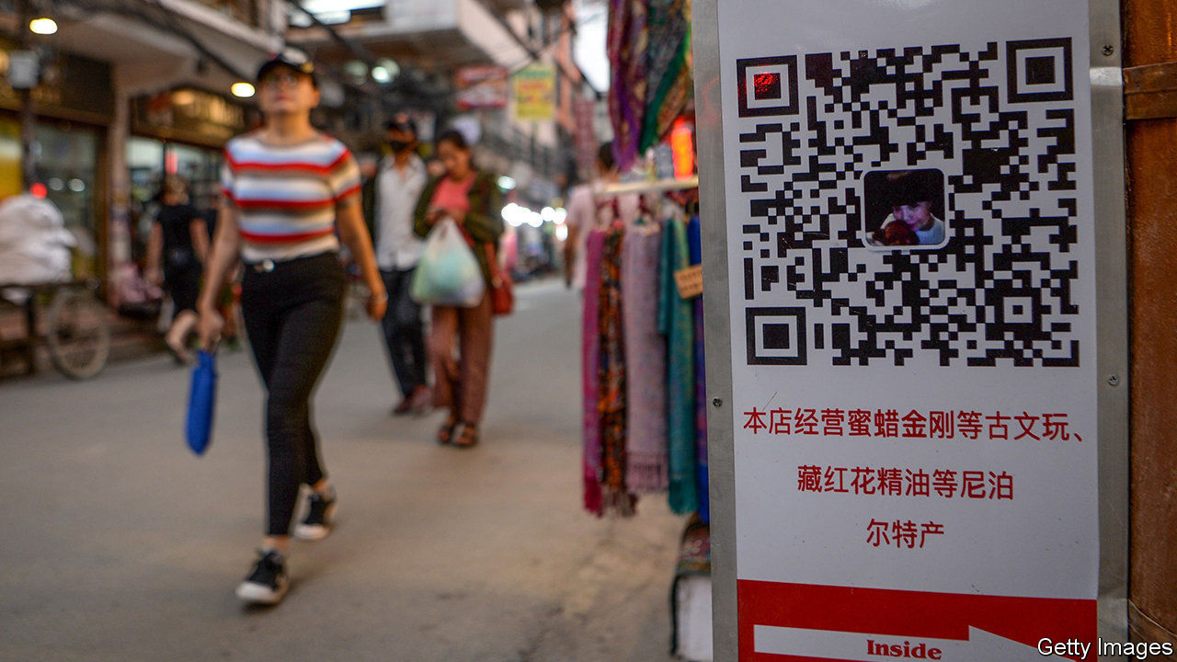

“LET THE users decide who wins the game, not monopoly and power.” So said Jack Ma in 2014 when Alipay, the slick payment service he created, came under attack from China’s lumbering state-owned banks. Six years on, the users have decided, and Alipay and its rival, Tenpay, known mainly for WeChat Pay, have won. There is little question that they constitute a duopoly. Alipay has a 54% share and Tenpay 39% of the Chinese mobile-payments market by value, according to Analysys, a research firm. And mobile today accounts for more than half of all non-cash retail payments in China (see chart).

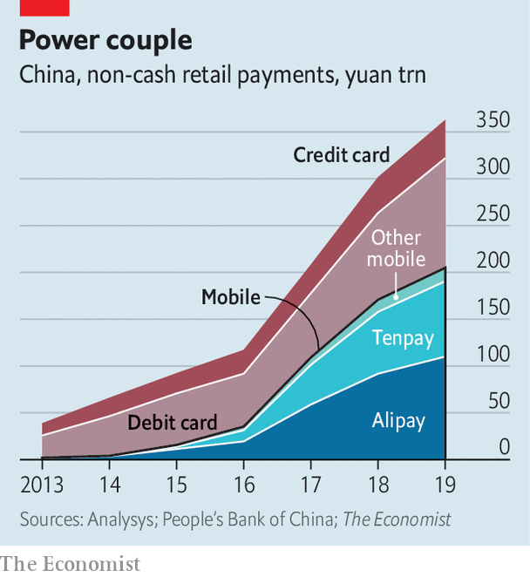

Not surprisingly, then, the former upstarts now face questions about their own power. According to Reuters, the central bank accuses them of misusing their dominance to limit competition. It reported on July 31st that the government’s antitrust committee is considering whether to investigate them, though has yet to make a final decision.

Alipay and Tenpay are sure to feel aggrieved about such scrutiny. In their view, their path to success was paved not with anti-competitive behaviour but with convenience and performance. Alipay began as a service for shoppers on Alibaba, China’s biggest e-commerce platform. WeChat Pay is an outgrowth of WeChat, the country’s main messaging app. They migrated offline by enabling people to pay in shops by scanning QR codes with their phones.

Seen as safe and reliable, they have earned the trust of merchants and shoppers. And as with much in the world of the internet, they have benefited from network effects: anyone who wants to make or take digital payments has little choice but to use Alipay or WeChat, or typically both, because just about everyone else does.

Given this dominance, there is potential for misuse. A rough parallel exists in rich countries, where Visa and Mastercard are the main platforms for processing card payments. These have faced antitrust lawsuits in America, Britain and Europe.

Alipay and Tenpay have acted in some ways that look anti-competitive, though typically by taking aim at each other. Within WeChat, for instance, it is impossible to open hyperlinks for products on Alibaba’s main shopping site. And on Alibaba you cannot make payments with Tenpay.

Yet for the financial system as a whole, Alipay and Tenpay have enhanced competition, not stifled it. As recently as a decade ago banking in China was a tortuous business, requiring heaps of paperwork and long queues. The digital duo dragged banks into the online era. They also offered users easy access to money-market products that allowed them to get better returns than available from banks.

More narrowly, they have improved the landscape for payments. Their underlying technology is simple, requiring just a smartphone. Even the humblest of fruit vendors can now accept non-cash payments. They have also lowered costs. They charge merchants fees of about 0.6% on transactions, down from the previous norm of roughly 1% on debit-card swipes.

Regulators have already put roadblocks in front of Alipay and Tenpay. The central bank limited the size of payments they can handle. It required that they hold customer funds in a zero-interest reserve account, denting their profitability. And it created a centralised clearing platform, NetsUnion, which Alipay and Tenpay must use, depriving them of exclusive transaction data.

Some in the payments industry see another possible explanation for an antitrust investigation. UnionPay, a state-owned firm, used to be the only show in town for handling card payments in China. As the market has evolved it has struggled to keep up with Alipay and Tenpay, and remains a bit player in mobile. Many in UnionPay’s upper ranks, including its departing chief executive, are former central-bank officials. This raises questions about the central bank’s impartiality when regulating UnionPay’s competitors.

The timing of the mooted investigation is also curious. The report came less than two weeks after Ant Group, which controls Alipay, announced plans for a long-awaited initial public offering, which could raise as much as $30bn, making it the world’s biggest-ever share sale. Perhaps someone wanted to spoil the party. If nothing else, a probe would serve as a reminder that China’s government keeps its tech champions on a short leash. ■

This article was downloaded by calibre from <https://www.economist.com/finance-and-economics/2020/08/08/do-alipay-and-tenpay-misuse-their-market-power>

|  |  |  |  |
| --- | --- | --- | --- |
| Previous | Articles | Sections | Next |

|  |  |  |  |
| --- | --- | --- | --- |
| Previous | Articles | Sections | Next |

#### Dud light

# Why European banks expect fewer bad loans than American rivals

It may be a sign of weakness rather than optimism

Aug 8th 2020 |

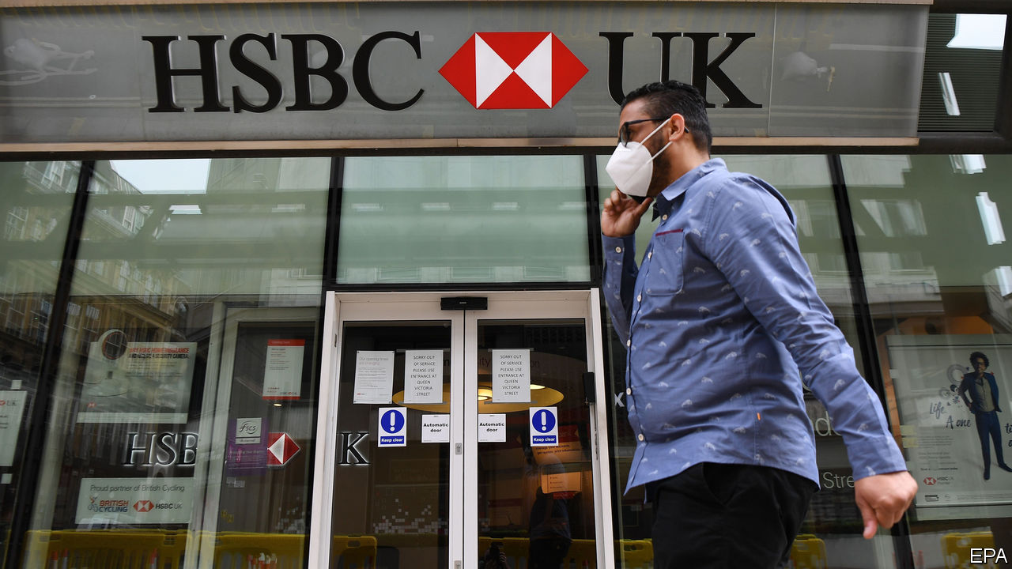

ANALYSTS HAD expected a blistering earnings season for European banks, which reported their second-quarter results in late July and early August. And painfully hot it was, with profits melting away as lenders made provisions for future loan losses. On August 3rd HSBC, Europe’s largest bank by assets, said that its post-tax profits had fallen by 88% on the year, to $617m. Loss-making lenders included Deutsche Bank in Germany, Santander in Spain and Société Générale in France.

Much like Wall Street titans, albeit on a smaller scale, European lenders with investment-banking arms saw losses tempered by a boost in trading revenue. As the coronavirus spread and markets turned volatile, investors rushed to reposition their portfolios. Many governments and companies took advantage of central-bank support and ultra-low interest rates to issue debt, allowing banks to pocket fat fees. BNP Paribas, France’s largest bank, saw trading revenue jump by 154%.

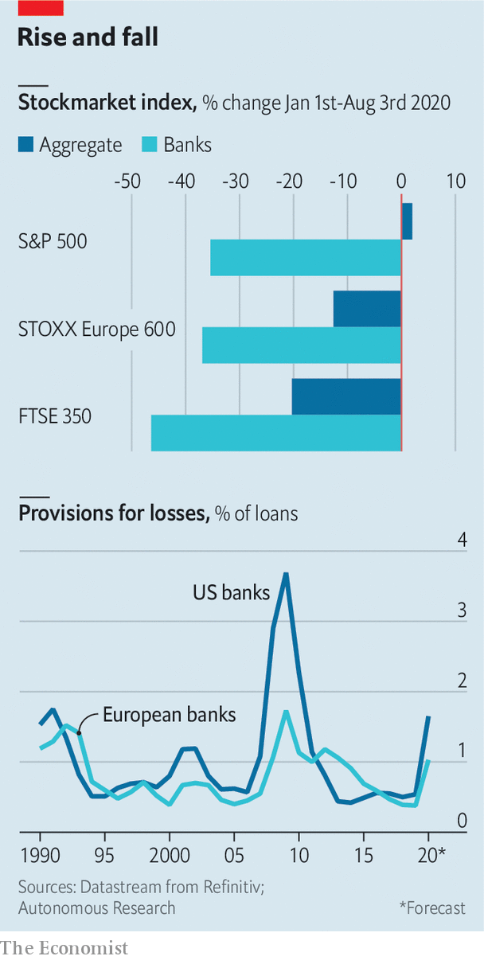

Such frenetic activity seems unsustainable. Indeed, says Stuart Graham of Autonomous, a research firm, debt issuance appears to have slowed in July. So the fate of banks will primarily be decided by the extent to which they are prepared for loan losses. Lenders on either side of the Atlantic have taken different approaches to the matter, with European banks booking smaller provisions, as a share of total loans. American banks have generally been more cautious in the past, only for European rivals to play catch-up (see chart). So who is right this time?

There is reason to think America’s banks may suffer more. Unemployment there has surged; Coface, a credit insurer, expects bankruptcies over the next year or so to rise by more than in Europe. A larger portion of American bank lending, including consumer and high-yield credit, is riskier and unsecured. European banks prefer to lend against collateral, for example through mortgages. That implies fewer and slower defaults, as well as higher recovery rates, when the cycle turns.

But the economic outlook is not the full explanation. America’s accounting rules require its lenders to make provisions against losses they expect on all loans over their lifetime. European rivals are required to account for lifetime losses only on loans that are closest to default (for performing assets they need to care only about the next 12 months). That makes them mechanically more myopic. In March the European Central Bank (ECB) encouraged more optimism by telling them to “avoid excessively pro-cyclical assumptions” when making provisions—in other words, to ensure that lending does not seize up in bad times.

Cultural differences compound prudential ones. American businesses, fans of transparency, tend to shoulder more pain upfront. European ones prefer to wait and see. Disclosure is not helped by the fact that fewer banks are listed. Only half of the 84 euro-zone lenders deemed “significant” by the ECB are publicly traded, says Nicolas Véron of Bruegel, a think-tank. By contrast, all America’s big banks are listed.

European banks’ smaller provisions could also be an admission of weakness. Most entered the crisis with a pre-existing condition: low profitability. Patrick Hunt of Oliver Wyman, a consultancy, says their return on tangible equity averaged 6% at the start of the year, half that of their American peers. That has left them with wafer-thin cushions with which to absorb provisions before they eat into core capital. The vast uncertainty about the economy translates into equally uncertain projections for defaults—and may have given banks the leeway to book provisions they can bear.

Investors are not fooled. European banks’ share prices have still fallen by as much as those in America, if not more. They have not been helped by the fact that the ECB, in an effort to preserve capital, has forbidden banks to distribute cash to shareholders until at least the end of the year. (In America regulators have banned share buybacks, but only capped dividends.) Investors usually covet European bank shares for their stable dividends, which they then funnel into high-growth technology or pharmaceutical stocks. The ban, says Ronit Ghose of Citigroup, a bank, is “another nail in the coffin”. ■

This article was downloaded by calibre from <https://www.economist.com/finance-and-economics/2020/08/08/why-european-banks-expect-fewer-bad-loans-than-american-rivals>

|  |  |  |  |
| --- | --- | --- | --- |
| Previous | Articles | Sections | Next |

|  |  |  |  |
| --- | --- | --- | --- |
| Previous | Articles | Sections | Next |

#### Selection effects

# What it takes to become an academic economist is changing

Pre-doctoral programmes are a new rung on the professional ladder

Aug 8th 2020 | WASHINGTON, DC

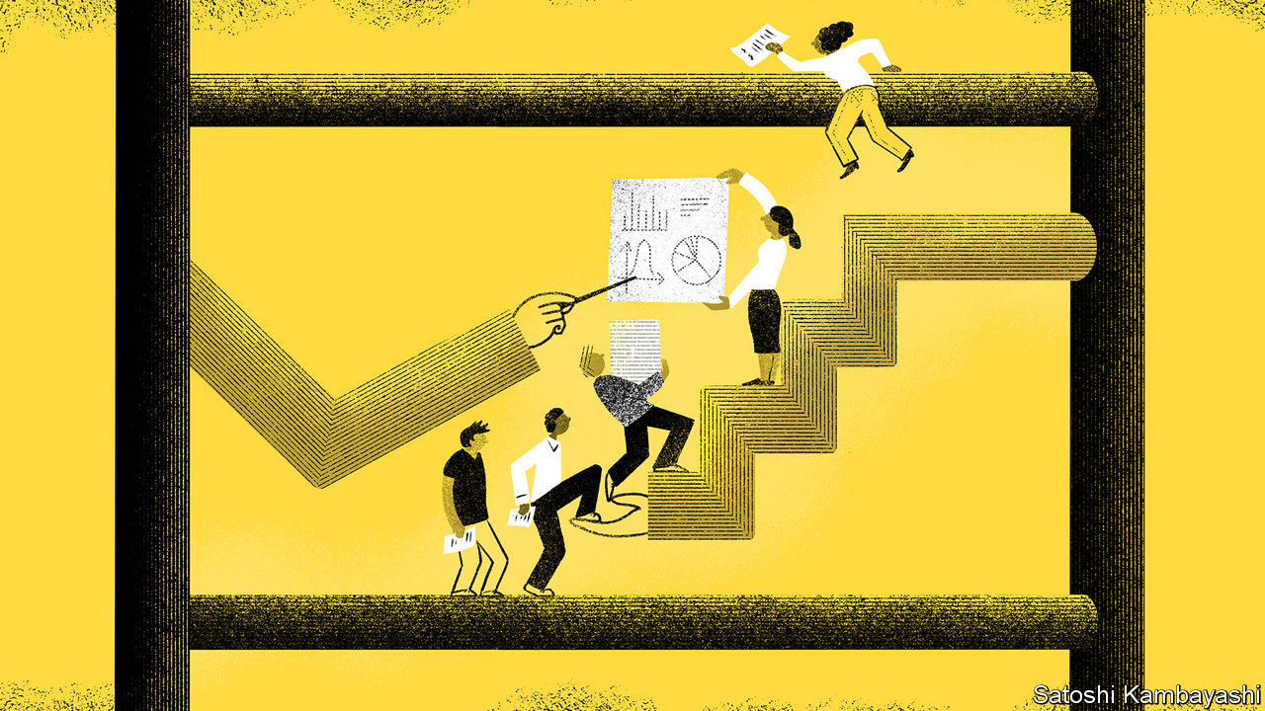

NABBING A TOP academic job in America requires obtaining a PhD, preferably from a good university. That, in turn, requires stellar undergraduate marks, the right maths courses and a glowing letter of recommendation. Increasingly, pre-doctoral programmes, or pre-docs, are serving as a new rung on the professional ladder. These schemes, which typically involve two years of research at a university, are both the cause and consequence of changes in the profession.

Economists have long sought work experience before embarking on a PhD, whether in consultancy, the public sector or finance. But over the past decade or so the nature of the experience has changed. A study by Kevin Bryan of the University of Toronto examined the CVs of sought-after economists, and found that none of those applying for economics jobs in 2013-14 had been research assistants at academic institutions before they began their PhDs, but around a fifth of those graduating in 2017-18 had.

Formal pre-doc programmes have burgeoned, especially in elite universities such as Harvard, Stanford, the University of Chicago and Yale. Participants clean and analyse data, write papers and do administrative tasks. In exchange they may receive free or subsidised classes, a salary in the region of $50,000, potential co-authorship of the papers they work on, and, most prized of all, a letter of recommendation to a top PhD programme.

In part pre-docs show how economic research has changed. “Economics has become more like the sciences in terms of both the methods and the production process,” says Raj Chetty of Harvard, who directs the Opportunity Insights team, a group with a reputation for working its pre-docs hard. When analysing tax records that gave access only to a certain number of people, he switched away from using part-time research assistants to a lab-like team, inspired by his own family of scientists. As bigger data sets, new techniques and generous funding made such collaboration worthwhile, others followed.

Done well, pre-docs enrich both economists and economics. They help produce good research and open up the profession. Peter Henry of New York University started his programme in 2014 to increase the representation of minorities. Camille Gardner, one of his pre-docs, says the experience has persuaded her to pursue a PhD, and taught her skills important for graduate study, such as how to write a good paper. She thinks of Mr Henry as her mentor, “not just my boss”.

There are some concerns, though, that pre-docs leave junior researchers open to exploitation. Academic economists are neither rewarded for good management nor punished for being bullies. Michael Greenstone of the University of Chicago argues that “if you misbehave, it is going to be hard to get people to work for you”. But academic economists, as the profession’s gatekeepers, still hold plenty of power.

Programmes vary widely. Sometimes it is unclear whether pre-docs are students or employees. One pre-doc tells of tensions over the timing of holidays. Another says they were told they would be collaborating with professors, but were then given much less freedom than that implied. Another complains of not being given enough time to take classes.

Others tell of a hyper-competitive work environment, fuelled by some professors ranking pre-docs in their letters of recommendation. More than one tells of being asked to game a statistical test until it showed the results the professor wanted, and of struggling to push back.

Fortunately such experiences do not seem to be common enough to deter many pre-docs from doing PhDs. According to a new survey of around 200 pre-docs by Zong Huang and Pauline Liang of Stanford and Dominic Russel of New York University, only 12% say their current position has dulled their interest in further study.

It is less clear, though, that pre-docs are helping diversify the profession. The evidence on the question is mixed. Those at the top seven institutions who responded to the survey were roughly balanced in terms of gender, but just 2% were black. Compared with recent PhD graduates, they were less likely to have attended a top-ten university. But they were more likely to come from a top-ten liberal-arts college—not quite the diversity the profession may have been striving for.

Programme managers like Yale’s Rebecca Toseland are working to alert a diverse set of students to their schemes; some say they review all applications from minorities. Others are considering whether to make sure undergraduates know which maths courses to take. But a few, like Mr Henry, are more sceptical, worrying that pre-docs could come to represent another stage in the credentials arms race. Indeed, nearly a quarter of pre-docs at top institutions who were surveyed had been full-time research assistants before starting in their position. In other words, as pre-docs have gained prominence, so too have pre-pre-docs. ■

This article was downloaded by calibre from <https://www.economist.com/finance-and-economics/2020/08/08/what-it-takes-to-become-an-academic-economist-is-changing>

|  |  |  |  |
| --- | --- | --- | --- |
| Previous | Articles | Sections | Next |

|  |  |  |  |
| --- | --- | --- | --- |
| Previous | Articles | Sections | Next |

#### Abandoning hope

# Official economic forecasts for poor countries are too rosy

Over-optimism at the IMF and the World Bank can have serious consequences

Aug 4th 2020 |

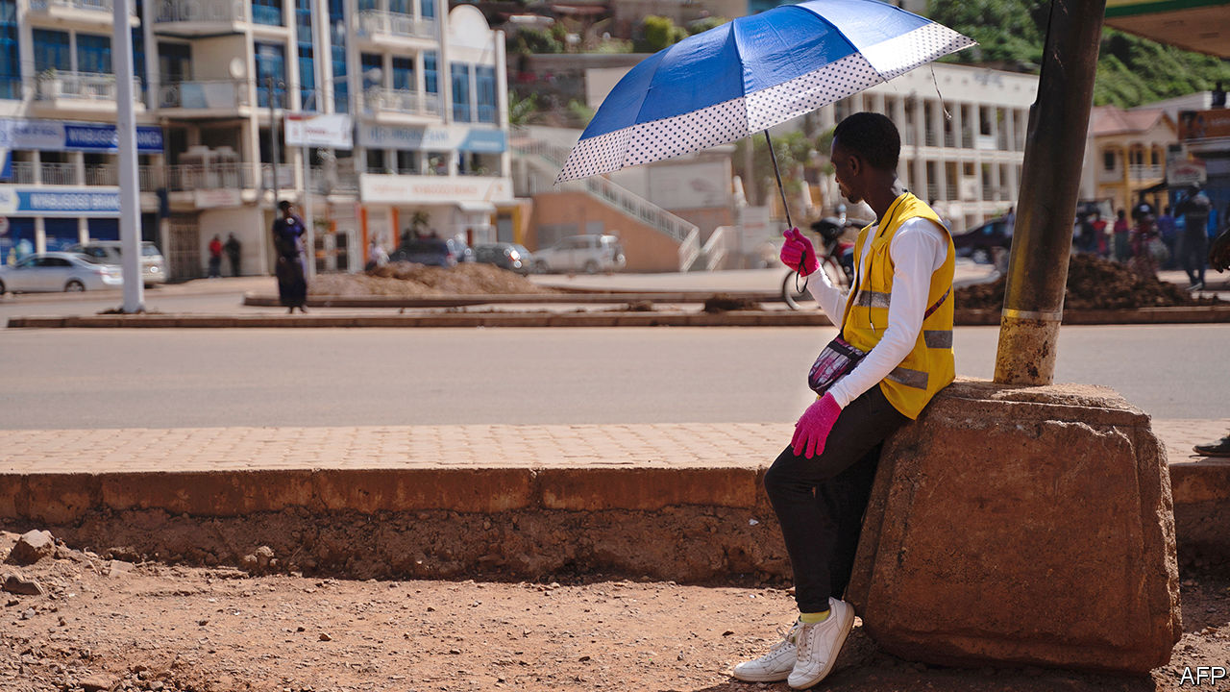

MOST PEOPLE, when presented with bad news, tend to play it down. Even professional economic forecasters are not immune to the temptations of hope. In February more than 500m people in China were experiencing some form of lockdown, and covid-19 had spread to Italy. Yet the IMF said that in its base-case forecast global GDP growth this year would be only 0.1 percentage points lower than previously expected. By April it had cut its forecast by 6.2 percentage points, to -3%. By June it had sawn off another 1.9 percentage points. Just a week later an informal poll of about 40 IMF staff found that two-thirds expected another downward revision in October.

By and large, economic forecasters are a sunny bunch. They rarely predict a downturn. Human nature, incentives and political pressure get in the way. Yet rosy forecasts by theIMF and the World Bank can have serious consequences. That is especially the case in poor countries today, where covid-19 is ravaging economies, and governments, international organisations and investors are using forecasts to guide their decisions.

IMF and World Bank projections can be very influential in some countries. They can affect governments’ spending and borrowing plans. Investors may lend more cheaply to countries expected to grow rapidly. And the forecasts determine whether the fund and the bank think a country’s debt is sustainable, which in turn determines whether it qualifies for a bail-out.

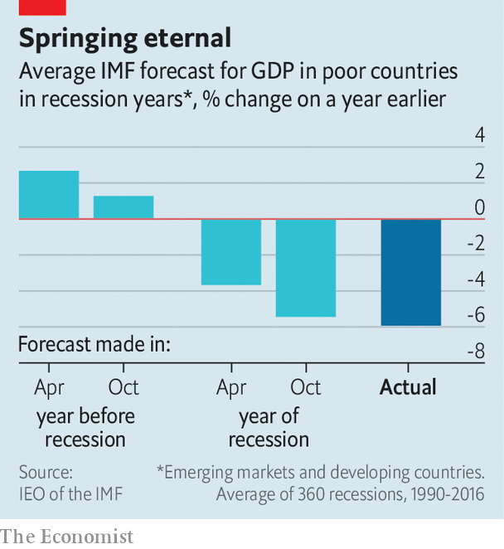

The fund tends to be optimistic. Its one-year-ahead growth forecasts for developing countries in 1990-2016 were, on average, 0.42 percentage points above subsequently published GDP figures. Most of the optimism comes from failing to predict downturns. Even once a recession has begun, forecasters are still slow to accept the news (see chart).

Such errors can drastically change debt dynamics. Take a country expected to have public debt of 50% of GDP in 20 years’ time. If annual economic growth is 0.5 percentage points less than predicted, and nothing else changes, then the debt ratio could instead be 90% of GDP. In a recent study Paul Beaudry of the University of British Columbia and Tim Willems of the IMF even link over-optimism to future fiscal crises. They find that overestimating average annual growth by a percentage point for the next three years, as the IMF does about 40% of the time, reduces growth three years later by a full percentage point. Governments and firms seem to celebrate good forecasts by racking up debt. Trouble sets in.

Predicting growth, and especially downturns, is fiendishly hard. Getting it right is not helped by forecasters having little incentive to spot clouds on the horizon. Analysts fear that gloom could become self-fulfilling. Standing out from the crowd and wrongly calling a recession damages a forecaster’s reputation more than failing to predict one along with everyone else. Then there is “pushback from governments”, says Maurice Obstfeld, who was the fund’s chief economist in 2015-18.

Internal pressure to nudge up forecasts in order to justify a lending package is also “definitely an issue ”, says Mr Obstfeld. A paper by Giang Ho and Paolo Mauro of the fund in 2014 found that forecasts were especially optimistic when countries were just about to enter a programme. The fund’s Independent Evaluation Office (IEO) acknowledges that forecasts tend to be rosy in high-profile bail-outs, but notes that these are usually corrected at the programme’s first review three months later. (By then, of course, the agreement has already been signed.)

Some economists at the fund are more optimistic than others, find Messrs Beaudry and Willems. In poor countries, less experienced economists tend to be less accurate. Although oil and mineral discoveries do not boost growth immediately, IMF forecasters consistently predict that they will, according to research in 2017 by James Cust of the World Bank and David Mihalyi of the Natural Resource Governance Institute, a think-tank.

The fund’s lack of consistency attracts criticism, too. Since the coronavirus pandemic began it has revised down growth in rich countries in 2020 by three percentage points more than that in developing ones. That is odd, argued Justin Sandefur of the Centre for Global Development, another think-tank, and Arvind Subramanian of Ashoka University, in June. Lockdowns and social distancing are at least as severe in poor countries as in rich ones. But fiscal responses have been much weaker, and, as the fund itself has argued, capital outflows and currency pressure are bigger threats. Perhaps, the authors speculate, the fund has been rosier about poorer countries this time in order to avoid having to provide support. TheIMF says that China’s success in containing the virus explains why its forecasts are more positive for developing countries and strongly denies lending influences its growth forecasts.

The other big official forecaster in poor countries is the World Bank. (Private firms, including The Economist’s sister organisation, the Economist Intelligence Unit, also publish forecasts.) Over the past decade, the bank has produced more accurate forecasts for Africa and the Middle East than the fund, but done a worse job for Latin America (though differences are small). Overall, a comparison of the forecasts published by both institutions every January by Prakash Loungani of the IEO suggests that the fund is still better than the bank at predicting downturns in poor countries.

Perhaps people should simply expect less of forecasts, says Mr Obstfeld. They may represent an expectation of the most likely outcome, but the chance of them being bang-on is slim. “You are getting something that is useful,” he argues, but “in general, you are not getting high accuracy.” ■

This article was downloaded by calibre from <https://www.economist.com/finance-and-economics/2020/08/04/official-economic-forecasts-for-poor-countries-are-too-rosy>

|  |  |  |  |
| --- | --- | --- | --- |
| Previous | Articles | Sections | Next |

|  |  |  |  |
| --- | --- | --- | --- |
| Previous | Articles | Sections | Next |

#### Free exchange

# Dollar dominance is as secure as American global leadership

The currency’s wobbles have fed fears that a reckoning looms for the world’s economic hegemon

Aug 8th 2020 |

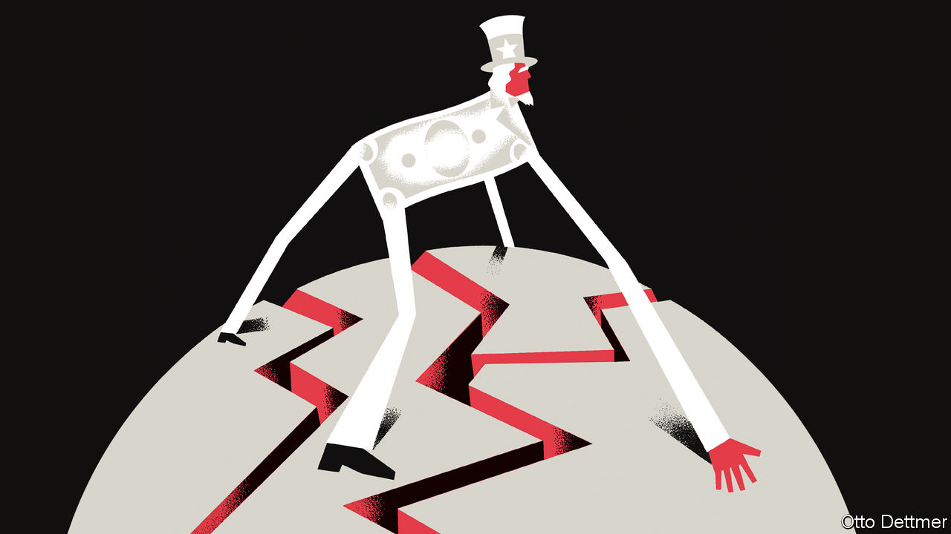

IT HAS BEEN an ugly summer for America and the dollar. The greenback fell by more than 4% against a basket of other major currencies in July, the largest monthly decline in a decade, as the value of euros, gold and even bitcoin soared. In a year packed with extreme market movements, the dollar’s wobbles might seem unimpressive. As they played out against a backdrop of American turmoil, though, they have fed fears that a reckoning looms for the world’s economic hegemon. An abysmal response to the pandemic, a stuttering economic recovery and soaring debt understandably contribute to concern about America’s economic wherewithal. But if there is reason to question the dollar’s dominance, it is not that America is becoming less economically mighty, but that the world order it built looks increasingly vulnerable.

Reserve-currency status is often cast as a matter of economic fundamentals. A reserve-currency issuer should play an outsize role in global trade, which encourages partners to draw up contracts in its currency. A historical role as a global creditor helps to expand use of the currency and encourage its accumulation in reserves. A history of monetary stability matters, too, as do deep and open financial markets. America exhibits these attributes less than it used to. Its share of global output and trade has fallen, and today China is the world’s leading exporter. America long ago ceased to be a net creditor to the rest of the world—its net international investment position is deeply negative. Soaring public debt and dysfunctional government sow doubt in corners of the financial world that the dollar is a smart long-run bet. And whispers, suggesting that the day of the dollar’s eclipse by the euro or the yuan looms, grow louder from time to time.

Debates about a changing of the guard are hampered by a dearth of historical comparisons. The replacement of one currency by another as the modern world’s monetary bulwark has occurred precisely once—when the dollar overtook sterling. That makes identifying its critical causal factors nearly impossible. Economists once thought that network effects made reserve-currency status a winner-take-all affair. It is more attractive to conduct trade or hold savings in a currency that is widely used by others, giving reserve currencies an edge over challengers. That America’s output overtook Britain’s as early as 1880, while the dollar did not clearly dominate until enshrined in the Bretton Woods economic institutions more than 60 years later, seemed to prove that dominant currencies are not easily dislodged. But accumulating evidence suggests a revision of these views may be warranted. In practice, leading currencies often share a reserve role with others. Sterling ruled the roost before the first world war, but still accounted for no more than two-thirds of global currency reserves at the end of the 19th century (German marks and French francs made up most of the rest). Furthermore, the dollar overtook sterling much earlier than once thought. By the early 1920s it already accounted for at least 50% of major economies’ foreign-currency reserves. Reserve-currency status may not be so unassailable after all.

Even so, challengers have for decades failed to knock the greenback from its perch. Part of the explanation is surely that America is not as weak relative to its rivals as often assumed. American politics are dysfunctional, but an often-fractious euro area and authoritarian China inspire still less confidence. The euro’s members and China are saddled with their own debt problems and potential crisis points. The euro has faced several existential crises in its short life, and China’s financial system is far more closed and opaque than the rich-world norm.

Dollar dominance also reflects factors that conventional economic analyses sometimes omit: geopolitics. Sterling ruled during a long period of increasing global integration to which Britain—as a financial, industrial and military powerhouse—was central. The first world war brought an end to that era, and sterling soon lost its position. It shared reserve-currency status with the dollar into the 1940s, but under very different circumstances than prevailed in pre-war times; global trade and cross-border investment did not return to the levels of 1913 until the final third of the 20th century. It was not just American economic superiority that put the dollar at the centre of the post-war order, but its unrivalled geopolitical might as well, which it used to reforge an integrated global economy. Work published by Barry Eichengreen of the University of California, Berkeley, and Arnaud Mehl and Livia Chitu of the European Central Bank highlights the role of power politics in currency choice. Analysing reserve holdings before the first world war, the authors find that military alliances influenced the composition of reserves. A pact, they reckon, boosted a currency’s share in an ally’s reserve holdings by 30 percentage points.

## Get the buck out of here

So the global role of the dollar does not depend on America’s export prowess and creditworthiness alone, but is bound up in the geopolitical order it has built. Its greatest threat is not the appeal of the euro or yuan, but America’s flagging commitment to the alliances and institutions that fostered peace and globalisation for more than 70 years. Though still unlikely, a collapse in this order looks ever less far-fetched. Even before the pandemic, President Donald Trump’s economic nationalism had undercut openness and alienated allies. Covid-19 has further strained global co-operation. The IMF thinks world trade could fall by 12% this year. Supply chains that sprawl across national borders may retreat amid concerns about economic conflict and national security. America and China seem to be sliding into a new cold war.

Though America’s economic role in the world has diminished a little, it is still exceptional. An American-led reconstruction of global trade could secure the dollar’s dominance for years to come. A more fractious and hostile world, instead, could spell the end of the dollar’s privileged position—and of much else besides. ■

This article was downloaded by calibre from <https://www.economist.com/finance-and-economics/2020/08/08/dollar-dominance-is-as-secure-as-american-global-leadership>

|  |  |  |  |
| --- | --- | --- | --- |
| Previous | Articles | Sections | Next |

|  |  |  |
| --- | --- | --- |
| Finance & economics | Sections | Science & ... |

Schools brief

A healthy dose of competition: From hospitality to hipsterism

.

|  |  |  |
| --- | --- | --- |
| Finance & economics | Sections | Science & ... |

|  |  |  |  |
| --- | --- | --- | --- |
|  | Articles | Sections | Next |

#### When big isn’t beautiful

# What more should antitrust be doing?

The first of a series on areas where economists are rethinking the basics

Aug 8th 2020 |

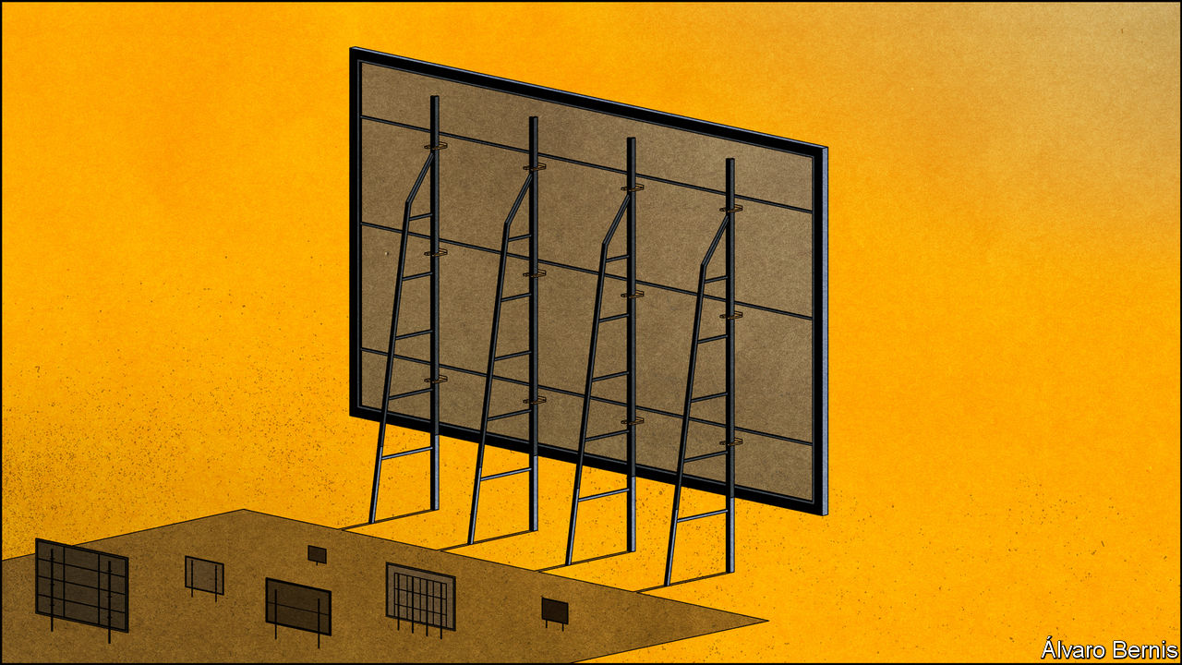

DONALD TURNER, America’s top trustbuster in the mid-1960s, saw antitrust law as benefiting from an “inhospitable” tradition: on many matters its default response was to say no. Government lawyers routinely blocked mergers merely on the grounds that the resulting company would be too big. The companies’ counterargument that being bigger would make them better was rarely entertained by the courts.

In the 1970s the “Chicago school” of antitrust law successfully harnessed economics to argue for a much more hospitable approach. Over the following decades America’s regulators became so welcoming that critics painted them as doormats. In many industries the largest firms have consistently gained market share without any official concern; the most successful technology companies have grown into veritable titans. Many economists studying the subject now worry that a lack of competition is an economic drag, especially online. Some scholars go further, arguing that the Chicago school’s sense of what is good for consumers is not serving their broader interests.

The Chicago school, built on the work of Aaron Director, an economist from the mid-20th century, reached its zenith in the writing of the legal scholars Robert Bork and Richard Posner. Its proponents argued that many activities which were assumed to be anti-competitive were entirely reasonable strategies for improving corporate efficiency. They also claimed that in some cases even things which couldn’t be justified that way could safely be left to the market to sort out without recourse to law.

Take “predatory pricing”. Regulators thought that selling goods below cost so as to bankrupt competitors was malfeasance that had to be stopped. The Chicago school argued that it was a poor business strategy which would fail. Even if the predator crushed its competition, it would not remain a monopoly long enough to recoup its earlier losses. Instead, its high profits would attract new competitors.

Perhaps because, in the 1970s, American business had started to look more in need of help than hindrance, such arguments found favour with the American courts. And though the Chicago school’s influence was more limited elsewhere, many jurisdictions, including the European Union, adopted one of Bork’s central ideas: that the sole purpose of competition law should be to protect consumers. It is a view which forbids regulators from considerations of the broad public interest, limiting them to the busting of cartels and the prevention of mergers that create monopolies. Under this “consumer-welfare standard”, competition cases turn on forensic analysis of “upward pricing pressure”—ie, of the degree to which a merger or strategy will leave consumers out of pocket.

But has this approach led regulators to miss the wood for the trees? In 2016 The Economist pointed to America’s high corporate profits and the rising market shares enjoyed by big firms as evidence that competition across the economy had waned. Later that year economists at the White House released a report making similar observations. A version of the trend can also be found in Europe. Research by the OECD, a club of mostly rich countries, finds that between 2000 and 2014 the share of sales accounted for by the top eight firms in a given industry rose by four percentage points in Europe and eight percentage points in North America (see chart).

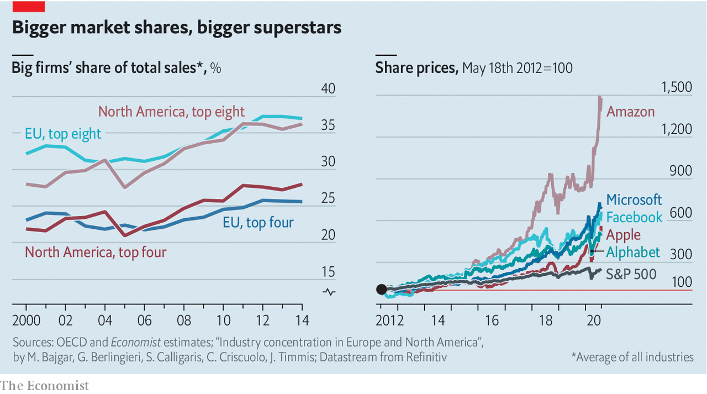

Many antitrust experts are unconcerned: industrial concentration, they argue, does not tell you how competitive the market for a particular good is. But some economists have blamed falling levels of competition for far-reaching economic ills, such as stagnant labour markets and growing inequality. In a paper published in 2019 the late Emmanuel Farhi of Harvard and François Gourio of the Federal Reserve Bank of Chicago argued that the rising market power of big companies was linked to low interest rates and weak investment, factors shaping the whole economy.

As in the days of the Chicago school, other economists see these critiques as ignoring the role of efficiency. A recently published paper by David Autor and John Van Reenen of MIT, David Dorn of the University of Zurich, Lawrence Katz of Harvard and Christina Patterson of the University of Chicago argues that globalisation and technological advances have concentrated economic activity in a small number of “superstar firms”. Because these firms are more productive, the industries which have seen the most of this concentration have also seen the fastest productivity growth.

It is when they are applied to technology giants that these arguments get most heated. In America the Department of Justice, the Federal Trade Commission, Congress and many states are investigating whether Amazon’s dominant position in online shopping, Apple’s immense profitability or the duopoly that Facebook and Google enjoy in online advertising can be seen as involving the abuse of the giants’ market power. Google has been the subject of three separate competition investigations by the EU and fined €8.2bn ($9.7bn).

## Competition in, or competition for?

Businesses built on “platforms”, as Amazon, Facebook and Google are, raise particular issues when it comes to competition because they have two separate sets of customers. Amazon deals with both retailers and consumers, Facebook and Google with both users and advertisers. In the 2000s Jean Tirole and Jean-Charles Rochet, two French economists, laid out an economic framework for looking at such platform businesses which showed that their optimal strategy will often be to provide cheap access to one side of the platform and charge steeply on the other. Consumers enjoy free Google searching and Facebook socialising; advertisers pay through the nose to reach them as they do so.

Platforms existed before big technology firms: television, newspapers and credit cards are all platforms of sorts. But the internet has provided vast scale and reach. Adding users is cheap, and it is often the case that the more users a platform has the more attractive it becomes to those yet to sign up. A firm that attains critical mass becomes overwhelmingly dominant: winner takes all.

Does it matter if the winning platforms dominate the digital economy? In terms of consumer welfare it seems, on the face of it, a sweet deal: users get stuff which is of real value to them at a price—zero—to which no one can object. But on the other side of the platforms things look more worrying. A recent investigation by Britain’s Competition and Markets Authority found that the cost of digital advertising for firms was worth £500 ($650) per household per year. Were the market less concentrated, those costs might fall—and some of the savings would be passed on to consumers in the form of lower prices.

Another potential worry is that there are conflicts of interest in many big-tech business models, such as when Apple sells through its app-store software which competes with its own, or when Amazon collects data about the sales of third-party products with which it competes.

Perhaps concentration would be tolerable if the big firms lived in fear of usurpation by a hot new entrant. But startup platforms face growing barriers to entry. One is amassing the reams of data which enable firms to tailor their services to individual users. Another is that in the digital economy it is relatively easy for an incumbent to see what it is that users like about what a startup offers, provide something similar and push it out to millions (if not billions) of existing users. That reduces the incentive to innovate in the first place. A final worry is that wealthy incumbents can close off the possibility of competition by buying new entrants before they pose a real threat, as when Facebook bought Instagram in 2012 and WhatsApp in 2014. In the decade to 2019 the five largest technology firms made over 400 acquisitions with scant intervention by competition authorities.

There are, broadly speaking, two sets of ideas for reforming competition economics and antitrust enforcement in response to these worries. Adherents of the more radical call themselves “neo-Brandeisians” after Louis Brandeis, an early-20th-century American Supreme Court justice who thought the overarching purpose of government antitrust action should be to prevent any one firm from exerting too much power over the economy. Neo-Brandeisians such as Lina Khan of Columbia Law School and Matt Stoller of the American Economic Liberties Project, a think-tank, want to broaden the purpose of antitrust investigations beyond promoting consumer welfare. Governments, they argue, should not fear breaking up the tech giants; they should fear leaving them be. In this view the companies’ size and power are a threat not just to consumers and workers but to democracy itself.

## Each time I roam...

To its Chicago-school critics, Neo-Brandeisianism is “hipster antitrust”, replacing a transparent and rigorous methodology with an ill-defined set of social goals. It might disempower technology firms, but it would empower regulators. If concentrations of market power should be viewed with suspicion, so should concentrations of regulatory power: they bring the risk of arbitrary and unaccountable decision-making. In America, its home territory, this debate is predictably partisan: neo-Brandeisians are listened to only by Democrats.

The second set of ideas for reform is more incremental. It seeks not to abolish the consumer-welfare standard but to reinterpret it. Carl Shapiro of the University of California, Berkeley, has suggested calling it the “protecting competition standard” to make clear that it takes into account all the harm that anti-competitive practices might do to consumer welfare, including that which is indirect or diffuse.

Applying this interpretation of the consumer-welfare standard to digital platforms means accepting that in some situations firms will naturally grow large, meaning that at any point in time there will be little “competition in the market”. But there can still be “competition for the market” if a new, better product has a chance to disrupt the status quo. That might mean blocking more of the sort of early acquisitions which snuff out potential competitors, or reversing the burden of proof in such cases, so that the merging companies have to show that their plans will benefit consumers. It also might mean forcing incumbents to share some of their data, or at least making it easier for users to switch easily between platforms.

This agenda might not do much to satisfy neo-Brandeisian complaints about the political power of tech titans today. But it could succeed at making life at the top slightly more precarious. ■

This article was downloaded by calibre from <https://www.economist.com/schools-brief/2020/08/08/what-more-should-antitrust-be-doing>

|  |  |  |  |
| --- | --- | --- | --- |
|  | Articles | Sections | Next |

|  |  |  |
| --- | --- | --- |
| Schools brief | Sections | Books & arts |

Science & technology

Artificial intelligence: Bit-lit

.

Covid-19 testing: Dive in

.

Entomology: Parasites under pressure

.

Cookery: A good grilling

.

|  |  |  |
| --- | --- | --- |
| Schools brief | Sections | Books & arts |

|  |  |  |  |
| --- | --- | --- | --- |
|  | Articles | Sections | Next |

#### Artificial intelligence

# A new AI language model generates poetry and prose

GPT-3 can be eerily human-like—for better and for worse

Aug 8th 2020 |

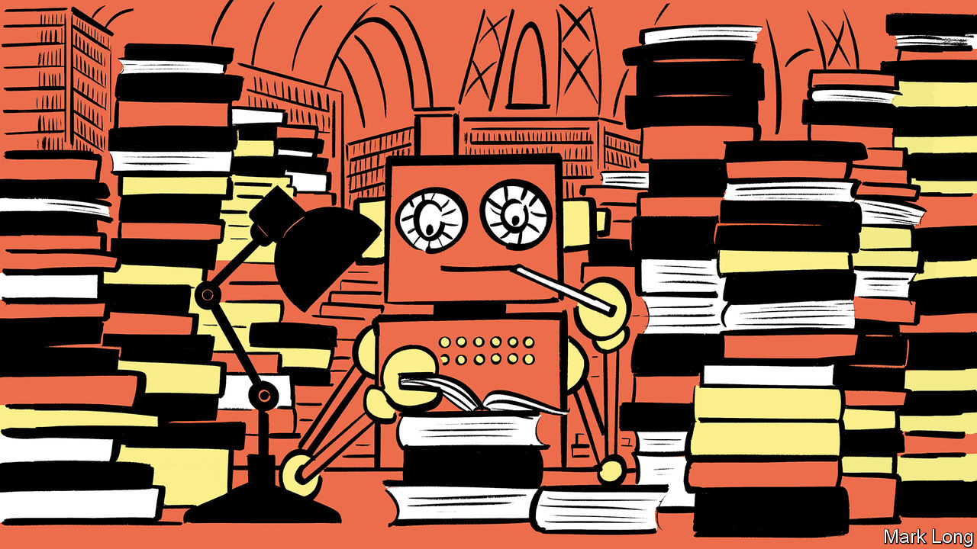

The SEC said, “Musk,/your tweets are a blight./They really could cost you your job,/if you don’t stop/all this tweetingat night.”/…Then Musk cried, “Why?/The tweets I wrote are not mean,/I don’t use all-caps/and I’m sure that my tweets are clean.”/“But your tweets can move markets/and that’s why we’re sore./You may be a genius/and a billionaire,/but that doesn’t give you the right to be a bore!”

THE PRECEDING lines—describing Tesla and SpaceX founder Elon Musk’s run-ins with the Securities and Exchange Commission, an American financial regulator—are not the product of some aspiring 21st-century Dr Seuss. They come from a poem written by a computer running a piece of software called Generative Pre-Trained Transformer 3. GPT-3, as it is more commonly known, was developed by OpenAI, an artificial-intelligence (AI) laboratory based in San Francisco, and which Mr Musk helped found. It represents the latest advance in one of the most studied areas of AI: giving computers the ability to generate sophisticated, human-like text.

The software is built on the idea of a “language model”. This aims to represent a language statistically, mapping the probability with which words follow other words—for instance, how often “red” is followed by “rose”. The same sort of analysis can be performed on sentences, or even entire paragraphs. Such a model can then be given a prompt—“a poem about red roses in the style of Sylvia Plath”, say—and it will dig through its set of statistical relationships to come up with some text that matches the description.

Actually building such a language model, though, is a big job. This is where AI—or machine learning, a particular subfield of AI—comes in. By trawling through enormous volumes of written text, and learning by trial and error from millions of attempts at text prediction, a computer can crunch through the laborious task of mapping out those statistical relationships.

The more text to which an algorithm can be exposed, and the more complex you can make the algorithm, the better it performs. And what sets GPT-3 apart is its unprecedented scale. The model that underpins GPT-3 boasts 175bn parameters, each of which can be individually tweaked—an order of magnitude larger than any of its predecessors. It was trained on the biggest set of text ever amassed, a mixture of books, Wikipedia and Common Crawl, a set of billions of pages of text scraped from every corner of the internet.

## Statistically speaking

The results can be impressive. In mid-July OpenAI gave an early version of the software to selected individuals, to allow them to explore what it could do. Arram Sabeti, an artist, demonstrated GPT-3’s ability to write short stories, including a hard-boiled detective story starring Harry Potter (“Harry Potter, in ratty tweed suit, unpressed shirt and unshined shoes, sits behind the desk looking haggard, rumpled and embittered…”), comedy sketches, and even poetry (including the poem with which this article opens, titled “Elon Musk by Dr Seuss”). Elliot Turner, an AI researcher and entrepreneur, demonstrated how the model could be used to translate rude messages into politer ones, something that might be useful in many of the more bad-tempered corners of the internet. Human readers struggled to distinguish between news articles written by the machine and those written by people (see chart).

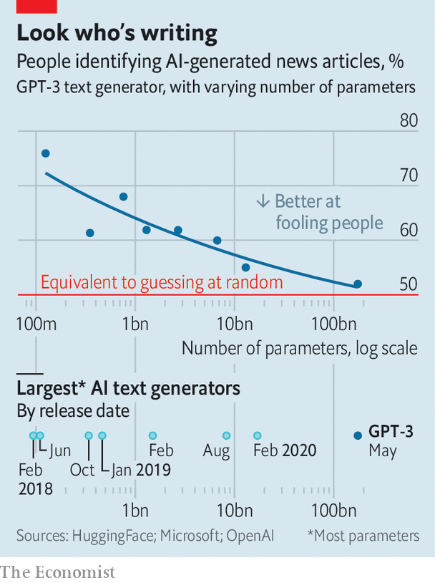

Given that OpenAI wants eventually to sell GPT-3, these results are promising. But the program is not perfect. Sometimes it seems to regurgitate snippets of memorised text rather than generating fresh text from scratch. More fundamentally, statistical word-matching is not a substitute for a coherent understanding of the world. GPT-3 often generates grammatically correct text that is nonetheless unmoored from reality, claiming, for instance, that “it takes two rainbows to jump from Hawaii to 17”. “It doesn’t have any internal model of the world—or any world—and so it can’t do reasoning that requires such a model,” says Melanie Mitchell, a computer scientist at the Santa Fe Institute.

Getting the model to answer questions is a good way to dispel the smoke and mirrors and lay bare its lack of understanding. Michael Nielsen, a researcher with a background in both AI and quantum computing, posted a conversation with GPT-3 in which the program confidently asserted the answer to an important open question to do with the potential power of quantum computers. When Dr Nielsen pressed it to explain its apparent breakthrough, things got worse. With no real understanding of what it was being asked to do, GPT-3 retreated into generic evasiveness, repeating four times the stock phrase “I’m sorry, but I don’t have time to explain the underlying reason why not.”

There are also things that GPT-3 has learned from the internet that OpenAI must wish it had not. Prompts such as “black”, “Jew”, “woman” and “gay” often generate racism, anti-Semitism, misogyny and homophobia. That, too, is down to GPT-3’s statistical approach, and its fundamental lack of understanding. Having been trained partly on text scraped from the internet, it has noted that words like “woman” are often associated with misogynistic writing, and will mindlessly reproduce that correlation when asked.

This problem is a hot topic in AI research. Facial-recognition systems, for instance, notoriously do better with white faces than black ones, since white faces are more common in their training sets. AI researchers are trying to tackle the problem. Last year IBM released a set of training images that contained a more diverse mix of faces. OpenAI itself was founded to examine ways to mitigate the risk posed by AI systems, which makes GPT-3’s lapses all the more noteworthy. GPT-2, its predecessor, was released in 2019 with a filter that tried to disguise the problem of regurgitated bigotry by limiting the model’s ability to talk about sensitive subjects.

Here, at least, little progress seems to have been made. GPT-3 was released without a filter, though it seemed just as ready to reproduce unpleasant prejudices as its predecessor (OpenAI added a filter to the newer model after that fact became obvious). It is unclear exactly how much quality control OpenAI applied to GPT-3’s training data, but the huge quantity of text involved would have made any attempt daunting.

It will only get harder in future. Language has overtaken vision as the branch of AI with the biggest appetite for data and computing power, and the returns to scale show no signs of slowing. GPT-3 may well be dethroned by an even more monstrously complex and data-hungry model before long. As the real Dr Seuss once said: “The more that you read, the more things you will know.” That lesson, it seems, applies to machines as well as toddlers. ■

This article was downloaded by calibre from <https://www.economist.com/science-and-technology/2020/08/08/a-new-ai-language-model-generates-poetry-and-prose>

|  |  |  |  |
| --- | --- | --- | --- |
|  | Articles | Sections | Next |

|  |  |  |  |
| --- | --- | --- | --- |
| Previous | Articles | Sections | Next |

#### Dive in

# Covid-19 testing labs are being overwhelmed

Pool-sampling may offer a solution

Aug 8th 2020 |

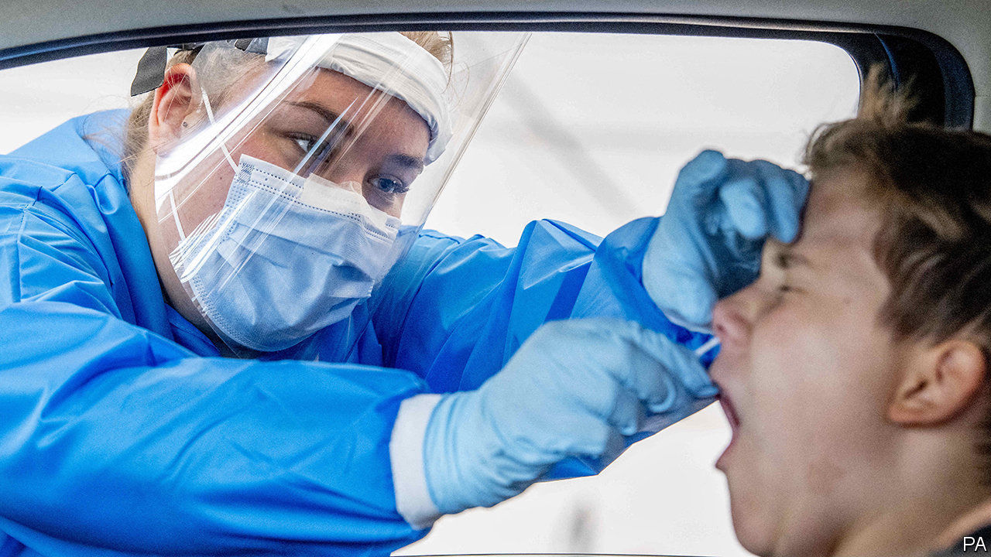

SINCE THE beginning of the coronavirus pandemic, many places have struggled with overwhelmed laboratories and a shortage of testing kits. In March, Germany was carrying out half the tests it needed. In Britain testing was limited until May to health-care workers, hospital patients and key workers. In America shortages of various components required for testing have been a cause of constant frustration. Now, as countries emerge from their lockdowns and case numbers begin to rise, the strain is being felt once more.

America carries out roughly 800,000 tests a day. A study published by Harvard University, however, reckons that the country would need to carry out 5m a day in order to reopen safely. Quest Diagnostics and LabCorp, two of the largest test-makers in America, have reported that overwhelmed laboratories mean that results are taking a week, sometimes two, to come through, instead of a couple of days.

A technique developed in the 1940s by Robert Dorfman, an American economist, may help resolve the problem. Dorfman proposed it as a way of testing soldiers en masse for syphilis. It is, in fact, quite obvious: pool together samples taken from several individuals and test the pool. If it is clear, none of its members is infected, and only one test has been used. Only if the pool comes up positive is individual testing required.

Pool-sampling has been used in America, Germany and Israel and has been introduced into China, India, Pakistan and Singapore. Sandra Ciesek at the University Hospital, Frankfurt, in Germany, says that if it were to do only individual testing, her hospital could process about 2,000 people a week. Now it can test ten times that number, which means tests can be given to every patient that is admitted, for any reason.

Testing pooled samples has its difficulties. For now, samples must be labelled by hand, which is slow. There are also concerns about loss of sensitivity that may result from dilution if too many samples are mixed. A group of researchers from Technion, Israel’s oldest university, and Rambam Health Care Campus, in Haifa, have said that up to 64 samples could be mixed, but they acknowledge that a pool this large would be difficult to manage and could have a higher risk of a false-negative result.

Peter Iwen, director of Nebraska’s Public Health Laboratory, is using tests with high sensitivity, and in pools of no more than five samples. “No test is 100%,” he says. “We feel very confident we can pick up at least 97% or better.” His was one of the first laboratories in America to use pool-sampling, after getting permission from Nebraska’s governor in March. On July 18th America’s Food and Drug Administration issued its first emergency authorisation for the whole country to follow suit.

Besides requiring high sensitivity, pool-sampling works best when the incidence rate is low. The more likely a positive result, the less efficient it is—since positive batches then have to be tested individually. It is best used, therefore, on the asymptomatic, since those with symptoms are more likely to test positive. But at the beginnings and ends of outbreaks, when most candidates for testing are, indeed, people without symptoms, it looks like a valuable time- and money-saving tool that might become standard procedure. ■

Editor’s note: Some of our covid-19 coverage is free for readers of The Economist Today, our daily [newsletter](https://my.economist.com/user#newsletter). For more stories and our pandemic tracker, see our [hub](https://www.economist.com/news/2020/03/11/the-economists-coverage-of-the-coronavirus)

This article was downloaded by calibre from <https://www.economist.com/science-and-technology/2020/08/08/covid-19-testing-labs-are-being-overwhelmed>

|  |  |  |  |
| --- | --- | --- | --- |
| Previous | Articles | Sections | Next |

|  |  |  |  |
| --- | --- | --- | --- |
| Previous | Articles | Sections | Next |

#### Parasites under pressure

# An exception to the rule that there are no marine insects

Lice that latch onto seals survive deep-sea rides

Aug 8th 2020 |

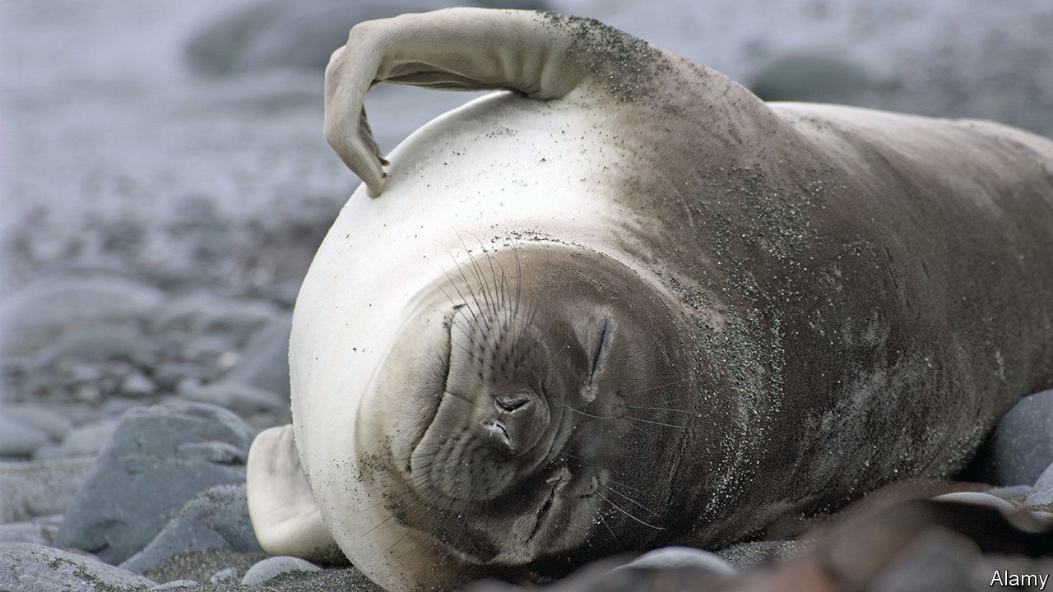

INSECTS DOMINATE dry land. About 1m species have been described, more than twice as many as all other multicellular animal species, terrestrial and marine, put together. Several times that number are reckoned to await discovery. The oceans, though, are mostly insect-free. A few skate over the surface, but none dive willingly below the waves.

At least, that was the consensus until recently. But Soledad Leonardi at CONICET-CENPAT in Argentina and Claudio Lazzari at the University of Tours, in France, have found an exception: the 13 species of lice that latch onto seals. That seals have lice is not news. But Dr Leonardi and Dr Lazzari have shown that, contrary to previous belief, these passengers do not abandon ship, as it were, and remain on dry land when the seals go swimming. Instead, they cling on and brave not only the hostile, saline chemistry of seawater, but also the tremendous pressures imposed when their hosts dive to depths of several hundred metres in search of prey.

Dr Leonardi and Dr Lazzari disposed of the salinity question in 2014 by the simple procedure of dunking seal lice in seawater for prolonged periods, and discovering that they did not die. Now, as they report in the Journal of Experimental Biology, they have dealt with the question of pressure.

To do so, they collected representatives of the louse species that dwells upon the deepest-diving pinniped of them all, the South Atlantic elephant seal, which can dive as far as 2,000 metres. Using tweezers, they prised 75 lice from the flippers of 15 weaned seal pups that were sitting by themselves on the beach. They then put their trophies into a bronze compression chamber, filled with salt water, and exposed the insects to pressures ranging from a mild 30kg/cm2 (much like swimming 300 metres below the surface) to 200kg/cm2 (the full two kilometres).

That 69 of the lice survived this treatment suggests that, far from abandoning their hosts when they go for a swim (which always sounded a slightly desperate approach, given that it meant surviving on the beach until another host came along), the lice almost certainly stay on board for the ride. Indeed, an accidental extension of the experiment caused by an equipment malfunction suggests 200kg/cm2 is peanuts for an elephant-seal louse. The malfunction caused one louse to suffer a whopping 450kg/cm2 for several minutes before the system could be shut down. The bug survived the ordeal intact.

Assuming lice are typical of the wider class of insects, it seems that neither chemistry nor pressure prevent insect colonisation of the oceans. As parasites, lice of all sorts lead fairly pampered lives compared with their free-living insect cousins. Perhaps that is the difference. Or maybe respiration is the obstacle—for insects, like seals, are air-breathing creatures, and would need, as seals do, to come to the surface to breathe until they evolved gills. But some freshwater insects (dragonfly nymphs, for example) have gills, so that does not seem an unimaginable step. Possibly, the explanation is that all the oceanic niches which insects might inhabit are already taken by their close relatives the crustaceans. But some crustaceans (woodlice and coconut crabs, for example) have managed the journey in the opposite direction, in the face of insect competition. So what is actually keeping free-living insects out of the sea remains a mystery.■

This article was downloaded by calibre from <https://www.economist.com/science-and-technology/2020/08/08/an-exception-to-the-rule-that-there-are-no-marine-insects>

|  |  |  |  |
| --- | --- | --- | --- |
| Previous | Articles | Sections | Next |

|  |  |  |  |
| --- | --- | --- | --- |
| Previous | Articles | Sections | Next |

#### Good grilling

# An indoor barbecue to prevent pollution problems

And avoid complaints about fumes from restaurants

Aug 8th 2020 |



AS THEY REOPEN after lockdown, many restaurants are firing up their barbecues. Diners appreciate food grilled over glowing charcoal embers, but the neighbours often do not. Pollution levels near restaurants can be notably higher than average, largely because of emissions from kitchens. With the increasing popularity of indoor barbecuing, it is a problem that is set to get worse.

Faced with complaints from residents about fumes and lingering smells, the German Environment Agency asked Mohammad Aleysa, an expert in combustion technology at the Fraunhofer Institute for Building Physics in Stuttgart, to investigate. The results of his experiments were so shocking they drove Dr Aleysa and his research team to invent a cleaner system for indoor charcoal grilling.

The researchers tested a commercial grill, complete with the sort of multi-stage filtering system used in many—though by no means all—restaurants. Apart from typical pollutants such as nitrogen oxides, carbon monoxide and particulate matter, they also discovered polycyclic aromatic hydrocarbons. These cancer-causing chemicals are mainly produced by the incomplete combustion of fats and oil-based marinades.

The researchers estimated that if their half-a-square-metre grill was used for nine hours a day, it would release between 400 and 500 kilograms of fine and ultrafine particulate matter into the air, along with 1.5 tonnes of hydrocarbons, every year. With many restaurants using 2.5-square-metre grills 16 hours a day, the level of pollution from most commercial operations would be much higher.

The researchers are investigating which extraction systems best protect neighbours and restaurant employees. Taller chimneys are one option. But Dr Aleysa suspects they would just shift the pollution elsewhere. The results of these tests will be published next year.

Meanwhile, Dr Aleysa’s team have come up with their own solution: a new kind of grill, which they reckon can cut pollutants by 90%. Dr Aleysa is reluctant to go into specifics. But the basic idea is that before being vented to the outside, the fumes are sucked back down through the embers and into a “combustion zone”, where hydrocarbons and odour compounds are fully burnt. That lessens the need for expensive extraction systems and fiddly filters that must be regularly cleaned.

An industrial partner is keen to put the grill into production. It could go on sale by the middle of next year. It will cost a bit more than a standard grill, says Dr Aleysa. But he believes that would be offset by lower maintenance costs. Better air quality around restaurants would be welcome. But the big test will be whether chefs believe the new grill can produce that same barbecue flavour.

For more coverage of climate change, register for The Climate Issue, our fortnightly [newsletter](https://www.economist.com/theclimateissue/), or visit our [climate-change hub](https://www.economist.com/news/2020/04/24/the-economists-coverage-of-climate-change)

This article was downloaded by calibre from <https://www.economist.com/science-and-technology/2020/08/08/an-indoor-barbecue-to-prevent-pollution-problems>

|  |  |  |  |
| --- | --- | --- | --- |
| Previous | Articles | Sections | Next |

|  |  |  |
| --- | --- | --- |
| Science & ... | Sections | Economic & ... |

Books & arts

Museums and restitution: Legacies of violence

.

Johnson: The Greatest Phrases!

.

Climate change: A glacier’s pace

.

New American fiction: The girl next door

.

Home Entertainment: In the woodshed

.

|  |  |  |
| --- | --- | --- |
| Science & ... | Sections | Economic & ... |

|  |  |  |  |
| --- | --- | --- | --- |
|  | Articles | Sections | Next |

#### Legacies of violence

# Activist curators are sharpening the debate on restitution

The battle lines between retainers and returners are being redrawn from inside museums

Aug 8th 2020 |

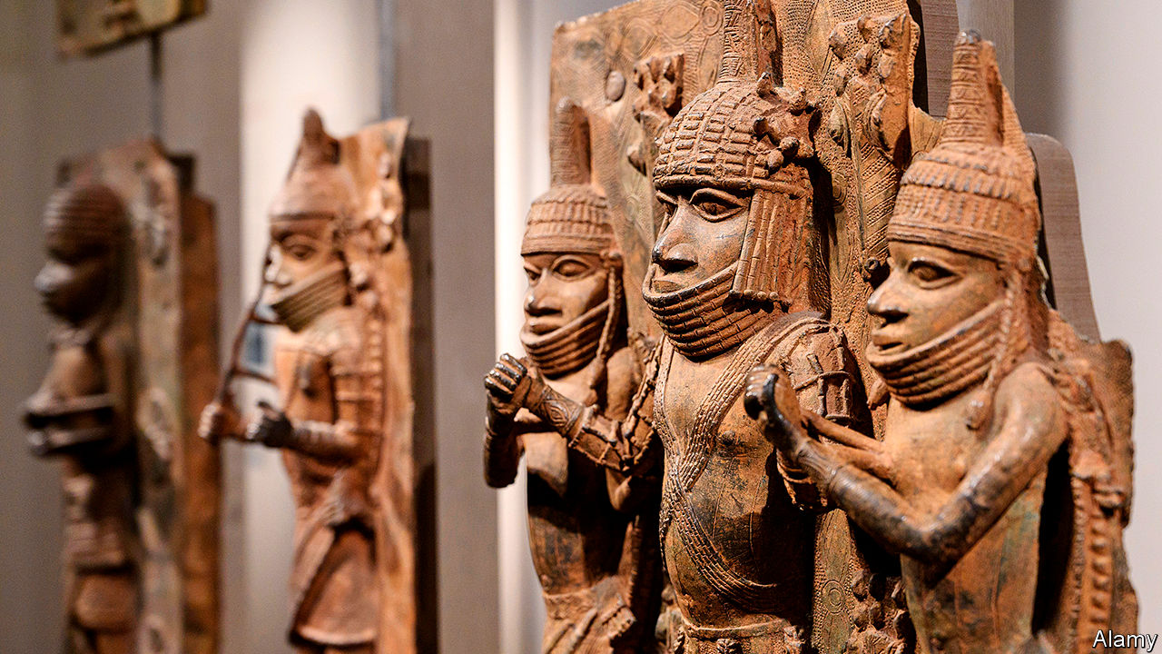

IN JUNE MWAZULU DIYABANZA marched into the Musée du Quai Branly in Paris with four friends. “I’ve come to recover goods that were stolen from Africa,” he said, seizing a funerary statue from South Sudan. With 70,000 objects, the Quai Branly has France’s biggest stash of African artefacts. Three years ago President Emmanuel Macron promised they would start to be returned. “I cannot accept that a large share of several African countries’ cultural heritage be kept in France,” he said during a speech in Burkina Faso.

Yet progress has been slow; Mr Diyabanza and his associates have lost patience. “We have the right to remove what belongs to us because it’s our patrimony,” the activist announced on YouTube, “and we’re going to take it home.” Instead, the friends were arrested, charged with theft and are awaiting trial.

Away from the spotlight, another group is also trying to sharpen the debate on restitution, this time from the inside. In America and Europe curators are speaking out about the colonial past of Western museums. Many of them became curators in the early 2000s when the idea of institutions as “world museums”, where visitors could compare cultures from all over the globe, was fashionable. But underpinning this viewpoint, one Western museum director says, was a selfish attitude of “what’s mine is mine and what’s yours is mine.”

These curators were emboldened by the report Mr Macron commissioned soon after his return from west Africa, which was published in 2018. In it, Felwine Sarr, a Senegalese economist, and Bénédicte Savoy, a French art historian, argued that the time had come for a “new relational ethics” in the discussion about the return of Africa’s cultural heritage. Since then, the Black Lives Matter and Rhodes Must Fall movements have only made these curators more determined. “Conversations about monuments outside are being applied to monuments inside,” says Dan Hicks, who oversees world archaeology at Oxford’s treasure-laden Pitt Rivers Museum. “Especially where they have a common history in terms of racism.”

Some of the most eloquent activist curators include Nanette Snoep, a Dutch anthropologist who runs the ethnological collections in Cologne; Chip Colwell, until recently a curator of Native American culture at the Denver Museum of Nature and Science; and Wayne Modest, the head of the Research Centre for Material Culture in Leiden, whose research focuses on slavery in the Caribbean. Mr Hicks may be about to become the best-known among them.

After working for nearly a decade as a digger on archaeological sites, Mr Hicks went to Oxford University in 1994 to read archaeology and anthropology. For his postgraduate work, he transferred to Bristol, where he learned about the city’s role in the transatlantic slave trade—a past that was dragged into the present when protesters against racism toppled a statue of Edward Colston, a profiteer from that trade, in June. Fieldwork in the Caribbean for his PhD pitched him deeper into debates about the history and legacy of empire.

In 2007 Mr Hicks joined the Pitt Rivers Museum. His first task was to study its collection, a mishmash of 500,000 objects. By 2015 Mr Hicks had a good idea where most of the items came from, but a social-media post by Rhodes Must Fall made him reconsider a wooden display case containing “Court Art of Benin”. The items had been “brought” to Britain, the label said, after a military skirmish. The tweet was pointed: “The Pitt Rivers Museum is one of the most violent spaces in Oxford #BeninBronzes”.

Knowing that object labels can be economical with the truth, Mr Hicks extended his research. He joined the Benin Dialogue Group, a salon of European museums and authorities in Benin City, but felt their ideas were too timid. In November Mr Hicks will publish his manifesto, “The Brutish Museums: The Benin Bronzes, Colonial Violence and Cultural Restitution” (Pluto Press). Using military and trade records, it shows how closely the Benin Bronzes, brutal expansionism and museums are linked.

By the late 1800s the Oba of Benin oversaw an empire that sold slaves, ivory and ebony in exchange for metal coinage, blades and guns. Britain was determined to seize control of this trade. When it learned that a small party approaching Edo, the capital of the kingdom of Benin, in January 1897 had been attacked, and seven British delegates killed, it quickly retaliated with a punitive expedition. Over 5,000 men from the British Royal Marines and the Niger Coast Protectorate, armed with 38 Maxim machineguns and 2m rounds of ammunition, razed the oba’s palace and the city, but not before they had packed up its vast collection of ivory and brass objects.

The small trading party was bait, Mr Hicks believes, a means to justify the dismemberment of the Benin empire. British soldiers seized and sold over 5,000 bronze objects (no one is quite sure precisely how many). They are now dispersed among more than 160 institutions, including the British Museum which, with around 900 pieces, has the single biggest hoard. There are also many private collectors, some of them descendants of soldiers who took part in the sacking.

“To the people of Benin and to Nigerians generally the Benin Bronzes represent a great artistic and spiritual loss,” says Ben Okri, a Nigerian poet and novelist. They “are a constant reminder of the Western disrespect for their traditions and their history.” Museums that fail to acknowledge this loss, and the destruction associated with it, collude in that violence, Mr Hicks argues. “The arrival of loot into the hands of Western curators, its continued display in our museums and its hiding away in private collections, was not some art-historical incident,” he says, “but an enduring brutality that is refreshed every day that a museum...opens its doors.”

The title of his book, “The Brutish Museums”, is spelled out in the same font that the British Museum uses, and the cover’s hue matches the museum’s stone-clad walls. It is a clear challenge to the 267-year-old institution, which mostly refuses to hand back artworks to the countries that produced them. “I think it’s misleading to call the British Museum the brutish museum,” says Hartwig Fischer, its director, who has not read the book. “The museum is engaged with the partners in Benin City in a long-term, comprehensive collaboration that aims at a sustainable development of cultural heritage.”

The royal court in Benin City plans to build a museum of its own, though work has not begun and it has yet to make a formal request to the Pitt Rivers or the British Museum. “But how many times do they really have to ask?” Mr Hicks says. “We shouldn’t have anything in that’s nicked. It’s as simple as that.” Last month Oxford University, which oversees the Pitt Rivers, published its formal procedures for dealing with restitution claims for objects taken under duress.

Beyond his own museum, Mr Hicks has joined forces with Ms Savoy, the co-author of the French report, on a £700,000 ($915,000) research project into the origins of collections in Britain and Germany. The Open Society Foundations (OSF) has also pledged $15m to help African organisations reclaim artefacts. Using $1m of that grant, Mr Hicks is establishing a museum network called Action for Restitution to Africa, working with curators in Europe as well as in Egypt, Ghana and South Africa. “We understood...that we could with our investment create some real binding connective tissue between academics, activists, artists, civil-society actors and governmental actors,” says Patrick Gaspard, president of the OSF.

There are still hearts and minds to win over within institutions. In 2019 Mr Hicks launched #BeninDisplays, a Twitter campaign which urges museums with Benin collections to provide honest contextual information. He hopes that the efforts of curators, as well as activists, will cause a reckoning over restitution that many believe should have happened long ago. ■

This article was downloaded by calibre from <https://www.economist.com/books-and-arts/2020/08/08/activist-curators-are-sharpening-the-debate-on-restitution>

|  |  |  |  |
| --- | --- | --- | --- |
|  | Articles | Sections | Next |

|  |  |  |  |
| --- | --- | --- | --- |
| Previous | Articles | Sections | Next |

#### Johnson

# Donald Trump’s language offers insight into how he won the presidency

His linguistic quirks reveal the salesmanship that has made his career

Aug 8th 2020 |

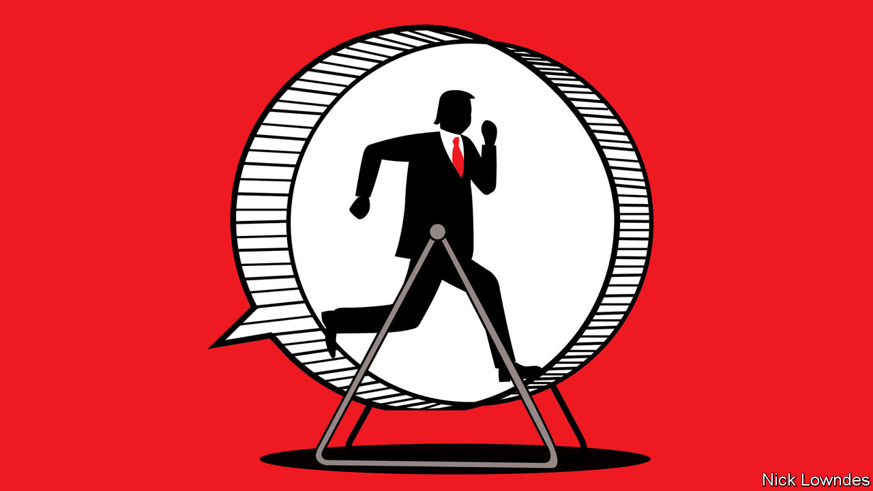

EVERYONE KNOWS how to do a Donald Trump impersonation. In speech, adopt his raspy timbre, bellowing volume and start-stop rhythm. In writing, throw in “bigly”, capitalise Emotional Noun Phrases and end everything with an exclamation mark. Such quirks of enunciation and spelling make Mr Trump easy to mimic, but they do not easily explain his political success. The way he constructs sentences, however, does offer some insight into how he captured the presidency.

Underpinning Mr Trump’s distinctive language is an extreme confidence in his own knowledge. Like Steve Jobs—who inspired his colleagues at Apple by making the impossible seem possible—Mr Trump creates his own “reality distortion field”. One of his signature tropes is “not a lot of people know…” He has introduced the complicated nature of health care, or the fact that Abraham Lincoln was the first Republican president, as truths that are familiar only to a few. A related sound-bite is “nobody knows more about...than I do”. The fields of expertise Mr Trump has touted this way include campaign finance, technology, politicians, taxes, debt, infrastructure, the environment and the economy.

His critics have often attributed this to narcissism, but a complementary explanation is that it is also one of his strengths—salesmanship. In Mr Trump’s framing, he is in possession of rare information. He is therefore able to cut a customer a special deal “not a lot of people know” about. Should you be tempted to take your business to a competitor, he will remind you that “nobody knows more about” what is on offer than he does.

And how does he convince listeners he really does know what he’s talking about? His language constantly indicates self-belief. Consider Mr Trump’s predecessor. Barack Obama was known for long pauses, often filled with a languid “uh…” He gives the impression of a man thinking hard about what to say next. But Mr Trump rarely hesitates and hardly ever says “um” or “uh”. When he needs to plan his next sentence—as everyone must—he often buys time by repeating himself. This reinforces the impression that he is supremely confident and that what he’s saying is self-evident.

Perhaps the most striking element of Mr Trump’s uncompromising belief in his sales technique can be glimpsed in an unusual place: his mistakes. Mr Trump is often presented as a linguistic klutz, saying things that make so little sense that his detractors present them as proof of major cognitive decline.

All people make some slips and stumbles when they speak: not just those known for them (say, George W. Bush) but those known for eloquence (Mr Obama, for example). Mr Trump regularly makes errors but his signature quality, by contrast, is to lean into them. Take a recent interview with Fox News, in which he talked about governors’ differing attitudes towards masks. Some are keener than others about requiring people to wear them to slow the spread of the coronavirus. Or, as Mr Trump put it, “they’re more mask into”.

What is remarkable is not the mistake. It is easy for anyone to go down a syntactic blind alley. Many people will say something like “they’re more mask” and then realise there is nowhere to go. The sentence, in linguists’ terms, requires “repair”, which usually involves backtracking. Unless, that is, you are Mr Trump, in which case you confidently intone “into” and move on, giving no hint of trouble.

This refusal to concede blunders shows up in more serious ways, of course, such as the president’s unwillingness to take responsibility for his administration’s missteps during the pandemic. It also helps explain two mysteries. The first is the odd disjunct between words that seem nonsensical on the page and a stage presence that enraptures audiences—it is Mr Trump’s assertive persona that convinces more than his words.

The second is how this works on his fans. In a recent survey conducted by Pew, Americans were asked to rank Mr Trump and Joe Biden, the presumptive Democratic nominee, on a number of characteristics. The trait for which Americans give Mr Trump the highest mark is telling. Despite a notably light schedule and a stated disdain for exercise, the president’s incessant speaking style is almost certainly the reason he received a good score on one quality in particular: 56% of voters, and 93% of his supporters, describe him as “energetic”.

Dig deeper:  
Sign up and listen to Checks and Balance, our [weekly newsletter](https://www.economist.com/checksandbalance/) and [podcast](https://www.economist.com/podcasts/2020/07/31/checks-and-balance-our-weekly-podcast-on-american-politics) on American politics, and explore our [presidential election forecast](https://projects.economist.com/us-2020-forecast/president)

This article was downloaded by calibre from <https://www.economist.com/books-and-arts/2020/08/08/donald-trumps-language-offers-insight-into-how-he-won-the-presidency>

|  |  |  |  |
| --- | --- | --- | --- |
| Previous | Articles | Sections | Next |

|  |  |  |  |
| --- | --- | --- | --- |
| Previous | Articles | Sections | Next |

#### A glacier’s pace

# A haunting meditation on climate change in Iceland

“On Time and Water” is part memoir and part scientific analysis

Aug 8th 2020 |



On Time and Water. By Andri Snaer Magnason. Translated by Lytton Smith. Serpent’s Tail; 352 pages; £16.99. To be published in America by Open Letter in March 2021; $26.

IN AUGUST 2019 an extraordinary plaque was unveiled at Borgarfjordur, in western Iceland. It commemorates Okjökull, the first of the country’s glaciers to be completely lost to climate change. Okjökull was declared “dead” in 2014, when it was no longer thick enough to flow across the landscape, as it had done for centuries. Framed as “A letter to the future”, the plaque reads (in Icelandic and English):

In the next 200 years all our glaciers are expected to follow the same path. This monument is to acknowledge that we know what is happening and what needs to be done. Only you know if we did it.

Along with the date, the memorial carries the words “415ppm CO2”: last summer, atmospheric carbon dioxide was measured at 415 parts per million, higher than at any point since humans have lived on Earth.

The text was written by Andri Snaer Magnason, an Icelandic author. As he notes in his haunting new book, “On Time and Water”, the amount of carbon dioxide in the Earth’s atmosphere has soared at shocking speed. At the beginning of the Industrial Revolution, the ratio was about 280ppm; by 1958 it stood at 315ppm. It is now rising by about two to three parts per million every year.

The author’s aim is to give readers a proper sense of geological time, so that they grasp, at a visceral level, how human activity is damaging the planet. He calls the current transformation “mythological”, affecting “the roots of everything we think, choose, produce and believe. It affects everyone we know, everyone we love.”

These high-speed changes, including the rise of the world’s waters, will alter life irrevocably within a more familiar time frame: “All this will happen during the lifetime of a child who is born today and lives to be my grandmother’s age, 95.”

There are plenty of books about the climate crisis. But Mr Andri Snaer Magnason’s perspective on his country’s environment is unique and compelling. His earlier book, “Dreamland: A Self-Help Manual for a Frightened Nation”, was a hymn to Iceland’s highlands and a critique of the government’s decision to build dams to provide power for aluminium smelting. Now he traces his family’s links to the landscape, notably those of his grandparents Hulda and Arni. They were early stalwarts of the Icelandic Glaciological Society, and spent their honeymoon in 1956 investigating the frozen world of Vatnajökull, an ice cap of 8,000 square kilometres—for now, at least—which was almost entirely unexplored in the mid-20th century. In old age Hulda recalls the indescribable smell of the glacier. “When you’re up on Vatnajökull,” she tells her grandson, “everything disappears; you forget everything. An infinite vastness. An absolute dream.”

“On Time and Water” is part family memoir, part scientific analysis, part meditation on subjects as wide-ranging as the “Poetic Edda”—Iceland’s medieval literary treasury—and the role of the Dalai Lama in 21st-century climate politics. The author tries to understand, and tries to make the reader understand, why the climate crisis is not widely perceived as a distinct, transformative event in the manner of, say, the fall of the Berlin Wall or the attacks of September 11th 2001. The fundamental problem, as this book elucidates, is time. Climate change is a disaster in slow motion, and yet “slow” is a great deal faster than many people seem able to comprehend. ■

For more coverage of climate change, register for The Climate Issue, our fortnightly [newsletter](https://www.economist.com/theclimateissue/), or visit our [climate-change hub](https://www.economist.com/news/2020/04/24/the-economists-coverage-of-climate-change)

This article was downloaded by calibre from <https://www.economist.com/books-and-arts/2020/08/08/a-haunting-meditation-on-climate-change-in-iceland>

|  |  |  |  |
| --- | --- | --- | --- |
| Previous | Articles | Sections | Next |

|  |  |  |  |
| --- | --- | --- | --- |
| Previous | Articles | Sections | Next |

#### The girl next door

# Lee Conell’s debut novel is a gripping tale of class and privilege

“The Party Upstairs” focuses on the tenants of one building on Manhattan’s Upper West Side

Aug 8th 2020 |

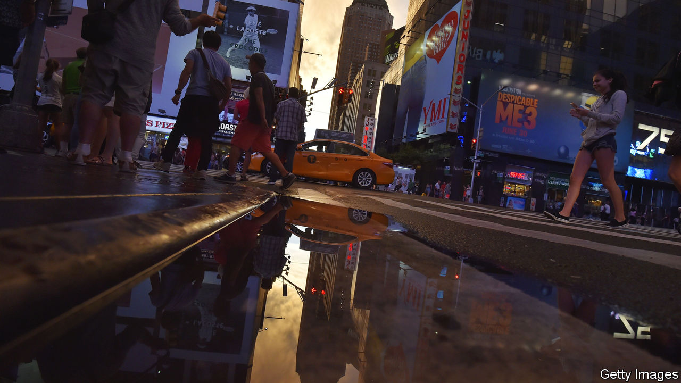

The Party Upstairs. By Lee Conell. Penguin; 320 pages; $26.

BEFORE THE pandemic pushed millennials to seek shelter with their parents, student debt, wage stagnation and unaffordable housing had already driven many in the “boomerang” generation home. For Ruby, one of the main characters in Lee Conell’s debut novel, being part of that trend is humiliating. Having graduated from college after the financial crisis of 2008, Ruby tells her mother and father: “It turns out you birthed a living, breathing think-piece. The failure to launch millennial blah-dee-blah.”

“The Party Upstairs” takes place over the course of a single day, not long after Ruby’s return to the basement apartment on Manhattan’s Upper West Side where she grew up. Her mother Debra is a librarian; Martin, her father, is the building superintendent and the novel’s other focus. In alternating chapters, father and daughter reckon with their past and present interactions with the building’s wealthy tenants.

Martin has recently taken up meditating and bird-watching in an attempt to lower his blood pressure and anxiety. Being a super means accommodating the tenants (and their complaints) while scheduling maintenance work. The tasks haven’t changed much in Martin’s 25 years on the job, but the building has, and the fancier it has become, the wider the gap between him and the residents. “And every year,” he observes, “the tenants behaved worse, it seemed.” Ever since Martin found Lily, the last occupant of a rent-controlled apartment, dead on her toilet, his patience for his spoiled neighbours has worn thin.

For her part, Ruby grew up between her father’s world and theirs. As a child, she spent many hours playing with Caroline, who lived in the penthouse and had more expensive toys and a stranger imagination for games; one involved role-playing “Holocaust-orphans-sisters-survivors”.

Martin worries that his daughter’s education has alienated her from him. Yet over the course of this page-turning story, which culminates in the party of the title, Ruby realises that Caroline and her trust-fund cronies will never understand what her life is like.

This article was downloaded by calibre from <https://www.economist.com/books-and-arts/2020/08/08/lee-conells-debut-novel-is-a-gripping-tale-of-class-and-privilege>

|  |  |  |  |
| --- | --- | --- | --- |
| Previous | Articles | Sections | Next |

|  |  |  |  |
| --- | --- | --- | --- |
| Previous | Articles | Sections | Next |

#### Home Entertainment

# The benefits of learning an instrument in lockdown

Today’s music students have access to past and present masters online

Aug 5th 2020 |

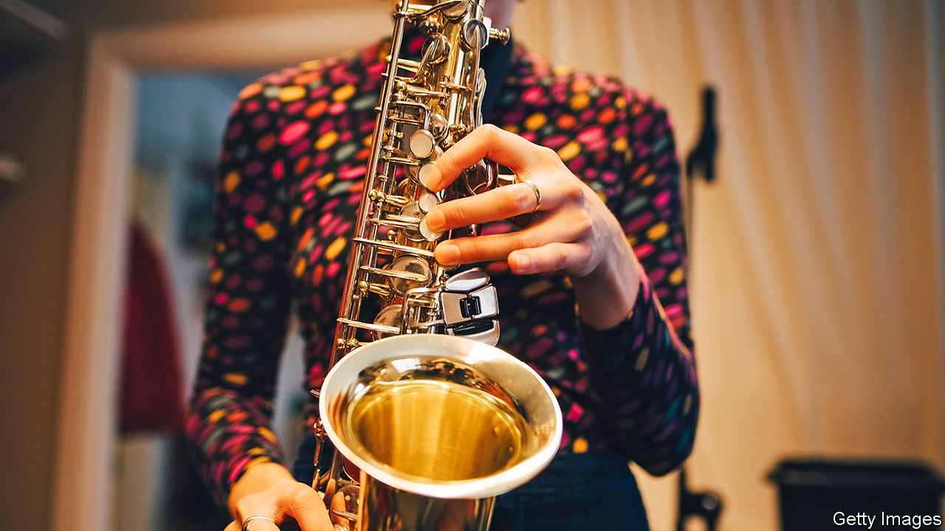

WHEN THIS correspondent formed a band in his early 20s with four other jazz maniacs, little did its members think it would still be going decades later. But then Night In Tunisia’s business model worked impeccably until the pandemic. Rather than charge money, the band bribed listeners with food and drink. Alas, that approach, now defunct, made this saxophonist lazy. His sound lacks control, squawking involuntarily like a duck being taken to the plucking shed. Fingers refuse the brain’s bidding. Ears cannot tell the phrygian mode from the aeolian.

Recording himself on a smartphone brought a brutal reckoning: intonation and technique were woeful. But then a strange thing happened—instead of dismay came mounting anticipation. Improving your playing can be a more pleasant prospect for an adult than for a young music student hectored by tiger parents. You are not aiming for the sky, yet gratifying progress can be swift. Even a few minutes’ focus on a study brings audible improvement.

As well as time for practice, the pandemic has bestowed another bonanza: teachers of all sorts of instruments. For instance, Chris Caldwell is a British saxophonist of the highest calibre, a member of the world-class Delta Saxophone Quartet and in normal times in demand from London to Pyongyang. As with so many freelance performers, these months have been brutal. But he now has time for lessons beamed anywhere via Zoom.

They are a revelation. Teacher and student are going back to first principles: turning air into breath into sound. A saxophone is a sinuously complex bundle of harmonic compromises—intonation varies not just in different octaves, but from one note to the next. Think not about taming the instrument, Mr Caldwell urges, but rather of living with the wilder acoustics that embody the saxophone sound. Amateurs may aim to reach the high notes of a soprano sax by belting them out. The approach, Mr Caldwell says, should be more like “walking on eggshells”.

Happily, today’s music students are also locked down with history’s masters. Every jazz great learned from those who went before, painstakingly copying solos from records—probably the most critical part of “woodshedding”, that is, practising by yourself. How much easier, technically, is the task today. Spotify provides a boundless library of recordings. Transcription apps let you slow down solos to commit every scoop and grace note to memory.

Other programmes provide a backing band to help you learn the “changes”—ie, the chord progressions in jazz tunes. Charlie Parker said that the secret to improvisation was to learn the changes and then forget them. To judge by this student’s progress, Night In Tunisia should not ditch its business model yet. But his homebound musical journey is its own reward. ■

This article was downloaded by calibre from <https://www.economist.com/books-and-arts/2020/08/05/the-benefits-of-learning-an-instrument-in-lockdown>

|  |  |  |  |
| --- | --- | --- | --- |
| Previous | Articles | Sections | Next |

|  |  |  |
| --- | --- | --- |
| Books & arts | Sections | Graphic detail |

Economic & financial indicators

Economic data, commodities and markets

.

|  |  |  |
| --- | --- | --- |
| Books & arts | Sections | Graphic detail |

|  |  |  |  |
| --- | --- | --- | --- |
|  | Articles | Sections | Next |

# Economic data, commodities and markets

Aug 8th 2020 |

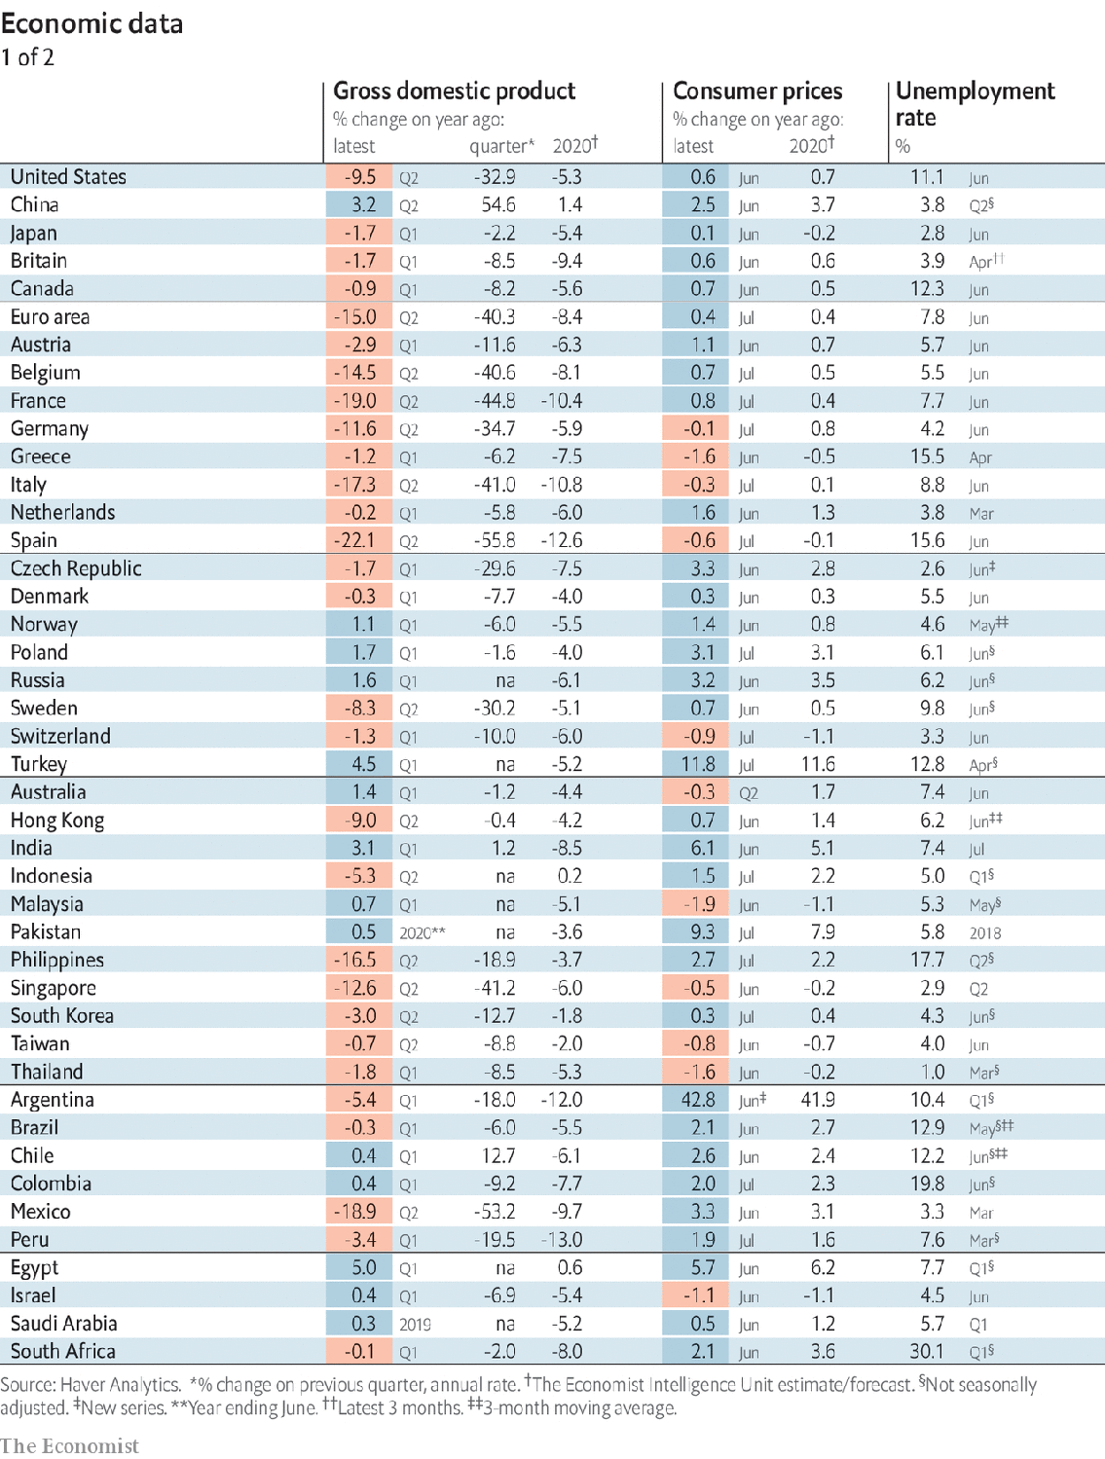

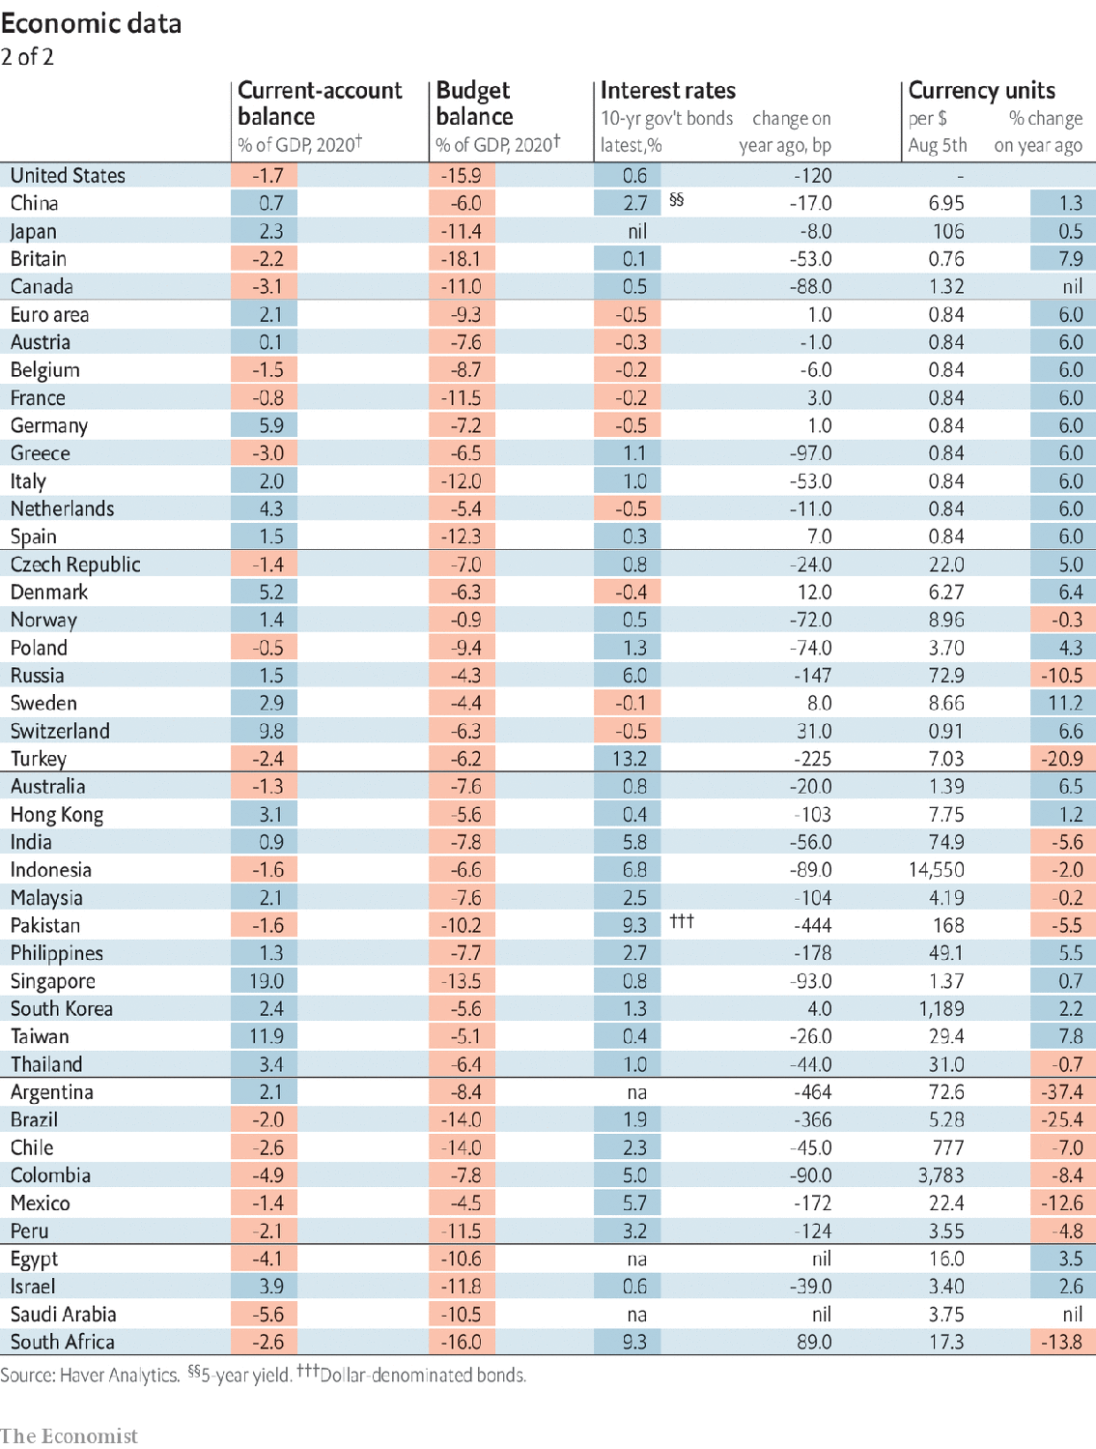

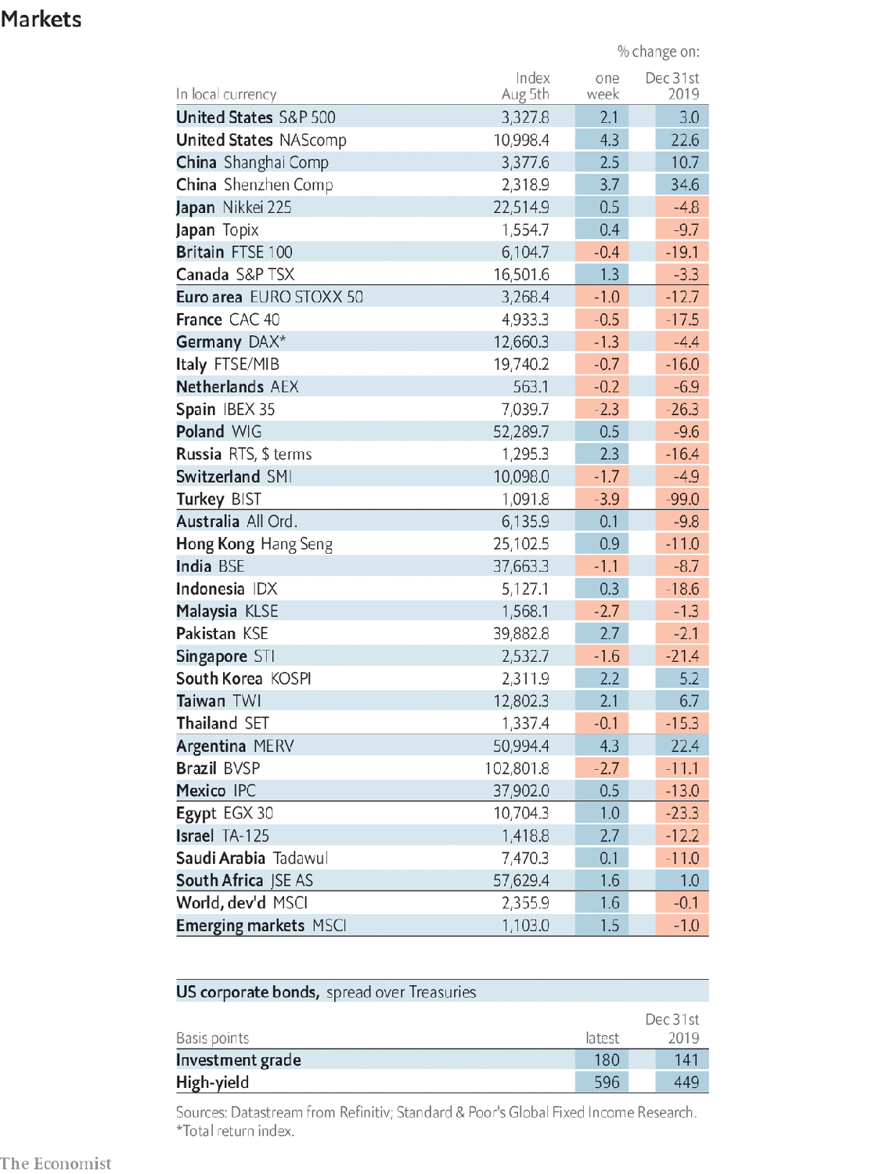

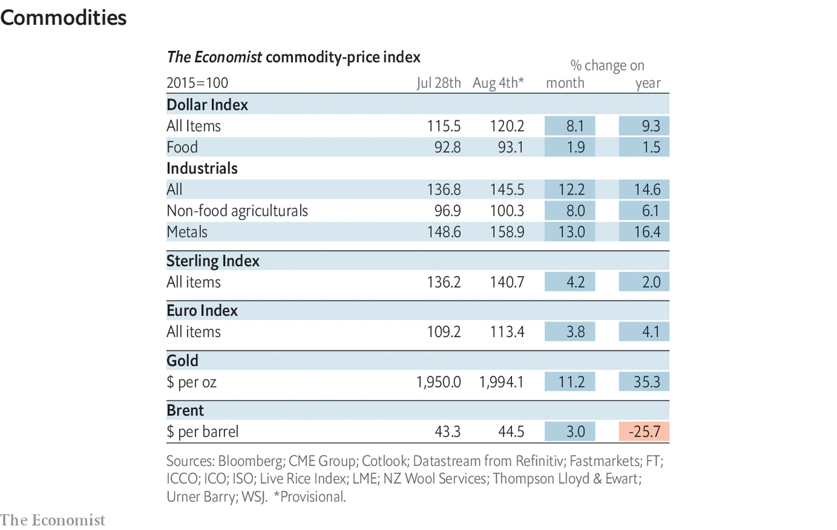

This article was downloaded by calibre from <https://www.economist.com/economic-and-financial-indicators/2020/08/08/economic-data-commodities-and-markets>

|  |  |  |  |
| --- | --- | --- | --- |
|  | Articles | Sections | Next |

|  |  |  |
| --- | --- | --- |
| Economic & ... | Sections | Obituary |

Graphic detail

Life in the time of corona: 90% economy, 120% gastronomy

.

|  |  |  |
| --- | --- | --- |
| Economic & ... | Sections | Obituary |

|  |  |  |  |
| --- | --- | --- | --- |
|  | Articles | Sections | Next |

#### 90% economy, 120% gastronomy

# Covid-19 seems to have changed lifestyles for good

Google search traffic for cooking, exercise and crafts remains above normal levels

Aug 8th 2020 |

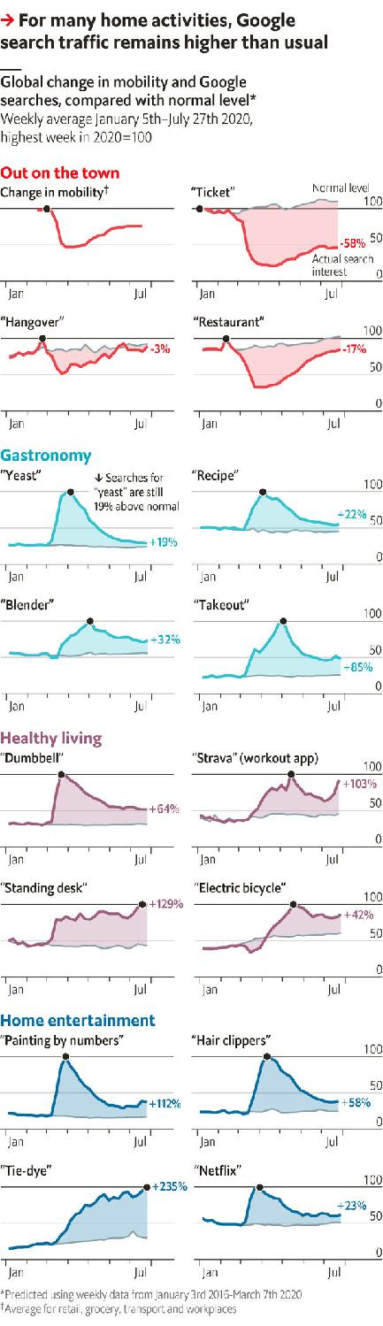

Editor’s note: Some of our covid-19 coverage is free for readers of The Economist Today, our daily [newsletter](https://my.economist.com/user#newsletter). For more stories and our pandemic tracker, see our [hub](https://www.economist.com/news/2020/03/11/the-economists-coverage-of-the-coronavirus)

COVID-19 HAS altered life as we know it. When governments imposed lockdowns in March, people transformed their homes into makeshift offices, gyms and pubs. For many, crammed commutes and bustling nightlife became a distant memory. Now that countries have eased restrictions, residents are venturing outside again—but not as much as before. Globally, they made perhaps 25% fewer trips per day in July than they did in early March, according to The Economist’s analysis of Google’s phone-tracking data.

Consumer caution has hit some industries harder than others. By training a statistical model on Google’s global search data since 2016, we find that traffic for “restaurant” (or similar words in other languages) is currently 17% lower than we would usually expect for this time of year. Booze stores may be doing better, since searches for “hangover” have rebounded to a normal level for raucous July, after dwindling by 40% in March. But enquiries for “tickets” are still down by 58%. This newspaper has called the result of such an uneven recovery “the 90% economy”.

Even as people are less comfortable going out and about, Google’s data show that they are persisting with home activities they picked up months ago. Take baking, for example. “Yeast” quickly became a fad, with searches rising by 280% in April—and by 1,300% in peckish Italy. Global interest has flattened since, but is still 19% above normal. Other gastronomic words show a similar pattern. The increase for “takeout”, however, has been even greater. Kneading and proofing is not for everybody.

Though people are feasting at home, fitness has also become a priority during quarantine. Searches for “dumbbell” and “Strava”, a workout app, remain more than 60% above the usual level, despite gyms reopening. The continued interest in “electric bicycles” and “standing desks” (especially in America) shows that workers are making their transport and home offices healthier too.

Likewise, arts and crafts adopted in April have made a lasting mark. Aspiring Picassos have kept searches for “painting by numbers” at more than double their normal rate. “Hair clippers” remain fashionable among amateur barbers, as does “tie-dye” with people willing to spatter their clothes (particularly Germans, who seem to be channelling their inner Jil Sander). As with cooking, however, there are plenty of slouches who lack inspiration for such artistry. Netflix can thank them for a rate of searches that was 23% higher than usual in late July, long after March’s mania for “Tiger King” wore off.

The Google trends for many of these home entertainments suggest that their new popularity may outlast the pandemic. If so, the world could end up poorer in earnings—but richer in experiences. ■

Sources: Google; The Economist

This article was downloaded by calibre from <https://www.economist.com/graphic-detail/2020/08/08/covid-19-seems-to-have-changed-lifestyles-for-good>

|  |  |  |  |
| --- | --- | --- | --- |
|  | Articles | Sections | Next |

|  |  |  |
| --- | --- | --- |
| Graphic detail | Sections |  |

Obituary

Olivia de Havilland: The ingénue who roared

.

|  |  |  |
| --- | --- | --- |
| Graphic detail | Sections |  |

|  |  |  |  |
| --- | --- | --- | --- |
|  | Articles | Sections | Next |

#### The ingénue who roared

# Olivia de Havilland died on July 26th

The last grande dame of Hollywood’s Golden Age was 104

Aug 8th 2020 |



ON THE FIRST day of rehearsals for “Captain Blood”, in 1935, Olivia de Havilland and Errol Flynn returned their lunch trays together to the canteen. Already she had thought “Oh!” at the sight of him; but, being sensible, she had eaten alone at a distant table. Now they sat together on the stage ramp, by the huge doors that opened onto the street, and his first words were: “What do you want out of all this?” She answered, in her clear young English tones: “I would like respect for difficult work well done.”

That sounded more modest than his aim, which was simply “success”. But it meant hard fights on several fronts. When she reviewed her proudest achievements later, they were not just her major role in “Gone With the Wind” in 1939 and her two Academy Awards for Best Actress, in 1947 for “To Each His Own” and in 1950 for “The Heiress”—still less her 49 feature films altogether. She had also broken the hold of Hollywood studios over their actors, leaving them freer to choose the roles they were best suited for.

To some extent no one was free at Warner Bros in the Golden Age. She worked six-day weeks there, dressed, up on her lines and on the set by 6.30am, shooting until 6pm and until midnight on Saturdays. She once got a cameraman to blacken her eyes to show Jack Warner she was tired. That was hardly the worst of it, though. Because she was small and flawlessly beautiful she was inevitably an ingénue: the lovely and mindless girl, her pleading eyes harking back to silent-cinema days, who would lead the hero windingly but inevitably to the marriage bed. Warner Bros had one great dramatic actress, Bette Davis, and two ingénues, one blonde and one brunette. She was the brunette. And with a burst of menthol in her eyes, she could weep real tears.

From the start, this rankled with her. She wanted to play women who were complex and thoughtful, when the best she could hope for was spirited, wimpled Maid Marian in “The Adventures of Robin Hood” (1938). In “Gone With the Wind” (made for MGM, not Warner, after she pleaded with Warner’s wife) she went for Melanie Hamilton, dignified, loving and forgiving, rather than the flighty Scarlett O’Hara. There were deeply feminine qualities in her she wanted to explore. She did so largely by herself, after a good read of Stanislavsky’s “An Actor’s Work”; in costume as Melanie, she would keep going back to commune with her in the dressing-room mirror. One day, still struggling, she asked Jimmy Cagney for advice. “Whatever you say, mean it,” he snapped. She made sure she did.

And she always had. To act had been her dream from the age of five, when she found her actress-mother’s make-up box and smeared her cheeks with rouge that would not come off. It grew steadily through the childhood elocution lessons, the Shakespeare-reading sessions and a local production of “Alice in Wonderland” in which she seemed to move in an enchanted world. (Her younger sister Joan, treading annoyingly on her heels, wanted just the same career and, as Joan Fontaine, got much of it, until their mutual snubbing became legendary.) Yet even after her big break, playing Hermia in Max Reinhardt’s “A Midsummer-Night’s Dream” at the Hollywood Bowl in 1934, to sign at once with a studio was terrifying. She was 18, and felt she was jumping off an Olympic diving board with no idea how to dive. That was before she found that pretty little women were hardly required to act.

Almost as fast as Warner Bros kept offering her brainless work, she declined it. After all, her favourite pursuit was to do cryptic crosswords. But the studio had a hold on her. Each time she turned down a role her contract was suspended, and the days not worked were added as time owed. Infuriated, she took the studio to court in 1943 and won, as she was pretty sure she would. Henceforth, under the De Havilland Law of 1945, actors were employed for proper calendar terms and the studio stranglehold was ended.

It was no coincidence that she did her best work after that. In “To Each His Own”, she played a mother trying over decades to retrieve the child she had given up, carefully changing her perfume to fix the character as she aged. In “The Heiress” she portrayed a woman who was shy and plain; scorned by her father and betrayed by her fortune-seeking lover, she took a calm, cold revenge on both of them. For “The Snake Pit” (1948) she became a wife sent by her husband to a mental asylum, striving to keep her dignity while assailed by inner demons. To research the role she consulted psychiatrists and visited a mental hospital to watch electric-shock treatment, with the horror of the body rising and forcibly held down. She knew just a little of constraint like that.

She was alert to other curbs on her freedom, too. She avoided marrying her leading men, preferring to carry on discreetly with several, including Errol (unconsummated, she insisted, despite eight films together), Jimmy Stewart and John Huston. Instead she married writers, promptly divorcing them when mutual interest faded. In the mid-1940s, though ardently liberal, she resigned from the liberal Citizens’ Committee to protest against the leadership’s pro-Soviet line, and even informed the FBI secretly about them. No other voice or group should dare to speak for her, or use her.

Her strongest bid for independence came in mid-life, when she left Hollywood behind. In 1955, having married a Frenchman, she went to live in Paris for the next 60 years. In her 19th-century mansion she would float about magnificently in Chinese silk and pearls, with a glass of Veuve Clicquot in her hand. Her screen work became rarer; she did not keep company with actors and directors, but with Voltaire and Monet. Real as she had made her characters, what she most loved now was actual authenticity: houses and churches made of stone, not canvas, and real princes to meet. On a visit to Beverly Hills in 1957 she bumped into Errol again, at a charity ball, and was surprised by the deadness of his eyes.

California stayed in her mind, however. She mused to Vanity Fair that if she could not come back to Earth as herself, a role she found perfectly satisfactory, she would like to be a redwood tree. Strong, deep-rooted, benevolent, tall— and reaching in unimpeded splendour for the sun, the moon and the stars.■

This article was downloaded by calibre from <https://www.economist.com/obituary/2020/08/08/olivia-de-havilland-died-on-july-26th>

|  |  |  |  |
| --- | --- | --- | --- |
|  | Articles | Sections | Next |